Product Form
Item | Description | Price
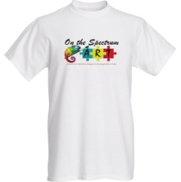M-logo 1  W-Logo 1 | Men’s Women’s  White Black  S M L XL XXL | $18.00  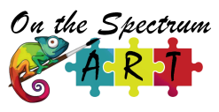
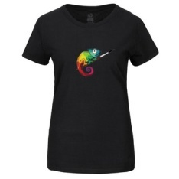M-Logo 2  W-Logo 2 | Men’s Women’s  White Black  S M L XL XXL | $18.00
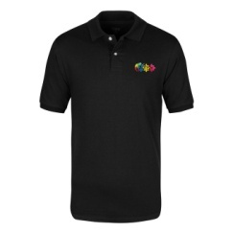M-Logo 3 | Men’s  White Black  S M L XL XXL  Special Autism Logo | $35.00
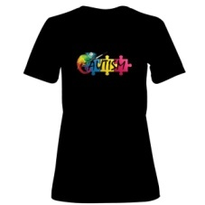W-Logo 3 | Women’s  White Black  S M L XL XXL  Special Autism Logo | $22.00
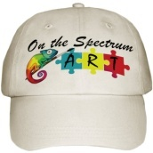 | One Size fits all | $22.00
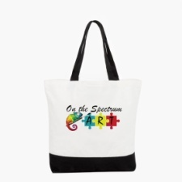 | Two Tone Cotton Tote | $25.00
 | 5x5 Clear Car Decal | $10.00

Order Form

Name: _______________________________________________________
Address: _____________________________________________________
Phone: _______________________________________________________

Item | Color/Size | Price | Subtotal
Total Amount Due

Payment for your order can be done via our website directly through PayPal

