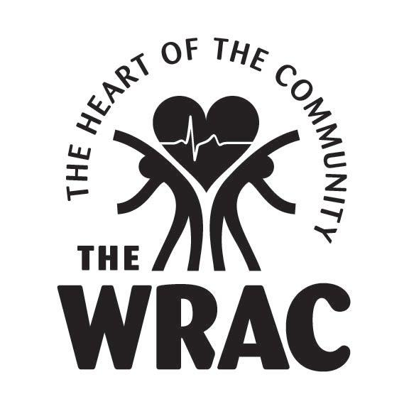 the WRAC BOARD application

Contact Information (PLEASE PRINT)

Date of Application:

First Name: Last Name:

Primary Email: Secondary Email:

Primary Phone: Secondary Phone:

Preferred Contact Methods: € Primary Email € Secondary Email € Primary Phone € Secondary Phone

Current or most recent professional position/employer:

Title (if applicable):

Website(s):

Please list your experience with the WRAC:

Please share why you want to serve on the WRAC Board:

the WRAC BOARD application

Current leadership roles (i.e. boards, committees, projects) outside your professional position
(if applicable):

Please share any ways in which you see the WRAC best serving its mission, stakeholders and larger community (“Providing Opportunities to Improve the Health of Our Community”) :

List how you can be an ambassador for the WRAC as interacting with the community is key:

the WRAC BOARD application

What skills, background and expertise do you have that you would like to share with the WRAC:

€ Assessment/Evaluation
€ Event Planning
€ Management/Operations
€ Marketing/Public Relations/Communications/Branding
€ Fundraising
€ Strategic Planning
€ Financial Management/Accounting
€ Personnel/Human Resources
€ Program Development
€ Technology (i.e. networking, web management)
€ Volunteer Development
€ Other. Please List.

The WRAC has various committees led by board members. On which committee(s) would you be interested in serving?

€ Board Development
€ Endowment
€ Budget/Financial Sustainability
€ Membership
€ Building/Property
€ Fundraising
€ Volunteer/Donor Appreciation
€ Grants

Please share any other information that you feel would be helpful for the WRAC board to know about you and your interest in serving on the board:

the WRAC BOARD application

NEXT STEPS

A WRAC board member will be in touch in the next 2 weeks about your interest in the board and we will subsequently conduct interviews with potential candidates for the board. If you are selected as a potential board candidate, we will have you attend a board meeting before joining the board to get a feel for how the WRAC board operates.

Please return this form completed to the WRAC front desk or scan and email to danahoff@wracofwray.org

THANK YOU for your interest in and support of the WRAC!

