**Letocetum Roman Town**

* **Letocetum** was located at the intersection between two strategically important Roman roads – **Watling Street** and **Ryknield Street**.
* **Watling Street**, which runs from [Richborough](https://www.english-heritage.org.uk/link/aa476337012d46b9bf16adf6da4924d1.aspx) (Kent) to north Wales, was the first major Roman road developed after the conquest. By the early 50s AD it linked the important towns of London, **Wroxeter** and **Chester**.
* The Roman army established a series of forts as part of its campaigns in the west and the north.

A map of Roman Wall showing its relationship to the junction of Watling Street and Ryknield Street

* A first fortress was constructed at Wall in the early 50s AD across the line of Watling Street, on flatter ground to the west of the earlier marching camps. It was needed to accommodate part of the **XIV Legion**.
* About a decade later, the legion moved on to Wroxeter and the fort was flattened.
* **Ryknield Street**, the major north–south road, was established at roughly the same time.
* A second fort was constructed at Wall in response to the Boudiccan rebellion in the south-east (AD 60 – 61). This was on a new site, north of Watling Street, suggesting that the flattened site of the first fort was then occupied by civilian buildings.
* Once the rebellion was suppressed this fort was also levelled.
* A further fort was built in the same position, and subsequently demolished. This final fort was probably associated with the Roman army’s campaign against the **Brigantes** in the north, in the 70s AD.
* Wall was well placed within the wider travel and communications network. It also lay at the boundary between two tribal areas, the **Cornovii** to the west and the **Corieltauvi** in the east. This position allowed the Roman army to maintain surveillance on both tribes.
* By around AD 80, Letocetum had become an important place by the addition of a ***mansio***, or official guesthouse. Establishments like this facilitated travel for Roman officials. They were spaced so that a day’s ride would take a traveller to the next one, where a meal, a bed, and a change of horse could be had, though probably not for the general public.
* 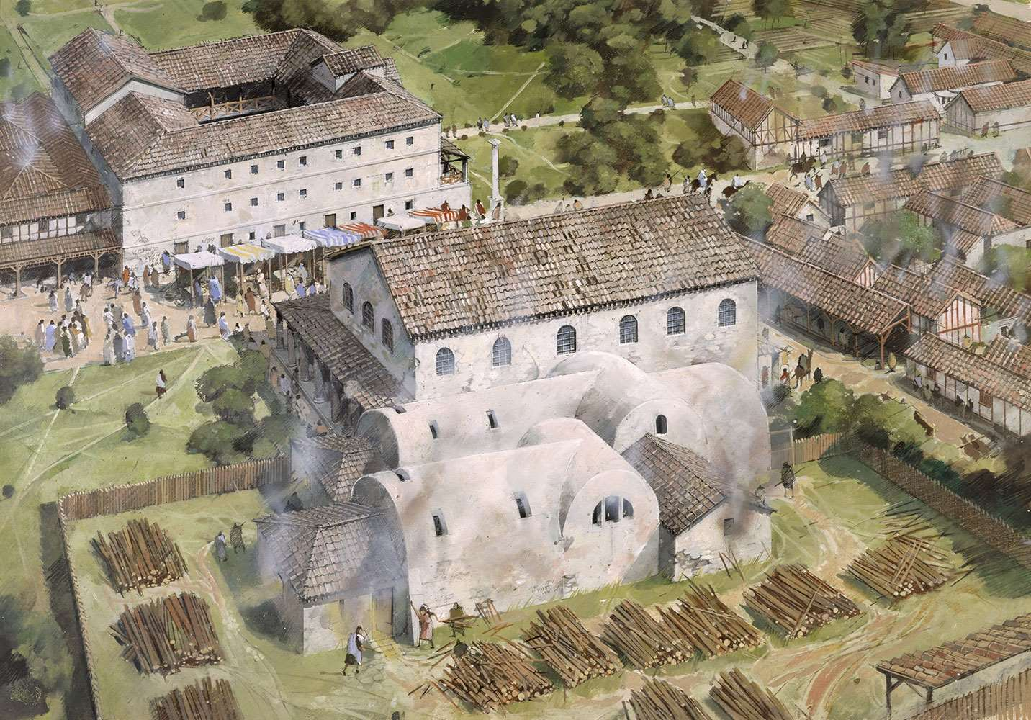A bath house was added soon after. The flattened sites of the former forts were reused for civilian and industrial buildings as the town expanded.

A reconstruction drawing of the baths complex and mansio at Wall© Historic England (illustration by Ivan Lapper)

* Official travel reduced in the 3rd century, and the mansio was demolished around AD 250. The bath house, which had been enlarged a number of times, survived a little longer, until around AD 300.
* In the 4th century a square defensive enclosure was built across the line of Watling Street, blocking the road, possibly in order to extract tolls from travellers.
* This smaller but well-defended settlement likely retained key functions (e.g. a market and taxes), but by the end of the 4th century the settlement reduced in size.
* After the end of Roman rule, the 4th-century defensive enclosure may have carried on being used.
* Many excavations have taken place here, both on the site of the baths and mansio and the wider settlement – the forts, domestic buildings and industrial sites, as well as cemeteries.
* Today, Wall Roman Site is made up of the excavated remains of the bath house and mansio. The earliest documented excavations of these buildings took place in 1912–14.
* Unfortunately, the exposed hypocaust of the bath house deteriorated rapidly after 1914 and the underfloor hypocaust was reburied until the mid-20th century, when the bath house and mansio complex were placed in the care of the state.
* Between the 1960s and the 1980s, investigation of the many archaeological sites in and around Wall intensified. There was further excavation of the English Heritage site as well as the forts, farmsteads and industrial sites on its periphery.