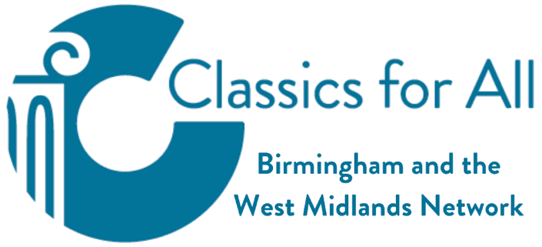
Roman Ariconium

- Ariconium served as a Romano-British settlement, functioning as both a roadside station and a centre for metalworking activities. The site was positioned at Bury Hill, situated between Weston under Penyard and Bromash, in close proximity to Ross on Wye.
- The surrounding Forest of Dean region had long provided a valuable supply of iron ore deposits and charcoal materials needed for industrial processes.
- Evidence suggests that pre-Roman British communities had already established the location as a metalworking centre, forming part of an established iron production network. Archaeological investigations have revealed traces of early extraction activities and furnace operations, with multiple forge installations arranged in grouped configurations.

- The settlement maintained continuous occupation during the entire Roman period, with industrial operations expanding significantly over time.
- Roman establishment of the site occurred around 50 AD, creating a complex that combined military fortifications, civilian habitation areas, and manufacturing facilities.
- Archaeological discoveries include pre-conquest British currency, notably specimens issued by Cunobelin, alongside Roman coinage spanning from the initial invasion period through to 360 AD, after which monetary evidence ceases.
- The site appears to have been deserted abruptly after 360 AD. This sudden termination suggests possible violent circumstances, potentially linked to the breakdown of Roman administrative control and widespread lawlessness documented during that era. No evidence has been uncovered indicating subsequent reoccupation.
- Prior to an accidental find in 1758, knowledge about Ariconium and its precise location remained limited.
- Excavations during the latter part of the 18th century yielded significant artefacts including fibulae (decorative fasteners), representations of lares (domestic deities), lachrymatories (vessels for tears), illumination devices, jewellery, and sections of mosaic flooring. Additionally, numerous ceramic fragments in red and grey varieties were recovered, some displaying ornamental patterns.
- During 1804, archaeological work uncovered human skeletal remains alongside the remnants of a stone structure - evidently representing a building's frontage.
- Numismatic evidence from the site encompasses coins ranging from the reign of Claudius (AD 41) through to Constantinus (AD 340).

Sources:
- Herefordshire Council, ‘Herefordshire Through Time’, https://htt.herefordshire.gov.uk/herefordshires-past/the-romano-british-period/herefordshires-roman-sites/major-roman-sites/ariconium/
- Roman Britain, ‘Ariconium’: https://www.roman-britain.co.uk/places/ariconium/
- Burgum Family History Society, ‘Ariconium’: https://www.burgumfamily.co.uk/pl2_ariconium.php
- Ancient Monuments, ‘Roman Town of Ariconium’: https://ancientmonuments.uk/103601-roman-town-of-ariconium-weston-under-penyard
- Wikipedia, ‘Ariconium’, https://en.wikipedia.org/wiki/Ariconium

