
Legio XIV Gemina

- Legio XIV Gemina ("The Twinned Fourteenth Legion") was first raised by Caesar in 57 BC during his raids into, and conquest of, Gaul.
- The name Gemina, meaning ‘twin’, identifies the Fourteenth as a legion formed by the amalgamation of two existing formations.

- Stationed in Moguntiacum, Germania Superior from AD 9, Legio XIV Gemina Martia Victrix was one of four legions used by Aulus Plautius and Claudius in the Roman invasion of Britain in AD 43.
- The first semi-permanent legionary fortress on British soil to house the Fourteenth was very likely in the Midlands at Mancetter Vexillation Fort.
- The fortress here was certainly occupied by AD46, and at this time was positioned at the edge of the newly fledged Roman province of Britannia.
- By AD 58 it had moved its base to Wroxeter.
- It took part in the defeat of Boudicca in 60 or 61.
- At the Battle of Watling Street the 14th defeated Boudicca's force of 230,000, according to Tacitus and Dio, with their meagre force of 10,000 Legionaries and Auxiliaries.

- The cognomen Martia Victrix (martial and victorious) was added following their service in the Pannonian War c. AD 9 and the defeat of Boudicca in AD 61.
- The emblem was the Capricorn, as with many of the legions levied by Caesar.
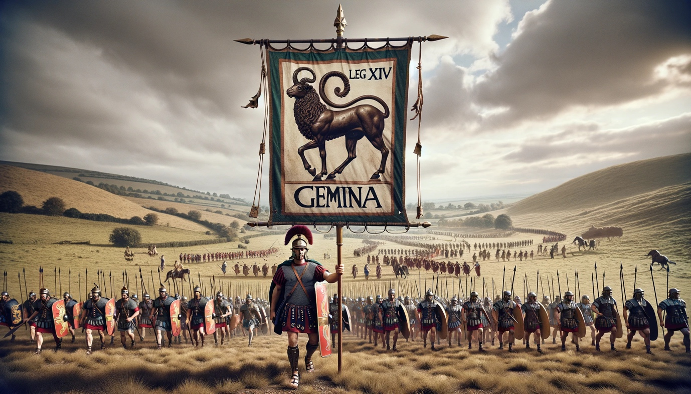
- In 67 AD the legion was sent to the Balkans in preparation for a campaign against the Parthians that Nero planned but which never materialised.

