
The XX Legion

- During the Imperial Period (c. 27BC - AD 476) a legion was made up of around 4,000 - 6,000 troops, including legionnaires and auxiliaries (additional troops).
- Each cohort was comprised of six Centuries of 80 men (originally 100 men – hence the name - but this had been decreased by the first century BC).
- The man in charge of a century was a ‘centurion’.
- Below the centurions were legionary soldiers, who enlisted in a legion for 25 years and had to be a Roman citizen under the age of 45.
- Auxiliary troops were non-citizens, however they also enlisted for 25 years, though in practice some served longer.

- The XX Legion was possibly founded after 31 BC by the emperor Augustus, who may have integrated older units into this new legion.
- Its first assignment was in Hispania Tarraconensis (Spain), where it took part in Augustus' campaigns against the Cantabrians, which lasted from 25-13 BCE.
- At least some subunits were transferred to Burnum (modern day Croatia) on the Balkans as early as 20 BC.
- In AD 6, the future emperor Tiberius led at least eight legions (including XX Valeria Victrix) against king Maroboduus of the Marcomanni in Bohemia (modern Czech Republic) while other Legions attacked along the river Elbe.
- It is possible that this was where the legion gained its name Valeria Victrix.
- After the disaster in the Teutoburg Forest (September AD 9), where the legions XVII, XVIII and XIX were destroyed, Tiberius, who had to restore order, took the experienced Twentieth Legion with him, and it was now redeployed in Germania Inferior (modern day Germany).
- In AD 21, a mixed subunit of XX Valeria Victrix and XXI Rapax, commanded by an officer from I Germanica, was sent out to suppress the rebellion of the Turoni in Gaul (modern France), who had revolted against the heavy Roman taxation.
- During the reign of Tiberius (r. AD 14-37) who succeeded Augustus as emperor, the XX Legion was transferred further north up the river Rhine to Novaesium (Neuss), probably around AD 35.

- Legions would have recruited locals in each location it served, so by the time the XX legion arrived in the West Midlands, it would have included members from the Balkans, Italy, Germany, Spain, and North Africa.
- Citizenship was awarded upon discharge, or occasionally to a whole unit for outstanding valour in battle.
- Later in the occupation of Britain, some recruits were already Roman citizens, the sons of former auxiliary soldiers.
- By the late 70s, in Britain, auxiliaries outnumbered legionaries.

- The XX Legion was also known as the Legio vigesima Valeria Victrix – the "Twentieth Victorious Valeria Legion."
- The origin of its name is unknown. But various theories have been put forward to explain why and when Victrix ‘victorious’ was added to the name.
- One idea is that the name was awarded from a victory the legion achieved during the Great Illyrian revolt under the command of the general Marcus Valerius Messalla Messallinus (AD 6 - 8). If correct, this could also explain the origin of the Valeria part of the name as well as the Victrix.
- Another theory suggests that the name came from the role played by the XX in defeating Boudica (ca. AD 60 - 61).
- The symbol of the XX Legion was a jumping boar, however the significance of this emblem is not fully understood.

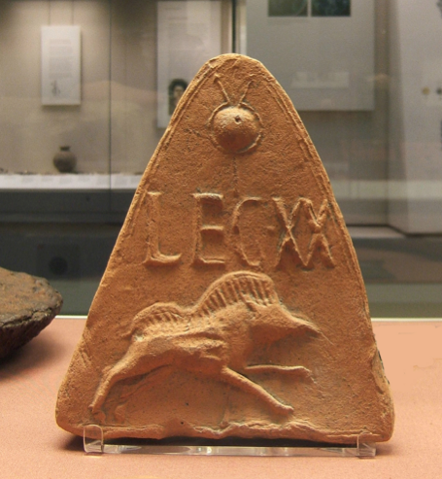
Moulded antefix roof tile showing the badge and standard of Legion XX, from Holt, Clwyd, Wales

- In AD 43, the emperor Claudius invaded Britain with II Augusta, VIIII Hispana, XIV Gemina and XX Valeria Victrix.
- In AD 44 the invasion force headed for Camulodunum (modern Colchester), where they received the submission of British tribal leaders.
- The first legionary fortress in Roman Britain was Camulodunum, the capital of the Trinovantes. It is thought that Legio XX built the fortress and occupied it until AD 49.
- In AD 49, Legio XX moved on, and the fortress were converted into a Roman civilian town. The town was settled with Roman army veterans - possibly some from the XX Legion.

- By participating in the invasion and settlement of Camulodunum, the XX Legion were involved in the war against the rebel British leader Caratacus.
- Caratacus was a son of the Catuvellaunian king Cunobelinus.
- Claudius' initial invasion of Britain had focused on Caratacus's stronghold of Camulodunon.
- Caratacus and his brother Togodumnus led the initial defence of the country against Aulus Plautius's four Roman legions, thought to have been around 40,000 men, primarily using guerrilla tactics.
- They lost much of the south-east after being defeated in two crucial battles, the Battle of the River Medway and River Thame. During the battle Togodumnus was reportedly killed.
- The Catuvellauni's territories were conquered, and their stronghold of Camulodunon was converted into the first Roman colonia in Britain, Victricensis (Colchester).

- After AD 48, the XX Legion was stationed at Glevum, (Kingsholm in modern Gloucester) and in AD 57, it moved to Usk (modern Monmouthshire in Wales).
- They set out from Usk to help defeat Boudica somewhere near the meeting place of the Fosse Way and Watling Street, somewhere in the vicinity of Coventry.
- It is possible that the Twentieth received its surnames Valeria Victrix as rewards for its courageous behaviour in this battle.

- In AD 75, XX Valeria Victrix was transferred to Viroconium (Wroxeter). Governor Gnaeus Julius Agricola led the legion to the north as part of his campaigns in the Scottish highlands (AD 78 - 84).
- VIIII Hispana launched its offensive from York at the same time. The two forces met at Stanwick, where they caught the warriors of the Brigantes in a pincer movement.
- From now on, northern England was part of the Roman empire.
- In AD 88, the Legion was ordered to return to England, where it founded a new base at Deva, modern Chester.
- We know soldiers of the XX Legion were active in the construction of Hadrian's wall (AD 122 - 125) and the Antonine wall (ca. AD140).
- We have carved examples of the boar of XX Valeria Victrix from the fort of Vindolanda, just south of Hadrian's Wall.

- Between AD 155 - 158, there was a widespread revolt in northern Britain. The British legions suffered severely, and reinforcements had to be brought in from the two Germanic provinces.
- In AD 196, governor Clodius Albinus of Britannia attempted to become emperor. The British legions were moved to the continent, but were defeated in 197. When they returned to Britain, they found the province overrun by northern tribes.
- In AD 208 Septimius Severus came to Britain, in an attempt to conquer Scotland.
- XX Valeria Victrix may have fought its way up north along the west coast, but returned home to Deva (Chester) during the reign of Severus' son Caracalla (AD 211-217).
- However, the legion had behaved courageously and was awarded the surname Antoniniana.
- The legion was still active during the reign of Carausius and Allectus (AD 286 - 293 and 293 - 296), but is not mentioned in the fourth century.
- Perhaps it was disbanded when the Roman emperor Constantius I Chlorus reconquered Britain.

