**Lunt Roman Fort**

* Lunt Roman Fort in Baginton was a Roman military camp created in around AD 60 or 61 to deal with the revolt of Boudica and/or its aftermath.
* The Lunt is close to the junction of two major Roman roads, the Fosse Way and Watling Street and this whole area appears to have been a highly militarised zone with forts at Wall (*Letocetum*), Mancetter (*Manduessedum*), Alcester (*Alauna*) and Metchley. Tacitus recorded that the whole army was kept mobilised during the winter to quell any remnants of the Boudican uprising.
* We have no record of the Lunt from Roman times or what it was called - the name Lunt was introduced later and refers to trees or a wooded slope.
* The fort sits on an ideal strategic site on a high plateau with a steep wooded slope overlooking the river Sowe to the north. The elevation from the top of the bank provides good views of the landscape to the north for two or three miles (4.0 km) in the direction of modern Coventry. To the south is a flat plateau while to the east and west the ground slopes appreciably, making the site an ideal location for a Roman fort. The Roman road now called the Fosse Way lies about 7 km to the south.
* Our knowledge comes entirely from archaeology and from how other similar sites were governed and worked.
* The site was identified when large quantities of Roman pottery were found in the 1930s during gravel-working in the village of Baginton.
* In the 1960s, Brian Hobley, keeper of field archaeology at the Coventry Museum, started a long-term project to combine excavation with a study of the methods by which Roman camps were built.
* Four distinct periods of occupation were identified.

**Period I (AD 60-64):**

* Lunt Fort may have started-off life as a large encampment used to house a mixed regiment or two of cavalry and infantry known as a cohors equitata, together with an unknown number of horses captured during the campaigns of governor Gaius Suetonius Paulinus against Boudica in AD 60-61.
* Soldiers in this type of regiment would have been accustomed to the care and use of horses and would have been the logical choice to garrison the Fort, able to care for and train the horses they had captured.
* Excavations between 1968-71 revealed the presence of barrack-like buildings and a granary in the Northeast corner of the fort.
* The camp seems to have had four building periods, all in timber, during the latest of which a large circular horse-training ring or ***gyrus*** was erected.
* Evidence for the presence of the **XX legion** at the fort might be suggested by a silver ring. The ring with a palm leaf engraved on the face has been taken to suggest the [presence at the fort of a winning gladiator](https://www.coventrytelegraph.net/news/coventry-news/ancient-find-lunt-hints-roman-3112115) – as the palm leaf as a symbol of victory was sometimes worn by such men.
* A closer look at the ring reveals the possible engraving of XX, one X either side of the palm. Could this ring have belonged to a soldier from the XX Legion?
* The XX were given the honorary title of ***Legio vigesima Valeria Victrix***. Some suggest the title was earned defeating Boudica, others that they were given the title earlier (AD 6-9) for their part in quelling a revolt in Illyria (modern Albania). Either way, the palm as symbol of victory might be a symbol for *Valeria Victrix*.

* The ***gyrus*** was a large circular structure on the east side of the fort, 34.06m in diameter with a funnelled entrance and double gate, probably indicating that the structure was used for livestock of some sort.
* This feature is not only unparalleled in Britain, but is the only known example in the Roman Empire. It has been suggested that the *gyrus* was associated with the training of horses.
* Evidence of horses is rife. Archaeological excavations uncovered finds associated with cavalry within the fort, with stable blocks uncovered from Period I. This strongly suggests that the *gyrus* was once a cavalry-training arena where the soldiers trained horses for combat.
* The Greek historian Xenophon referred to such a structure as a *gyrus*, but there is no equivalent Latin word and we do not know what the Romans themselves called this type of structure.
* Though not part of the initial fort design, the *gyrus* was an important part of the fort and two barrack blocks were shortened and one was moved to accommodate it. Once built, the arena remained a constant feature while the rest of the camp continued to be altered and developed.
* The *gyrus* was constructed from fifty semi-circular cut timbers set upright in a circular trench, probably supporting a framework of cross-timbers. A single funnel-shaped entrance passage adjoined the structure on the northeast, which had gates at both ends, presumably to control the animals entering or leaving the ring. Probably both horses and men were trained within the *gyrus*.
* A circular dirt ring with a wooden fence

  Description automatically generatedThe continuing equine focus of the camp going in to Period II, together with dating evidence which places the foundation of the fort at the same time as Boudica's revolt of AD 60/61, has led to the conclusion that the camp was constructed specifically in order to deal with the large number of horses and ponies presumably taken as booty following the defeat of the British.

**Period II (ca. AD 64- 77/78):**

* In AD64 the fort was reduced in size and assumed its characteristically odd shape.
* While the north, south and west sides followed the usual pattern for a Roman camp of straight ditches and ramparts, on the eastern side the defences bulged out around the 32m diameter *gyrus*.
* This turf and timber fort had most of its interior buildings rebuilt in stone, aside from the three timber-built granaries and the *gyrus*, which now lay in the central area of the new fort adjacent to the eastern defences.
* It is the defences and interior buildings of this period that are on display at the modern site.
* Towards the end of the AD 70s the number of barrack blocks was reduced. Based on the number of barrack blocks, it has been estimated that there were approximately 480 foot soldiers and 120 cavalry soldiers here during this period.
* Granaries were an important feature of all Roman forts - they not only housed the grain for the troops, but also stored valuable equipment.
* Each fort was supposed to hold a year's supply of food in case they fell under siege.
* The granary buildings were usually situated in the centre of Roman forts as far as possible from the reach of attackers’ fire arrows.
* Granaries were raised off the ground to keep grain damp free and to allow air to circulate easily.
* A wooden building with a porch

  Description automatically generated with medium confidenceThe granary at the Lunt was sited to the west of the Principia, and dates to between AD 64 and AD 78. It was built on top of a structure that has been identified as the commanding officers house (praetorium).

**Period III (ca. AD 77/78 - 79):**

* The third period included construction of a double ditch system, a twin-portalled gateway on the south, and occupation outside the defences until the fort was decommissioned.
* The fort was shortened during this period, reduced to approximately 91 x 113 m.
* The third period fort was abandoned after a relatively short period of use, perhaps because following Boudica’s revolt, the West Midlands tribes developed good relations with their Roman overseers.
* The fort of Period III likely represents further scaling-down of operations at the fort which continued to operate with a reduced garrison for a short time before the defences were finally demolished and the site abandoned during the administration of governor Gnaeus Julius Agricola, its garrison possibly withdrawn for use in his northern campaigns.
* In AD79 Agricola became governor of Britain and there was a move northwards to conquer the whole of the island.
* The fort was finally abandoned around AD80.

**Period IV (ca. AD 260):**

* After AD 260, perhaps during the rebel Gallic Empire, the Lunt was recommissioned as a temporary fort with ditches on a similar alignment but slightly larger than that of Period II, though the fort itself was smaller – around 91 x 165 m.
* No interior buildings dating to this period have been found, which probably indicates that occupation did not last long, the troops perhaps living in field conditions in tented accommodation.
* Evidence for the dating of this occupation period is a single coin found in the post hole of a gateway minted under the emperor Gallienus (ruled AD 260-280), and some third-century pottery.
* There is no other evidence of occupation so the coin could have been a casual loss long after the fort had been abandoned.

Drone footage of the fort can be found [here](https://www.luntromanfort.org/explore).

**The Rebuilding of Lunt Roman Fort:**

* The reconstruction was overseen in the late 1960s and early 1970s by the archaeologist Margaret Rylatt MBE (seen in the photo below standing on the far right with a group of her students), using the same tools and techniques that the military engineers of the Roman Army would have used.
* 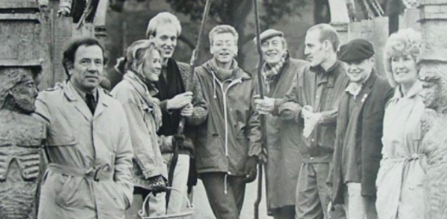Margaret persuaded the Royal Engineers Army Team to build the replica Roman military buildings and defences at the Lunt Fort.
* The soldiers first built ditches, then the ramparts, wooden fences and a grand entrance gate that is now the most recognised feature of the Lunt.
* These features of the fort were reconstructed upon the original foundations, including a section of the wall, a gateway, one of the three granaries and the gyrus.
* With no evidence of the look of the gateway, other than the clues given by its archaeological footprint, it was decided to model the fort on images found on Trajan's column.
* Each year the Army would come back and build something else, such as the Granary (see photo below) which houses the Museum and interpretation centre.
* After that came the 'Gyrus'.
* Unfortunately, the Army project stopped around the time of the Falklands war and was the start of many cuts in the military budget.
* 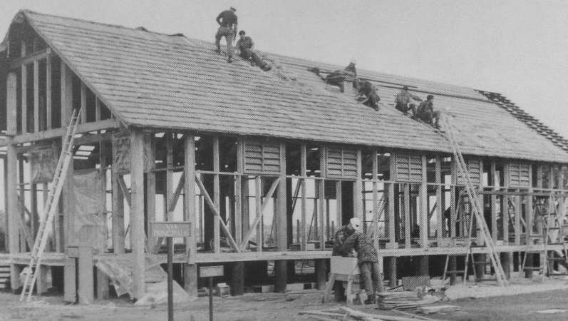A collage of people on a construction site

  Description automatically generatedThe reconstructions gave real insights into the durability of buildings and defences within military establishments, and how much resource was required.