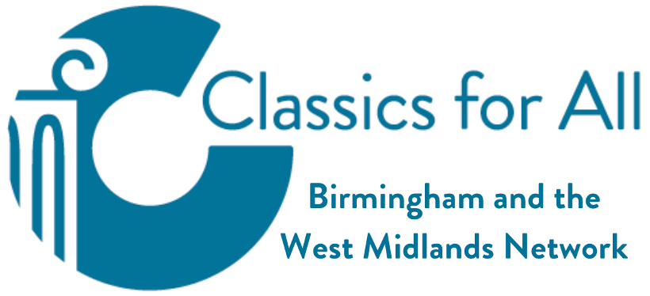
Coins

Possible Resources:
World History Encyclopedia – Roman Coinage
Britannica Money – Roman coins, republic and empire
Year 4 Roman Coins Lesson Plan
KS2 Romans and Iceni Teacher’s Cross-Curricular Pack
English Heritage Education – Paid like a Roman
Roman Bath – Make your own virtual Roman coin
Make your own Roman purse
My Learning - Counterfeit coins!
Twinkl – Roman coins

Suggestions:
- Show students images of Roman coins. Think about the following questions:
  - What can they see? What do they think the images might represent?
    - Introduce students to some of the gods/ goddesses. Explain the context of symbols – e.g. laurel wreath as a symbol of military victory
  - Why decorate coins at all?
    - Think about who can and can’t read –the idea of propaganda
  - Who might the people on the coins be? Why? (Even in a distant land like Britain, citizens of the empire knew what their Emperor looked like!)
  - What might coins be made of? Which coins might be the most valuable?

- How do you think the British people might have felt seeing Roman money/ the face of the Roman emperor on their money?

- What might it tell us about the Roman Empire/ Roman Britain that archaeologists can find Roman coins here?
  - The Emperor is shown on the coin – tells us when the Romans were here
  - Large number of coins found in one place might suggest a settlement
  - Random coins in unusual locations might suggest trade was happening
  - If there are no Roman coins in an area, perhaps that means the Romans hadn’t successfully invaded there yet

- Design your own coin, meant to celebrate the conquest of Britain. What would it show? Why?
  - Students could draw their designs, or make coins using clay, play-doh, or plaster of paris
- Write a speech from the Roman emperor, explaining why he has decided on this design, and why it will be effective in inspiring loyalty/ fear across your empire
- Design an ad, introducing the Roman Empire to this coin!

