**Letocetum Roman Town**

* **Letocetum** occupied a crucial position where two major Roman thoroughfares converged – **Watling Street** and **Ryknield Street**.
* **Watling Street**, stretching from Richborough in Kent to the regions of north Wales, represented the primary arterial route constructed following the Roman invasion. During the early 50s AD, this highway connected significant urban centres including London, **Wroxeter**, and **Chester**.
* The Roman military established a chain of fortified positions to support their western and northern military operations.

A map of Roman Wall showing its relationship to the junction of Watling Street and Ryknield Street. English Heritage.

* An initial fortress was established at Wall during the early 50s AD, positioned across **Watling Street** on level terrain west of earlier temporary military encampments. This installation was required to house elements of the **XIV Legion**.
* Approximately ten years afterwards, the legion relocated to Wroxeter and the fortification was dismantled.
* **Ryknield Street**, serving as the principal north-south arterial route, was developed during roughly the same period.
* A secondary fort was erected at Wall following the Boudiccan uprising in the south-eastern regions (AD 60-61). This new installation was positioned north of Watling Street, indicating that the demolished first fort's location had been taken over by civilian construction.
* Following the suppression of the rebellion, this fortification was also demolished.
* An additional fort was constructed in the identical location and later destroyed. This final military installation was likely connected to the Roman army's operations against the **Brigantes** in northern territories during the 70s AD.
* Wall enjoyed an advantageous position within the broader transportation and communication infrastructure. The settlement also stood at the frontier between two tribal territories: the **Cornovii** to the west and the **Corieltauvi** to the east. This strategic placement enabled Roman forces to monitor both tribal groups effectively.
* Around AD 80, Letocetum gained significance through the construction of a ***mansio***, serving as an official accommodation facility. Such establishments supported travel for Roman administrators. These were positioned at intervals allowing a day's journey between each facility, where travellers could obtain meals, lodging, and fresh horses, though access was likely restricted from ordinary citizens.
* A bathing complex was constructed shortly thereafter. The levelled areas of previous military installations were repurposed for civilian and commercial buildings as the settlement grew.

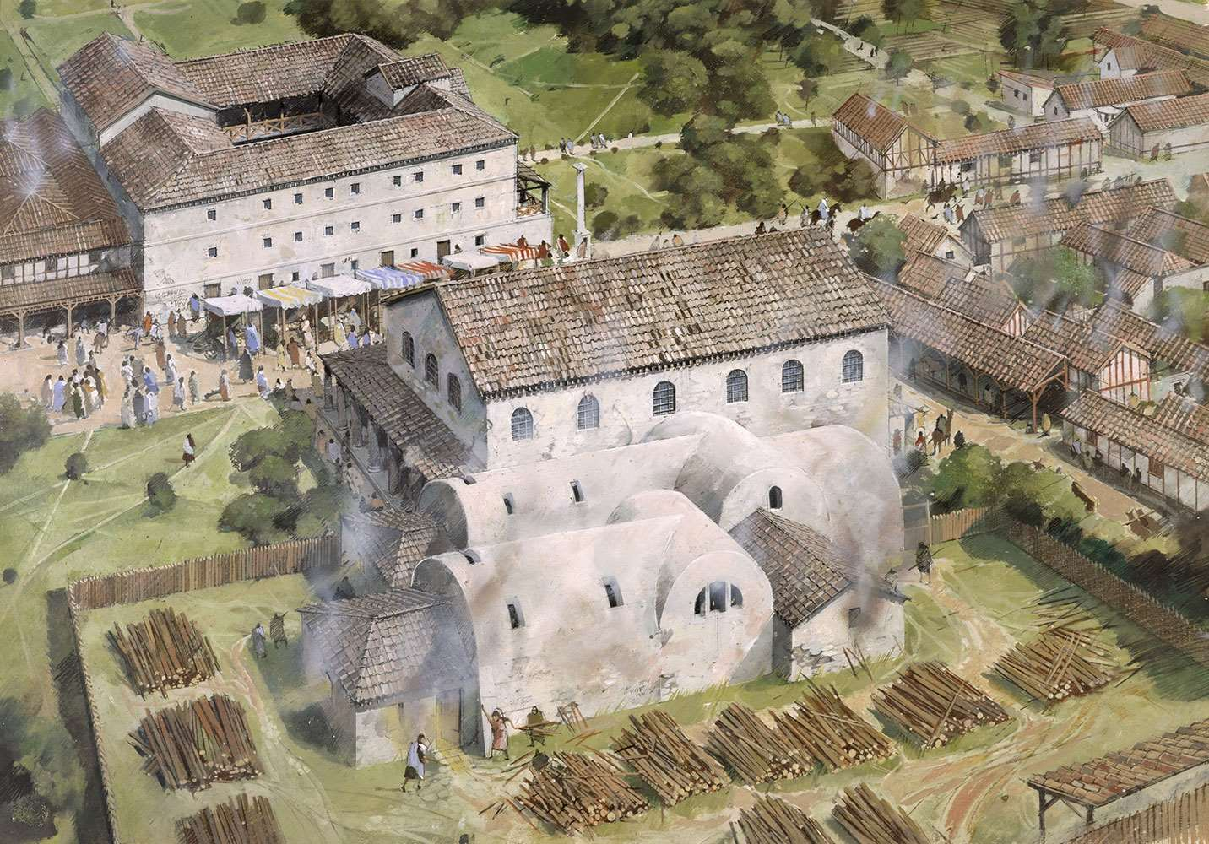

A reconstruction drawing of the baths complex and mansio at Wall© Historic England (illustration by Ivan Lapper). English Heritage

* Official travel diminished during the 3rd century, leading to the demolition of the *mansio* around AD 250. The bath complex, which had undergone multiple expansions, continued operating slightly longer until approximately AD 300.
* During the 4th century, a square fortified enclosure was constructed across **Watling Street**, blocking the roadway, potentially to collect tolls from passing travellers.
* This reduced but well-fortified settlement probably maintained essential services (such as marketplace activities and taxation), though by the close of the 4th century the community had contracted significantly.
* Following the conclusion of Roman administration, the 4th-century defensive structure may have continued in use.
* Numerous excavations have been conducted at this location, encompassing both the bathing and *mansio* structures and the broader settlement area – including military installations, residential buildings, industrial areas, and burial grounds.
* Currently, Wall Roman Site comprises the excavated remnants of the bath complex and *mansio*. The earliest recorded archaeological work on these structures occurred between 1912-14.
* Regrettably, the exposed underfloor heating system of the bathing facility degraded quickly after 1914, necessitating reburial of the hypocaust until the mid-20th century, when the bath and *mansio* complex came under state protection.
* From the 1960s through the 1980s, investigation of the numerous archaeological locations in and around Wall increased substantially. Additional excavation occurred at the English Heritage site along with the fortifications, agricultural settlements, and industrial locations in the surrounding area.

**Sources:**

* English Heritage. "History of Wall Roman Site." Available at: <https://www.english-heritage.org.uk/visit/places/wall-roman-site/history/>
* English Heritage. "Wall Roman Site." Available at: <https://www.english-heritage.org.uk/visit/places/wall-roman-site/>
* Historic England. "Wall Roman Site, Wall, Staffordshire - Educational Images." Available at: <https://historicengland.org.uk/education/schools-resources/educational-images/wall-roman-site-wall-9586>
* Historic England. "Roman site, Letocetum, Wall, Staffordshire." *National Heritage List for England*, Scheduled Monument. Available at: <https://ancientmonuments.uk/104331-roman-site-letocetum-wall>
* Historic England. "Roman site, Letocetum, Wall, Staffordshire." *National Heritage List for England*, Scheduled Monument. Available at: <https://ancientmonuments.uk/104331-roman-site-letocetum-wall>
* "Letocetum." *Historic UK*. 25 November 2023. <https://www.historic-uk.com/HistoryMagazine/DestinationsUK/Letocetum-Wall-Roman-Site/>
* "Letocetum | Wall Roman Site." *Wall Roman Site - Friends of Letocetum*. Available at: <https://www.wallromansitefriendsofletocetum.co.uk/index.asp?pageid=632232>
* "Wall (Letocetum) Town." *Roman Britain*. 5 April 2023. <https://www.roman-britain.co.uk/places/letocetum/>
* "Wall Roman Site | How Wall Got Its Name." *Wall Roman Site - Friends of Letocetum*. Available at: <https://www.wallromansitefriendsofletocetum.co.uk/index.asp?pageid=697244>
* Wikipedia contributors. "Letocetum." *Wikipedia, The Free Encyclopedia*. Last modified 7 June 2025. <https://en.wikipedia.org/wiki/Letocetum>