**Wroxeter Roman City**

* Wroxeter was one of the largest cities in Roman Britain.
* It was founded in the mid 1st century AD as a legionary fortress. The city was established in the 90s AD.
* Thanks to its relatively remote location, there was little disturbance to the Roman remains. Archaeologists have used cutting-edge technology to reveal details of the city, which has revolutionised our understanding of the site.
* Before the Romans arrived, the Cornovii lived in this area.
* Archaeology tells us what the Cornovii did and did not do. For example, they did not use coins. Their pottery mainly consisted of large containers of salt, which was traded from the salt springs in Cheshire.
* They were skilled metalworkers, fittings from metal vessels, chariots, and elaborate brooches have been found.
* Their territory was landlocked, but they would have made use of the Severn to travel.
* The first evidence for the Cornovii coming into contact with Rome is the arrival of the Roman army in the late 40s AD (around 4 years after the invasion of Britain).
* The Romans built temporary camps on both banks of the Severn, at Cound and Leighton, which were used to control the crossing points. They also made a second approach along the high ground to the north of the Wrekin (later Watling Street).
* It doesn’t appear they met much resistance – perhaps the locals welcomed them?
* In AD 47 a fort for 500 cavalrymen was established, south of Wroxeter village.
* A decade later, the surrounding countryside was under Roman control. A fortress replaced the fort a kilometre to the north. This would be the nucleus of the later city.
* Constructing a fortress meant a large area of land was taken up. It wasn’t just the space needed for the fortress, but also the land needed to support those inside it.
* The 14th legion built the fortress. It was designed to provide everything the legion required: living space for the 5,000 troops and 500 cavalrymen; workshops; stores; a hospital; the headquarters building; a bath house; accommodation for the men in barracks; houses for the officers; and a mansion for the commander.
* All food was acquired locally but supplemented by produce not found in Britain, e.g. olive oil, wine, dates and figs, and goods such as glass vessels and fine pottery.
* Soldiers were trained in crafts such as woodworking, leathermaking, iron-smithing, metalworking & potting, catering for the everyday needs of the army. Other soldiers were architects, plasterers and engineers, providing the expertise for building.
* The fortress was used as a campaign base throughout the 50s – 60s AD. In around AD 68 the 14th legion was replaced by the 20th legion.
* In AD 78 the governor Agricola led the 20th legion in the conquest of north Wales and northern Britain.
* As the legion moved north, Wroxeter became a depot rather than an active base.
* In around AD 85, the legion began to build a new fortress at Inchtuthil (Scotland), and thus Wroxeter was redundant.
* Defences were removed, but the street grid remained as the nucleus of the new city.
* It’s likely that a number of veteran soldiers and their families were part of the early community of this new city.
* The city had a new civic authority, likely a mixture of the veteran soldiers and local elite families
* The city was 78-hectares (vs. the 16-hectare fortress), made up of 48 city blocks.
* Only one early civic building can be identified – a post-inn or mansio.
* Much of the city is unexcavated, but geophysics and aerial photography has contributed to the understanding of the city.
* An aerial view of a city

  Description automatically generatedThere are around 240 houses, most likely stone-founded, with timber & clay superstructures. These are mostly in the centre & west of the city, likely the houses of richer inhabitants.

An artist’s impression shows the Roman city of Wroxeter as it may have appeared at the end of the 2nd century, looking south. © English Heritage Trust (illustration by Josep R Casals)

* The poorer inhabitants probably lived in the outlying areas of the city, or in back plots. Activity and vague outlines of houses can be seen in these areas, although little detail. These houses would have been made of timber and clay.
* The combination of timber and open hearths resulted in at least two major fires, both likely accidental.
* The core of the city, its civic centre, was completed between AD 130 - 150.
* There was a civic bath house which included a market hall and shops. On the other side of the road was the city’s forum – its official marketplace, county hall and judicial centre. To the north was another large civic building, likely Wroxeter’s main civic temple.
* A large open area at the highest point of the city may have been the site of a livestock market, which supplied materials for various trades in the city, e.g. bone working, leatherwork and textile production.
* At the end of the 2nd century/ beginning of the 3rd, a city wall was built from timber and turf, like a Roman fort or native hillfort. There’s no evidence for an attack prompting this, so it was likely an expression of the civic status of Viroconium.

A bird’s-eye reconstruction of Wroxeter’s bustling forum on market day, looking west© English Heritage Trust (illustration by Josep R Casals)

* It’s difficult to completely understand what happened in Wroxeter in the 3rd/ 4th centuries, however it’s clear there was change and eventual decline.
* The civic bath buildings became increasingly dilapidated, and early in the 4th century the forum was partially abandoned. Massive civic buildings were expensive & difficult to maintain, so it was easier to remove than repair them.
* Economic decline and social change caused the city to become a less desirable place to live, and by the mid 5th century Wroxeter’s city centre had been abandoned.
* Much of Wroxeter gradually decayed and returned to the farmland it had once been. However, people did not completely abandon the city. A small community stayed close to the ford, where the modern village is, clustered in time around the Church of St Andrew.



**Research on Wroxeter Roman City:**

* When considering research on an archaeological site, the strengths the site has in terms of its research potential must first be considered.
* For Wroxeter, its main strength is how little excavation has been carried out there. Since it remained largely deserted for two millennia, buildings that lie beneath the fields can be seen with incredible clarity.

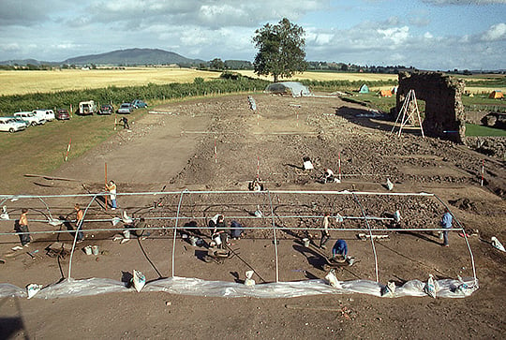

Archaeologists at work at Wroxeter in 1974© Historic England Archive

* This clarity is partly due to how the houses were built, and the underlying geology of the site.
* The houses were constructed largely of organic materials – timber and clay – which over time transformed into topsoil.
* Larger houses had walls which stood on low stone walls. It’s these that show up clearly in geophysics and from the air when there are drought conditions.
* As the soil dries, shallowly buried remains parch first, so lines of pale brown stand out against the greener grass: patterns of walls, roads, temples and other features slowly appear.
* 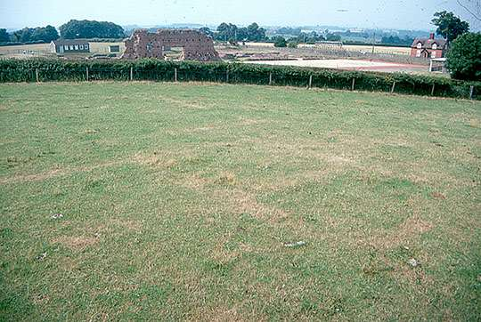These are best seen from the air, and now drones can be used.

Cropmarks of a building visible in the grass at Wroxeter during drought conditions© Dr Roger H White

* While aerial archaeology & geophysics provide the outline of the city’s history & development, only archaeology provides details such as dating & the evolution of the buildings.
* Recovery of artefacts and ecological information, e.g. animal bones, seeds, occasionally, timber, paired with the remains of buildings & other structures, allows us to develop a nuanced understanding of how the city was constructed, used and modified through time.
* Archaeology is responsible for some remarkable discoveries in the city, and for recovering the names of the few people we know who once lived there.
* Most of them are soldiers who served in Wroxeter’s fortress and whose tombstones can be seen in the [Shrewsbury Museum and Art Gallery](https://www.shropshiremuseums.org.uk/collections/archaeology/).
* The area outside the city (essential for its economic support) is also of interest to archaeologists.
* It has also produced evidence, about the farms and settlements around the city, & the fields & trackways which provide evidence for where the city’s food was grown.
* The city’s cemeteries lay outside its walls. Some of these have been investigated, along with a roadside shrine dedicated to an unknown god.
* On the flood plain of the river Severn there is evidence for seasonal work – tile and pottery production that took place in the hot summer months.
* These discoveries provide a deeper & richer understanding of Wroxeter’s hinterland and of the relationship between the city and the landscape around it.
* Visitors to the site museum and Wroxeter, and to the Shrewsbury Museum and Art Gallery, can see many objects found at Wroxeter. These are, however, only the tip of a large iceberg of evidence that sits in the stores of both English Heritage and the Shrewsbury Museums Service.
* These objects are kept for research and engagement. As science develops, new information can be discovered. For example, when animal bone and environmental evidence was collected from the baths basilica site between 1966 – 1990, it was not possible to date this material scientifically.
* However, technology has now advanced so far that samples of around 1 gram can be radiocarbon-dated. This has enabled the baths basilica site to be completely redated, changing the understanding of this area of occupation.