**Romans in the West Midlands - Timeline**

In AD 43, the Emperor Claudius invaded Britain with four legions: the II Augusta, VIIII Hispana, XIV Gemina and XX Valeria Victrix.

By AD 47, the Romans had conquered the lands southeast of the **Fosse Way**, a Roman Road built by the Romans.

In around 48 AD, **Metchley fort**, on the site of today’s University of Birmingham, was built.

In 50 AD, the XX legion helped to defeat **Caratacus**, leader of the resistance to the Roman conquest of Britain, at the **Battle of Caer Caradoc** (Shropshire).

Around 50 AD, the fort of **Manduessedum** was founded. There is little sign it was occupied after AD 70.

By about AD 55 the XIV legion had built a large legionary fortress at **Mancetter** (North Warwickshire).

In about AD 55 the XIV legion moved to **Wroxeter** (Shropshire), near the end of the **Watling Street** Roman Road.

Late 50s AD: Metchley Fort is expanded, perhaps at the time of Queen Boudicca's rebellion.

In AD 60 or 61, the XX Legion helped to end the revolt of **Queen Boudica**.

In AD 75 legion XX was transferred to Wroxeter.

By AD 80, Metchley fort had been abandoned by the Romans, although it was still occupied for a further hundred years.

About 90 AD a fort half the size of the original Metchley Fort was built inside the old fort's ramparts and the old ditches re-dug.

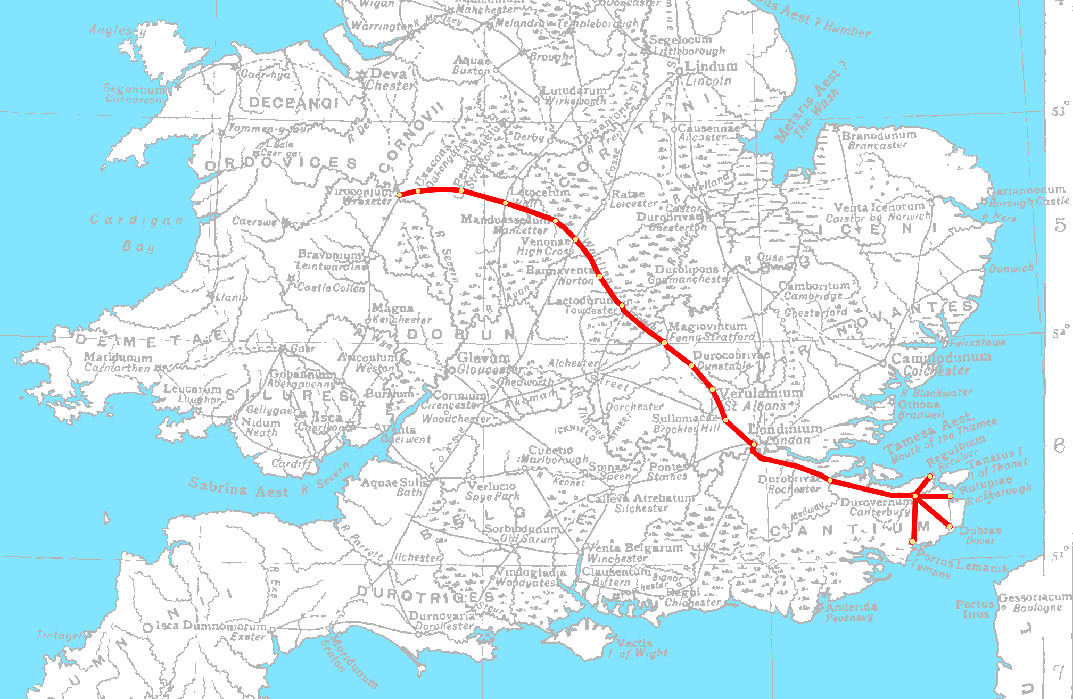

A map of Watling Street overlaid on the 1911 Encyclopædia Britannica map of Roman Britain

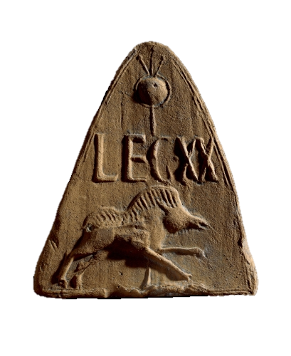

Moulded antefix roof tile showing the badge and standard of Legion XX, from Holt, Clwyd, Wales

<https://www.britishmuseum.org/collection/object/H_1911-0206-1>

