
Roman Roads in the West Midlands

- A number of Roman roads converged on the Birmingham area.
- In many places the course of these roads have been lost, since they pass through urban areas.
- However, in other locations, the path of these roads have been preserved.
- Roman roads that went through the West Midlands included Icknield Street, Watling Street and the Fosse Way.

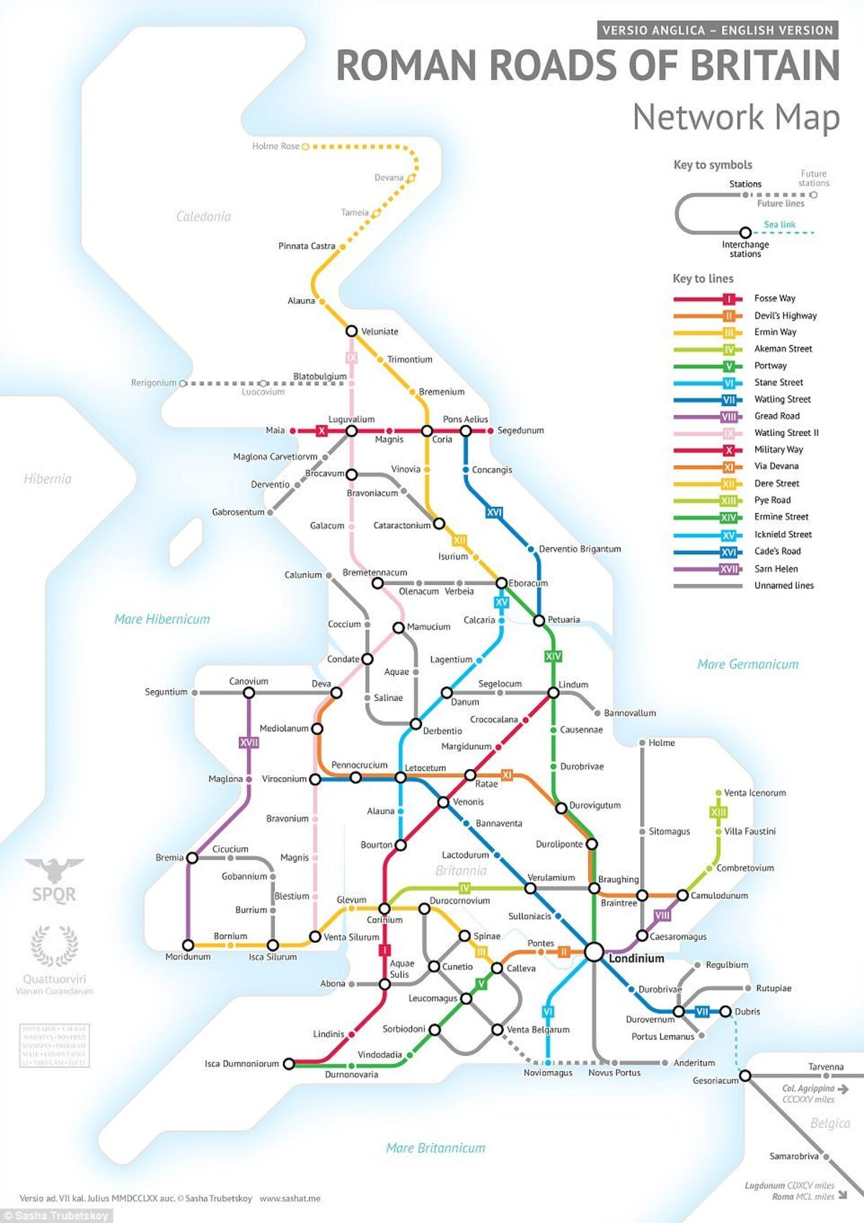

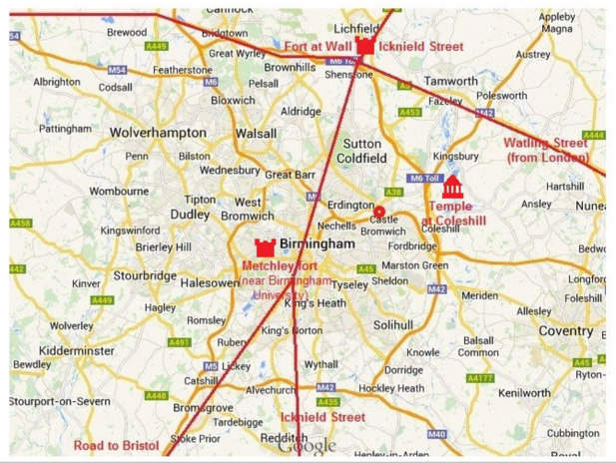

Icknield Street:
- Icknield Street had a route roughly south-west to north-east.
- It ran from the Fosse Way at Bourton on the Water in Gloucestershire to Templeborough in South Yorkshire, passing through Alcester, Studley, Redditch, Metchley Fort, Birmingham, Sutton Coldfield, Lichfield, Burton upon Trent and Derby.
- Much of the Midlands route of the Icknield Street is used by modern roads, most notably the A38 from Lichfield to Derby.
- A 1.5 mile stretch of Icknield Street can be seen at Sutton Park. Entering at Banners Gate, before crossing a bog, heathland and a golf course. The road is best seen near the Royal Oak Gate, off Chester Road North.
- It is made of gravel and pebble and is flanked by ditches, with estimations of its width varying from 26ft to 60ft.
- The road also gave the name to the nearby suburb of Streetly, its name translating to 'the clearing by the Roman road'.

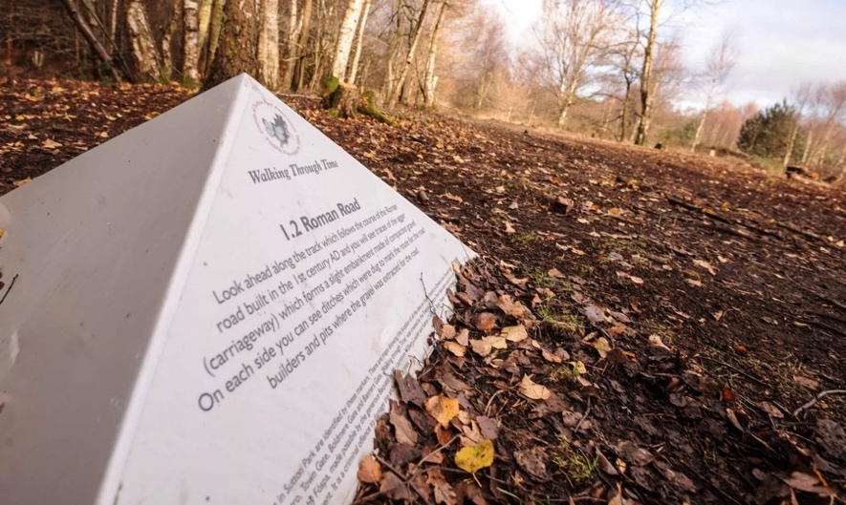

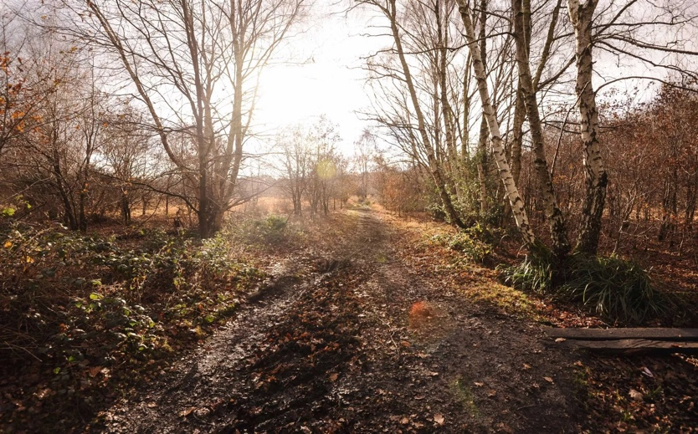

Watling Street:
- A historic route in England that crosses the River Thames at London and which was used in Classical Antiquity, Late Antiquity, and throughout the Middle Ages.
- It was used by the ancient Britons and paved as one of the main Roman roads in Britannia
- The route linked Dover and London in the southeast, and continued northwest via St Albans to Wroxeter.
- The original Celtic and Roman name for the road is unknown, and the Romans may not have viewed it as a single path
- The broad, grassy trackway found by the Romans had already been used by the Britons for centuries.
- The Roman Antonine Itinerary lists sites along the route of Watling Street as part of a longer route of 500 Roman miles connecting Richborough with Hadrian’s Wall via Wroxeter.

The Fosse Way:
- The word Fosse is derived from the Latin fossa, meaning 'ditch'.
- For the first few decades after the Roman invasion of Britain in 43 AD, the Fosse Way marked the western frontier of Roman rule.
- It’s possible that the road began as a defensive ditch that was later filled in and converted into a road, or possibly a defensive ditch ran alongside the road for at least some of its length.
- It was 230 miles long, running southwest to northeast from the West Country and all across the Midlands. It linked Exeter (Isca Dumnoniorum) to Lincoln (Lindum Colonia) via Ilchester (Lindinis), Bath (Aquae Sulis), Cirencester (Corinium Dobunnorum) and Leicester (Ratae Corieltauvorum).
- Much of the route is today marked with modern roads.

