
Diversity in Roman Britain

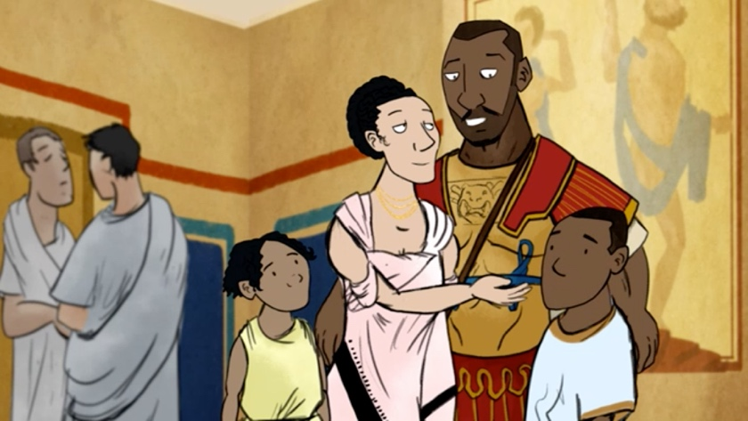
- In 2016, a BBC created animation on Roman Britain depicted of a racially mixed Romano-British family.
- This depiction had some protesting that it was a case of political correctness, and that it is a far from typical image.
- Nevertheless, evidence suggests that this was a perfectly plausible family in Roman Britain.
- This can lead to interesting discussion about the diversity of the Romans in Britain. Who were they? Where did they come from? What evidence do we have?

- There is plenty of evidence that the Roman empire was relatively diverse.
- This is perhaps unsurprising - trade and mobility was encouraged across an empire that stretched from Hadrian’s Wall to north Africa, the Rhine, and the Euphrates.
- Rome was a melting pot of people from all over the Mediterranean and beyond. Outside of Italy, the Roman army encouraged this diversity.
- Its legions, recruited from Roman citizens, were posted all over the empire. Soldiers could have local common-law wives and marry them when they retirement, creating new generations of Roman citizens outside Italy who would also be eligible for legionary service.
- Internet discussion surrounding the BBC animation often focused on the inclusion of a black Roman soldier at Hadrian’s Wall.
- But there is an ancient account supporting this…

- The emperor Septimius Severus (himself from Libya) was inspecting his troops on the Wall when one of the garrison’s well-known jokers, an ‘Ethiopian’ (a black African) offered him a garland.
- No-one seems to have been surprised at the presence of an ‘Ethiopian’ at the northern edge of the Roman empire (Hist. Aug. Severus 22).
- There were other Africans on the wall – a 3rd century AD cohort of Mauri (north west Africa) are attested in an inscription at Burgh-by-Sands near Carlisle.

“Hadrian’s Wall had garrisons of Tungrian and Batavian troops from Belgium and the Netherlands, as well as units from as far away as Syria”

- Auxiliary military units, levied from non-citizens, were posted to areas of the empire far from their home province. Hadrian’s Wall also had garrisons of Tungrian and Batavian troops from Belgium and the Netherlands, as well as units from as far away as Syria.
- Auxiliary units passed on Roman military discipline, Latin, and Roman cultural habits. They often rewarded their soldiers with grants of citizenship on retirement, producing more new citizens with a long training in Roman ways.
- Roman army units in frontier provinces built roads and harbours and created instant large markets for food, drink, and services, stimulating the growth of towns outside the fortress gates. In the long-term, this also monetised trading economies that drew in more civilian settlers from around the empire.
- Dr Hella Eckardt’s analysis of skeletal remains found in York suggest that the city was home to immigrants from North Africa (find out more here), while Professor Peter Kruschwitz has written on moving inscriptions that document the lives and deaths of immigrants in the Roman empire (see below).

[A] remarkable monument, discovered in Arbeia (South Shields) at the eastern end of Hadrian’s Wall, documents the life of a British wife of a Syrian immigrant from Palmyra, including text in Palmyrene, one of several pieces of evidence for a near eastern people in northern Britain.

- According to Prof Mary Beard in a Guardian article, a man called Quintus Lollius Urbicus (a Berber from modern Algeria), governor of Roman Britain from AD 139-142, may have been the inspiration for the BBC video.
- Explaining that it can be difficult to be sure of ethnicity because Africans took on Roman names, she said:
Even in the case of Septimius Severus, the first Roman emperor from Africa [Libya], we don’t actually know the colour of his skin, how far he was ‘native’, how far the descendent of Italian settler. The same goes for Quintus Lollius Urbicus, often claimed to be Berber, which he may well have been, but it isn’t certain.

- There is scientific evidence for the presence of North Africans in over 45% of the sites investigated as part of a 2012 study identifying origins using analysis of tooth enamel.
- The investigation was summed up in A note on the evidence for African migrants in Britain from the Bronze Age to the medieval period from the blog of Dr Caitlin Green of the ICE Cambridge University. The diagram from the blog as shown below revealed the findings clearly for the Roman period.
- The analysis was based on oxygen isotopes (different 'types' of oxygen molecules which differ slightly in atomic weight) found in your tooth enamel - and taken in via drinking water - which differ according to where you were brought up.
- Isotopes at a level consistent with North Africa origin were very prevalent during the Roman era—the mid-first to early fifth centuries AD.

- Roman inscriptions from Britain include numerous examples of individuals who self-identify as Syrians by nationality.
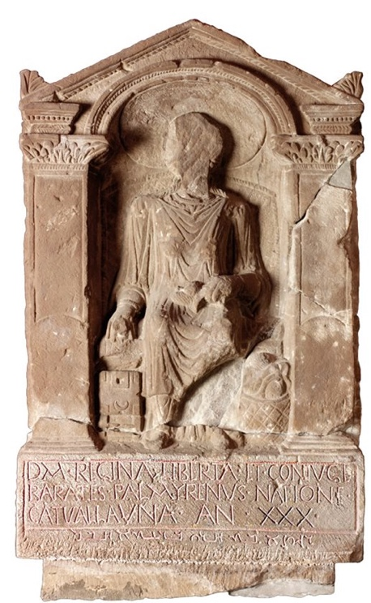
- For example, a lavish (and undoubtedly expensive) memorial was discovered at Arbeia (South Shields), by the Eastern end of Hadrian’s wall: a tombstone for a woman called Regina of uncertain date (possibly second century A. D.?).
- The ‘main’ (bigger/framed) inscription is written in Latin:

D(is) M(anibus). Regina(m) liberta(m) et coniuge(m)
Barat(h)es Palmyrenus natione
Catvallauna(m) an(norum) XXX.
- In English:

To the Spirits of the Departed. Barathes of Palmyra (sc. buries here) Regina, a freedwoman and his wife, a Catuvellaunian by origin, aged 30.

- Barathes, a Syrian, who self-identifies in this inscription as a native of Palmyra, is a foreigner not only to Britain, but to the Roman Empire.
- What were he and his wife Regina doing in Roman Britain near Hadrian’s wall?

- Regina is described as a native of the Britannic tribe of the Catuvellauni (north of modern-day London) as well as a freedwoman.
- How did she end up at Hadrian’s wall? And how did she end up in Barathes’ possession?
- The first question is impossible to answer. The second question cannot be answered with any certainty, but there are two main options: either she was captured and sold into slavery due to a Roman military campaign, or – equally possible – she was sold into slavery by her own family.
- It is not clear as to whether Barathes was the ‘first’ owner of Regina as a slave, or whether he acquired her from someone else.
- Regina (‘queen’) is a Latin name, so it is unlikely to be her native Celtic name. It must be assumed that she took this name during her enslavement.
- The way Barathes had his former slave and then wife represented in this sculpture lives up to the notion of, if not a queen, an eminently dignified, upper-class lady.
- The editors of the Roman Inscriptions of Britain describe the artwork as follows:

[T]he deceased sits facing front in a wicker chair. She wears a long-sleeved robe over her tunic, which reaches to her feet. Round her neck is a necklace of cable pattern, and on her wrists similar bracelets. On her lap she holds a distaff and spindle, while at her left side is her work-basket with balls of wool. With her right hand she holds open her unlocked jewellery-box. Her head is surrounded by a large nimbus (…)

- Barathes presents Regin as almost sitting on a throne – presented in the garments and posture of a lady from Palmyra, dignified, wealthy, leading a distinguished, civilised life up to the time of her (relatively young) death.
- There is another aspect to the memorial. Underneath the framed Latin inscription, there is a second one, written in Barathes’ native tongue, Palmyrene, which reads as follows:
רגיןאבתחריברעתאחבל
Regina, freedwoman of Barathes: alas!

- In letters rather less awkwardly written than the Latin (leading some scholars to believe this was carved by an Eastern craftsman rather than a local one), the inscription adds the personal expression of grief, ‘alas!’
- It is visible only to those who pay attention to the bottom, understandable only to those who know the script and the language, meaningful only to Barathes himself.
- Barathes, the Syrian in Roman Britain, has acquired, freed, and married a girl from Britain, whose life had taken a disastrous. He, as the tombstone suggests, gave her dignity, safety, and made her his queen, not only in name.
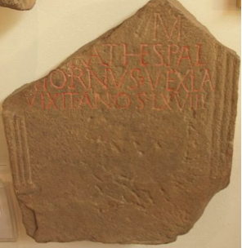
- Another inscription from Hadrian’s wall, discovered at the Roman fort of Coria (Corbridge) is less well executed, but mentions another citizen of Palmyra.
- Due to its fragmentation, the stone does not exhibit his name in full – all that survives is the second half of it: [- – -]rathes (RIB 1171):
- It is tempting to supplement this as [Ba]rathes. But is this the same man as the Barathes of the inscription above? Barathes was not an uncommon name in Palmyrene nomenclature. But how many of them will have been at Hadrian’s wall at the time…?
- If the two Baratheses are identical (more likely than not, they were NOT), the second stone reveals the man’s occupation: he was a vexil(l)a(rius) and died aged 68 (vixit an(n)os LXVIII).
- The most obvious understanding of vexil(l)a(rius) is ‘standard-bearer’ or ‘flag-bearer’, i. e. a military position.
- There are good reasons to assume that neither Barathes (whether or not they were identical) were Roman citizens.
- In that case, one must wonder if the second Barathes was a military man at all, or whether vexillarius was a title for either a merchant in flags and other signs (unattested otherwise, but not to be ruled out) or whether he held a ceremonial function in a collegium fabrorum (‘guild of engineers’), for example.
- The discrepancy in lavishness between the stone for the wife and for Barathes himself (if identical!) could thus be explained by a decrease in wealth, once Barathes reached a certain age and could no longer work as a craftsman.

- The University of Reading has produced some good resources on diversity created by Runnymede, the UK's leading independent race equality think tank.
- Their Romans Revealed site gives information on various individuals with possible links to the continent.

- One way we can learn about early migration history is through the work of archaeologists.
- For example, the grave of a young woman (see The Our Migratory History website) was discovered in 1901 in Sycamore Terrace York.
- She was buried in a stone sarcophagus with very rich grave goods (objects placed into a burial for the afterlife, or as an offering to the dead) in the later 4th century. The objects placed into her grave included bracelets made from local jet and more exotic ones made of ivory.
- A short inscription on a bone mount, that once probably decorated a box, suggests that this high-status young woman was a Christian: Hail, sister, may you live in God.
- The skull and teeth were examined by scientists at the University of Reading.
- The shape of her skull suggests she had North African ancestry. This is not very surprising for York, where inscriptions and written sources mention Africans.
- Studies of the remains of the Ivory Bangle Lady suggest she was born and brought up in the south of Britain, or the continent, rather than in Africa. Archaeologists can interpret this finding in a number of ways. For example, it’s possible one parent was from North Africa, but that she grew up in a different part of the Empire.
- Other skeletons from York & other Romano-British towns show some incomers look almost like locals in terms of their burial rites and grave goods, while some very exotic looking burials are those of people born locally. Why could this be?
- We need to consider the fact that the dead do not bury themselves. Grave goods and burial rites might be shaped by parents or partners who had a different geographical origin to the deceased.

- Cambridge Faculty statement concerning ethnic diversity in Roman Britain

Roman Britain has long been an important part of the teaching and research in the Faculty of Classics. The question of ethnic diversity in the province has been getting unusual amounts of attention recently. Professor Mary Beard has been at the centre of some of this attention. In the Faculty we welcome and encourage public interest in, and reasoned debate about, the ancient world, such as Professor Beard has always sought to encourage. The evidence is in fact overwhelming that Roman Britain was indeed a multi-ethnic society. This was not, of course, evenly spread through the province, and it would have been infinitely more noticeable — it can be assumed — in an urban or military context than in a rural one. There are, however, still significant gaps in our understanding. New scientific evidence (including but not limited to genetic data) offers exciting ways forward, but it needs to be interpreted carefully."

