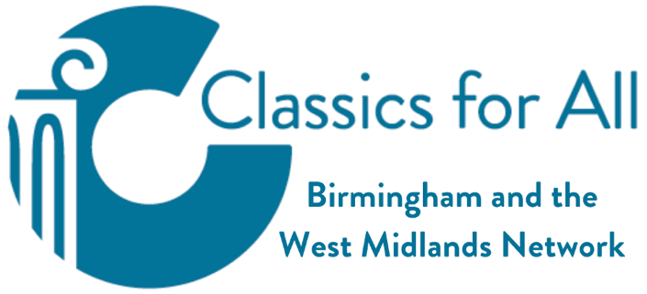
Roman Ariconium

- Ariconium was a small Roman town, road station and place of iron working in Roman Britain. It was located at Bury Hill, between Weston under Penyard and Bromash not far from Ross on Wye.
- The Forest of Dean and nearby areas were an ancient source of iron ore and charcoal.
- The site was occupied by the pre-Roman Britons, likely as part of an iron working industry. There is evidence of early mining and smelting, and there were many sites consisting of groups of forges.

- Ariconium was continually occupied throughout the Roman era, and the scale of industrial activity increased over the period.
- The Roman site was founded in about 50 AD and consisted of a military fort, a settlement and an industrial complex.
- Finds have included pre-Roman British coins, including one minted by Cunobelin, and coins from the Roman arrival until 360, after which there are no coins found.
- It seems to have been abandoned shortly after 360. Its sudden abandonment is consistent with a violent end, and may be related to the collapse of authority and widespread marauding at that time. Evidence of later occupation of the site has not been found.

- Before a chance discovery in 1758, little was known about Ariconium or its location.
- In the late 1700s finds included fibulae (brooches/buckles), figures of lares (household gods), lachrymatories (tear-shaped bottles), lamps, rings and fragments of tessellated pavements. There were also many pieces of red and grey pottery, some with decoration.
- In 1804, several skeletons were discovered and also the remains of a stone wall - apparently the facade of a building.
- The coins found at this site dated from Claudius (AD 41) to Constantinus (AD 340).

