
Romans in the West Midlands Overview

- Exploration of Roman military sites in the West Midlands region is a relatively recent development.
- Prior to the Second World War, relatively little was known.
- It was only in the 1950s and 1960s that this began to change, thanks to the efforts of three aerial archaeologists: J. K. St Joseph of the Cambridge University Committee for Aerial Photography, Jim Pickering, and Arnold Baker.
- Following WWII, these men were able to utilise a previously unavailable resource - cheap, surplus RAF aircraft equipped with high-specification cameras and fully qualified pilots to fly them.
- Individuals tested these newly discovered sites by digging trenches, attempting to establish dates for these sites, and thus evidence of the chronology of the Roman invasion in the area.
- Thanks to this work, sites directly associated with the Roman army in the West Midlands can be characterised as a variety of camps and forts, as well as an associated road system.
- Chronologically the earliest impact of the Roman army in the West Midlands is the evidence for the Conquest.
- For the Roman army, the West Midlands was an area of transition, to be moved through relatively swiftly in their push to occupy more of the North.
- The Romans knew of the existence of extensive mineral resources, including precious metal deposits, in and wanted to exploit them at the earliest opportunity,
- The relationship between the British tribes and the Romans depended on the attitude of the local leaders. When there was acquiescence, Roman rule could be light. Where there was resistance, the response was brutal.
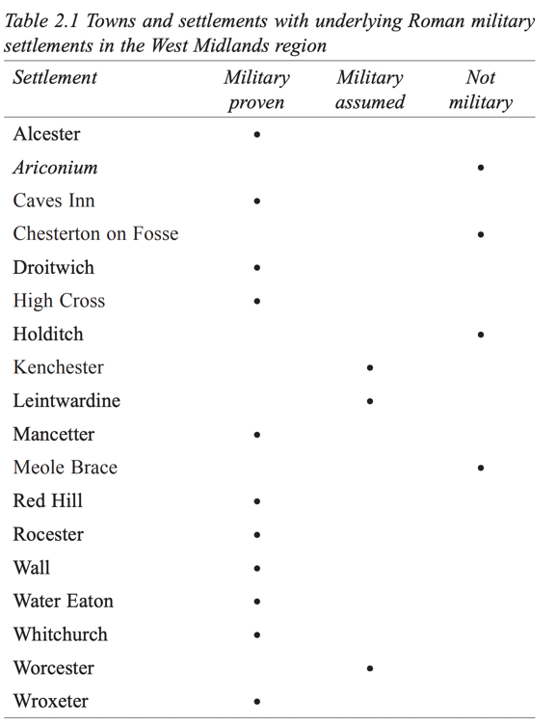

Table from Clash of Cultures? : The Romano-British Period in the West Midlands, by Roger White and Mike Hodder, page 16.

