**Tripontium - Roman Rugby**

* Tripontium(the place of the three bridges) established as a military frontier post soon after the Roman invasion of Britain in AD 47. Its name references the bridges over the River Avon and two of its tributaries.
* Earliest occupation is indicated by Flavian Samian pottery (late-1st century),
* Tripontium later developed into a civilian town which was inhabited for around 400 years, peaking in the 2nd century, before being abandoned in the late 4th century when the Romans left Britain.
* The latest coin is of Valentinian I, A.D. 365 – 375.
* *Tripontium*is located within the modern town of Rugby, Warwickshire, the area of which was also occupied by the ***Corieltauvi***and ***Catuvellauni***tribes.
* Excavations of the site revealed that it was an important [Romano-British](https://en.wikipedia.org/wiki/Romano-British) town.
* It had large public [bath houses](https://en.wikipedia.org/wiki/Thermae), an extensive [administrative building](https://en.wikipedia.org/wiki/Basilica), and a staging post (***mansio***). Such buildings were provided to allow Roman officials and travellers to rest.
* Numerous pieces of [pottery](https://en.wikipedia.org/wiki/Pottery), Roman [coins](https://en.wikipedia.org/wiki/Coin), and other remains have been found.
* Some of the area of the town has been destroyed by gravel extraction in modern times and part of the site is unavailable for excavation. Nevertheless, it seems highly likely that more buildings, such as the remains of a [temple](https://en.wikipedia.org/wiki/Temple) or a [forum](https://en.wikipedia.org/wiki/Forum_(Roman)), remain to be found.
* The exact position of Tripontium remained a mystery for centuries, but it was found by the antiquarian Matthew Bloxam in 1836.
* 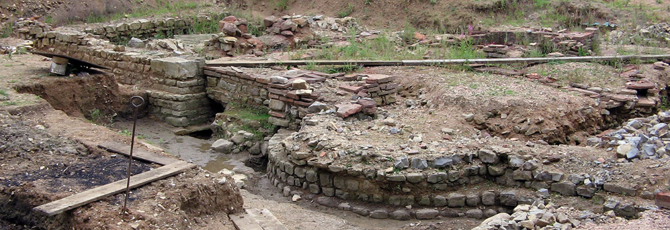Excavation works at the site were begun in 1961 by the Rugby Archaeological Society and have continued to 2006.
* The research at the site of Tripontium is one of the largest and longest running excavations to have been undertaken by an independent archaeological society.
* 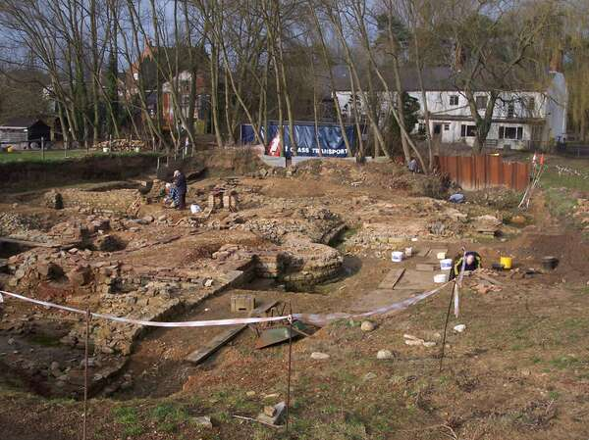The work took place in four distinct stages. The first two stages were rescue digs, in advance of sand and gravel extraction. Stage 3 was a research excavation of a substantial stone building, interpreted as possibly the administrative centre of the settlement. The fourth stage was the bathhouse excavation, which, in summer 2005, is just reaching its final stages.

*The Tripontium Bathhouse Excavations 2005*

* Since 1990 all the society's resources have been concentrated on the bath-house complex, which was located in 1989.
* The bathhouse was first completed in about 100 AD. The first phase (Flavian) consisted of a traditional ‘row type’ containing the *frigidarium*(cold room), *tepidarium*(warm room), and *caldarium*(hot room).
* These rooms allowed the visitor to participate in a traditional bathing regime in which the warm room was used to acclimatise the bather to the environment before attending the hot room and eventually cooling down in the cold room.
* In the second phase, the bath was rebuilt at a higher level in the early second century AD, probably due to flooding.
* The Second phase (Hadrianic) was much larger and grander with additions of the *atrium*(reception area which also contained niches for statues), *apodyterium* (changing area), and*palaestra*(exercise hall).
* After lying derelict for some time, a new bathhouse building was constructed on the same foundations in about 200 AD. This third and final phase of the bathhouse had a long life, with evidence of occupation up to the early 5th century AD.
* The bath house contained some unusual features, the Alveus, the footbath and the circular cold plunge.
* Bathhouses are easily identifiable due to their structured rooms; the *frigidarium* (cold),*tepidarium*(warm), and *caldarium*(hot,) and their unique heating system known as the hypocaust.
* Bathing in the Roman world was not only important for hygiene but was also a social activity. Bathhouses allowed visitors to socialise, play games, and eat and drink together.
* 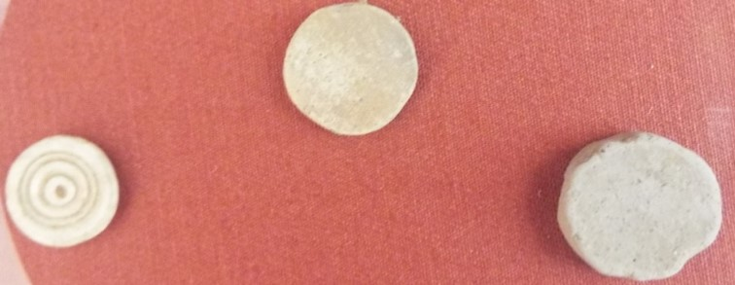Intaglios (gem inset rings) were found in the main drain one of which bore a depiction of Jupiter-Serapis with a corn measure on his head. Only three intaglios of this kind have been found in Britain and were likely to have been possessed by an eastern trader due to the depiction of a Mediterranean deity with corn. The baths attracted food and wine sellers as they were busy places and ensured business.

The presence of game counters suggests games and gambling took place here.