
Roman Alcester

- Archaeological evidence suggests that people have lived in the Alcester area for approximately 6,000 years.
- Neolithic inhabitants left behind flint implements and some of Warwickshire's oldest ceramic remains. Archaeological discoveries from the Bronze Age include pottery fragments, a small golden ring, and at least two bronze cooking vessels. The Iron Age period is represented by pottery shards, coins, and an unusual miniature bronze shield found within the town boundaries.

- Around AD 47, the Romans established their first military installation at Alcester.
- Alcester occupied a crucial strategic location on the frontier between the Catuvellauni and Dobunni tribal territories, making it perfectly positioned for controlling extensive surrounding regions.
- This initial fortress was subsequently replaced by a more permanent fort alongside a civilian settlement that developed nearby.
- Alcester sits at the intersection of two significant Roman thoroughfares: Ryknild Street and the Salt Way. These represented vital military and commercial arteries, connecting Alcester to other key Roman settlements across Britain.
- Around AD 200, defensive earthworks were constructed around the town's north-eastern section. During the late 4th century, these were upgraded to stone fortifications. Archaeological evidence indicates that Alcester remained active well into the 4th century.
- Excavations near Birch Abbey uncovered an extensive paved area surrounded by small stall-like buildings, believed to represent an ancient marketplace.
- Numerous Roman coins discovered through both systematic excavations and accidental finds suggest that by the 4th century, Alcester operated a market-based economy.
- The circumstances surrounding Roman Alcester's eventual decline remain largely unknown.

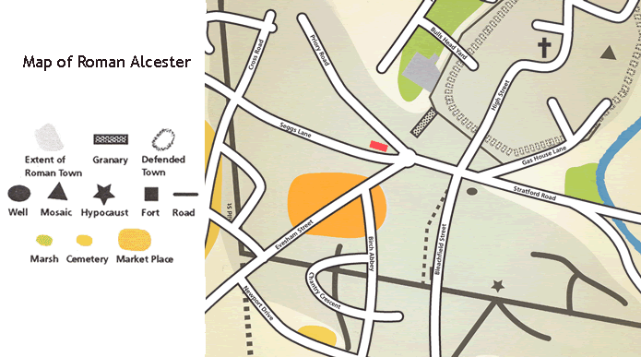
- In 1766, excavation of a prominent earthwork called the Castle, located beyond the western fortifications, revealed substantial Roman bathing facilities. Aerial photography from 1943-45 identified playing-card-shaped enclosures surrounded by defensive ditches.
- 1990 excavations concentrated on the Roman military compound beneath the later civilian town and its fortified extension.
- In 2003, archaeologists discovered fragments of a gravestone belonging to Lucius Valerius Geminus, a former soldier of the Legio II Augusta.
- The Latin inscription translates as: "To the spirits of the dead: Lucius Valerius Geminus, son of Lucius, of the Pollia voting tribe, from Forum Germanorum, veteran of the Second Augustan Legion, aged 50(?), lies here. His heir arranged this according to his wishes."

- This inscription reveals that he completed his military service whilst stationed at Alcester, despite originating from north-western Italy (his three-part name confirms his Roman citizenship), and remained in the local area until his death.
- His retirement must have occurred between Britain's Roman conquest in AD 43 and approximately AD 60, when the legion relocated to Exeter.
- Given that legionary service lasted a minimum of 25 years during this period, he would have enlisted before Britain's invasion.
- Following the pattern of many fellow veterans, he chose to remain in Britain amongst his military companions or family rather than returning to Rome.
- The fortress must have been well-developed and likely connected to a nearby civilian settlement or vicus.

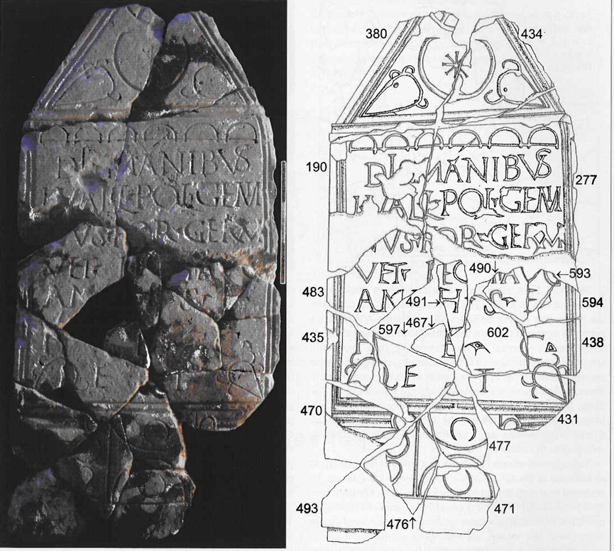

Sources:
- Roman Alcester Museum, ‘Alcester History’: https://romanalcester.org/
- Roman Britain, ‘Alcester Roman Fort’: https://www.roman-britain.co.uk/places/alcester/
- The History Blog, ‘The tombstone of Britain’s first Roman legionary’: https://www.thehistoryblog.com/archives/25669
- Wikipedia: https://en.wikipedia.org/wiki/Alcester
- Roman Inscriptions of Britain. RIB 3121. Tombstone for Lucius Valerius Geminus: https://romaninscriptionsofbritain.org/inscriptions/3121

