
Roman Alcester

- The earliest traces of habitation around Alcester date back nearly 6000 years.
- Neolithic people left traces such as flint tools and some of the earliest pottery found in Warwickshire. Bronze Age pottery, a small gold ring and at least two bronze cauldrons have been found in the area. Iron Age pottery coins and a rare bronze miniature shield have also been found in the town.

- The first Roman fort at Alcester was established around AD 47.
- Alchester was in a strategic position in the border region of the Catuvellauni and Dobunni tribes, and in an ideal position to exercise control over wide areas
- The first fort was replaced by a later fort and a civilian settlement which grew up around it.
- Two Roman roads, Ryknild Street and the Salt Way cross at Alcester. These were major routes for both the army and trade, linking Alcester with other important Roman centres in Britain.
- In about AD 200, a rampart was built around the north-east part of the town. This was replaced by a stone wall in the later 4th century. Excavations show that Alcester continued to function into the 4th century.
- Excavations around Birch Abbey revealed a long, open gravelled area with ‘booth’ type structures around the edge. This is thought to be the site of a marketplace.
- Many Roman coins have been found thanks to excavations and chance finds. These show that from the 4th century Alcester probably had a market economy.
- Little is known of the end of Roman Alcester.
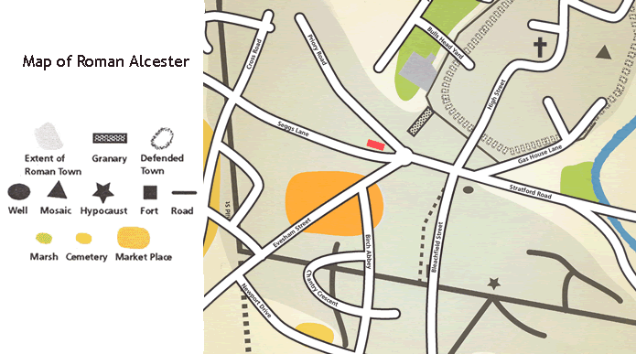

- Outside the western defences, excavation in 1766 of what was then a prominent mound known as the Castle uncovered a sizable Roman bath.Playing-card-shaped enclosures with ditches were shown on aerial photographs taken in 1943–45.
- Excavations in 1990 focussed on the Roman military enclosure near and under the later Roman town, and then on its fortified annex.
- In 2003, fragments of the tombstone of Lucius Valerius Geminus, a veteran of the Legio II Augusta were found.
- The inscription reads:

Dis Manibus/ L(ucius) Val(erius) L(uci filius) Pol(lia tribu) Gemi/nus For(o) Germ(anorum)/ vet(eranus) Leg(ionis) [I]I Aug(ustae)/ an(norum) L h(ic) s(itus) e(st)/ he(res) c(uravit)/ e(x) t(estamento)

"To the souls of the departed: Lucius Valerius Geminus, the son of Lucius, of the Pollia voting tribe, from Forum Germanorum, veteran of the Second Augustan Legion, aged 50(?), lies here. His heir had this set up in accordance with his will."

- The inscription shows he retired from the legion while stationed at Alchester even though he came from north-west Italy (his three names show that he was a Roman citizen) and lived in the vicinity until his death.
- He must have retired some time between the Roman invasion of Britain in AD 43, and c. AD 60, which was the latest the legion was moved to Exeter.
- Since a legionary’s period of service was (at this time) at least 25 years, he must have joined the army before the invasion of Britain.
- Like many other veterans, he preferred to stay in Britain with his comrades or family, rather than return to Rome.
- The fortress must have been well-established and probably associated with a nearby vicus.

