**Metchley Fort**

Metchley Fort was built by either ***Legio XIV Gemina*** or ***Legio*** ***XX Valeria Victrix*** in around AD 48. It was one of a network of forts or temporary military encampments constructed during the Roman advance through the midlands.

The fort was laid out near an important road junction, with **Ryknild (Icknield) Street** leading to Droitwich and Alcester to the south, and **Watling Street** to **Wall** (Staffordshire) in the north.

The site was near good water supplies, and lay on a raised plateau, commanding wide views over the surrounding area.

Archaeological evidence suggests that the site was occupied continuously for around 150 years, and that the fort went through several phases of building work.

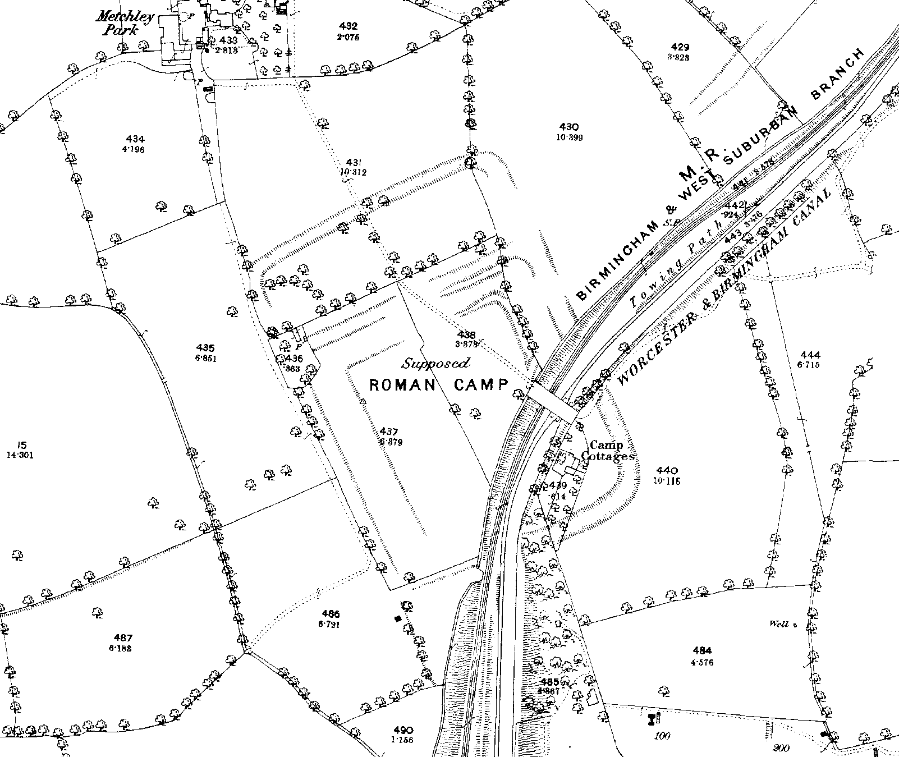

The remains of Metchley Fort as shown on the 1890 Ordnance Survey map of Warwickshire. The footbridge over the railway is the site of University railway station

**Phase 1:**

* AD 40s/ 50s - an early garrison fort was built mostly from earth and timber
* It could house up to a thousand soldiers.
* The fort was approximately 200 square metres
* It was defended by double ditches, a **palisade**, and a turf **revetted rampart**, which was the main barrier to attack.
* Buildings such as a double barrack-block with verandas, an officers quarters, a storehouse, a granary and two loading-bays, and a possible ***fabrica*** (a building used to repair tools and equipment) have been identified.
  + A double barrack-block (formed by two barrack-blocks constructed back-to-back, without the normal intervening space is an unusual feature of a Roman fort). It may have been done as a space-saving arrangement.
* Buildings would have been surfaced with **daub**, found extensively in deposits.
* Roofs were presumably made of wooden shingles, since no tiles were found

**Phase 2:**

* AD 50s/ 60s - later, **annexes**, defended by ditches, were added on the northern, eastern and southern sides of the fort
* The earlier interior structures of the camp were removed, and temporary, irregularly shaped timber-framed buildings were built.
* These structures included a store, a possible ironworking floor or wicker granary, a stable or groom's quarters and some associated fenced compounds.
* It’s believed that the size of the garrison was substantially reduced
* As the Romans turned their attention to campaigning further north in England, Metchley Fort became a supply point for the soldiers.

**Phase 3:**

* Following a period of abandonment, a smaller fort, enclosing approximately 2.6ha, was built within the site of the earlier defences.
* This construction was done some time in the AD 60s – 80s.
* Re-establishment of a fort suggests that the importance of this site was renewed.
* This small fort was defended by a ditch and turf rampart, later reconstructed in timber (possibly because of the instability of the marshy ground at the site).
* Interior buildings included a small granary and cookhouse.
* A possible stable, which may have accommodated a single row of horses, perhaps interspersed with smaller rooms for grooms or the storage of fodder or equipment.

**Phase 4:**

* The fort was abandoned around AD 75.
* There is evidence of some later Roman activity, continuing until around AD 120.
* For example, there is evidence for recutting of the earlier fort ditches and other military style ditches dug on different alignments. This latest phase of activity is believed to represent a more sporadic military occupation of the site.
* The site may have fulfilled an official function, such as providing overnight accommodation or a change of horses for travellers on official business.

**Excavations of Metchley Fort:**

The presence of a Roman fort in this location hasn’t always been known. The site was first identified in the 18th century as above-ground earthworks in antiquarian descriptions and maps. Historic maps, the earliest dating from 1718, show the fort surviving as a series of earthworks until 1917.

However, not everyone believed that this was a Roman site. Writing in his *History of Birmingham* in the late 18th century, William Hutton suggested that, due to the unusually large area enclosed, the earthworks were ‘the work of those pilfering vermin the Danes… better acquainted with other people’s property than their own!’

Excavations at this site took place between 1934 – 1936 by St Joseph and Shotton. They then took place in 1954 by Webster, in the 1960s and 1990s, and between 2003 – 2005 in advance of the rebuilding of the Queen Elizabeth Hospital.

It was only in the 1930s, during the first archaeological excavations, when Roman pottery was collected, that the early Roman date of the site was confirmed!

During excavations during the 1990s, a small civilian settlement, known as a ***vicus*** was identified. It sprang up outside the gate to the west of the fort, and it was where local people lived and traded with the soldiers.

This settlement included timber-framed buildings, hearths, ovens and trackways, extending over an area measuring up to 1ha lying to the west of the fort.

Finds such as a coil of wire, loops, including loops associated with clothing, a small open ring (possibly for a child), lengths of bronze sheathing forming a handle or the beam of a pair of scales, and a sickle-shaped piece resembling the votive models found on religious sites, have been found here.

Unfortunately, understanding the site has been hampered by the damaging effects of canal and railway construction, and the extension of the University Hospital.

**Excavation finds:**

The excavations have unearthed a variety of finds over the years. For example, during the [1999 – 2001 excavation](https://archaeologydataservice.ac.uk/archiveDS/archiveDownload?t=arch-1959-1/dissemination/pdf/reports/0751.pdf), the following finds were discovered:

|  |  |  |
| --- | --- | --- |
| **Material** | **Quantity** | **Description** |
| Glass | 1 object | A glass gaming counter, two half **melon beads** |
| Copper Alloy | 3 objects, 2 plate fragments; various unidentified objects | Three objects: the handle of a ladle, a **penannular brooch**, and a **head-stud brooch**. |
| Lead | 1 object | A small lead weight |
| Iron | 6 objects; 14 plate fragments; 74 nails | A brooch, possible **stylus**, a hook, two small fragments of chainlink. |
| Leather | 1 fragment |  |
| Worked stone | 6 fragments | A **ballista ball or weight**, possible polishing implement, possible **whetstone**, a gambling counter or token, a rectangular-shaped piece of stone which may have been a fragment of ***tessera*** or inlay for jewellery. |
| Roman **coarse wares** | 1242 **sherds** | Most of the pottery dated to the pre-Flavian period, although small quantities of **Flavian-Trajanic** pottery were also found. |
| **Samian ware** | 56 sherds | Sherds of samian ware which indicate a broadly 1st century date.  11 sherds were decorated - identifiable images include trailing plant motifs typical of pre-Flavian vessels. |
| **Mortaria** | 11 sherds | Imported mortaria, possibly from northern Gaul. |
| **Amphora** | 326 sherds | Olive oil amphorae, wine containers. A possible Southern Spanish amphorae, containing fish sauce. The dominant form of amphora was the **Baetician Dressel 20 form**, which can be dated to AD 30 – 70. |

Artefacts and pottery from the site demonstrate extensive use of both imported and locally sourced pottery, with little trade from elsewhere in Britain, the exception being quern stones from the site, which derived from deposits in Derbyshire, Staffordshire and the Pennines.

In [2004](https://archaeologydataservice.ac.uk/archiveDS/archiveDownload?t=arch-2862-1/dissemination/pdf/1195_Metchley_Roman_Forts_Birmingham.pdf), two coins were discovered.

A **denarius**, dated to 79 BC and minted in Rome.

**Observe**: depicts the head of **Venus**

**Reverse**: **Victory** in **triga**, holding reigns

A **denarius**, dated to 68 BC and minted in Rome.

**Obverse**: Bust of **Diana**, with bow.

**Reverse**: A boar wounded by spear and attacked by a hound.

This dig also revealed three incomplete **bow brooches**, two knives, a possible axehead, a cleaver, three possible whetstones, two incomplete melon beads, two fragments of possible kiln furniture, and 23 glass fragments.

In [2010](https://archaeologydataservice.ac.uk/archiveDS/archiveDownload?t=arch-2862-1/dissemination/pdf/2035_report.pdf), a gemstone **intaglio**, depicting the goddess **Minerva** with a plumed helmet, with an oval shield and a spear was discovered.

[Excavations](https://archaeologydataservice.ac.uk/archiveDS/archiveDownload?t=arch-2862-1/dissemination/pdf/2035_report.pdf) have also unearthed the remains of ancient plants. For example, charred samples of the following have been found: fragments of hazelnut shells, chickweed, turnips, bramble, oats, barley, rye, and wheat.

Pollen evidence, found in a ditch from Metchley fort, has revealed that the area would have been a well-established woodland during the time of the Romans.