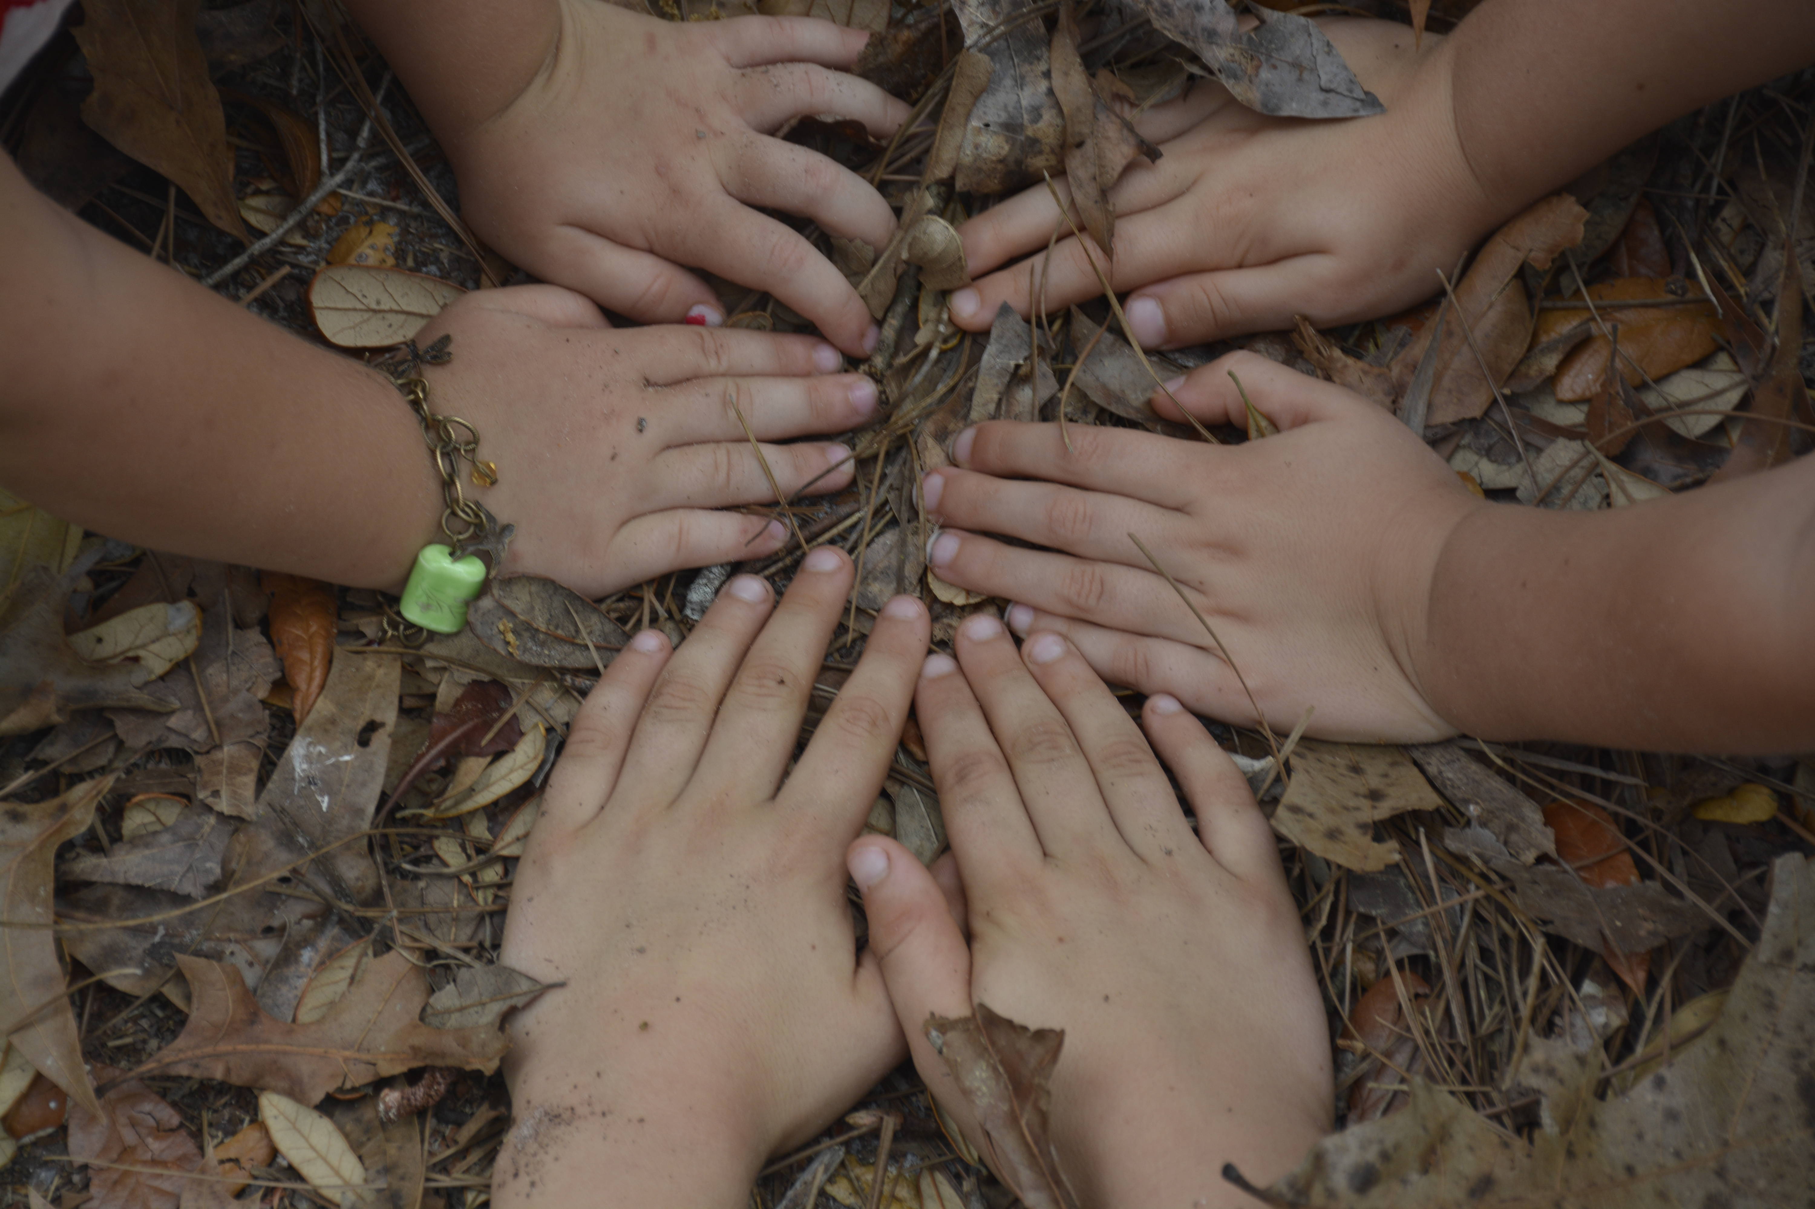
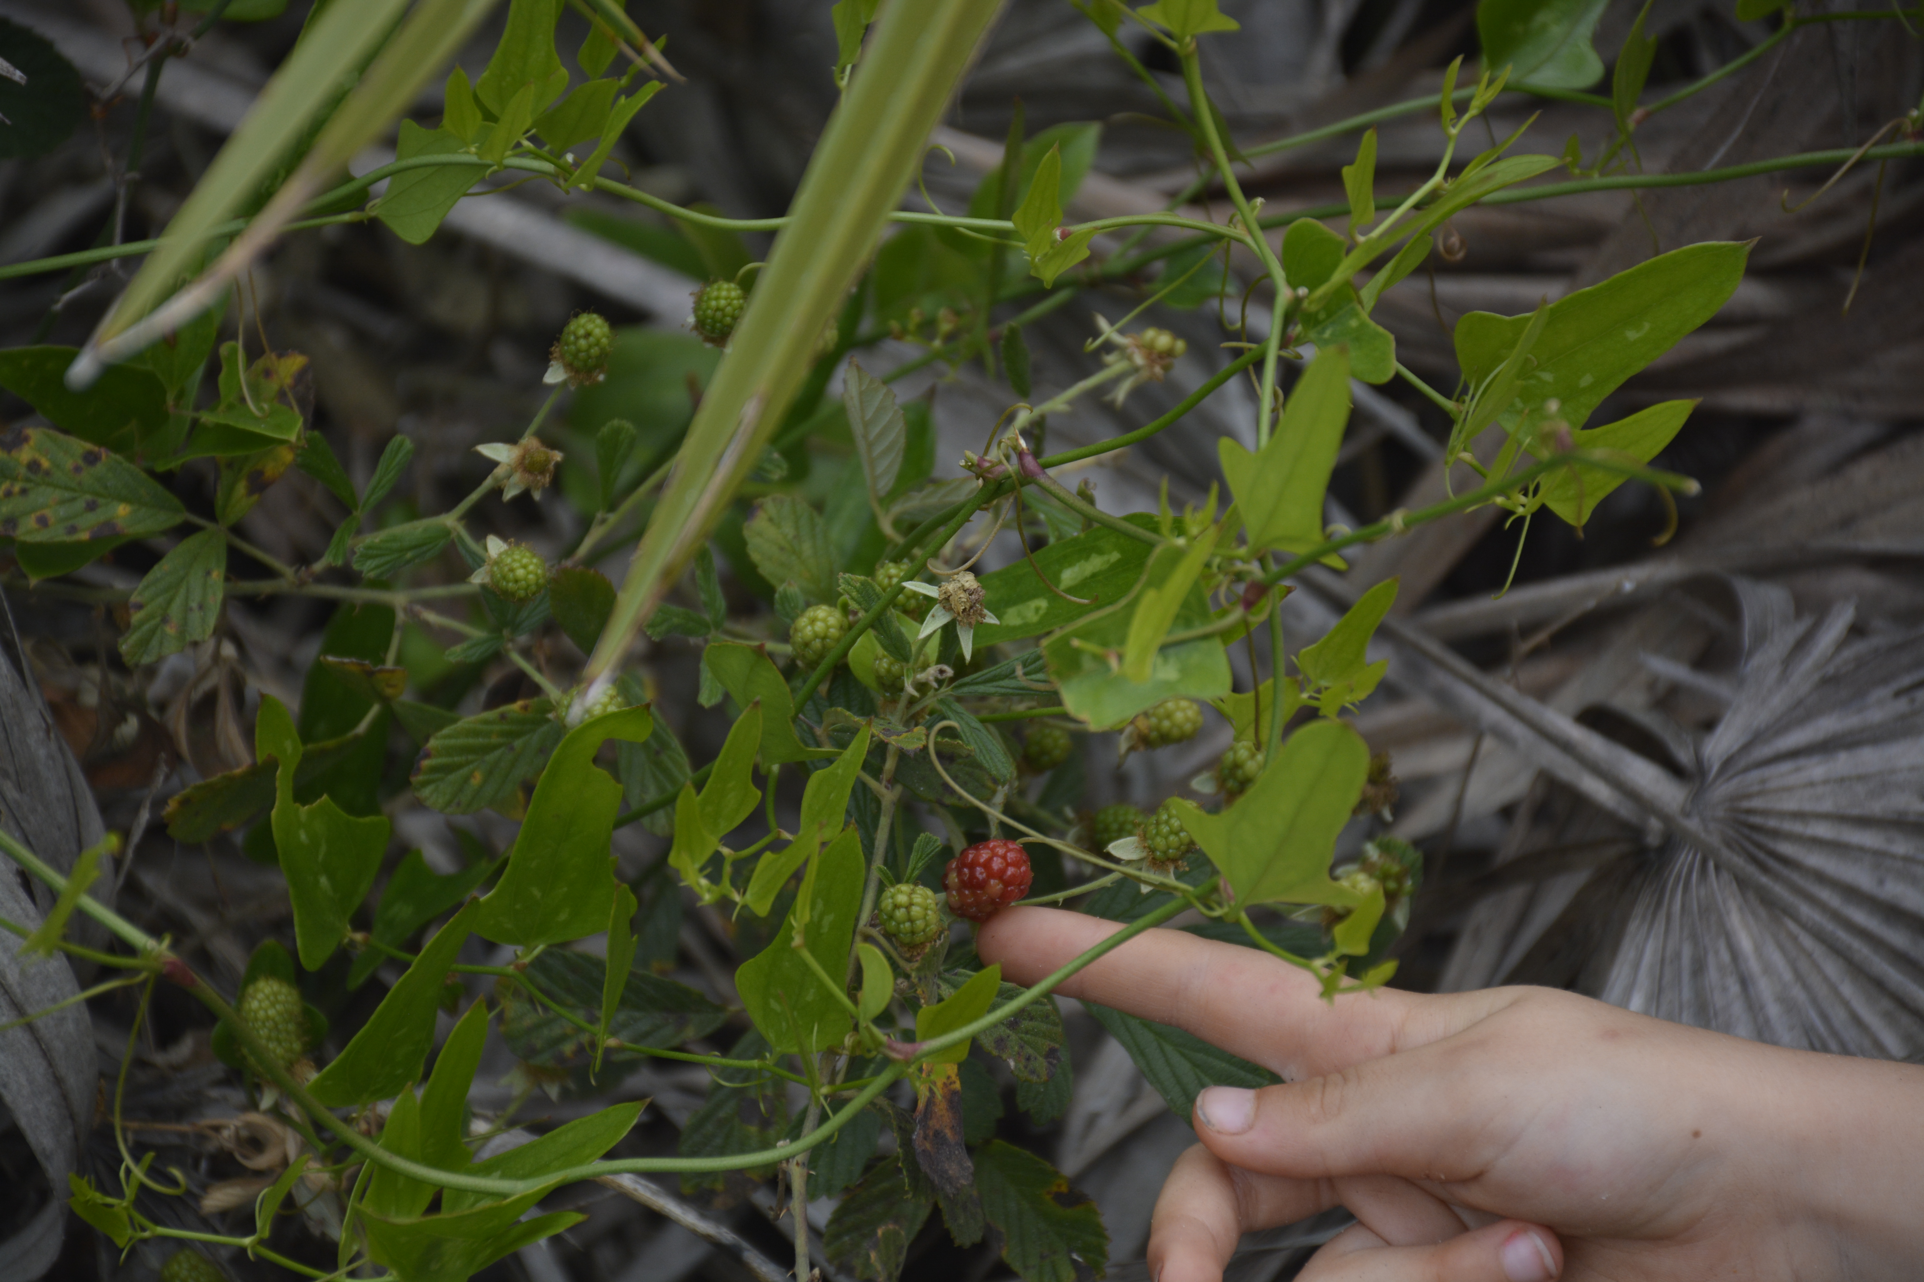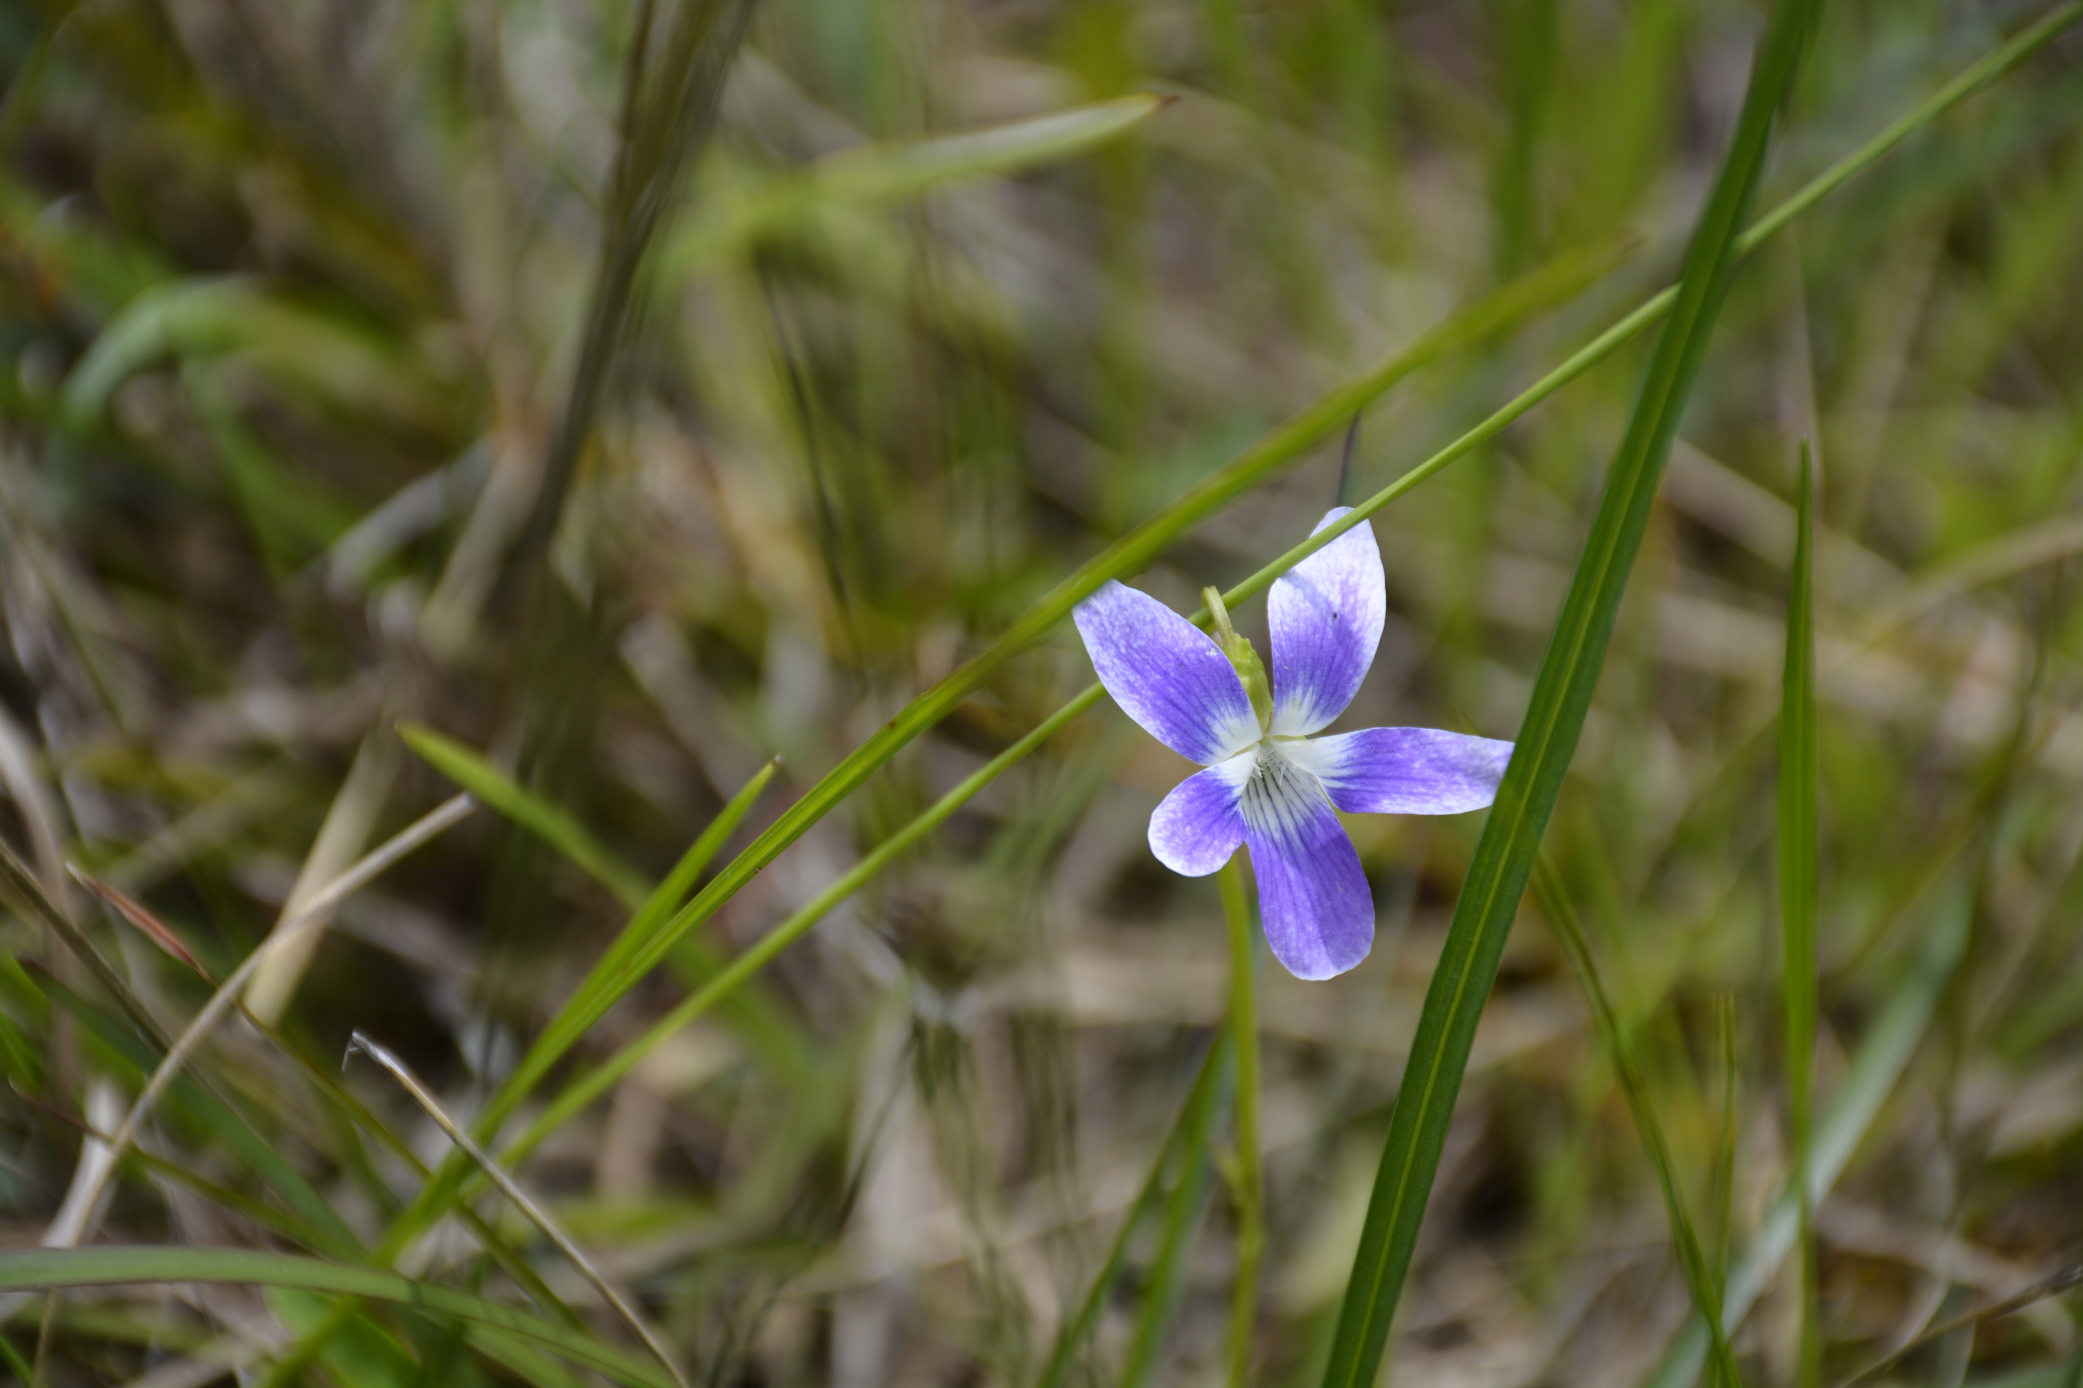
Flatwoods Forest School Registration
Nature Camp Registration Instructions: Parent or legal guardian should complete one form for each child attending nature camps.
Child’s Name:_____________________________________________
Date of Birth:____/____/____ Boy/Girl:________
Parent/Guardian 1:______________________________Relationship: _________________________
Mailing Address: ___________________________________________________________________ Home Phone :(____)___________ Mobile Phone:(____)____________
Email: ______________________________________________
Parent/Guardian 2:______________________________ Relationship: _________________________
Mailing Address: ___________________________________________________________________ Home Phone:(____)___________ Mobile Phone:(____)____________
Email: ______________________________________________
Emergency Contact Name: ______________________ Emergency Contact Phone: (___)____________
List anyone else who is authorized to pick up your child: _______________________________________ _______________________________________________________________________________ _______________________________________________________________________________
Dates of Camp: (Check all that child will attend)
February 17, 2019 _____
March 17, 2019 _____
April 14, 2019 _____
May 19, 2019 _____

September 16, 2018 ______
October 21, 2018 ______
November 18, 2018 ______
January 20, 2019 ______
Price: (40$ per session) 10% discount for siblings. 5% discount if paid in full for duration of program. Please make checks payable to Flatwoods Forest School.
It is the family’s responsibility to dress appropriately for the weather. We go outside, rain or shine.
Does your child have any medical conditions or allergies? (Please describe)
_______________________________________________________________________________ _______________________________________________________________________________ _______________________________________________________________________________
Is there anything else that would be helpful to know about your child?______________________ _______________________________________________________________________________ _______________________________________________________________________________ _______________________________________________________________________________ _______________________________________________________________________________ _______________________________________________________________________________
Is your child attending camp with a friend? Please list name/s: __________________________________

Cancellation Policy :
Flatwoods Forest School has implemented the following cancellation policy based on the time, resources and staffing that goes into planning a camp. We cannot recover these expenses if you cancel. Cancellations made on short notice can also prevent others from attending. All programs have a non-refundable, 25% deposit. If you cancel for any reason: ▪ Cancellations made at least 15 days prior to the first day of camp will receive a full refund, minus the 25% nonrefundable deposit. ▪ Cancellations made between 8 and 14 days prior to the first day of camp will receive a refund of 50% of the total camp tuition. ▪ Cancellations made 7 days or less prior to the first day of camp, or after the start of a program, are not refundable. Oops Policy: You have 48 hours from the time of purchase to cancel your registration with no penalty. (Cancellation must be requested prior to the start of the program.)

Waiver and Photography Release
My child has my permission to participate in all session and field trip activities. In the case of an emergency, I hereby request and authorize any physician, hospital or health care provider to provide medical treatment promptly, whether or not I may be contacted or informed. I am the Parent or Legal Guardian of the above-named child, who is under the age of 18 years and who wants to participate in Flatwoods Forest School programs. In consideration of my child’s participation in the programs, I hereby release, waive, indemnify and discharge Flatwoods Forest School and all of its instructors, employees, officers, directors, agents, sponsors, and volunteers from any and all liability to me, my child and to all my legal representatives, assigns, heirs, and next of kin, for damage and injury to my child or to any person or property arising out of participation in the program, and of future use of materials and other objects created during the program whether on Flatwoods Forest School property or elsewhere. This agreement includes but is not limited to claims or demands on account of injury or damage caused or allegedly caused by the negligence of Flatwoods Forest School or any of the individuals listed above. Flatwoods Forest School has the right to use any student drawings, journal excerpts, video and any photos taken during the program for promotional purposes for itself and its affiliates. I HAVE READ AND FULLY UNDERSTAND THE PROGRAM DETAILS, THE WAIVER AND RELEASE OF ALL CLAIMS FOR PARTICIPATION IN THE FLATWOODS FOREST SCHOOL PROGRAM.

Parent/Guardian Signature: _________________________________________ Dated:_____________

Printed Name of Parent/Guardian: ______________________________________________________

Want to help others know about our programs? Please tell us how you first heard of Flatwoods Forest School:
___St. Augustine Farmer’s Market, ___Saw a Poster, ___Flyer at School, ___Web Search, ___Friend

