***TODAY’S DATE***

***YOUR ATTORNEY NAME***

Attorney General

***YOUR ATTORNEY ADDRESS***

***SUBURB STATE ZIP CODE***

**LEAVING YOUR LEGACY**

Dear ***ATTORNEY CHRISTIAN NAME***

I trust you’ve been well.

I have become aware that **No More Homeless inc from Australia have a solution to eradicate the Type-4 Homeless Crisis of those Sleeping in the Cars or Couch Surfing.**

**They have available an extremely cost effective 36 m² 2Bedroom Movable Home, Fully-furnished with Airconditioning and Septic Tanks for a mere UK£32,,000 that can be erected on any parcel of land and moved at any time**.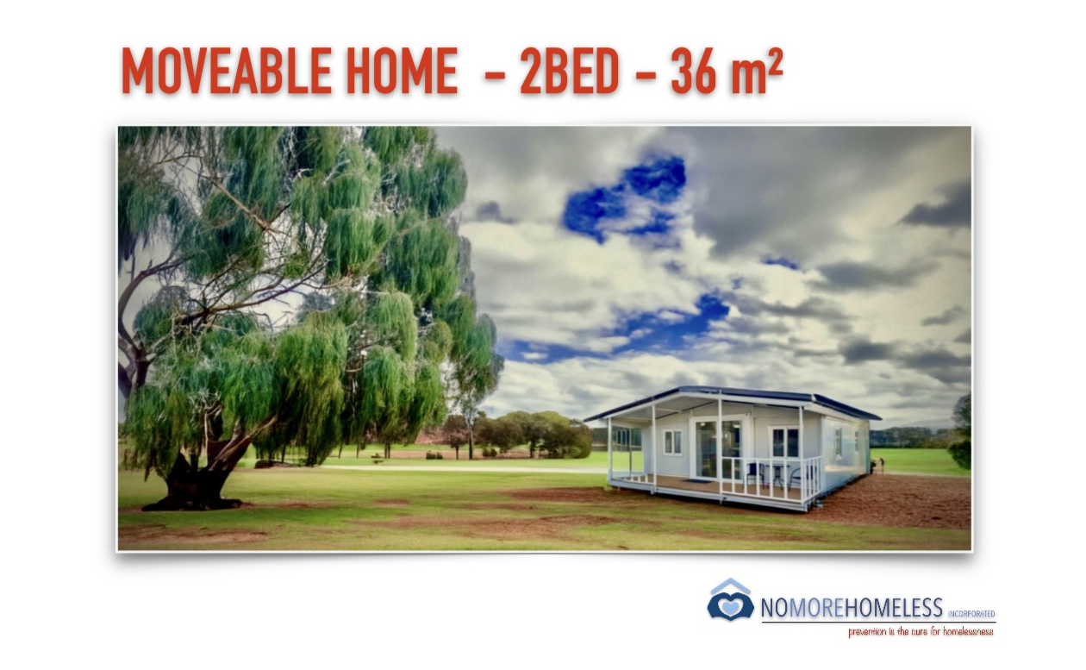

They also have the same home that is a **Totally Off-grid 2Bed home for UK£41,000 with Solar, Battery Storage, Diesel Generator Back-up, Water Storage and Septic Tank than can be erected anywhere.**

**C**onsidering an **Asylum Seeker is immediately put into Hotel Accomodation until they can secure Permanent Long-term Accomodation, I see no reason for this solution not to be initiated immediately to House our Homeless.**

I ask you to speak to your **Minister for Land** to identify **Lazy Land that is no longer required for Road or Rail Expansion and any other land suitable for the purpose of Immediately opening up land for the Homeless.**

Not only will we house our Homeless, most importantly, we will be **Giving Their Lost Human Rights Back which is crucial.**

These homes will be **solely for the purpose of Housing the Homeless**, would need to be **numbered and registered just like any Caravan or Motor Vehicle** and **can be Privately Funded with a 7% Return to the Investor**.

Ultimately they should be Government funded as a **one-off cost of UK£41,000** is much more efficient than the **current Astronomical Spend. on each Homeless every year.**

**By housing the Type-4 Couch-Surfers or those Sleeping in their Cars, its inevitable that the Type-1 Street Homeless numbers will drastically reduce in numbers.**

Incidentally, according to **Dr. Amanda Stafford, Head of Royal Perth Hospital Emergency in Australia, 80% of the Street Homeless would assimilate back into society if they had a roof over their head with Wrap-around Services and that would arguably be the same in the United Kingdom.**

There are only positive outcomes from making such simple changes.

***ATTORNEY CHRISTIAN NAME*, with your involvement, you can be the catalyst that changes the face of Homelessness in *YOUR STATE*.**

When can we meet to discuss in more detail?

Warmest regards,

***YOUR NAME***

***YOUR ADDRESS***

***YOUR CONTACT NUMBER***