

CHANGZHOU CLOVERAGRI MACHINERY Co., LTD.
6 JIANYE ROAD,HI-TECH,CHANGZHOU,JIANGSU,P.R. CHINA
Tel:+86-519-83380108 Fax:+86-519-82060778 www.cloveragri.com
MOWER(Flail mower with horizontal axis)
Manual
MODELS

VCD260,VCD280,VCD300,VCDH260,VCDH280,VCDH300
VD170,VD190,VD200,VD220,VD240,VDA170,VDA200,VDA220,VDA240
VM190,VM200,VM220,VM240,VMA190,VMA200,VMA220,VMA240
VMZ190(TORO-190),VMZ200(TORO-200),VMZ220(TORO-220),VMZ240(TORO-240),
VMZS200,VMZS220,VMZS240,VMZSU200,VMZSU220,VMZSU240
VF85,VF95,VF105,VF115,VF125,VF135,VF145,VF155,VF165,VF175
VFM85,VFM95,VFM105,VFM115,VFM125,VFM135,VFM145,VFM155,VFM165,VFM175
VFMH105,VFMH115,VFMH125,VFMH135,VFMH145,VFMH155,VFMH165,VFMH175
VFLA105(EFGC105),VFLA115(EFGC115),VFLA125(EFGC125),VFLA135(EFGC135),
VFLA145(EFGC145),VFLA155(EFGC155),VFLA165(EFGC165),VFLA175(EFGC175)
VFLAM105,VFLAM115,VFLAM125,VFLAM135,VFLAM145,VFLAM155,VFLAM165,VFLAM175
VFLAH105(EFGCH105),VFLAH115(EFGCH115),VFLAH125(EFGCH125),
VFLAH135(EFGCH135,MASTER135),VFLAH145(EFGCH145),VFLAH155(EFGCH155,MASTER155),
VFLAH165(EFGCH165),VFLAH175(EFGCH175, MASTER175)
VFLU125(INTERFILA-130),VFLU135,VFLU145(INTERFILA-150),VFLU155,VFLU165,VFLU175
VFSA180(EFGC180),VFSA190(EFGC190),VFSA200(EFGC200),VFSA220(EFGC220),
VFSA240(EFGC240)
VFSAH180(EFGCH180),VFSAH190(EFGCH190),VFSAH200(EFGCH200,MASTER200),
VFSAH220(EFGCH220,MASTER220),VFSAH240(EFGCH240)
1JS180,1JS200,1JS210,1JS240,1JS250

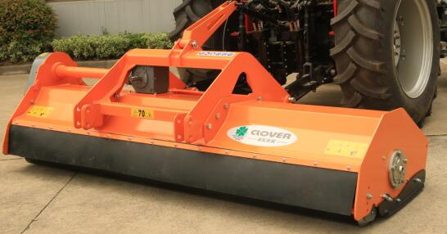

JY2018030001 Rev A
manual
dated 20180307
The original instruction

JY2018030002 Rev A Parts Book
dated 20180307
The original instruction

EC DECLARATION OF CONFORMITY

Manufacturer:
Changzhou Cloveragri Machinery Co., Ltd.
Address:
6 Jianye Road, Hi-tech, Changzhou, Jiangsu, P.R.China

Name and address of the person authorised to compile the technical file in the Community:
jansen gmbh & co.kg
muehlenstrasse 50, 49824 emlichheim, germany

Product Name:
type:
Model:
Serial no.:
Production year:

Declares that the product above complies with the following EC Directives:
Machinery Directive 2006/42/EC

and the following harmonized standards:
EN ISO 4254-1:2015 Agricultural machinery — Safety Part 1: General requirements
EN ISO 4254-12:2012 Agricultural machinery – Safety Part 12: Rotary disc and drum mowers and flail mowers

Full name in block size：chen yagang
Qualification: vice general manager
Place: Changzhou, p.r.china
Date:

Signature and stamp: ________________

CLOVER wants to thank you for having chosen one of our products.

The technological evolution and the new request of the agricultural world have pushed our firm to a continue improvement, focused on the product, on the quality of the materials and on the quality of work.

The present manual contains the description of the machine and the necessary instructions to correctly use it, along with the instructions for an ordinary and periodic maintenance of the shredder.

Such manual is subdivided in easily recognizable chapters for a practical consultation.

The indications in the present manual are addressed to a professional user, who must have specific knowledge about the driving modalities of the tractor with which the machine is connected. The user has to be authorized, instructed and opportunely trained.

We recommend you to use only original spare parts and accessories.

The use of non-original parts could be dangerous reducing the duration and the performances of the machine as well as the decay of the warranty.

In the case of doubt about the interpretation of the subjects illustrated in this handbook, we suggest you to contact the dealer who will be ready to assist you whenever you need it.

1,GENERAL INFORMATION

I.I INFORMATION ABOUT THE MANUAL

The using prescriptions shown in this Handbook must be carefully observed to obtain the best performances, to assure the greatest duration of the different parts and to avoid damages to the machine and accidents to the operator.

lt is advised the careful reading of the present handbook, to deepen the knowledge of the MULCHER before starting to use it.

The present manual is to be considered an integral part of the machine, it must go with the machine in case of resale and till its demolition.

Some illustrations in this manual show particulars or accessories that could be different from those of your machine, some component could have been removed to assure the clearness of the illustrations.

The subjects dealt in this handbook are those expressly requested by the "CE/98/37directive" and by the relatives technical standards.

On the machine are inserted apposite pictogram, which the operator will take care to maintain in perfect visual state and to replace when they are not more readable.


This Handbook has been written following the effective regulations at the moment of its printing. It is an integral part of the machine and must go with the machine with the Declaration of Conformity in case of resale.

1.2 IDENTIFICATION OF THE MACHINE

You will find on frame of each machine: the EC mark and a plate reporting the information about the constructor, the model and the serial number, the year of construction, the weight.

EC Identification plate

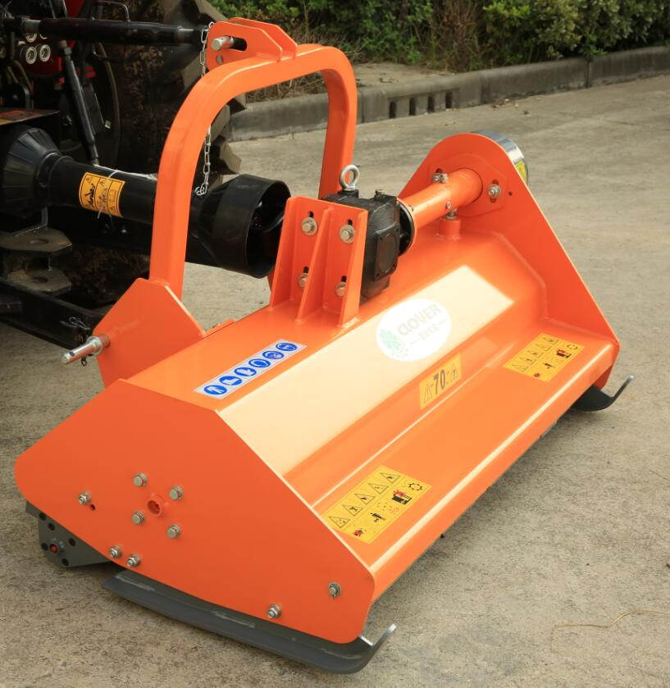

I.3 INFORMATION ABOUT THE MACHINE

Before leaving the production factory this specific model has been subjected to a severe testing to guarantee the greatest reliability.

I.3.I Foreseen usages

The RMZ road mulcher for grass, residue of vegetables, bushes and pru-ning up to Ø 3-4 cm., with 3-point linkage Cat. II (Cat. I on request). Suited for tractors from 40 to 90

HP and ideal for clearing green areas, gardens, slopes, ditches, banks of watercourses, road side banks.

The shredders with openable hatchback door must be used exclusively with such door (with hydraulic or manual opening) COMPLETELY CLOSED, the use of such door is exclusively of maintenance (we remember that for any intervention on the

machine all the instruction in the chapter of this handbook reported must be observed). A use different from the one specified is considered improper.

The machine must be used by one only operator. A use different from the one specified is considered improper.

The machine must be used exclusively by authorized, instructed and opportunely trained people.

This machine is usually used during the day, if exceptionally the night use or in condition of low visibility is requested, the lighting system of the tractor must be used.

Each arbitrary modification made to this machine, releases CLOVER from any liability for damages or lesions, serious too, that could occur to the operator, third person or things.

A correct use of the machine, a scrupulous observance of the here listed rules and the strict application of all the precaution to prevent possible dangerous situations, will avoid the danger of injuries or accidents, will let work the machine better and longer and will reduce faults to the minimum.

CLOVER DECLINES ALL RESPONSIBILITIES, OBJECTIVE AND SUBJECTIVE, IF

THE RULES REPORTED IN THIS MANUAL ARE NOT OBSERVED

1.3.2 Contraindications

- be sure that on the ground to work there aren’t stones or rock of notable dimensions (diameter upper to 10 -15 cm);
- make sure that on the ground to work there aren’t tree stumps projecting over about
10cm and of diameter upper to about 10 — 15 cm;

- make sure that on the ground to work there aren’t metal elements of every kind, in particular nets, cables, ropes, chains, pipes, and so on;

- observe and apply carefully the instructions of regulation of the height of the machine from the ground, however avoid that in the range of work of the machine till 50 meters other people could stand;

- it is advised never to work "Close to the ground" on wet grounds not to compromise the performance and the balancing of the machine, risking to damage the rotor too. In these cases the hoes are too much consumed, notable power is drawn from the

engine, there is the risk to HII inside the protective case of the rotor with pressed mud;

• a prolonged work "close to the ground" tends to petrify and to make the ground harder, getting its characteristics worst and compromising the good result of future cultivation.

l.3.3 Noise level

The noise testing have pointed out a Sound Pressure level equal to 84 dB(A) x 1 dB, measured in open field at a distance of 3 m. from the machine and at 1.6 m. on working land, in continuous maximum allowed working rate conditions.

According to these information it is recommended to wear an individual ear protection.


Though there is a connection between the sound emission and the exposure level, this datum can’t be used to determine if it is necessary to take some precautions. ln fact other factors exist that can affect the sound exposure level, such as for example the characteristics of the working environment and the presence of other noise sources. The information about the noise level emitted by the machine will however help the user or the employer in the writing of the valuation of the dangers and risks.

1.3.4 Storage

If the machine is not used for a long period it is necessary to store it in a sheltered place in order to protect it and to avoid dust accumulation. Before the storage we recommend to clean carefully the whole machine and to oil carefully the mechanic parts to protect them from the rust.

Before storing the machine for a long period, we recommend to operate as follows:
- wash carefully the machine;

- make a general sight checking of the machine to locate possible structural lesions, notice possible deep scoring on the painting, verify that the original safety pictogram are present in their right position, that they are complete and readable;

- grease all the mechanical parts, such as the tightening bolts, the joint shaft to the PTO shaft;

- recover, if possible, the machine in a covered room and lean the machine on wood boards on a flat surface;
- cover the machine with a sheet, binding it opportunely.

The used oil must not be dispersed in the environment, because, according to the effective law regulations, it is classified as special waste, and as such it must be given to the special collect centre. Please apply to the nearest Consortium of used oils.

1.3.5 Scrapping

In case of scrapping the machine should be disposed in appropriate dumps observing the effective legislation.
Before proceeding to the scrapping it is necessary to separate the plastic or rubber parts, the electric and electronic material.

Recover the possible run-down oils and dispose them in the appropriate collection centres. The parts completely made of plastic material, aluminium, steel, can be regenerated if collected in the special centers.

1.4 TECHNICAL DETAILS AND IDENTIFICATION OF THE COMPONENTS

These machines are suitable to low and medium power wheel tractors. They are composed of a supporting frame in electric-welded steel bringing the joints for the connections to the tractor, power a power transmission system composed of an angular dismissal, a pair of pulleys connected by trapezoidal belts and by an electronically balanced rotor knives-bearing.

The models of this manual are brought by the tractor through 3 points joint, and act on the ground with their own weight and rotation of the power-taking.

By regulating the height of the lateral slides, of the wheels and of the rear roller, it is possible to vary the working height of the machine.
These machines are suitable for forest and garden working.

TECHNICAL SPECIFICATIONS

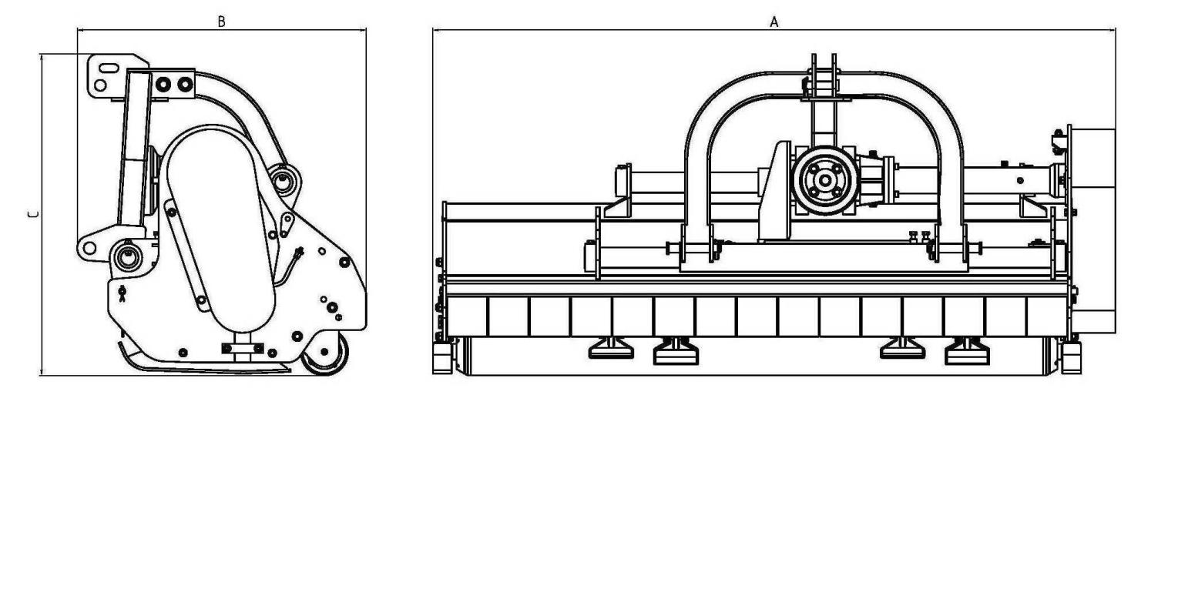

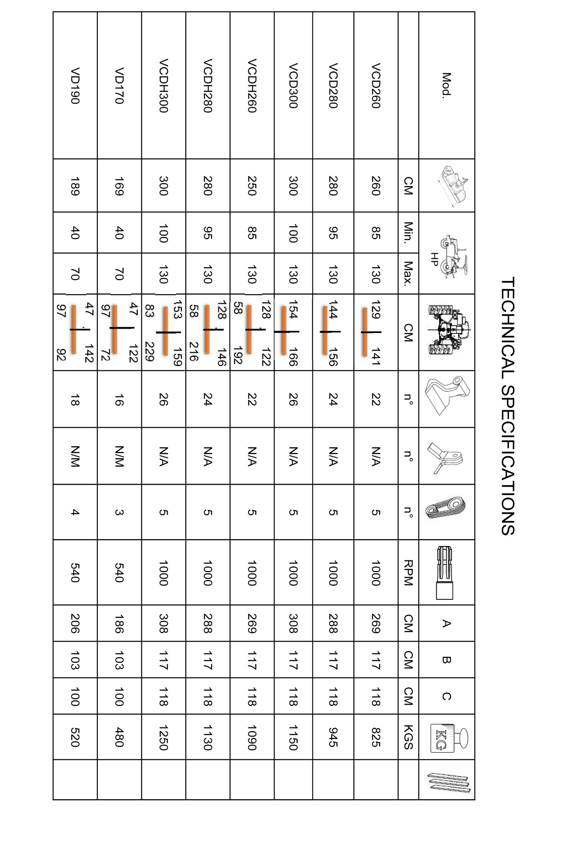

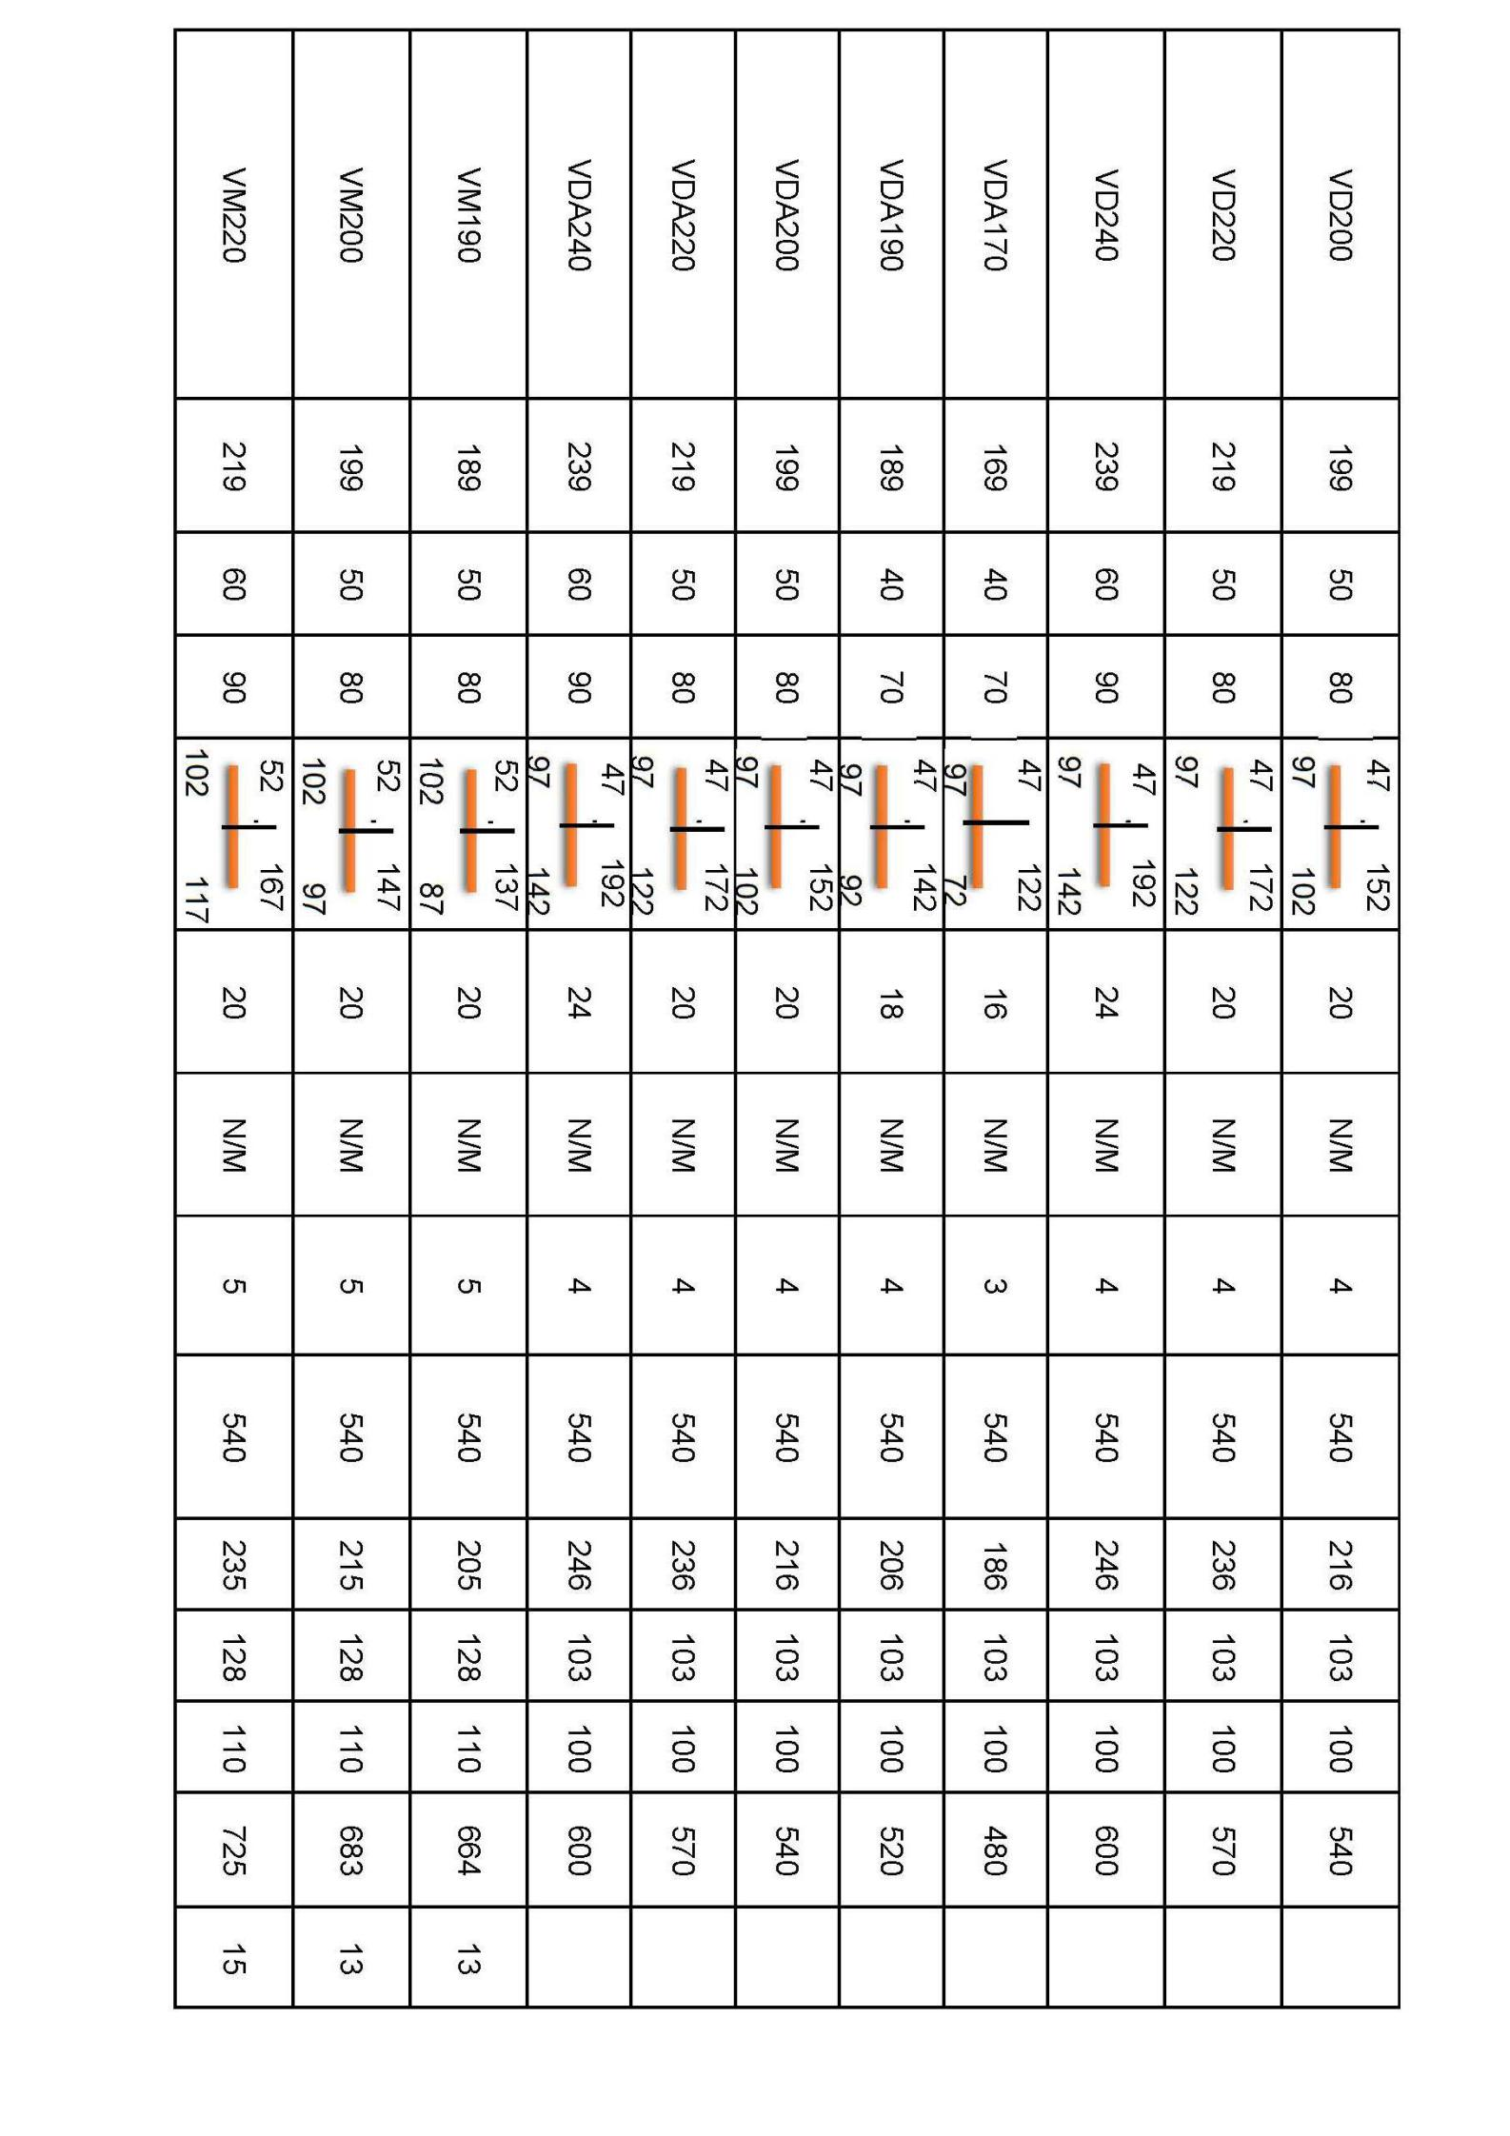
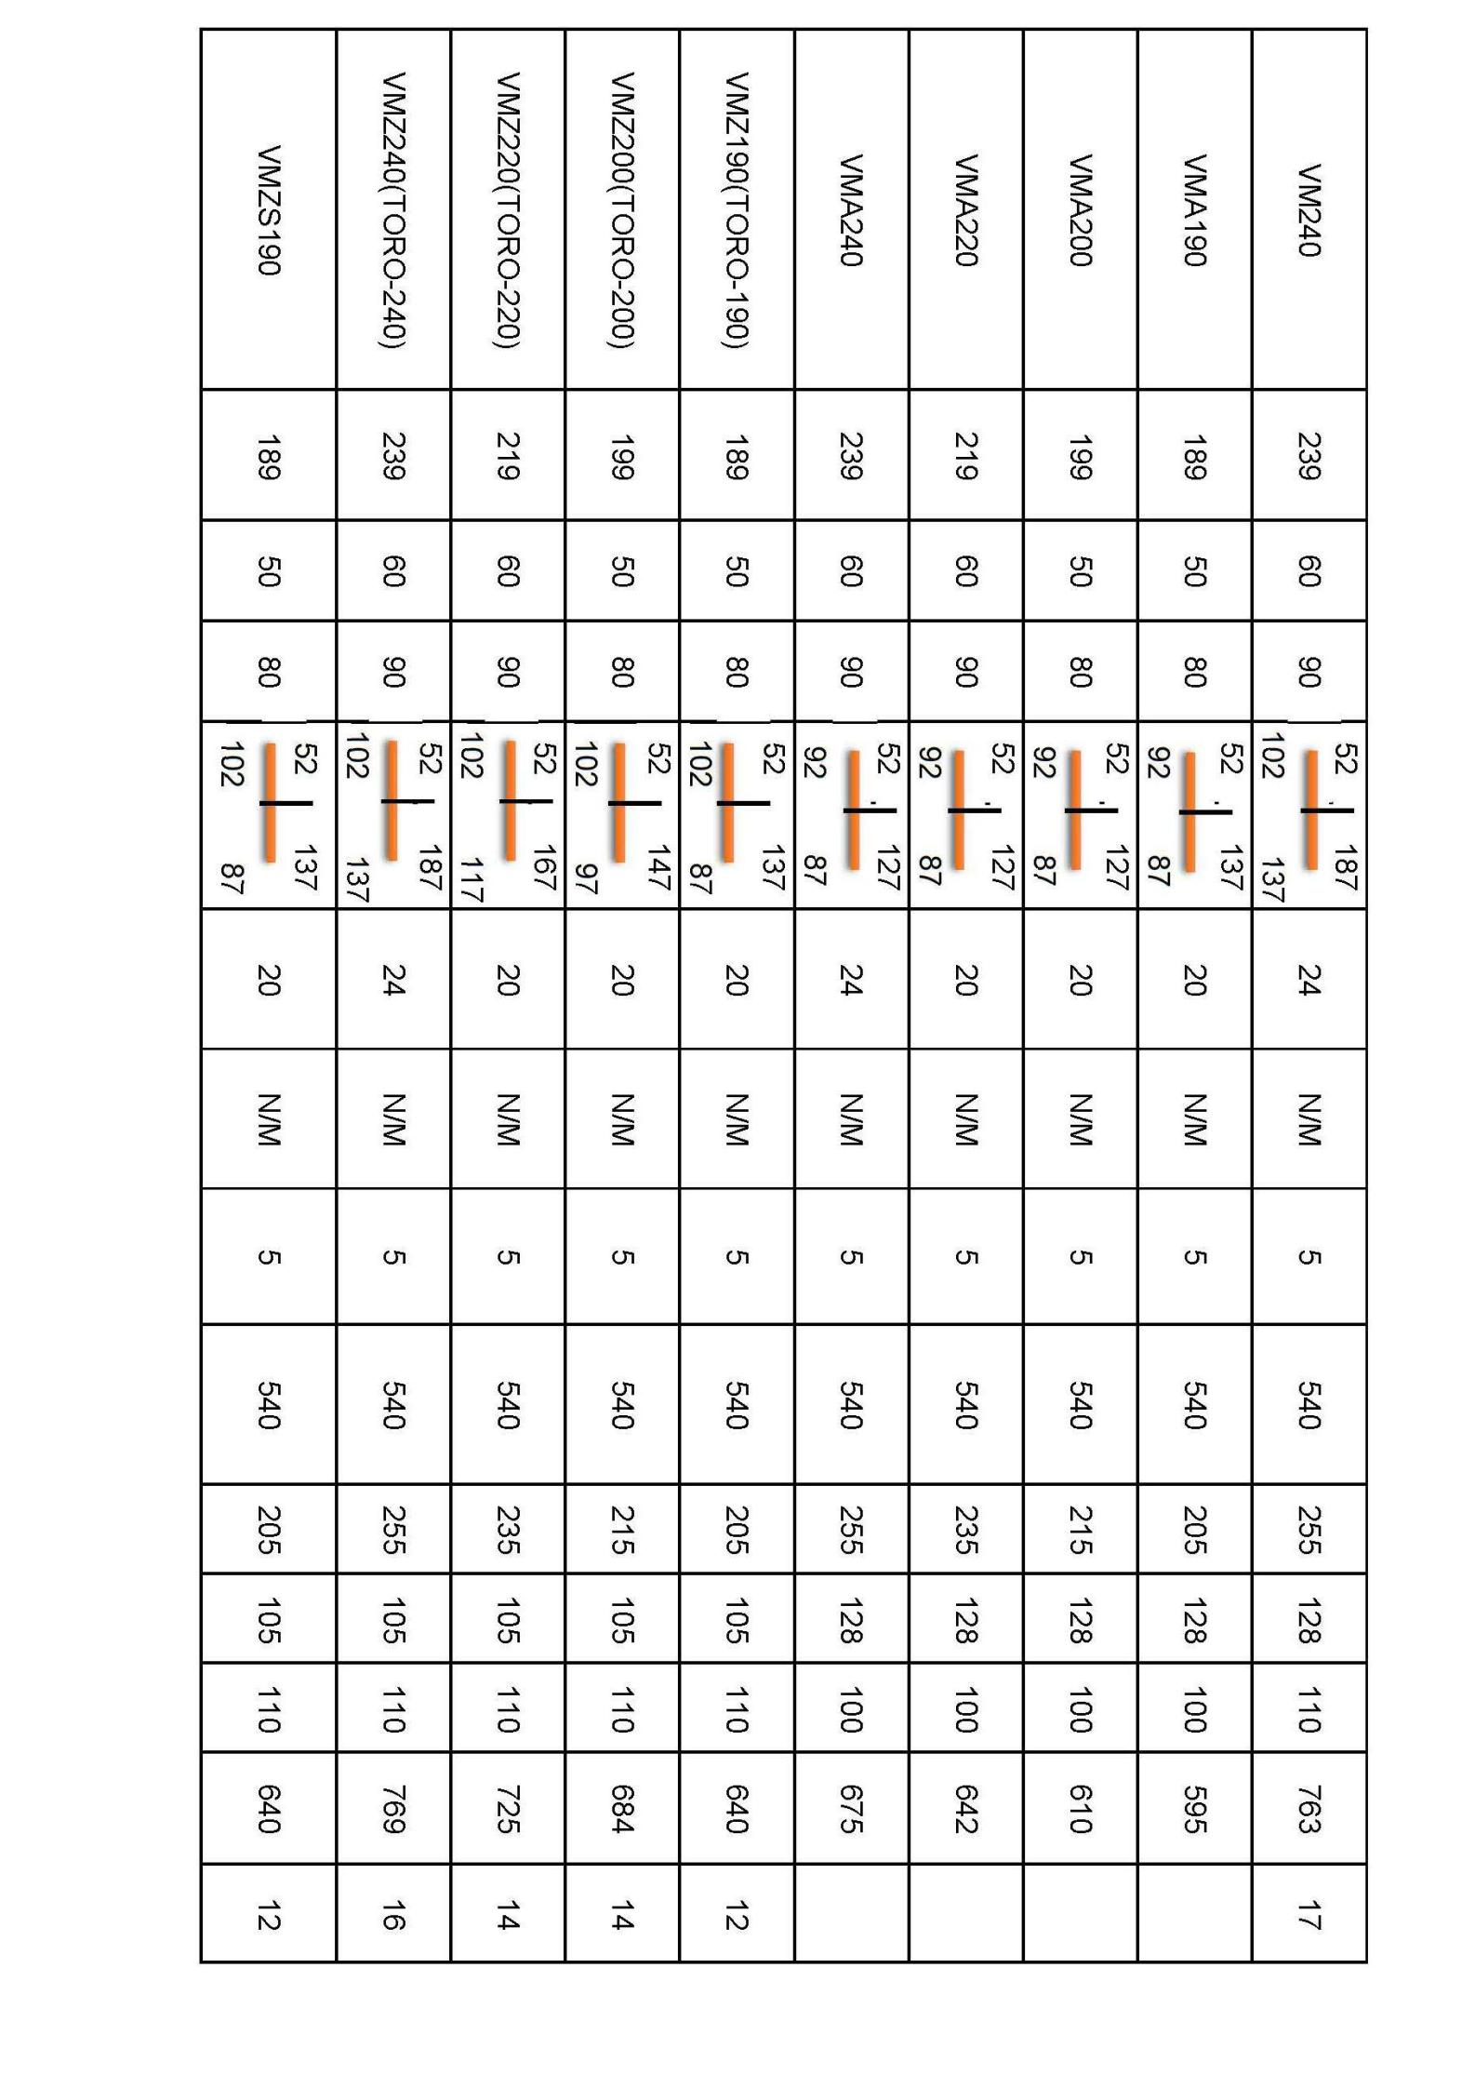
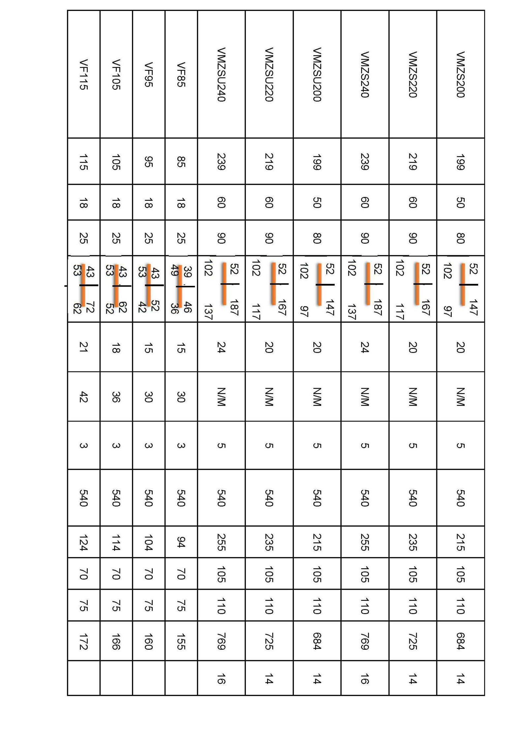
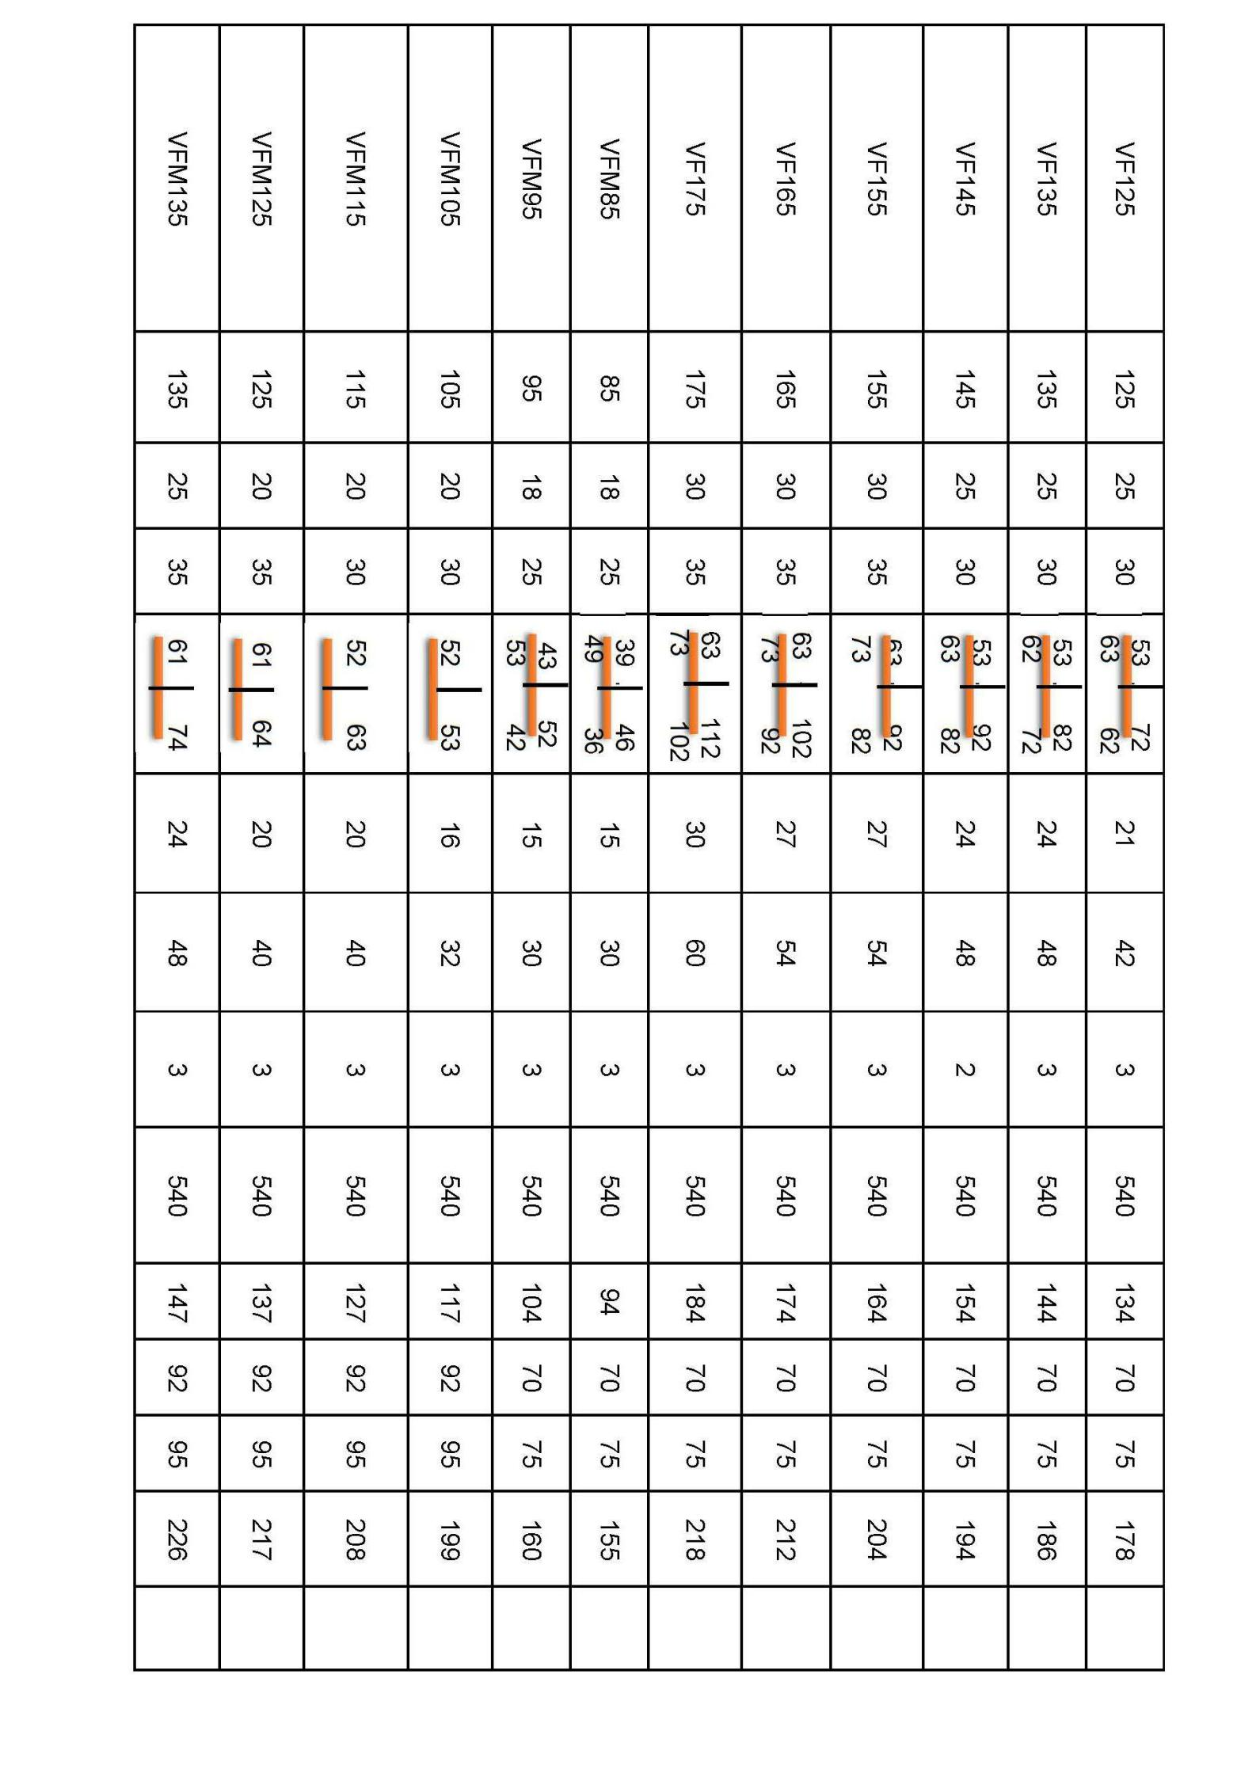
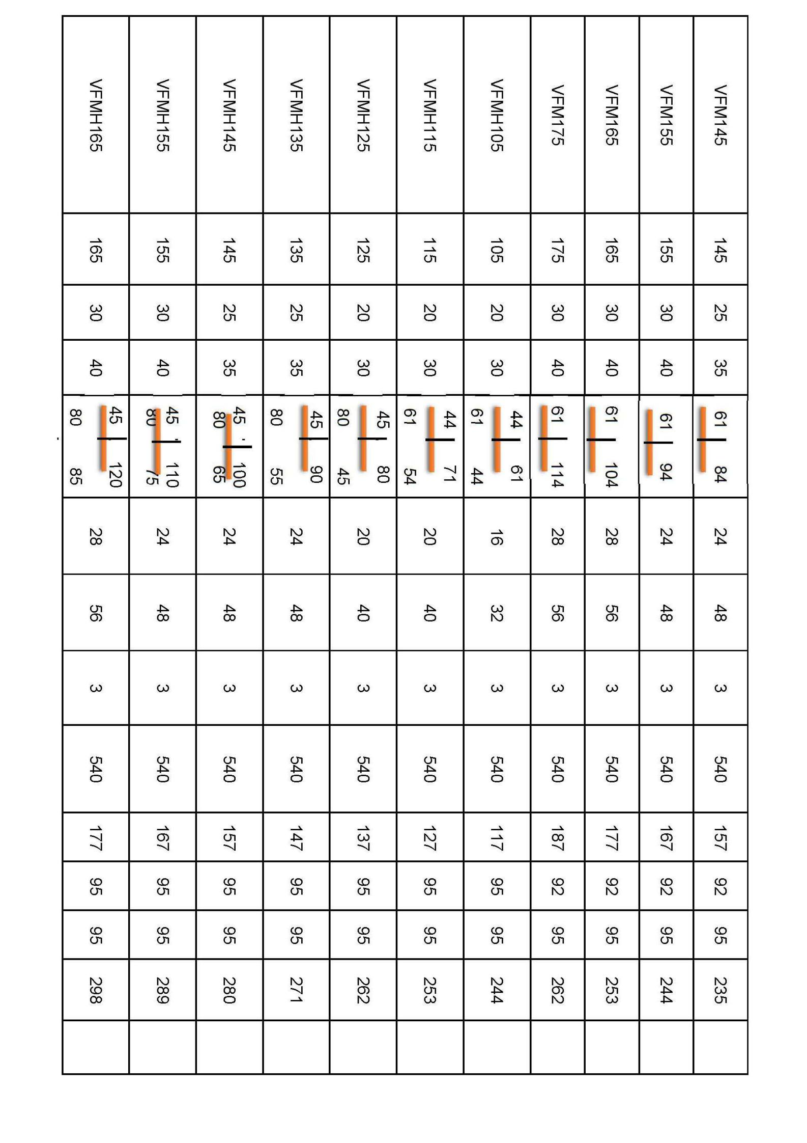

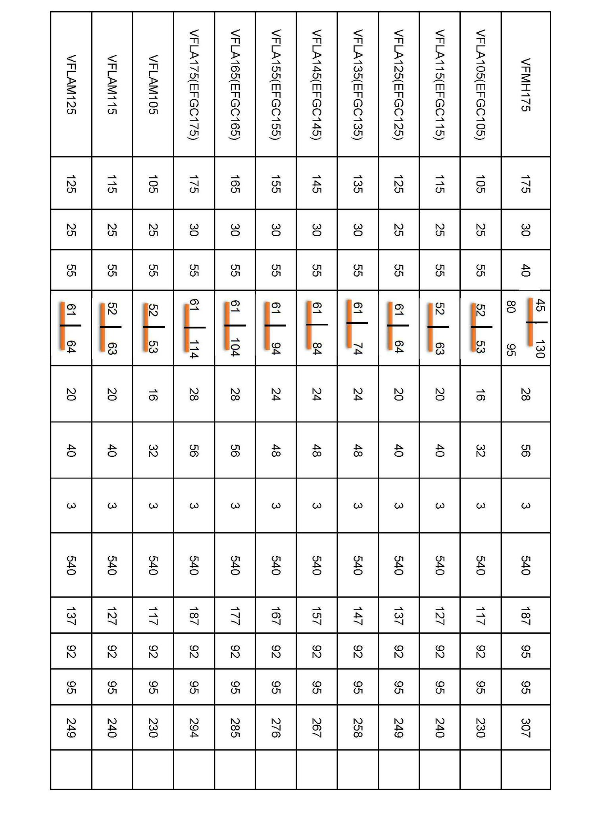

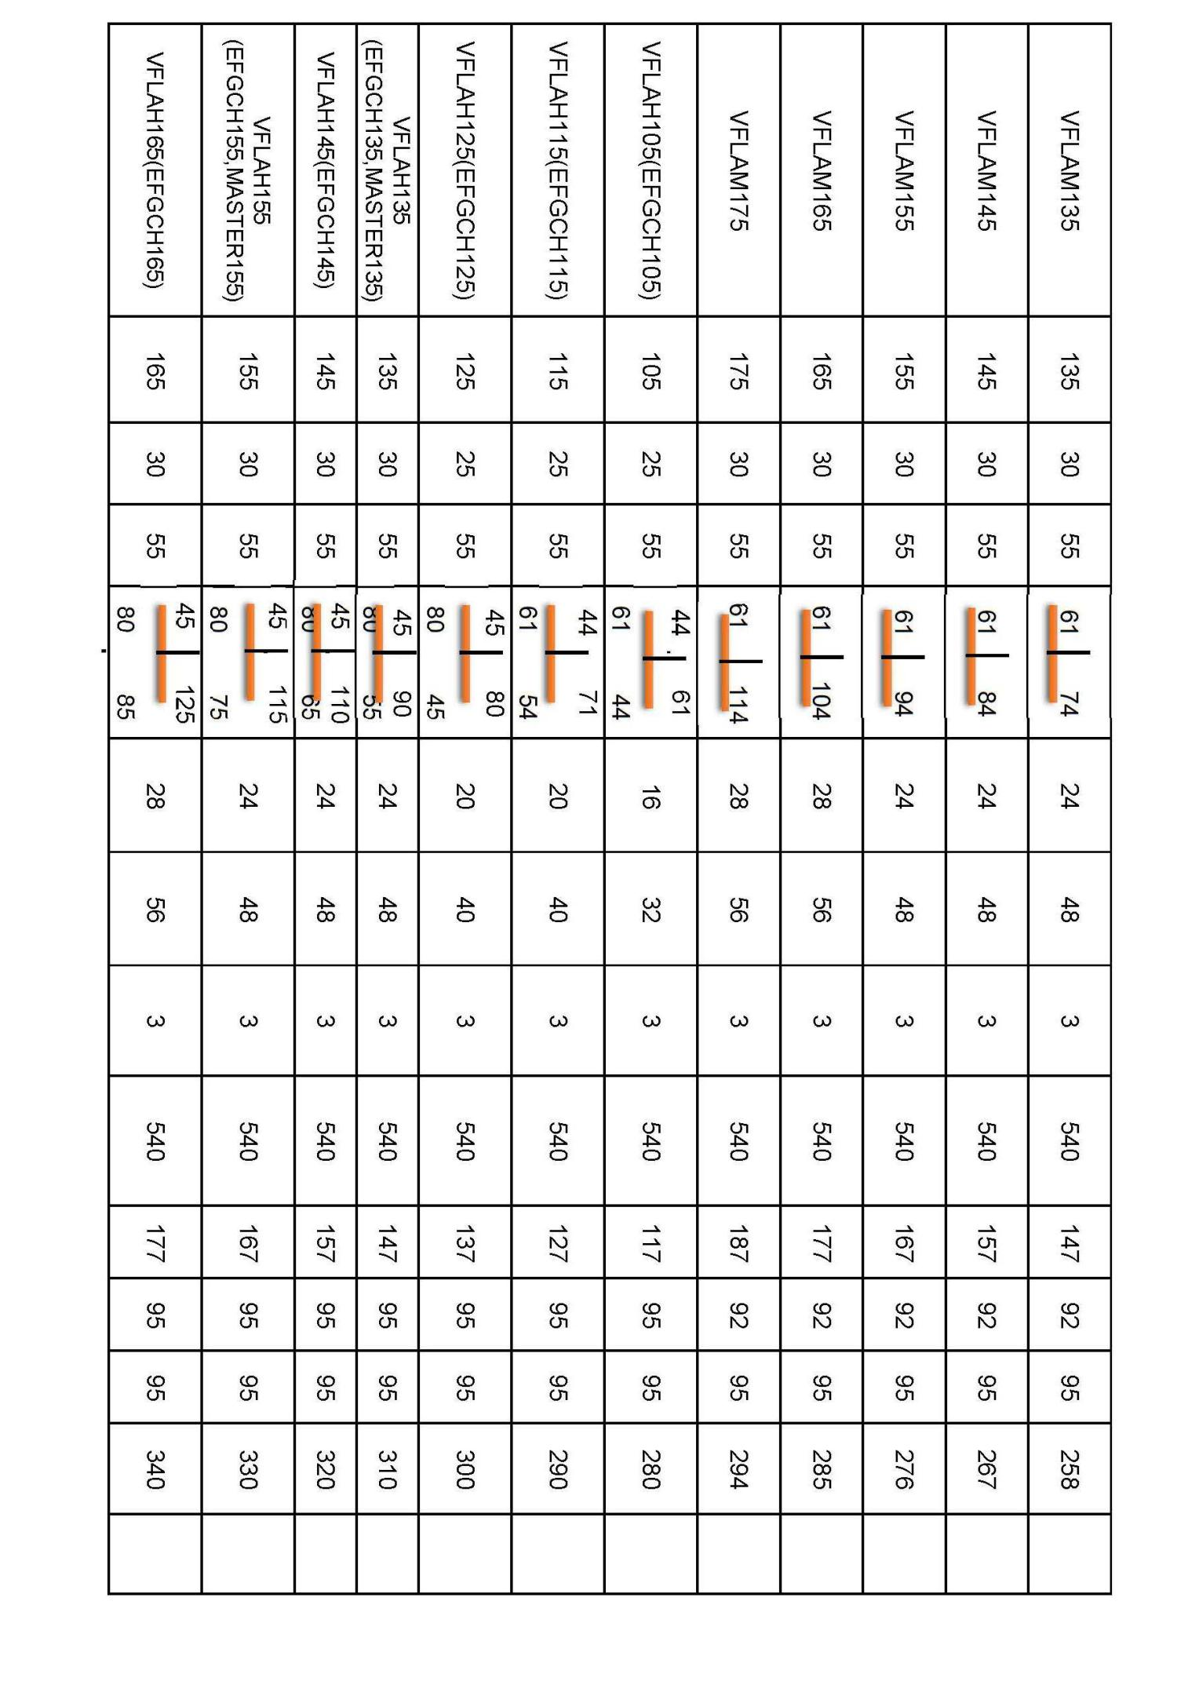
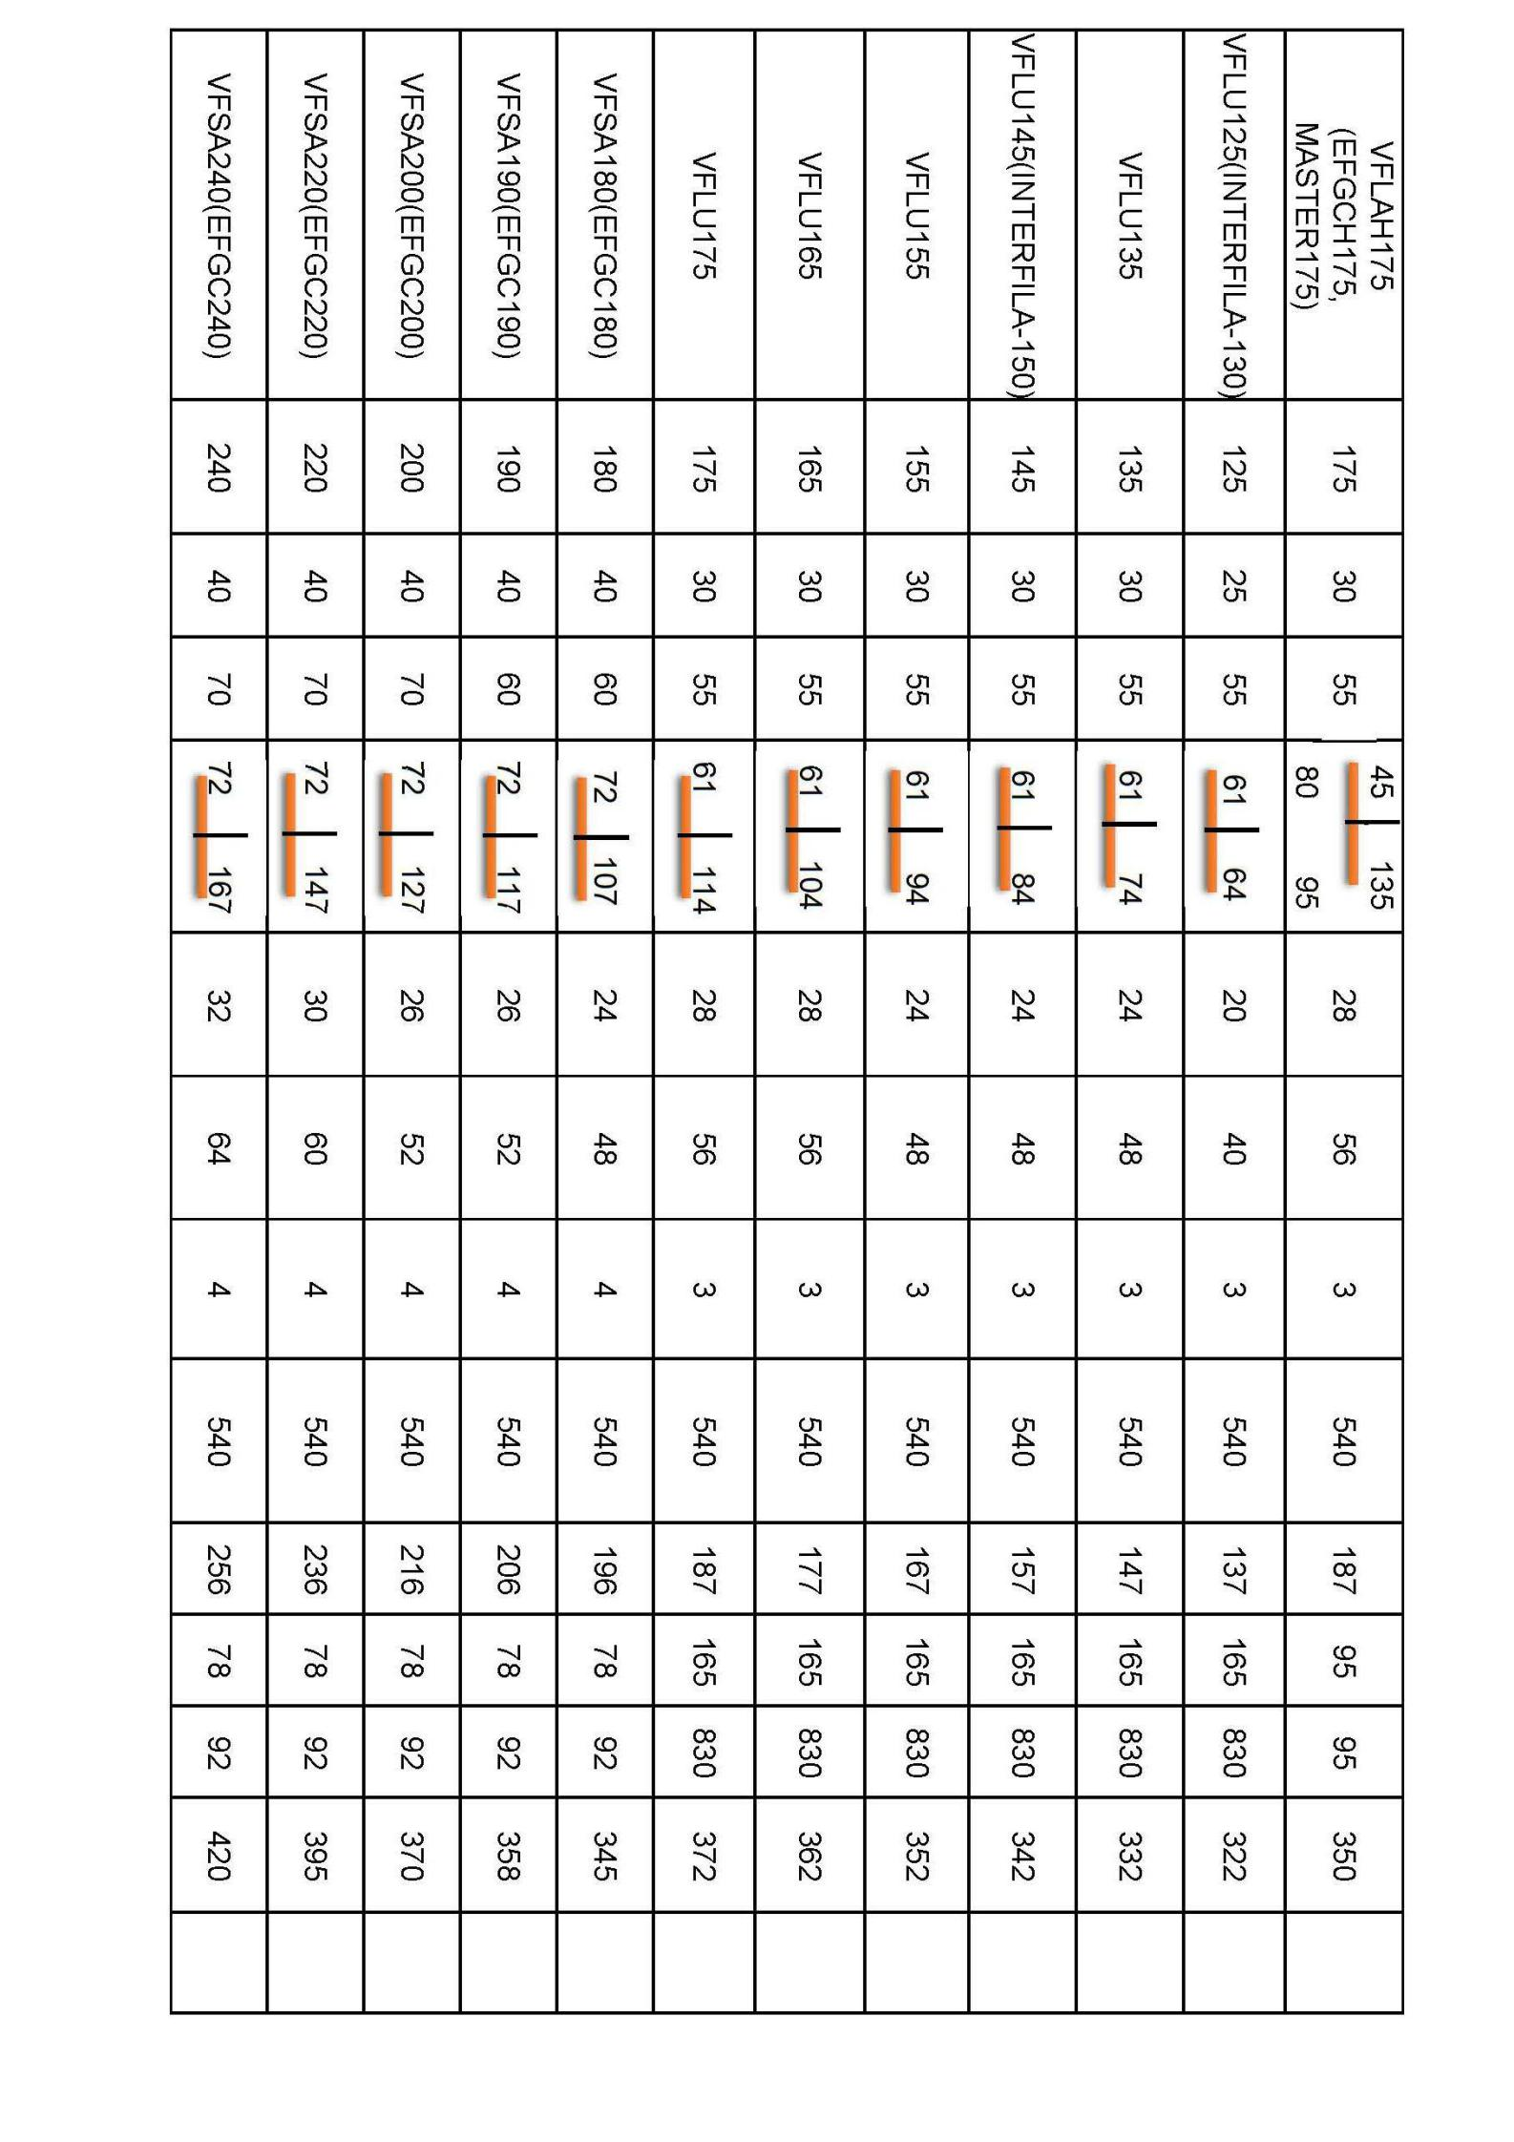
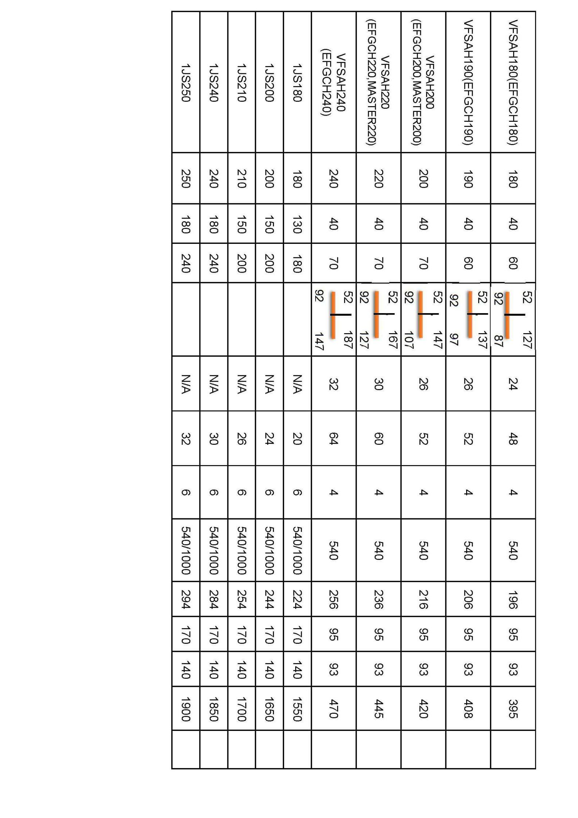

Hydraulic system

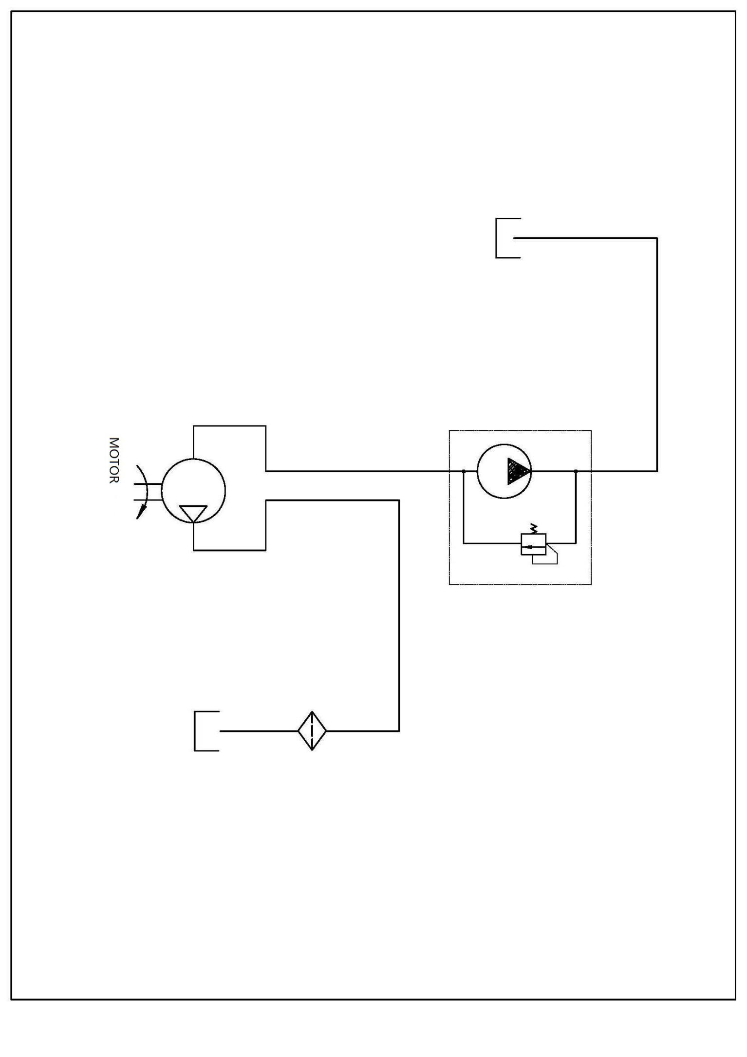

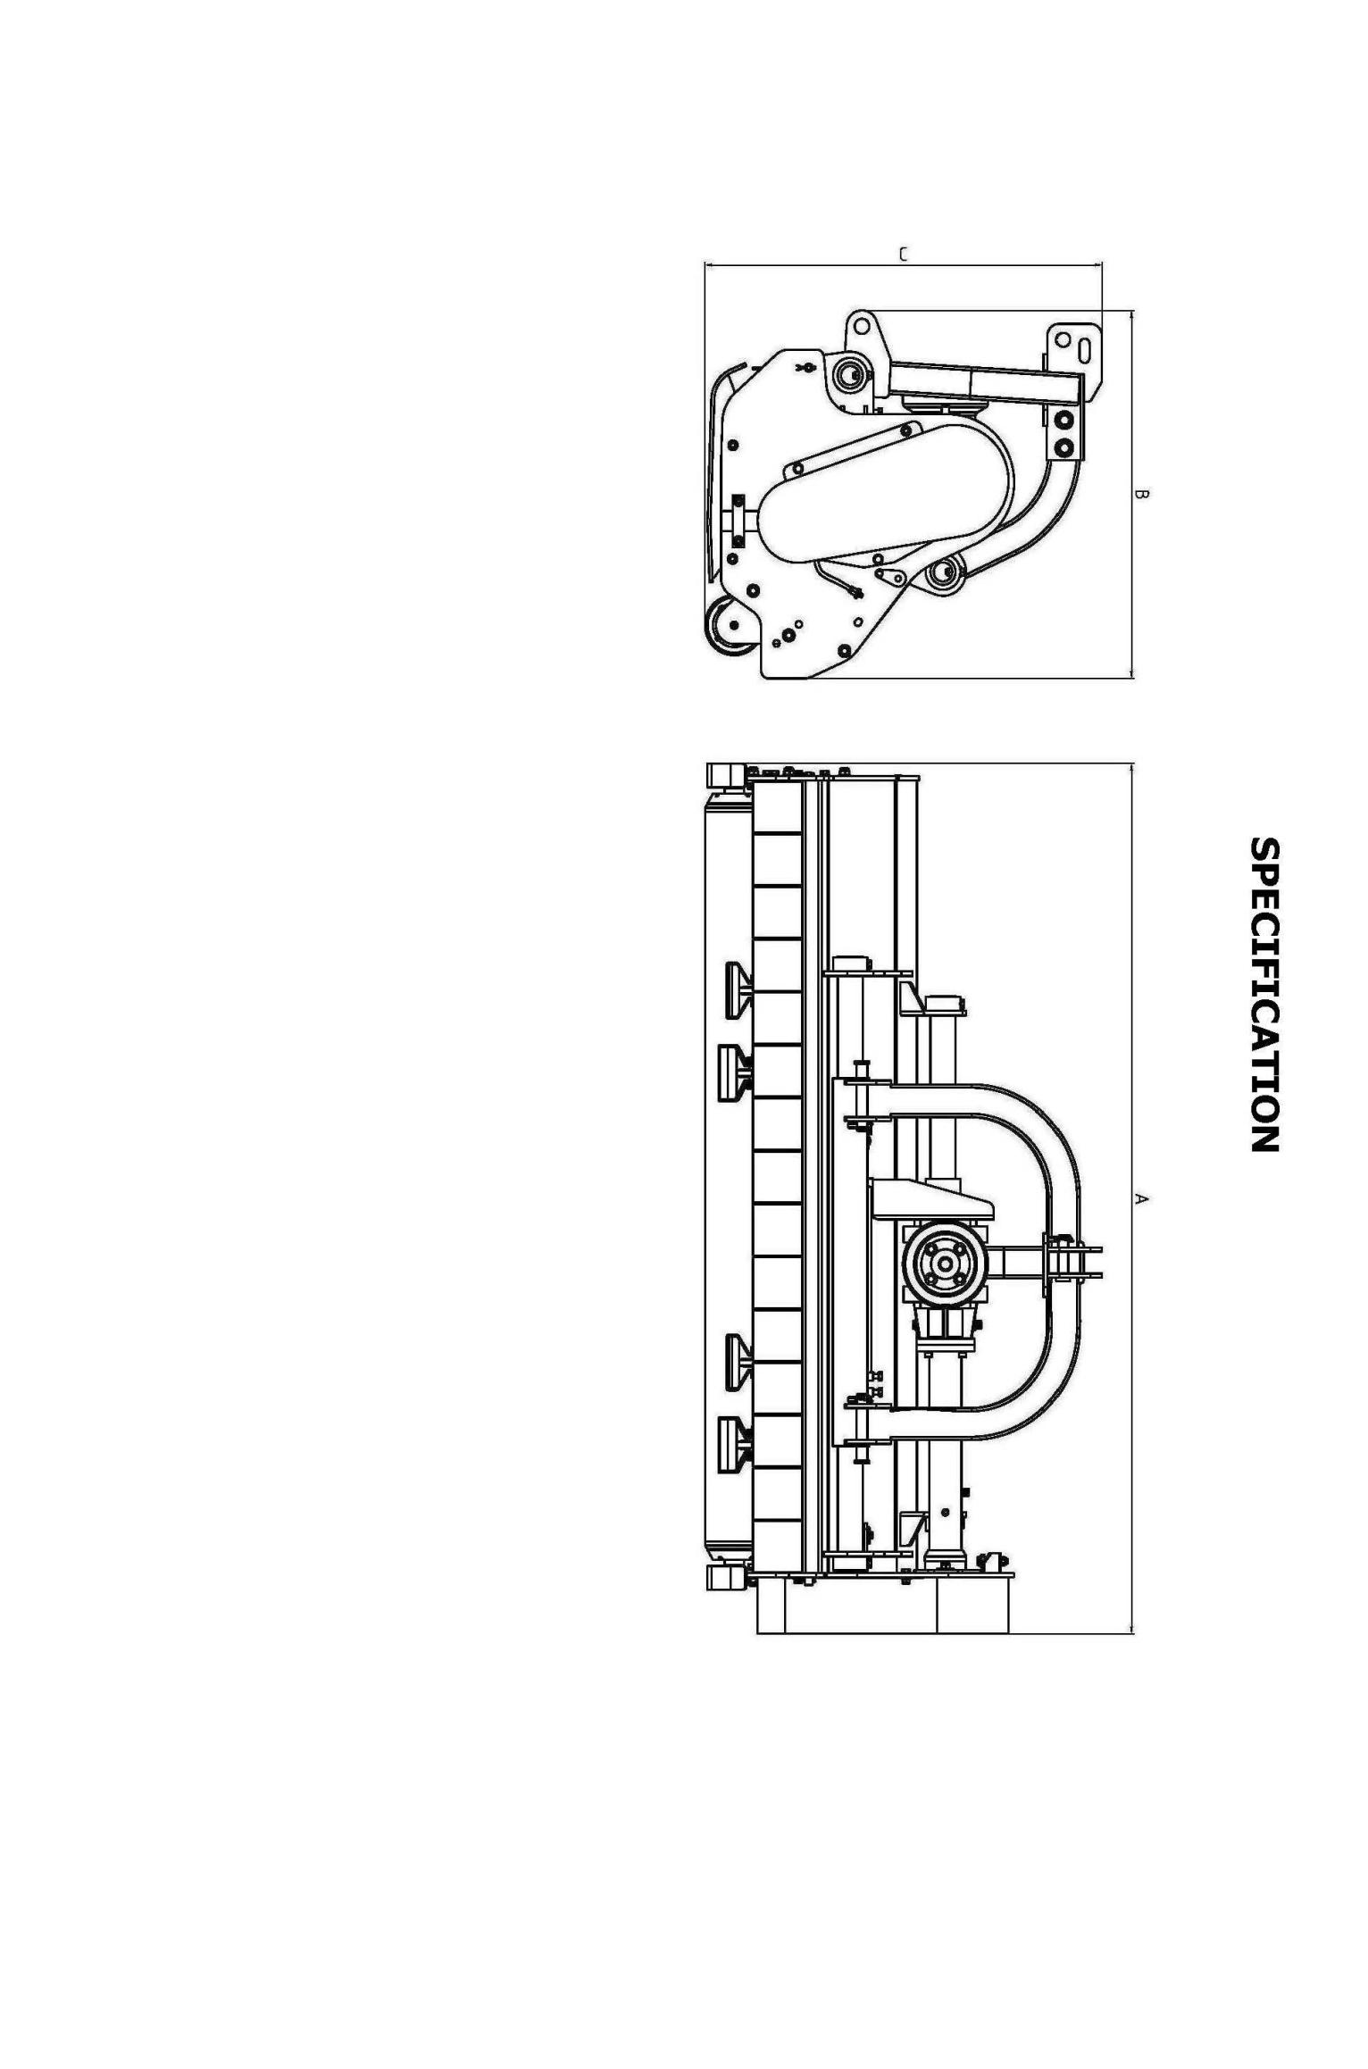
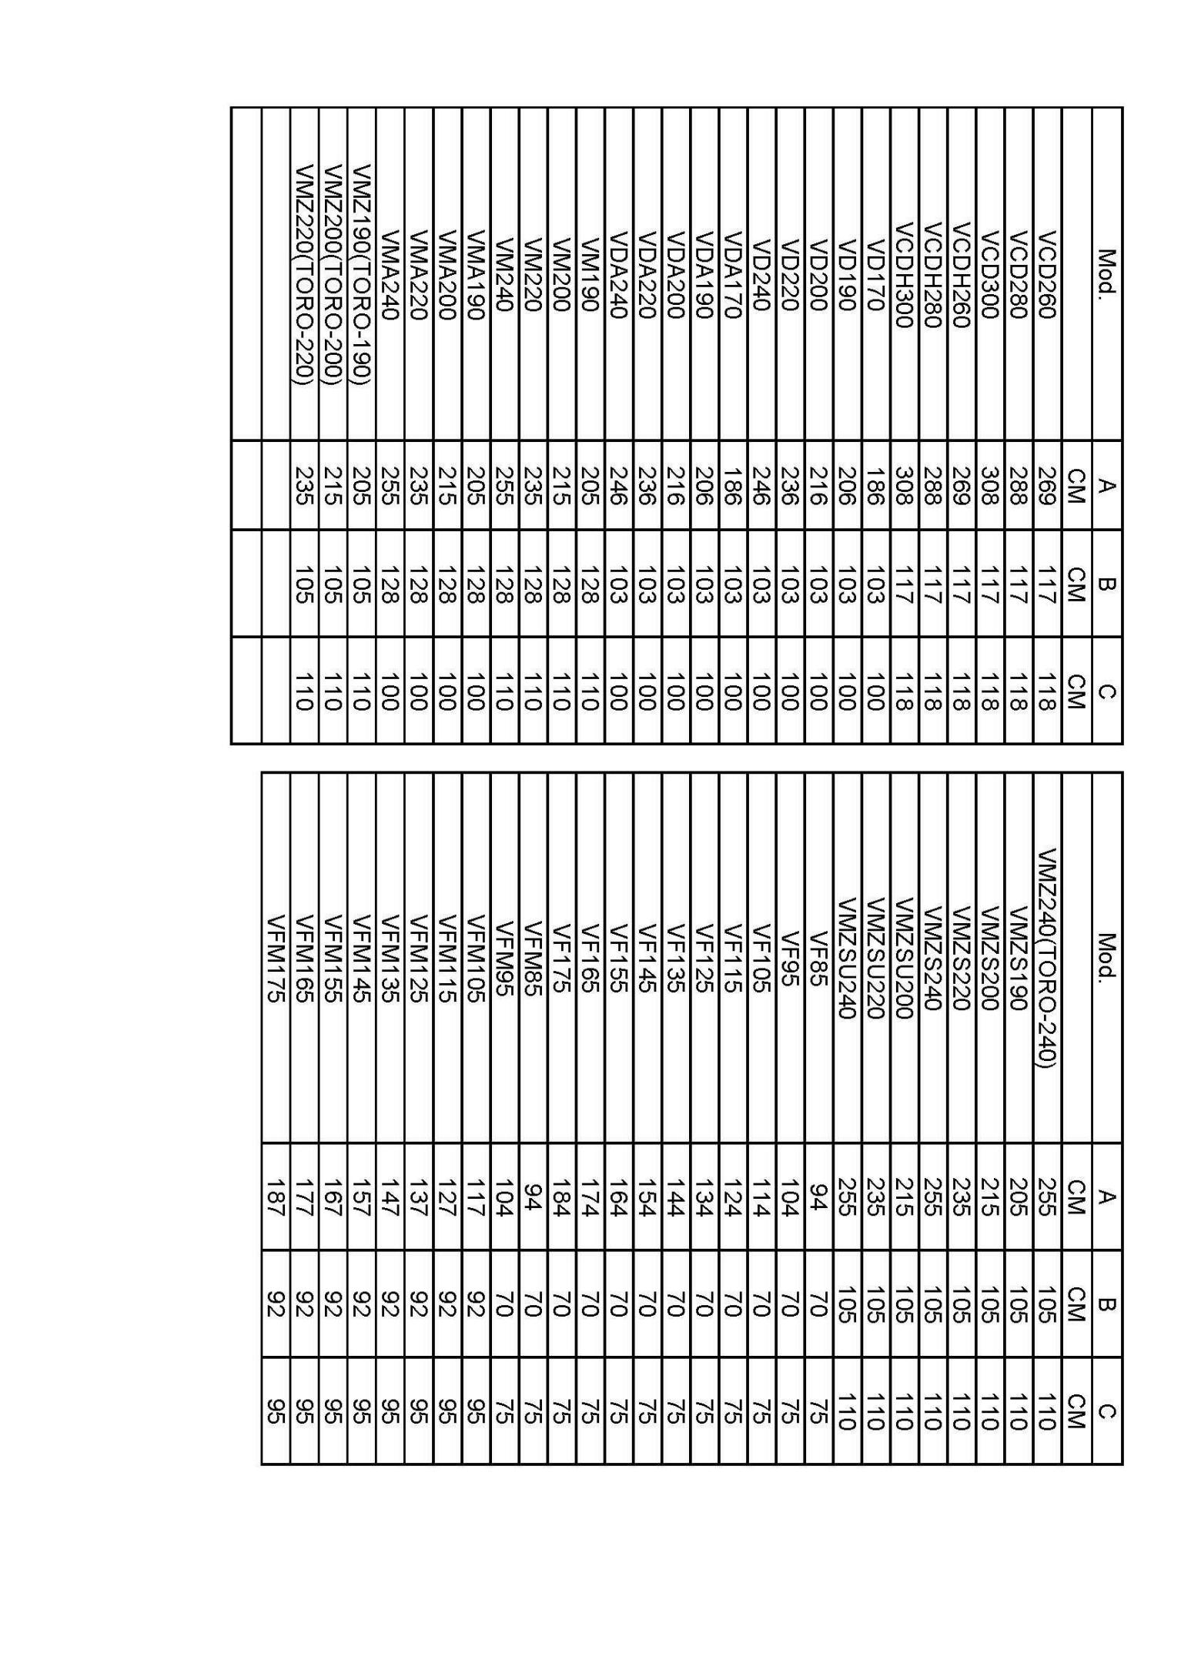

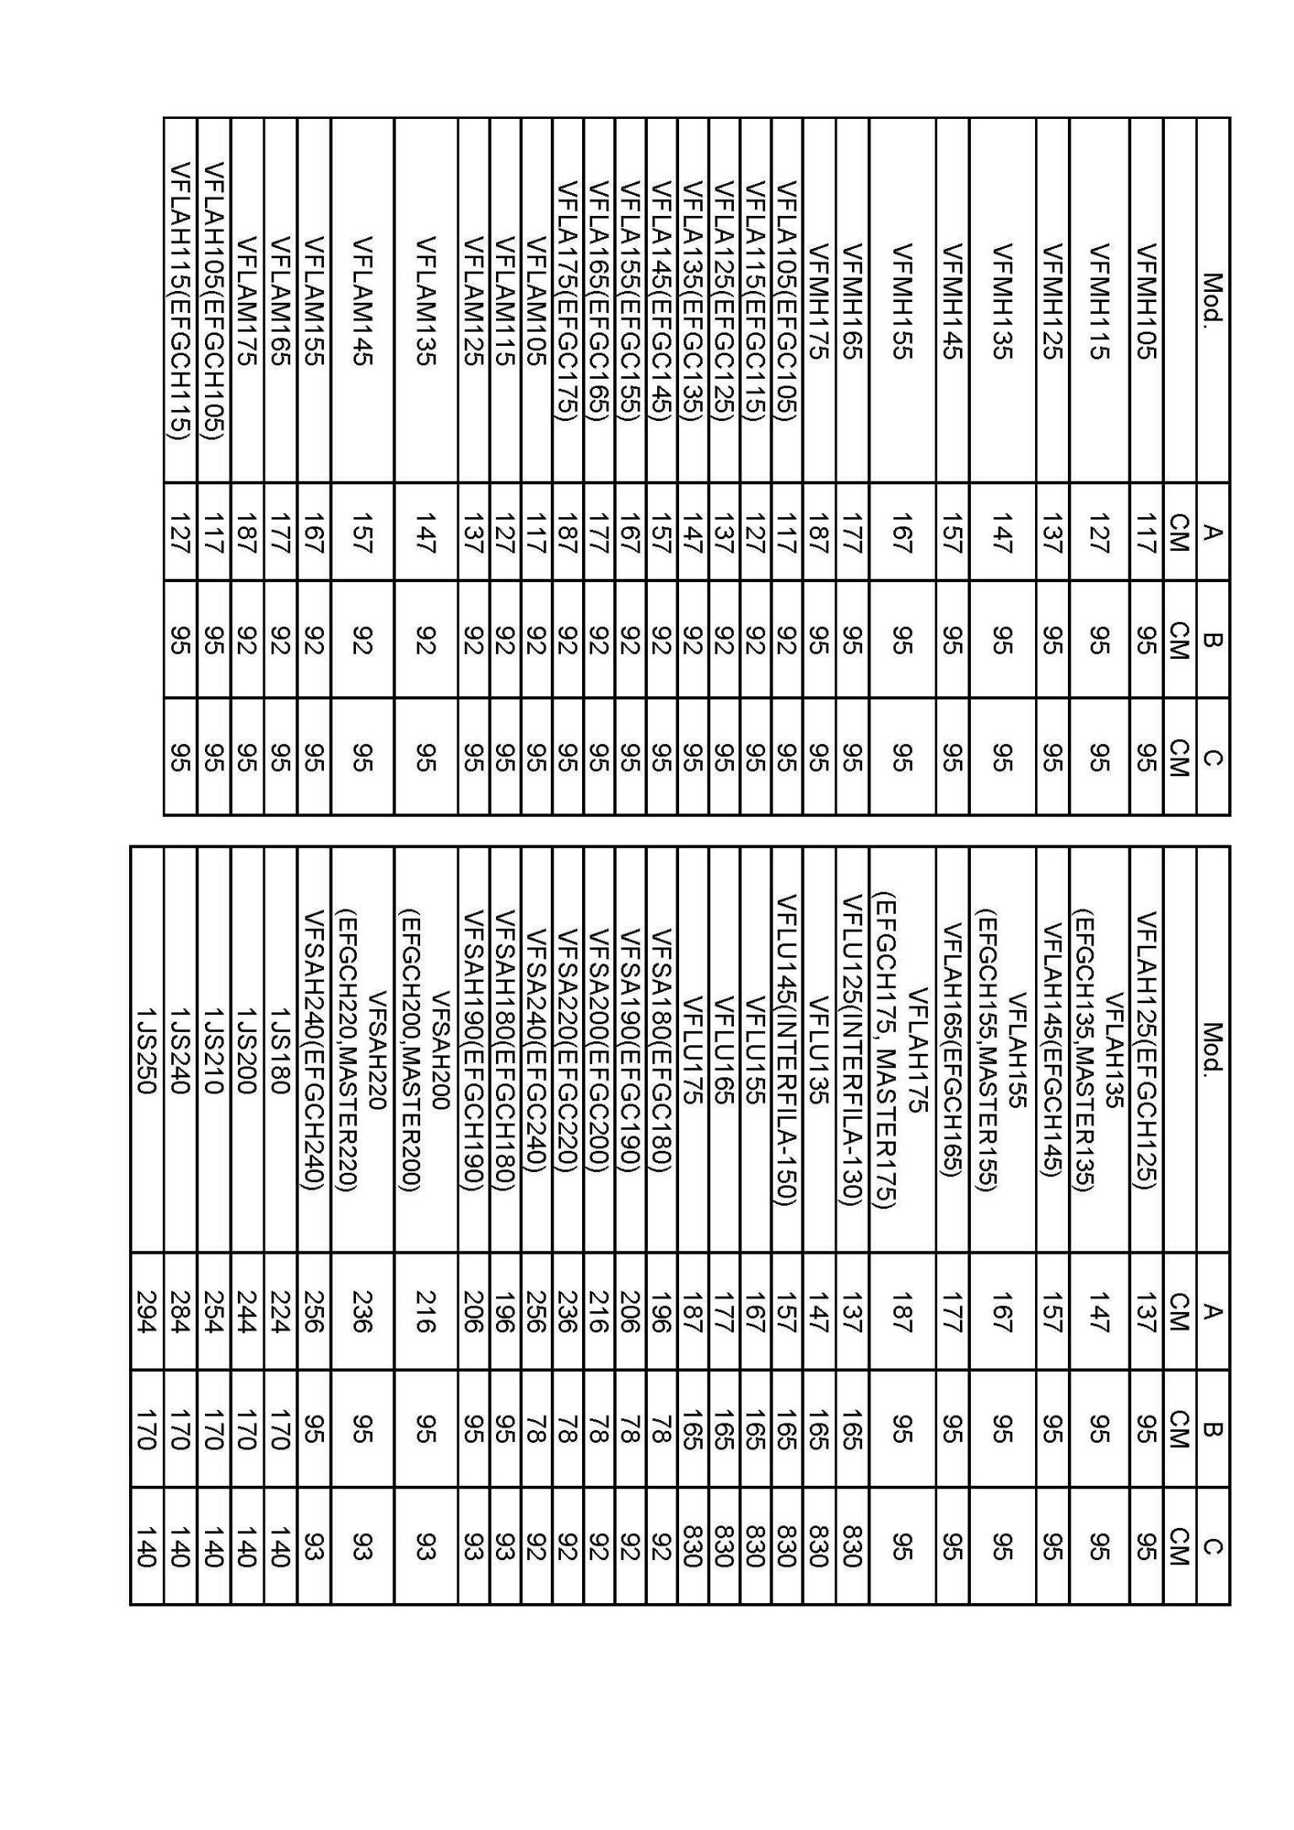

2 ,SAFETY PRESCRIPTIONS

Use the machine, make the periodic checks and the maintenance intervention in conformity with what is foreseen by the effective safety regulations.

The in-observance of the regulations or basis precautions about the safety may cause
accidents during the working, the maintenance and the repairing of the machine.

The CLOVER SHREDDER has been produced and planed exclusively to cut grass, brushwood, prune remaining and corn trees, every other use modality must be explicitly authorized by the Company on a written document.
Any unauthorized modification on the machine excludes the company’s responsibility.

Clover is not responsible for any possible damage caused by a not foreseen or inadequate use of the machine.


The machine must be used only by authorized, trained people, who know its potential dangers. If you have any doubt, do not hesitate to contact one of our technicians.

The instructions written in this manual must be observed carefully.

2.I SAFETY AND ACCIDENT- PREVENTION RULES
Verify carefully the machine before to turn it on

CLOVER can’t foresee all the possible circumstances which might create a potential danger. The warnings presented in this document are therefore not exhaustive

-Observe, besides the warnings in this manual container, all the general safety and accident-prevention regulations. Do not let the machine work or make the maintenance till the instructions have not been read and understood.

-The signals applied on the machine give a series of important indications: their observance is useful to your safety.

- Make sure that all the safety pictogram are readable. Clean them and eventually replace them with new labels.



- Before using the machine make sure that all the safety devices are correctly placed and in a good state; in case of breakdowns or damages to the protections replace them immediately. In particular check that the front panels are present and complete, free to swing around the bolt on which they are hinged.

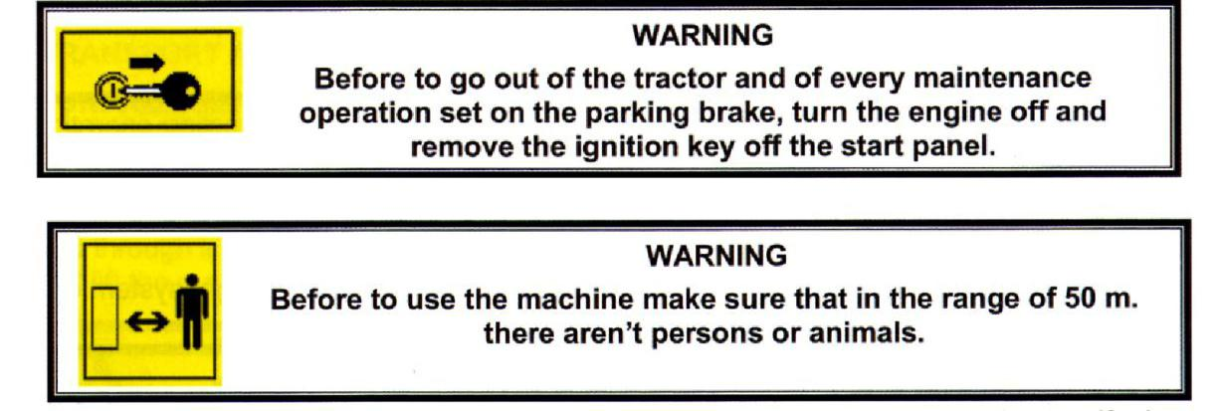

- The handbook must always be in an handing distance, allowing you to verify the operative cycle. If the book is lost or damaged you can ask to CLOVER for a copy.

- The machine must be used exclusively by authorized, instructed and trained people.
- The machine is planed to be used by only one operator.

- Do never work with this machine if you are tired, ill or under the influence of alcohol, drugs or medicines.

- It is recommended to the operator not to wear articles of clothing that could cause catching (sleeves without closed cuffs, belts, necklaces, bracelets, rings).



- During the use the shredder can give place to dust-emissions, in case of work with wet ground. It is advised to use tractors equipped with cabin with filters on the fan system or to use suitable protection systems of the respiratory tract such as anti-dust masks or masks with filter.

- Do not move the machine when the shredder is working.
- The machine must not be let unguarded when started.

- Check that the machine hasn’t been damaged during the transport and in this case warn immediately CLOVER

- Keep the machine clean from foreign materials (rabbles, tools, various objects) that could damage the working or the operator.



It is absolutely forbidden to go on or to let oneself transport when the machine is in motion.

-Make sure that the PTO shaft is correctly engaged after each connecting operation of the machine.

- Disconnect the machine from the tractor only on a compact and flat round, verifying that it is still and stable.

- Use the machine with enough natural light or, in alternative, use the light system of the tractor.



-In case of breaking or deterioration of the protections of the PTO shaft, take care of their immediate replacement.

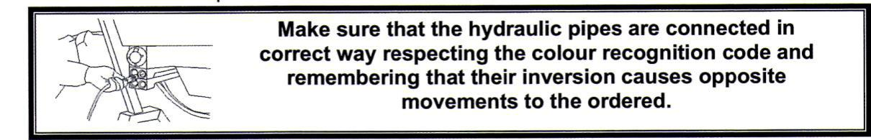

- Verify the wear state of the hydraulic pipes. In case of deterioration take care of their replacement. In any case replace the hydraulic pipes every 5 years.

- When the machine is not connected to the power unit, the hydraulic pipes must be connected on the special supports.

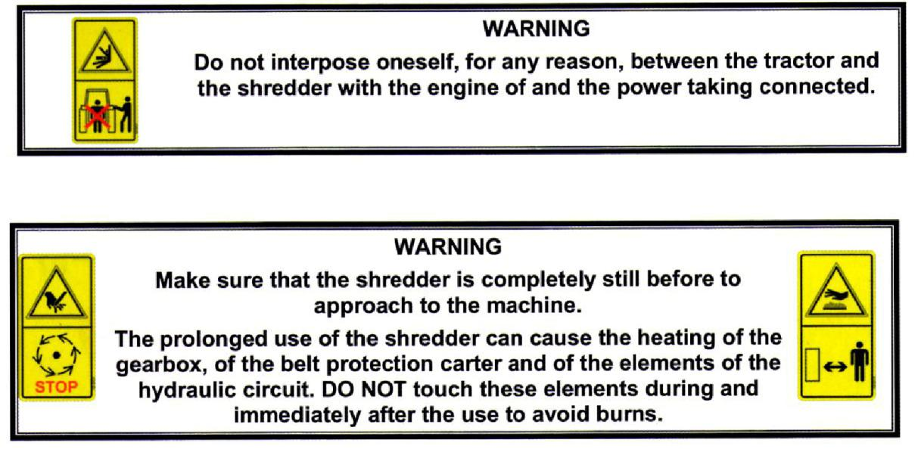

- Any changes on the machine may cause some problems. In this case the user will be the only responsible for possible accidents.



Use exclusively original spare parts of CLOVER firm.

CLOVER considers itself released from each possible responsibility in the case of:

- Improper use of the shredder by not trained people;
- Serious lack in the foreseen maintenance;
- Not authorized changes or interventions;

- Use of not original spare parts;
- Total or partial non-observance of the instructions;
- Non-observance of the common safety standards in the working range;
- Outstanding events

WARNING

BE SURE that the safety pictogram are readable. Clean them using a cloth, with water and soap. Replaced the damaged labels placing them in the correct position as it is described in the images below.

2.2 SAFETY SIGNALS

2.2.1 Location of the pictogram on the machine

2.2.2 Description of the pictogram




IMPORTANT:Safety valves on these machines can not be removed,otherwise it will cause big damage to machines or people would be injured.

3, TRANSPORT AND INSTALLATION

3.1 UNPACKING AND POSITIONING
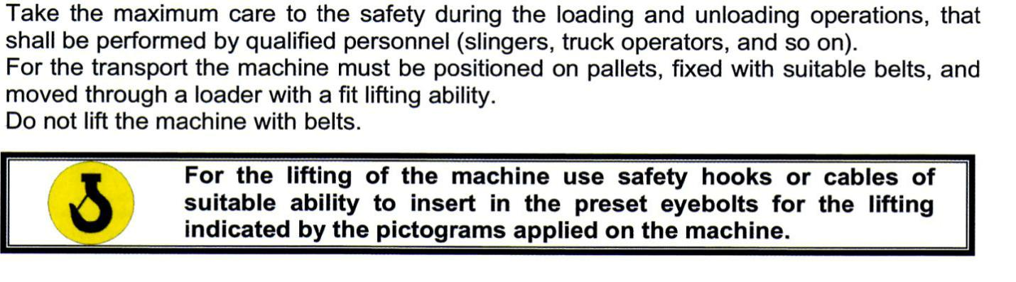

3.2 CHECK OF THE LIFTING CAPABILITY AND OF THE STABILITY OF THE
TRACTOR
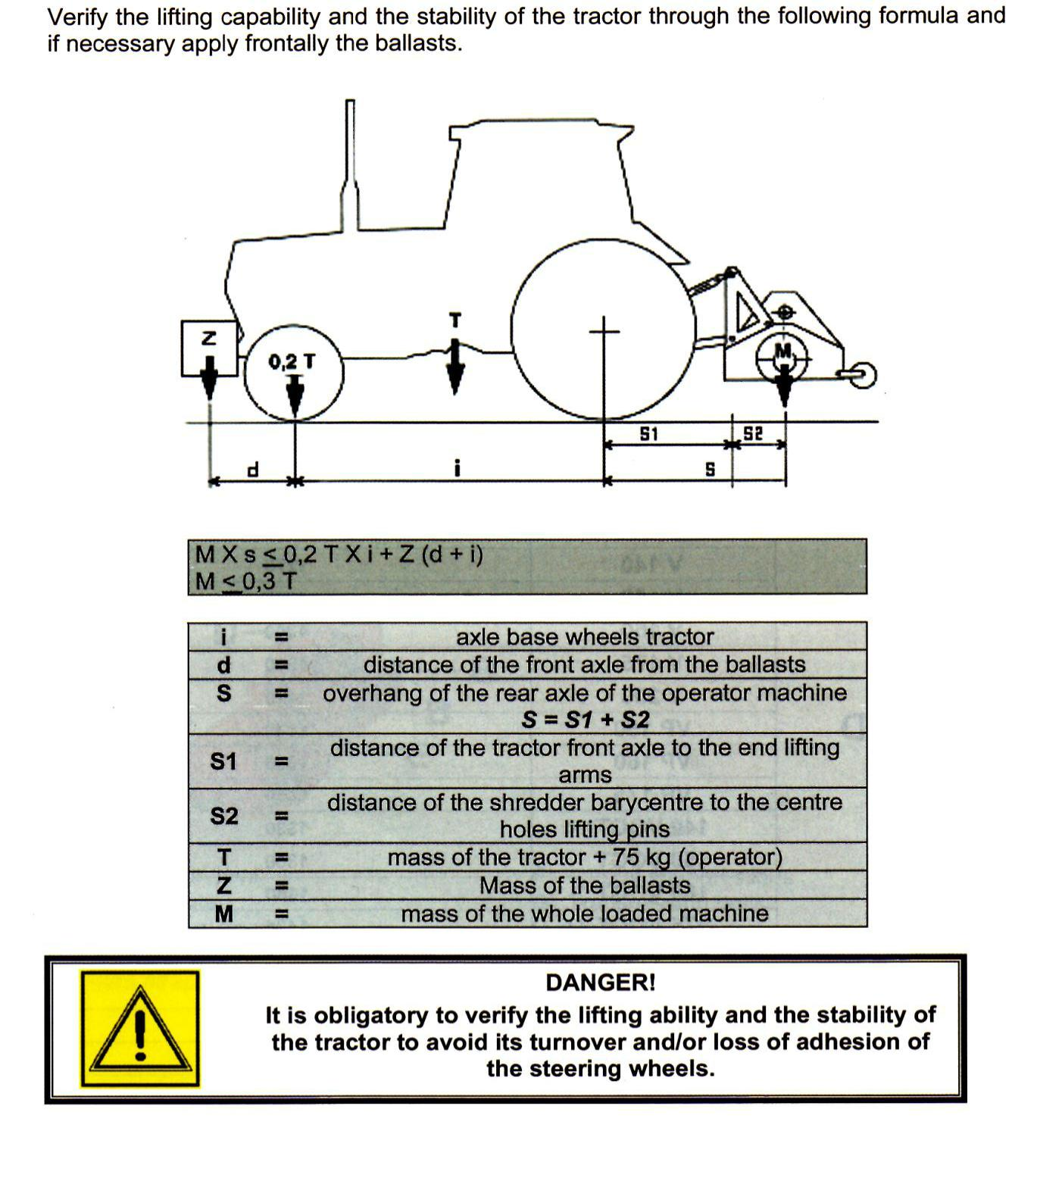

4 ,CONNECTION TO THE TRACTOR

The behaviour on the road, the steer and brake capacity are influenced by the used tools. The front axle of the tractor is lightened in relationship to the weight attached at the moment of the coupling to the lifting arm: the loading of the front axle must be at least 20% of the weight of the empty tractor.

Before the connection of the machine to the 3 points joint, position the safety device of the tractor to make impossible the unwanted and/or casual lifting and lowering.

The 3 points joint of the tractor and of the machine must coincide or be adapted.

In the rods zone of the rear lifting arms of the tractor there is the danger of injury owing to squashing and cutting points.

Do not use the outside control for the lifting of the machine.
In the transport position block the side halt of the rods and the control level of the lifting.

4.1 CONNECTIONS



4.1.1 Assembly of the shredder and regulations

The machine is equipped with bolts for the 3 points joint of the tractor.
For the connection of the structure of the machine to the tractor operate as follows:

- Approach the tractor to let the lifter bars coincide with the 3 points joint and connect them through the bolts on issue.



-Connect the third point to the upper joint and regulate it to position the machine in a parallel way to the ground. Verify that the knives or the hammers of the rotor shaft, when the machine is to the round, don’t touch the round during the rotation. In the versions equipped with slides verify that these lean on the round along its whole surface.

To avoid that the knives or the hammers go into the ground it is necessary to regulate the height of the rear roller lightening the blocking screw and inserting it in the chosen hole.

- Lift the machine and acting on the rods of the lifter bars block the movement.



4.1.2 Connection to the PTO shaft

After having executed these operations you can connect the transmission PTO shaft of the power taking to the grooved shaft of the gearbox of the machine (covered by a protection counter guard) and then to the power taking of the tractor:

-clean and grease the power taking;

-grease, if necessary, the PTO shaft following the indications given by the producer of the PTO shaft (see Use and Maintenance Handbook of the PTO shaft):

-clutch the PTO shaft observing the mounting sense prescribed by the producer and indicated on the outside covering of the protection.

-Hitch the anti-rotation chain.

-Make sure that the anti-withdraw safety block (push button) is correctly inserted and blocked in its own housing.



When disengaged, the PTO shaft, must be connected to the apposite support.

For a correct and sure working of the machine use exclusively PTO shaft with EC mark. The length of the PTO shaft must be suitable to the kind of tractor that is used.

CLOVER is not responsible for any damages caused by a non correct use of the cardan transmission.

4.l .3 Hydraulic connections for lateral shifting

Switch the engine off (if on), set the handbrake on and remove the ignition key off the start panel

Verify that there isn’t pressure in the hydraulic system of the tractor.

Connect the hydraulic pipes with rapid clutch to the tractor after having checked that all the joints are clean and in very good preservation state.

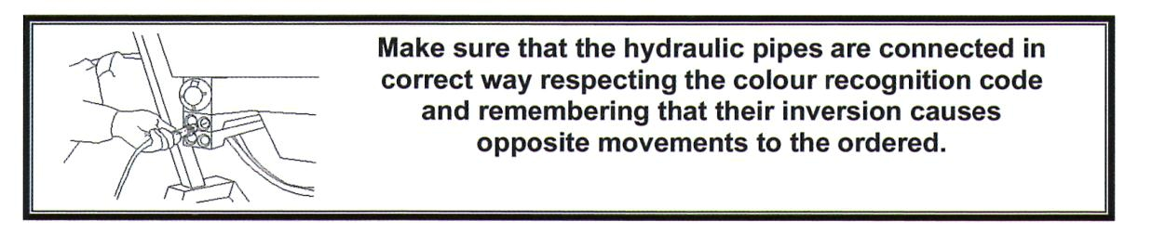

Give pressure to the hydraulic system, verify that there aren’t drippings and that the connection is correct.

As the shredding operations are finished, the hydraulic pipes released from the tractor must be fixed in the apposite supports for this purpose foreseen.



Before connecting, turn the hydraulic pipes off, stop the engine of the tractor and set on in both senses the control levels to let the oil flow from the system.

5. USE OF THE MACHINE

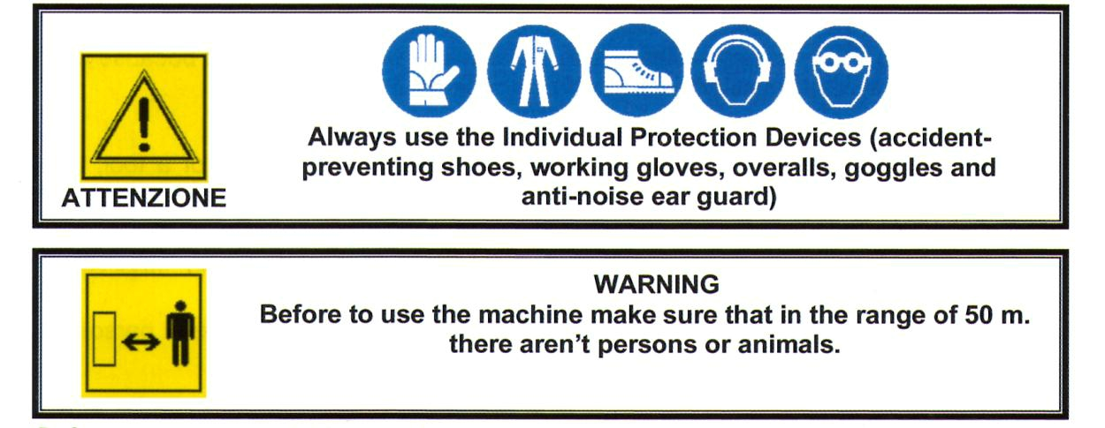

Before starting to work you need to regulate the machine to obtain a good working trim (see "Assembly and regulation", par. 4.1.1).

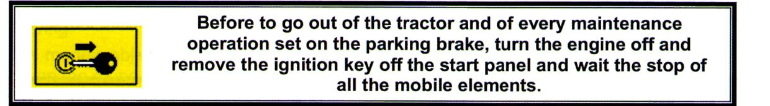

For a very good work we recommend to proceed to an advancement speed of 2,5 km/h on grass round and of 2,0 km/h on pruning residual.

During the work do not take curves with the machine to the ground, nor work in reverse.

Always lift the shredder for the direction changes and the curves, inserting first the power taking.

During the use the shredder can give place to dusts emissions, in that case you are working with a dry ground. We recommend to use tractors equipped with cabin with filters on the fan system or, to use suitable system for the protection of the respiratory tract such as anti-dust masks or masks with filter.

6 MAINTENANCE

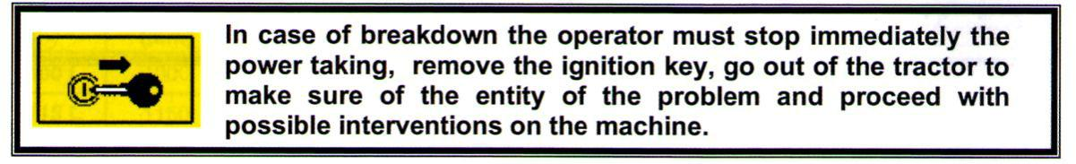

It is advised that all the maintenance operations must be performed by qualified and trained people, with the machine still and disengaged from the tractor.

It is necessary to verify daily the wear state of the knives, of the hammers and their connecting points, replacing immediately the ones that are worn or damaged because their breaking may cause dangerous projections of components.

6.I ROTOR

The rotor shaft has been preliminarily balanced: in case of replacement of a tool, it is advisable to replace all the series. To assemble not original tools can cause vibrations of the machines or breaking of the rolling bearings.

The replacement of the damaged parts must be performed exclusively by specialized people.

For the knives replacement interventions it is necessary to apply to specialized people making use of the assistance service by CLOVER or its dealers.

6.2 FRONT PROTECTION BARS

The protection bars must always be in good state to avoid possible throw of materials in the front zone.

Immediately replace such parts even if they’re lightly bended or warn.
For the bars replacement it is necessary:

-To unscrew the fixing screw of the bolt on the left side of the machine and withdraw the fixing bolt

-Replace the damaged bars
-Take care of the clamping of the fixing screw of the bolt.

Use exclusively original spare parts

6.3 ORDINARY MAINTENANCE

- Perform the maintenance with the machine disconnected by the tractor and opportunely positioned.
- Any maintenance work, regulation and cleaning must be performed with the machine to the ground, the engine of the tractor turn off, power taking disengaged, handbrake set on, ignition key disengaged and removed from the start panel

- Each 4 hours of work check the tension of the belts, You must always must care about their regulation

Perform this regulation only with the tractor turn off and power taking disengaged, remove the ignition key, wait until all the mechanisms are stopped.

6.3.1 Regulation of the belts

Loosen the screw A and B that block the support shaft
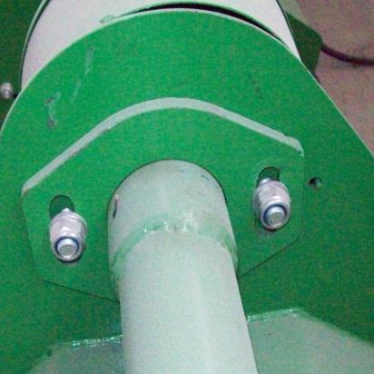
And loosen the counter nut C

Loosen the screws that block the gearbox on the support shaft D

A

B

C
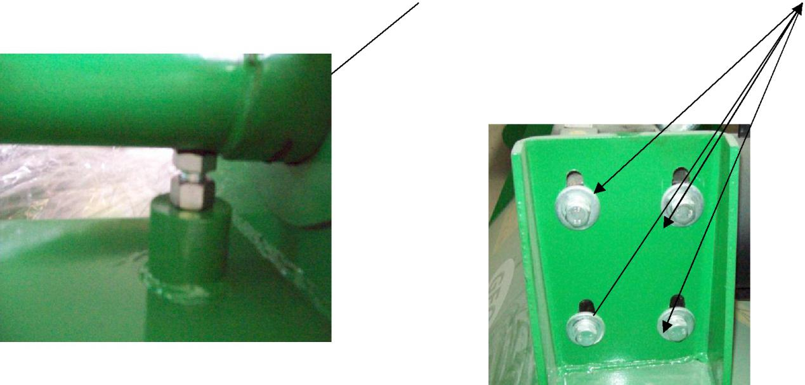
D

6.3.2 GREASING
AND

LUBRIFICATION

Each 4 hours of work:
- Verify camping of the nuts
• Grease with lithium oil when it is indicated by the symbol GREASE

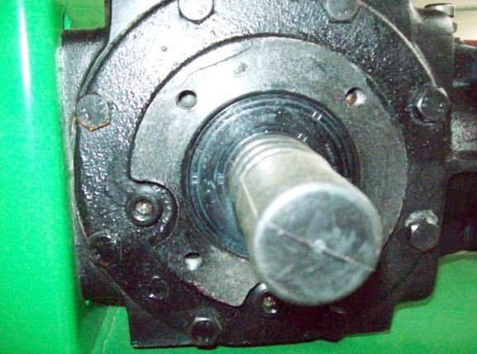
After 50 hr of work:

-verify the right amount of oil in the transmission unit and restore it till a good level, using oil type SAE 90 EP API GL4

Each 100hr of work:

-verify the right amount of oil in the transmission unit and restore it till a good level

6.4 INCONVENIENCES AND REMEDIES

INCONVENIENCES | CAUSE |  | REMEDY
Clogging of | Rotor speed is too low |  | Increase rotor speed
hammers/knifes
Excessive wear of | Rotor speed is too high |  | Decrease rotor speed
hammers/knives
Shredder vibrates during | • | Foreign matter | • | Remove foreign
works |  | stuck in between |  | matter
 | • | hammers/knives | • | Replace hammers
 |  | broken | • | Lock bolts
 | • Bolts of the rotor
 |  | shaft support have
 |  | come lose

7, WARRANTY CONDITIONS

7.l DURATION OF THE WARRANTY PERIOD

The manufacturer warrants all its products as free of defects in material and in workmanship for one year from the date of delivery of the machine.
7.2 WARRANTY CONDITIONS

- the commitment of this warranty is limited only to the replacement and/or repair of those elements considered to be defected in material or workmanship after an inspection of our technician;

- the damaged elements must be in unaltered conditions, not disassembled by unauthorized persons and furthermore must not have been subject to bad use, negligence or accidents;

- labour and transport fees for the repair or replacement of defected parts are excluded from this warranty;

- no warranty performed by someone other than the manufacturer shall be considered valid or binding;
- the manufacturer holds the right to perform modifications without prior notice and whenever modifications take place the manufacturer shall not be obliged to carry out these modifications on products manufactured previously;

- upon delivery check that the machine was not damaged during transport and that it is complete in every part. Claims must be presented by writing within 8 days from the date of delivery of the machine.

7.3 DECAY

The warranty does not cover the customer when :
- The damage is due to a manoeuvre error;

- The damage is due to repairs made by unauthorized people or using non original spare parts
- The instructions written in this manual are not followed.

7.4 WARRANTY CERTIFICATE

Dear Customer,

We thank you and we congratulate you for having chosen a CLOVER product.

Our brand is a guarantee of quality and avails of a wide net of dealers who are able to intervene and resolve any problem connected with the product that you have purchased.

The warranty validity conditions are already mentioned in the previous pages of this manual.

WARRANTY COUPON NUMBER:

MACHINE TYPE:

- Model…………………………………

- year of construction……………………………………….

- serial number…………………………………………………..

- manufacturer……………………………………………………

