Ivy Pay Billing System FAQ

What is Ivy Pay? Ivy Pay is an independent billing system that was created specifically for therapists. It is HIPAA compliant and secure. It allows space for clients to have a registered payment method, without the clinician having to be responsible for safely storing and protecting client credit card information.

What form of payment is accepted? You can pay using a credit card, debit card, FSA or HSA

How do I get started with Ivy Pay? It’s easy! After your first session with your therapist, your therapist will put basic information about you into Ivy Pay and send a request via text to enroll in Ivy Pay. This request will come through as a text message to your provided mobile phone number. You will need to click on the link in the text. You will then be redirected to a website where you will be asked to put in your information, along with your form of payment. You should be able to click on this link at any time to access their account.

How do I get billed for each session? You will billed after your session with your therapist. You will receive a text message from Ivy Pay indicating that you have been charged. You can click the link to view the charge, to view past charges, and/or to change payment type. Clients who cancel less than 24 hours in advance, will be charged a session fee.

My card was declined - what happens next? If the credit card was declined, your therapist will send a request through Ivy Pay asking you to put a new card on file. You can also click on the link sent to you by IvyPay to change payment method.

Can I get a superbill through Ivy Pay? Yes. If you chose to do this, please let your clinician know ahead of time. This way your therapist can ensure that the information needed by the insurance company is included in your information.

Visuals for Ivy Pay

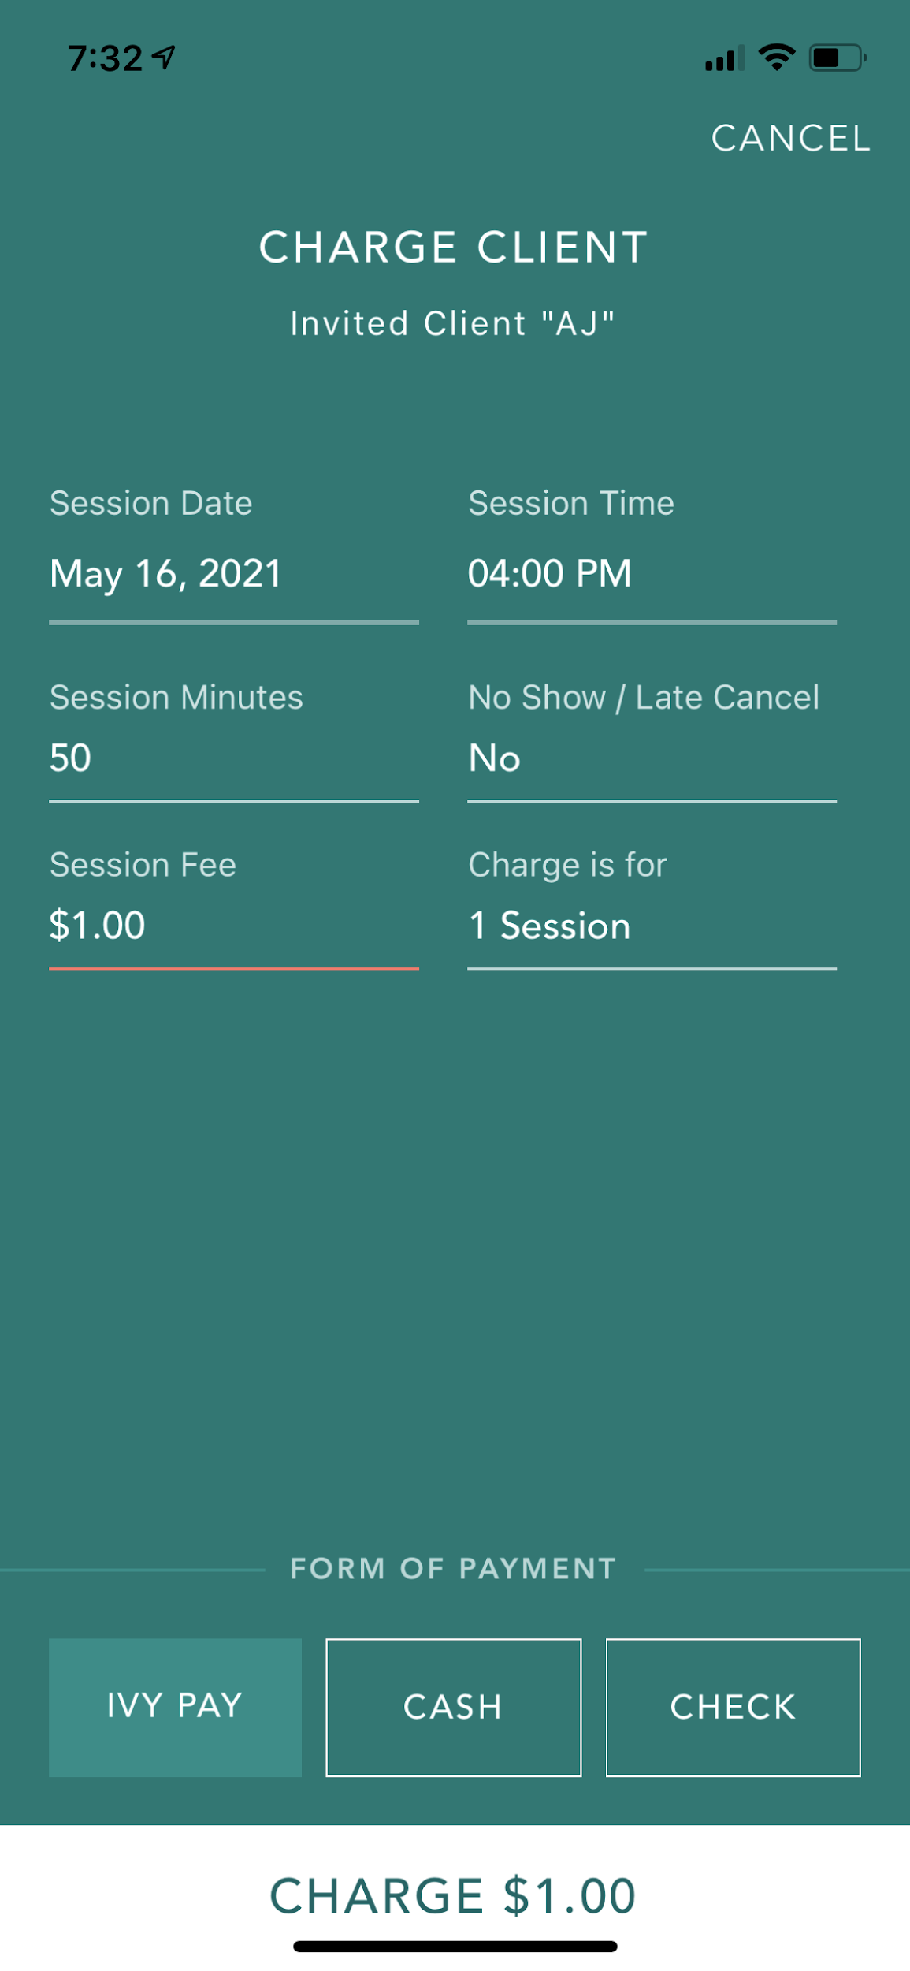
Your clinician will input basic information about you to create a charge through Ivy Pay. Your clinicians charge screen looks like this. This is also how you are billed for each session. Once you add your information, it changes from initials to your full name.

You will receive the following text from Ivy Pay. If you have a phone that allows for messages to be separated by “known” and “unknown” senders, you will need to pay extra attention. When you are billed going forward, you will receive a similar text. It will identify that it is from Ivy Pay, and indicate that you have been billed and for how much. There will again be a clickable link where you can view your account. If you need to update your credit card, or payment fails, you will also get a text indicating this.

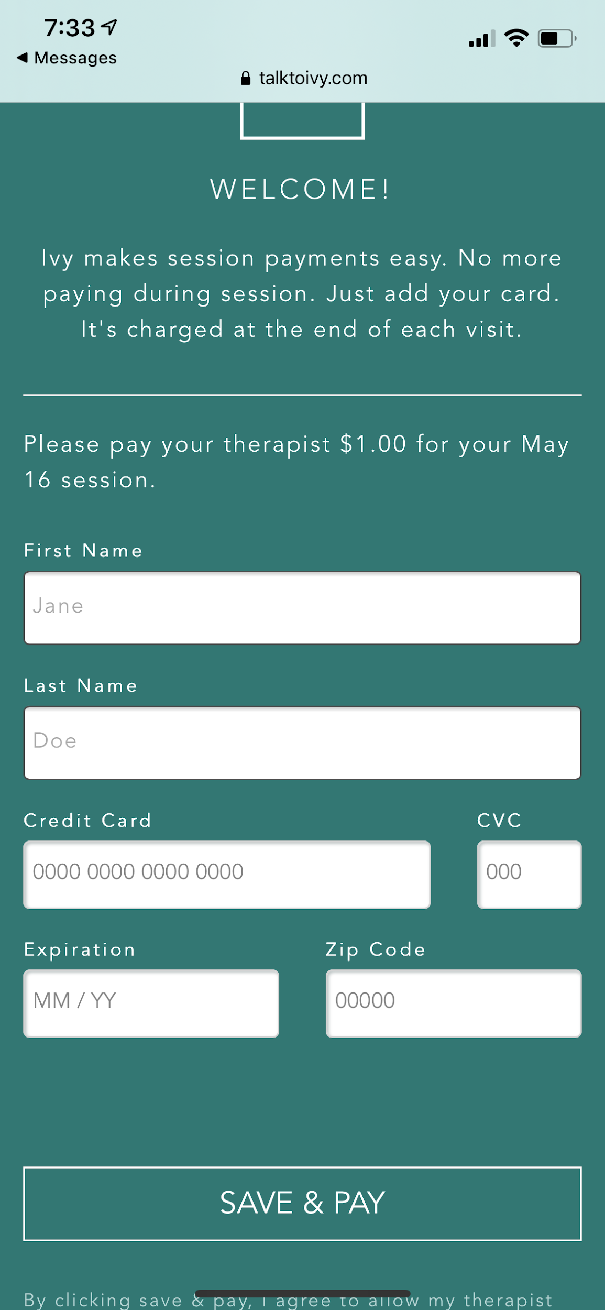
When you click the link you will be directed to the following screen. You will follow prompts to add your billing details and payment form. This is the ONLY time you will be required to do this.

