|  |
| --- |
|  |
| Seeley Lake Rural Fire Department |
| New Member Application Packet |
|  |
|  |
| **Version 12/7/2017** |

**Seeley Lake Rural Fire District**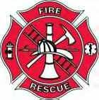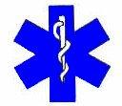

Dear Applicant,

If you enjoy hard work, pride, camaraderie, and an overall feeling of accomplishment, then joining the Seeley Lake Rural Fire Department is for you! This letter is to give you a brief overview about our Fire District and the application process.

About membership

* Safety for our members and the public is always a focus of our training and operations
* There is a place in the fire department for everyone! If you have questions about a certain aspect of our operation, please ask.
* We have a strong local tax support, federal grants, and dedicated members that ensure all of our equipment is up-to-date and well maintained.
* All necessary training and equipment are provided to members free of charge.
* New Members are required to complete classes in hazardous materials, structural firefighting, wildland firefighting, CPR for health care providers, and the Incident Command System (ICS).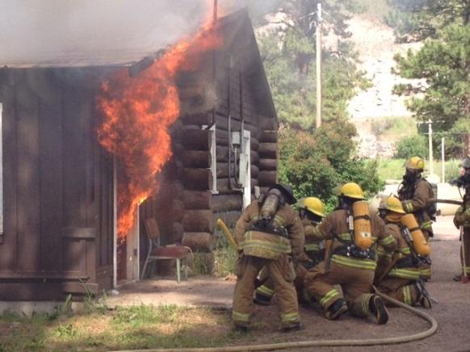
* New Members without current firefighting certification should expect 80-100 hours of basic required training in their first year. This training will be provided on evenings and weekends whenever possible. Members are required to complete at least 30 hours of department approved training each year to remain a member of the department.
* Members carry a radio pager and respond to structure, wildland, rescue, and service calls. Seeley Fire currently utilizes a program called “ IamResponding” to track responders on their way to the station.

**Fire Department Overview**

The Seeley Lake Rural Fire Department is dedicated to the protection of life and property in our community and surrounding areas. The SLRFD is an ALL VOLUNTEER fire department with the exception of the Chief, District Administrator and Maintenance Supervisor. We respond to wide variety of incidents including structure fires, wildland fires, vehicle accidents/extrication/fires, medical emergencies, and hazardous materials. Our firefighters strive to bring the community we serve the finest protection possible. We take great pride on working with our neighbors and cooperating agencies for the benefit of the community.

The Seeley Lake Rural Fire Department currently operates out of two fire stations and responds to an average of 200 calls per year. The Department serves an area of about 30 sq. miles and over 2,500 residents. Our equipment includes:

* 1 Structural Fire Engine
* 2 Water Tenders
* 2 Wildland/Rescue Engines
* 2 Ambulances
* 2 Command/Support Vehicles

**Eligibility Requirements**

Because the Seeley Lake Rural Fire Department provides a critical service to the community, it must take every precaution to select the best possible candidates.

* Must be 18 years of age or older.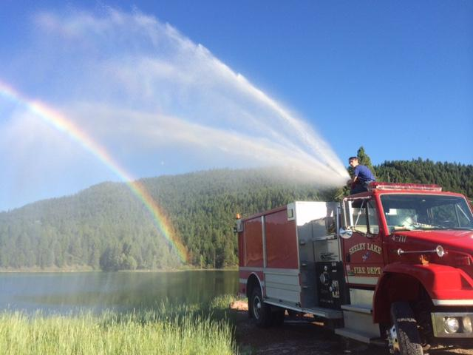
* Be a high school graduate or equivalent (certain cases will be considered by the Chief)
* Hold a valid State of Montana Driver’s license and possess vehicle liability insurance to maintain active membership.
* Must have residence or employment within the Seeley Lake Rural Fire district.
* Be able to carry out his/her responsibilities and provide good communications in a calm, positive and professional manner under emergency conditions. Good training will help you overcome fear
* Driver’s License and background check is required prior to being accepted as a member Seeley Lake Rural Fire Department. A negative finding does not automatically disqualify a potential member.
* Must adhere to a strict drugs/alcohol policy
* Must be available for training and meetings.

**Application Process**

To start the process and become a Fire Recruit candidate, please fill out the application as completely as possible. It is critical that you answer all questions truthfully and honestly. Include all additional pertinent information and accurate phone numbers so we may contact you. Once the application is received back at the Fire Department by the Chief, the process will be as follows:

1. **Review of application by the chief and district administrator**

Each application receives a full and unbiased review by the fire chief and district administrator. If approved, the applicant will be presented to the company members at the monthly membership meeting as a new Probationary Fire Recruit of the Seeley Lake Rural Fire District.

1. **Conditional Position Offer and assignment of Officer/Mentor**

Provided all is favorable, a conditional offer will be made to the applicant by the fire chief. You will be provided a copy of the Seeley Lake Rural Fire Department Operations Manual and Probationary Firefighter Task Book. The Chief will assign each new Fire Recruit an officer/mentor to help guide the new recruit through the Task Book and the probationary period. Probationary firefighters will be required to review and understand the Operations Manual by the end of their probationary period.

1. **Probation Period**

Upon receipt of a conditional offer, the Fire Recruit will begin a six-month probationary period. During this period the recruit will work to complete the Probationary Firefighter Task Book and work to complete as much of the initial training (listed below) as possible. The assigned mentor will assist in this process. Probationary members may be terminated at the chief’s discretion at any time during their probationary term.

1. **Initial Training**

To be able to operate safely on an emergency scene there is a fair amount of training during the year. Most training is conducted on evenings and weekend days. It is strongly encouraged that all firefighters complete initial training by the end of their second year to include;

* + - Basic Structural Firefighter Course (30 hours)
    - Basic Wildland Firefighter Course (16 hours)
    - CPR (3 hours)
    - Online ICS Classes (9 hours)
    - Hazardous Materials (4 hours)
    - Individuals wishing to become Emergency Medical Technicians will also be required to complete an EMT course (120 hours)

1. **Review of Probation**

Upon successful completion of the required probation period, the Fire Recruit will be considered for full membership based on the following criteria:

* + - Percent of initial training completed, and training hours completed to-date
    - Call response participation
    - Recommendation of Chief and assigned Officer/Mentor

If the member has not satisfactorily met any of the evaluation criteria or, at the discretion of the chief, an additional 6-month probationary period may be required.

1. **Acceptance as a Full Member**

Once all tasks are completed to the satisfaction of the chief, based on input from the recruit’s mentor, officers, and other members of the department, the recruit will be considered a full member of the Seeley Lake Rural Fire District.

The chief does maintain final decisional authority on offering full membership to any recruit however, mentor, officer and membership input will heavily influence that decision.

**Conclusion**

Whatever your reasons for choosing to become a firefighter, we truly appreciate your decision. It is important to remember that this business is inherently dangerous, and you will be required to make split second decisions during stressful situations. You will see and experience human tragedy which is an unfortunate part of the business. You will be critically depended upon by your fellow firefighters and members in our community. However, being part of a Volunteer Fire Department is very rewarding. You'll meet new people, learn new skills, and the camaraderie is something rare to find outside of the profession. Being part of your local fire department is a serious commitment of time and energy, but if you're in the right place in your life to join us, the rewards are even greater. Please feel free to contact the Fire Chief for any further information.

Thanks again for your interest in our organization!

Sincerely,

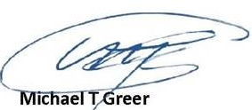

Fire Chief

Seeley Lake Rural Fire Department

406-677-2400

**Application for Membership**

**Seeley Lake Rural Fire Department**

**PO Box 309**

**Seeley Lake, Montana 59868**

**406-677-2400**

|  |  |  |  |  |  |
| --- | --- | --- | --- | --- | --- |
| **Position Applying For:** | Fire | EMS | | Fire/EMS | |
| **Section 1: Personal Data** | | | | | | | | | | | | |
| Name: Last, First, MI | | | | | | | Home Phone | | | | Cell Phone | |
| Street Address | | | | | | | City | | | | State | ZIP |
| Mailing Address | | | | | | | City | | | | State | ZIP |
| DOB (MM/DD/YY): | | | Email Address: | | | | | | | | | |
| Driver’s License Number: | | | | | | State: | | | Social Security Number: | | | |
| **Section 2: Employment** | | | | | | | | | | | | |
| **#1** | Current or Most Recent Employer: | | | | Month/Year Started: | | | | | Month/Year Ended: | | |
| Complete Address | | | | Reason For Leaving (If Applicable) | | | | | | | |
| Your Title or Position | | | | Name and Title of Supervisor | | | | | | | |
| Contact Phone Number | | | |
|  | Current Work Schedule: | | | | Will your employer let you leave in the event of an emergency? | | | | | | | |
|  |  | | | |  | | | | | | | |
| **#2** | Previous Employer: | | | | Month/Year Started: | | | | | Month/Year Ended: | | |
| Complete Address | | | | Reason For Leaving | | | | | | | |
| Your Title or Position | | | | Name and Title of Supervisor | | | | | | | |
| Contact Phone Number | | | |
| **Section 3: References**  **(Please list two persons that have known you for at least 3 years and are not previous employers, are not relatives, and do not live with you)** | | | | | | | | | | | | |
| **#1** | Name: | | | | | | | Complete Address: | | | | |
| How does this person know you? | | | | | | | Phone Number: | | | | |
|  |  | | | | | | |  | | | | |
| **#2** | Name: | | | | | | | Complete Address: | | | | |
| How does this person know you? | | | | | | | Phone Number: | | | | |

|  |  |  |  |  |  |  |
| --- | --- | --- | --- | --- | --- | --- |
| **Section 4: Education** | | | | | | |
| **#1** | Name of High School: | | | Diploma Received?  Y / N | | Year of Completion |
| **#2** | Name of College/University/Technical School | | | Degree or Certification | | Year of Completion |
| **#3** | Name of College/University/Technical School | | | Degree or Certification | | Year of Completion |
| **Section 5: Fire/Rescue/EMS Experience (If Applicable)** | | | | | | |
| **#1** | Current/Previous Fire/Rescue/EMS Affiliation: | | Membership Dates: | | Phone: | |
| Positions or Ranks Held: | | | | Contact Name: | |
| Previous Training (Please Include Certificates): | | Current Status or Reason for Leaving? | | | |
|  | | | | | | |
| **#2** | Current/Previous Fire/Rescue/EMS Affiliation: | | Membership Dates: | | Phone: | |
| Positions or Ranks Held: | | | | Contact Name: | |
| Previous Training (Please Include Certificates): | | Reason for Leaving | | | |
| **Section 6: Miscellaneous** | | | | | | |
| **YES** | **NO** | Place an “X” In the appropriate box. **If you answer yes to any of the questions, please attach or include an explanation with your application.** | | | | |
|  |  | Do you have any moving violations on your driving record in the last 3 years? | | | | |
|  |  | Have you ever been discharged from a job or organization for alleged misconduct or poor performance? | | | | |
|  |  | Have you ever been on, or applied for membership of the Seeley Lake Fire Department before? | | | | |
|  |  | Have you been turned down or discharged from membership in a Fire/Rescue/EMS organization before? | | | | |
|  |  | Are you currently a member of another volunteer fire department? | | | | |
|  |  | Do you outside of the Seeley Lake Rural Fire District boundaries? | | | | |
|  |  | Are you currently taking any prescribed medications? | | | | |
|  |  | Are you currently listed as disabled? | | | | |
|  |  | Do you have any personal limitations that may hinder you from doing strenuous physical labor? | | | | |
|  |  |  | | | | |
|  |  |  | | | | |

After receipt of this application, the Fire Chief will schedule an orientation and administration day to review SLRFD policies and procedures. At this time you will need to provide copies of your driver’s license and proof of current vehicle liability insurance.

|  |  |  |  |  |
| --- | --- | --- | --- | --- |
| **Section 6: Certification** | | | | |
| I certify that all the information on this application is accurate and complete to the best of my knowledge and I understand that misleading, false, incomplete or misrepresented statements will constitute sufficient cause for denying volunteer membership.  In consideration of acceptance as a volunteer, I agree to become thoroughly familiar with the ordinances, rules, policies, and by-laws of the Fire District, Fire Department and Fire Company and to comply with such rules and regulations  I authorize the Seeley Lake Rural Fire Department to investigate information concerning my education, employment experiences an all other aspects of my background relevant to my proposed volunteer position. I release the Seeley Lake Fire Department and its members from all liability arising from such investigation.  I certify that I have reviewed this application and that all information provided above is true and correct. | | | | |
| Signature: | | | | Date: |
|  | | | | |
| **FOR DEPARTMENT USE ONLY** | | | | |
| Attachment/Checks | Name | Date | Notes | |
| Copy of Driver’s License |  |  |  | |
| Copy of Vehicle Liability Insurance |  |  |  | |
| Signed Disclosure and Release Form |  |  |  | |
| CPR Card (If applicable) |  |  |  | |
| EMT/NREMT Certification (If applicable) |  |  |  | |
| Mandatory Minimums Met |  |  | Over 18, Diploma, w/in district, Driver’s License | |
| Driving Background Check |  |  |  | |
| Fire Recruit Conditional Offer Made |  |  |  | |
| Officer/Mentor Assigned |  |  |  | |
| Completion of Probationary Period |  |  |  | |
| Completion of Probationary Firefighter Task Book |  |  |  | |
| Full Membership Offer |  |  |  | |
|  |  |  |  | |
|  |  |  |  | |