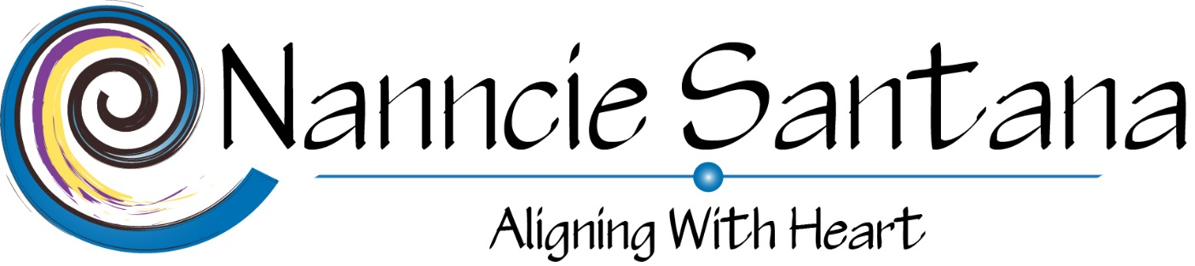

I, _________________________________________ understand that all information is held in strict confidentiality. It is very important that I build a strong sense of trust with Nanncie Santana LLC. If there is anything further I would like to discuss with Nanncie Santana LLC before the session or any boundaries that I would like to set to ensure I am comfortable and relaxed, I am aware I need to bring it to Nanncie Santana LLC’s attention prior to our sessions.
I understand that Nanncie Santana LLC is not to give legal, financial, or medical advice. I agree that I am solely responsible for any action that I take or refrain from taking in connection with the topics discussed during our session(s).
I have completed the Client Intake Form to the best of my ability, and I have disclosed any mental or physical health problems that may be pertinent to the safe facilitation of my sessions.

Please note: Nancy Santana/Nanncie Santana LLC is not a medical professional and cannot diagnose or treat any medical or psychological issues; I am also not a financial or legal advisor.
For legal reasons, this service is “for entertainment purposes only”.
​You control your own future and your choices and you have free will, taking certain actions can of course change the outcome.
I am not responsible for any actions you may take as a result of these sessions.
**Please note all sales on sessions, readings and reiki treatments are final, no refunds**
Nanncie Santana LLC

______________________________________________________/________/_______
Client’s Signature Date

