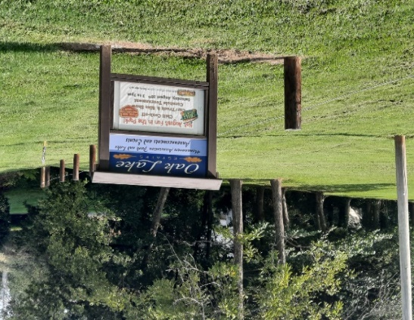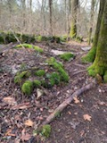
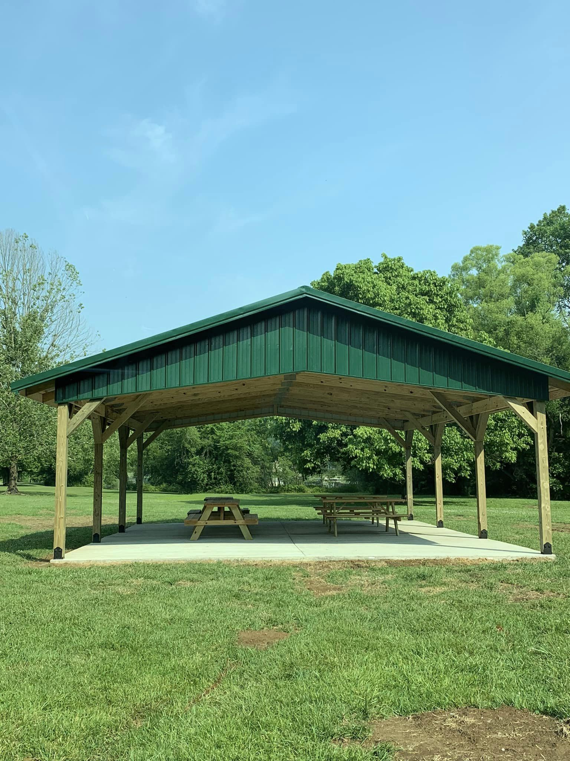
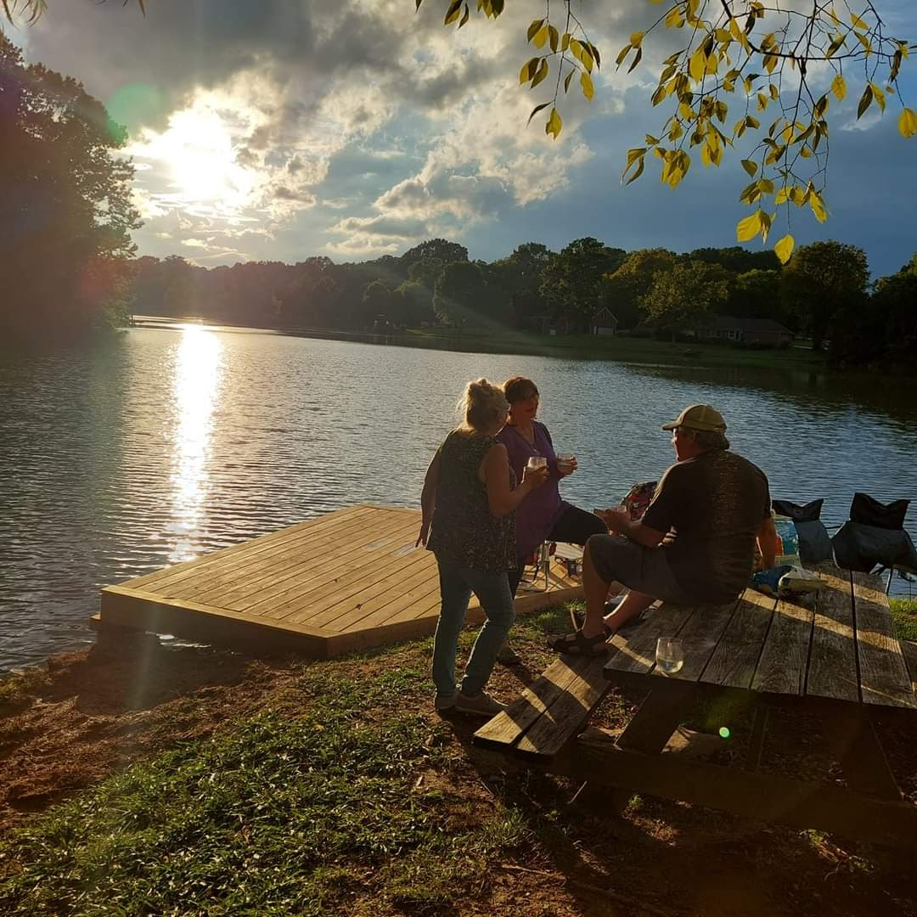
Annual Dues pay for upkeep of our community landscape and Big Oak Park and Lake…

We are a privately run neighborhood HOA!
Pavilion for Events and
Member use
Community Events
Members access to
Dock and Boat Launch
Oak Lake Estates Homeowners Association

Be a part of the Lake Community!
Enjoy unlimited access to our
gorgeous 5-acre Park and enjoy
Big Oak Lake and our Nature Trail

Great Fishing!

Big Oak
Nature Trail
See more fun community photos at our website - Olehoa.com
Contact us at olehoaboard@gmail.com
for more information!
Kayaking and Beautiful Sunsets!

