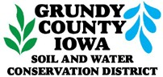

# JOB VACANCY ANNOUNCEMENT

**Position Title: Project Coordinator, Grundy County**

(Full-time, grant funded position through September 30, 2023)

**Location:** Grundy Center, Iowa

**Contact:** Grundy Soil & Water Conservation District (SWCD) 805 West 4th St

Grundy Center, IA 50638

Phone: (319) 824-3634 ext. 3 Fax: (866) 255-6697

**Hours:** Full-time, 40 hours per week (no overtime) **Number of openings:** (1) One

**Opens**: June 12, 2020 **Closes:** July 10, 2020

# Method of application: Submit a resume and cover letter to the Grundy SWCD by 4:30 p.m. on July 10, 2020.

**Job Description:** Lead activities focused on planning and development of approaches that will inform, prioritize and coordinate implementation of conservation practices in the Black Hawk Creek Watershed within Grundy and Black Hawk Counties. These practices include wetlands, saturated buffer, bioreactors, cover crops, reduced tillage, and nutrient management. Work effectively with partners and area producers/landowners to identify opportunities, funding sources and feasibility for installation of Iowa’s Nutrient Reduction Strategy (NRS) practices in a targeted and cost-effective manner. Maintain and develop new public- private partnerships to support watershed activities. Outreach to watershed community through press releases, newsletters, community presentations, and field days. Efforts will focus on positioning planning efforts within the project area for efficient transition to practice implementation phase at the conclusion of the grant.

**The successful candidate should:** Have knowledge of principles, practices, terminology, and techniques of agricultural science related to nutrient management, water quality, and soil conservation. Have knowledge of state, federal, and local environmental laws and regulations. Demonstrate knowledge of the Iowa Nutrient Reduction Strategy. Utilize Geographic Information Systems (GIS). Have the ability to generate computer reports and educational materials. Possess skills in interpersonal relationships i.e., motivation, written and verbal communications with producers and partners to meet their needs in a courteous and cooperative manner. Display high standards of ethical conduct. Commit to quality service. Display a high level of initiative and commitment. Work with minimal supervision. Demonstrate responsible behavior and attention to detail. Follow policy and cooperate with supervisors. Market, organize, and conduct public outreach programs to inform watershed landowners and producers of available funding to address their resource concerns.

**Required Education:** A degree from an accredited college or university with major coursework in an agricultural or environmental science field is preferred. However, a two-year degree and/or two years of equivalent experience will also be considered.

Coursework in marketing, public relations, and agricultural or environmental science would be beneficial.

**Wage**: $22.69/hr - $34.22/hr commensurate with experience

**Benefits**: IPERS retirement contributions, paid state holidays, and compensated time off are provided. Telework will be an option during the COVID-19 pandemic. No health insurance is provided.

**Job Qualifications:** Applicant should be a detail orientated individual with the ability to work independently and prioritize work schedule. Applicant needs good communication skills, both verbal and written. Knowledge of Arc GIS software, engineering equipment, and agricultural practices beneficial. Need to possess a valid driver’s license. Successful candidate will need to undergo a Federal background investigation and fingerprint check.

**Working Conditions:** Job will occasionally require walking through rough terrain and/or inclement weather conditions along with carrying equipment. Some evening work may be required.

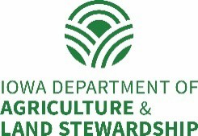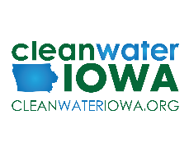

Grundy Soil & Water Conservation District is an Equal Opportunity Employer and Provider