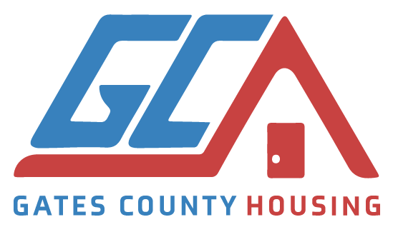
2025-2026 GATES COUNTY HOUSING COMMITTEE
COMMISSIONER REPORT
July 1, 2025 – March 26, 2026
- Urgent Repairs:
  - Work completed on 5 homes:
    - Windows, Floors
    - Front & Back Doors, Steps, Ramp Boards
    - Roof
    - Kitchen
    - Porch
    - Electrical, Duct Work
  - 1 Home in progress
- Pending Repair List:
  - 2 clients – Admin waiting for their response to additional info before starting work
  - 6 approved and waiting for contractors
- Waiting List:
  - 14 Homes
- Referral Agencies – 3 referred
  - Albemarle Commission
- Fundraising Strategies Implemented:
  - Giving Tuesday
  - Roanoke Chowan Foundation Grant
  - NC Saves Program
- Marketing:
  - Web page live: https://Gchousingcomm.org
  - Pending: Dept. of Social Services Farmer Market Resource Table
  - Pending: Gatesville Dragons – Spring Fling
- Meet monthly, 4th Monday from 1:00 – 2:00 via Zoom and in-person

Submitted by Reba Green-Holley, Chairperson, 3.26. 2026

