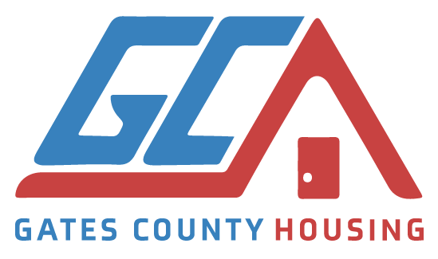
2021-2022 COMMISSIONER HOUSING REPORT
Summary of activities from operating year January 1, 2021 – December 31, 2021:
- Received 13 housing repair request applications
- 2 not qualified for service
- 4 referred to State grant funds – Barnette and Associates
- 1 referred to EIC
- 2 Tarp installed on roof
- 2 Roof repaired
2 referred to Upgrade to Save REA
1 referred to Independent Living
- COVID-19 shutdown services. A limited number needing assistance have started contacting the Housing Committee for assistance. State and local health guidelines were and still are being followed.
- Have served as a sounding board for client complaints concerning status of Replacement Grant applicants’ homes by McDavid and Associates.
- Secured two volunteers to assist with small home repairs.
- Collaboration with Roanoke Electric:
  - Referral of Roanoke Electric Cooperative member-owners to the Upgrade 2 $ave or SolarShare Program.
- Received church donations.
- Developed and implementing comprehensive marketing and branding plan to increase awareness of housing assistance, housing resources and improve/increase fundraising efforts. Web page has gone live. https://Gchousingcomm.org
- Donation strategies are in the process of being implemented: PayPal, Amazon Smile.
- Meet monthly, 3rd Monday from 1:00 – 2:00 via Zoom.

Membership list attached.
Submitted by Reba Green-Holley, Chairperson, March 16, 2022

