BHUSRA MAHILA VIKASH SAMITI

Annual report 2023 - 2024

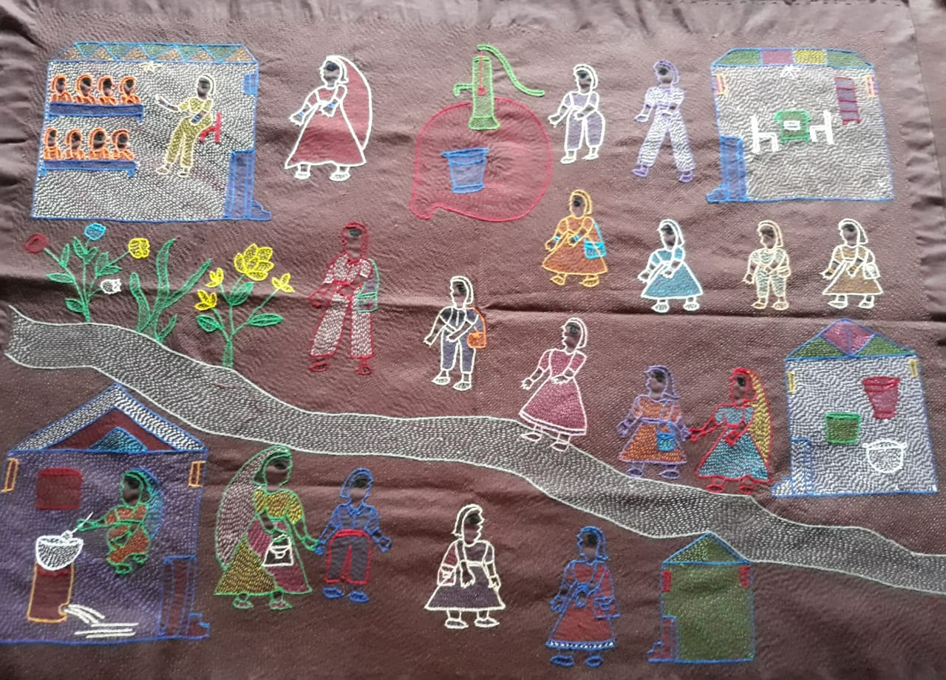

**Head office Administrative office Bhusra Mahila Vikash Samiti Bhusra Mahila VikashSamiti**

**Village- Bhusra, P.O.- Hasna, Shivpuri , Lane no. 1**

**Dist.- Muzaffarpur Damuchauk, Muzaffarpur**

**Mob.No- 9973245342 / 9939390981 Mob.No- 9973245342 / 9939390981**

**E-mail –** [bmvs2003@gmail.com](mailto:bmvs2003@gmail.com" \t "_blank) **E-mail –** [bmvs2003@gmail.com](mailto:bmvs2003@gmail.com" \t "_blank)

**INTRODUCTION**

**Mr. Kailash Prasad Singh, Secretary, Bhusra Mahila Vikash Samiti (BMVS) had his initiation into social work as a staunch Sarvodayi in 1966. Having stayed a close associate of Shri Vinoba Bhave for 12 years, he joined Vanwasi Sewa Kendra in 1978, a reputed NGO working amidst, Dalit and Tribal women in Sasaram and Rohtas districts of Bihar with income enhancing opportunities for women as the key focus of its work. Driven by the plight of his native place, he returned to his village Bhusra in 1988 and** **collectively decided to form an organisation as a Bhusra Mahila Vikas Samiti ( A women dominant NGO).** **Over three decades, the organization enabled over 55,000 women to transform their lives, and protected around 25,000 vulnerable children from child protection issues. We believe that leadership comes from within the most affected communities.**

**Vision :-**  **The organization envisions the establishment of a society based on principles of equity, justice and human dignity.**

## MISSION :-

## It stands for the economic and social empowerment of the poor women and children to ensure their effective and equitable participation in the social mainstream.

## TARGET GROUP :-

**The target group of the organization primarily consists of the socially and economically exploited women and children particularly from the scheduled caste, ST, muslim and backward castes.**

**Geographical reach**

|  |  |  |  |  |
| --- | --- | --- | --- | --- |
| District | Block | Panchayat | Village | Ward |
| Sitamardhi | Runnisaidpur | 6 | 15 | 30 |
|  | Nanpur | 4 | 5 | 25 |
|  | Belsand | 2 | 3 | 5 |
|  | Bokhra | 2 | 2 | 2 |
|  | Pupari | 4 | 4 | 4 |
| Muzaffarpur | Gayaghat | 4 | 4 | 12 |
|  | Katra | 4 | 4 | 12 |
| Darbhanga | Jale | 5 | 10 | 30 |

Organisational profile

|  |  |  |
| --- | --- | --- |
| **1** | Name of the organization | BHUSRA MAHILA VIKASH SAMITI |
| **2** | Year and type of registration (whether society, trust, Sec.25 company or other). | Registered under Indian Trust Act, 1882  Reg. No. 1 dated 18.10.1996 |
| **3** | Name of the Chief Functionary of the Organisation | Shri Kailash Prasad Singh (Secretary)  Mobile No. 9973245342 |
| **4** | Contact Person & Address of the Administrative Office of the Organization | Dr. Punam Kumari ( programme head)  Shivpuri, Lane No.01 ,Damuchak,  Muzaffarpur (Bihar) Pin – 842001  Mobile No. 09939390981, 09973245342  [bmvs2003@gmail.com](mailto:bmvs2003@gmail.com) ,Website.- bmvsindia.org |
| **5** | Address of the Registered Office of the  Organization | Village – Bhusra, P.O. – Hasna,  Via- Bochahan,District-Muzaffarpur,  State – Bihar (India) Pin- 843103 |
| **7** | FCRA No. with year of FCRA registration & Renewal Date | 031140012 dated 24.04.2001  **18.12.2021** |
| **8** | Income Tax Regn. No. under Section 12A | 3698-700 |
| **9** | PAN No. of the Organisation | AAATB4609E |
| **10** | TAN no. | PTNB05526D |
| **11** | DARPAN Reg. No. | BR/2017/0/178609 |

|  |  |  |  |
| --- | --- | --- | --- |
| **Organization Turn-over for last 3 years (as per audit reports)** | Year | **Receipts (in Rs.)** | **Payments (in Rs.)** |
| 2023- 2024 | 3289787 | 3064175 |
| 2022-2023 | 4228408 | 2607345 |
| 2021-2022 | **5059437** | **3701260** |

## PROJECT GOAL :- Children and families vulnerable to debt bondage and child labour are linked tohealthcare insurance, livelihoods and education schemes with the support of DCPUand panchayats

**Project Objective**

* Families of children at risk of child labour to healthcare insurance/ free healthcare.
* Connect families of children at risk of child labour to livelihood/income-generating opportunities.
* Connect children at risk of child labour to education benefits that help keep them in school.
* State-level activities to support a functioning child protection safety net.

**activities**

* Coordination meeting with PRI was conducted at Panchayat level.
* Community level and Block level interface meeting was conducted with stakeholders and community/CVC.
* Block level stakeholder meeting was conducted in which CSC operator, BPM, ASHA, DPM, community and champion members participated.
* A coordination meeting was held with BPM and CM at the block level.
* A review meeting was held with DPM.
* A coordination meeting was held with PRI and CLM at the Panchayat level.
* Identification of pockets vulnerable to debt bondage / child labour throughout the district and facilitating camps through the Block Development Officer to the PRI.
* Demand generation and creation of golden cards and E-shram cards through groups affected by child labour, child and adolescent groups, PRIs, DCPU throughout the Panchayat.
* Support the district in developing an action plan for disseminating PM-Jay through vulnerable pockets and get it ratified by DCPU.
* Interface between communities and PM-Jay stakeholders (Ongoing meeting for increasing the Ayushman card registration and services in the scheme)
* Strengthen district-level systems to ensure last-mile delivery of PM-Jay through integration into GPDP.
* Through PRA exercise and with the involvement of Jeevika Didi, Ward member or CPC develop a list of vulnerability indicators that are ratified by DCPU.
* Support the State in Integrating the child protection indicators in the NRLM framework so that families of at-risk children receive employment.
* Roll-out this process and assess how SHGs and CPCs can coordinate to protect employment to vulnerable children.
* Partners and CVCs support the District Administration in developing guidelines / toolkit on enrolment drives including specific focus on boys, girls and children from SC/ST, CWSN in the age group of 6-18 are enrolled in school by SMCs and SMDC and to ratified by DCPU and supported by panchayats.
* Partners support the District Education Department in rolling out training modules for SMCs and SMDCs and this is ratified by DCPU.
* Partners work with the district to ease access timely access to entitlements by resolving DBT issues.
* Support the DCPU and District Education authorities in sending needs to the State on how to retain children who drop out repeatedly.
* Partners support Gram Panchayats to allocate and utilize funds towards child labour reduction.
* State level consultations between Departments and communities to build support for recommendations for improving access to social protection
* Support Gram Panchayats to allocate and utilize funds towards child labour reduction

**ACHIEVEMENTS :-**

* Regular meetings of CPC have started at the block level.
* Child protection issues were included in 4 panchayats and budget provision was also made.
* **Aware the 80%community of child protection issues**
* **Empowered the 56 CVC & 80 champions’ members.**
* A circular was issued at the district level to ensure 100% enrollment of the above mentioned children, in which the accountability of the SMC was ensured.
* A letter was issued by the district to ensure that Dalit, Scheduled Caste and vulnerable children who are victims of child labour are enrolled in school.
* 1499 vulnerable children have been enrolled in school, of which 772 are girls and 727 are boys.¬
* 1052 children who were not getting DBT and other benefits have also got benefits with the help of champion members. Children are going to school regularly.
* 232 vulnerable families were able to join Jeevika. Children of all these families are going to school regularly. Their income is more than 7000. They now make other people aware about child labour.
* A circular was also issued by the civil surgeon.
* 2861 people in the targeted community registered for Ayushman card and got the golden card. Because there was coordination with Swasthya Swachhta Mission, due to which they got 5 kg of sarees along with the card.
* 11 people of the community who were ill, got their treatment done through Ayushman card due to which they did not have to take loan for treatment. Treatment cost per person up to Rs. 35,000.
* After the steps taken at community, panchayat, block and district level by the community, CVC and champion members for Ayushman Card, camps started being organized among the community.
* Protecting and saving our children from child labour by using Ayushman Card during treatment is a big success.¬
* CVC has been strengthened in the community and collective leadership has developed.¬
* 24 ward level CPC meetings have started.
* 6 Panchayat level CPC meetings have started.¬
* With the help of BMVS HLN, data of all districts was compiled and analysis report was prepared for state level which was also presented by BMVS in state level workshop.
* The district level report was given by the district level. After that a WhatsApp group was created by DPC Ayushman in the name of PMJAY CSC Sitamarhi on (03.07.2023), in which the workers of BMVS were also added, another group PMJAY Camp Sitamarhi was also created on 20 August, in which members of CVC were also added. CVC members and workers of BMVS were also added to this group. A circular was also issued by the Civil Surgeon. Due to which a total of 3091 Ayushman cards were made..

**Impact**

* **For the safety of the children, a circular has been issued by the Education Department, under which instructions have been given for the orientation related to the enrollment, stay, entitlement and formation of SMC, rights and duties of the children.**
* **For the safety of the children, a suggestion letter was given by the champion members at the district level, after that a circular came out from the DCPU, in which instructions have been given for the Panchayat and ward level CPC by fixing the date for the formation and training of BCPC in all the blocks. The works have also been executed in the light of the above circular.**

**ORGANIZATIONAL HUMAN RESOURCES:-**

* BMVS presently has team strength of 6 full time staff and the remaining 3 are involved in administrative work.

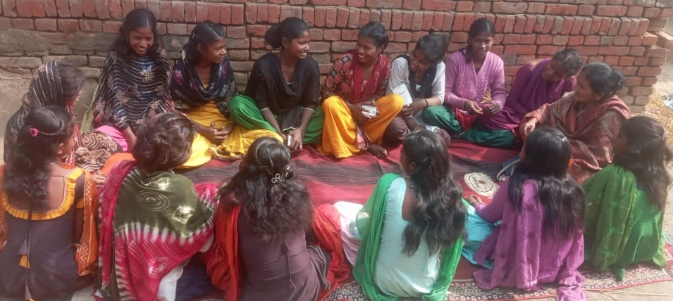 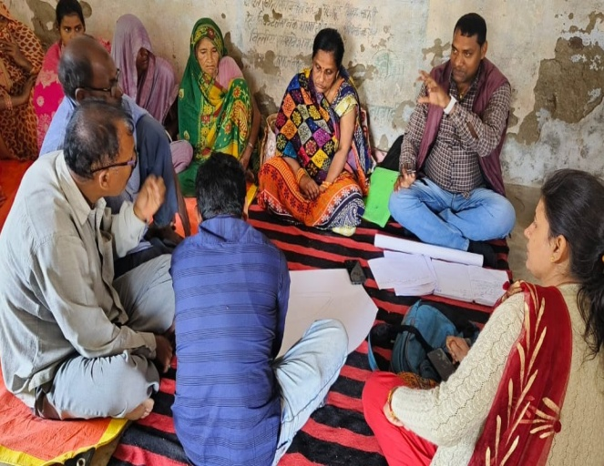

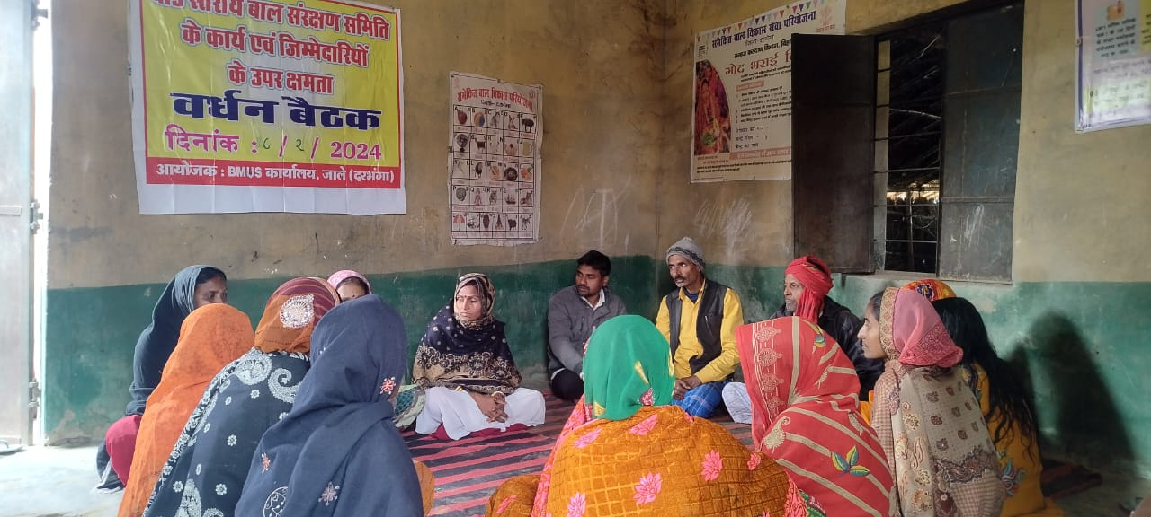

**THANKS**