BHUSRA MAHILA VIKASH SAMITI

Annual report 2022 - 2023

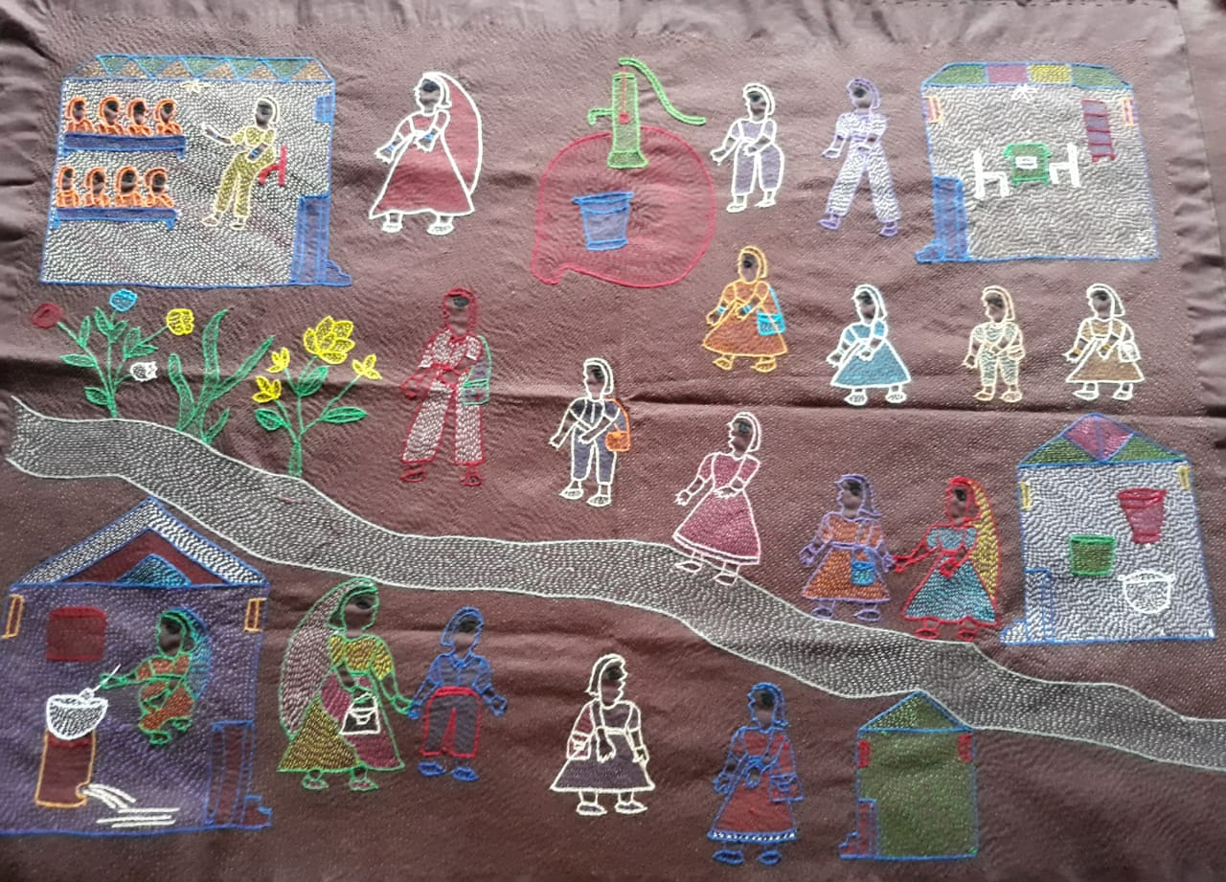

**Head office Administrative office Bhusra Mahila Vikash Samiti Bhusra Mahila VikashSamiti**

**Village- Bhusra, P.O.- Hasna, Shivpuri , Lane no. 1**

**Dist.- Muzaffarpur Damuchauk, Muzaffarpur**

**Mob.No- 9973245342 / 9939390981 Mob.No- 9973245342 / 9939390981**

**E-mail – [bmvs2003@gmail.com](mailto:bmvs2003@gmail.com" \t "_blank)**  **E-mail – [bmvs2003@gmail.com](mailto:bmvs2003@gmail.com" \t "_blank)**

**INTRODUCTION**

**Mr. Kailash Prasad Singh, Secretary, Bhusra Mahila Vikash Samiti (BMVS) had his initiation into social work as a staunch Sarvodayi in 1966. Having stayed a close associate of Shri Vinoba Bhave for 12 years, he joined Vanwasi Sewa Kendra in 1978, a reputed NGO working amidst, Dalit and Tribal women in Sasaram and Rohtas districts of Bihar with income enhancing opportunities for women as the key focus of its work. Driven by the plight of his native place, he returned to his village Bhusra in 1988 and** **collectively decided to form an organisation as a Bhusra Mahila Vikas Samiti ( A women dominant NGO).** **Over three decades, the organization enabled over 55,000 women to transform their lives, and protected around 25,000 vulnerable children from child protection issues. We believe that leadership comes from within the most affected communities.**

**Vision :-**  **The organization envisions the establishment of a society based on principles of equity, justice and human dignity.**

## MISSION :-

## It stands for the economic and social empowerment of the poor women and children to ensure their effective and equitable participation in the social mainstream.

## TARGET GROUP :-

**The target group of the organization primarily consists of the socially and economically exploited women and children particularly from the scheduled caste, ST, muslim and backward castes.**

**Geographical reach**

|  |  |  |  |  |
| --- | --- | --- | --- | --- |
| District | Block | Panchayat | Village | Ward |
| Sitamardhi | Runnisaidpur | 6 | 15 | 30 |
|  | Nanpur | 4 | 5 | 25 |
|  | Belsand | 2 | 3 | 5 |
|  | Bokhra | 2 | 2 | 2 |
|  | Pupari | 4 | 4 | 4 |
| Muzaffarpur | Gayaghat | 4 | 4 | 12 |
|  | Katra | 4 | 4 | 12 |
| Darbhanga | Jale | 5 | 10 | 30 |

Organisational profile

|  |  |  |  |  |
| --- | --- | --- | --- | --- |
| **1** | Name of the organization | | BHUSRA MAHILA VIKASH SAMITI | |
| **2** | Year and type of registration (whether society, trust, Sec.25 company or other). | | Registered under Indian Trust Act, 1882  Reg. No. 1 dated 18.10.1996 | |
| **3** | Name of the Chief Functionary of the Organisation | | Shri Kailash Prasad Singh (Secretary)  Mobile No. 9973245342 | |
| **4** | Contact Person & Address of the Administrative Office of the Organization | | Dr. Punam Kumari ( programme head)  Shivpuri, Lane No.01 ,Damuchak,  Muzaffarpur (Bihar) Pin – 842001  Mobile No. 09939390981, 09973245342  [bmvs2003@gmail.com](mailto:bmvs2003@gmail.com) ,Website.- bmvsindia.org | |
| **5** | Address of the Registered Office of the  Organization | | Village – Bhusra, P.O. – Hasna,  Via- Bochahan,District-Muzaffarpur,  State – Bihar (India) Pin- 843103 | |
| **7** | FCRA No. with year of FCRA registration & Renewal Date | | 031140012 dated 24.04.2001  **18.12.2021** | |
| **8** | Income Tax Regn. No. under Section 12A | | 3698-700 | |
| **9** | PAN No. of the Organisation | | AAATB4609E | |
| **10** | TAN no. | | PTNB05526D | |
| **11** | DARPAN Reg. No. | | BR/2017/0/178609 | |
| **12** | **Organization Turn-over for last 3 years (as per audit reports)** | Year | **Receipts (in Rs.)** | **Payments (in Rs.)** |
| 2022-2023 | 4228408 | 2607345 |
| 2021-2022 | **5059437** | **3701260** |
| 2020.2021 | **5215176** | **6055137** |

## PROJECT GOAL :- Children and families vulnerable to debt bondage and child labour are linked tohealthcare insurance, livelihoods and education schemes with the support of DCPUand panchayats

**Project Objective**

* Families of children at risk of child labour to healthcare insurance/ free healthcare.
* Connect families of children at risk of child labour to livelihood/income-generating opportunities.
* Connect children at risk of child labour to education benefits that help keep them in school.
* State-level activities to support a functioning child protection safety net.

**activities**

* Identification of pockets vulnerable to debt bondage / child labour throughout the district and facilitating camps through the Block Development Officer to the PRI.
* Demand generation and creation of golden cards and E-shram cards through groups affected by child labour, child and adolescent groups, PRIs, DCPU throughout the Panchayat.
* Support the district in developing an action plan for disseminating PM-Jay through vulnerable pockets and get it ratified by DCPU.
* Interface between communities and PM-Jay stakeholders (Ongoing meeting for increasing the Ayushman card registration and services in the scheme)
* Strengthen district-level systems to ensure last-mile delivery of PM-Jay through integration into GPDP.
* Through PRA exercise and with the involvement of Jeevika Didi, Ward member or CPC develop a list of vulnerability indicators that are ratified by DCPU.
* Support the State in Integrating the child protection indicators in the NRLM framework so that families of at-risk children receive employment.
* Roll-out this process and assess how SHGs and CPCs can coordinate to protect employment to vulnerable children.
* Partners support SRLM / NRLM to ensure that SHG groups work actively to reduce the prevalence of child labour.
* Partners and CVCs support the District Administration in developing guidelines / toolkit on enrolment drives including specific focus on boys, girls and children from SC/ST, CWSN in the age group of 6-18 are enrolled in school by SMCs and SMDC and to ratified by DCPU and supported by panchayats.
* Partners support the District Education Department in rolling out training modules for SMCs and SMDCs and this is ratified by DCPU.
* Partners work with the district to ease access timely access to entitlements by resolving DBT issues.
* Support the DCPU and District Education authorities in sending needs to the State on how to retain children who drop out repeatedly.
* Follow up with district and State-level authorities to provide evidence and feedback of how orders / directives are being implemented
* Partners support Gram Panchayats to allocate and utilize funds towards child labour reduction.
* State level consultations between Departments and communities to build support for recommendations for improving access to social protection
* Support BRLPS-Jeevika / NRLM to ensure that SHG groups work actively to reduce the prevalence of child labour
* Support Gram Panchayats to allocate and utilize funds towards child labour reduction
* Support State efforts to make CPCs functioning more effective by working with NCPCR, SCPCR, SCPS, SLSA, HCJJ, tangibly reducing child vulnerability.

**ACHIEVEMENTS :-**

* **Aware the 60%community of child protection issues**
* **Empowered the 36 CVC & 80 champions’ members.**
* **Organized the monthly meeting. Collective decision under group meeting.**
* **CBOs have started putting his issue in front of the local governance and block level officers.**
* **CBOs have started identifying its problems and working towards a solution by making a micro plan.**
* **CVC champion member support the community for reducing the child labor.**
* **Regular meeting organized the CPC, BCPC in target Block and Panchayat**
* **CSC, Panchayati Raj Executive Assistant for the successful operation of Ayushman Bharat Pradhan Mantri Jan Arogya Yojana. In collaboration with volunteers, SHGS, a circular was issued to organize camps at village, ward, panchayat level.**
* **Camps started in the entire district, 65 camps were organized in the targeted area, in which 9323 people have got a golden card. 45 people have also been treated**
* **Camp was organized in Anganbari center and school for COVID Vaccine. 23735 people took the vaccine.**
* **6895 children’s have been admitted to middle school ( 1 to 5 class ) from target community.**
* **15866 children who were not getting DBT and other benefits have also got benefit with the help of champion members. Children are going to regular school and their KYC has also been done.**
* **Champion member and CVC have put the issues to admission and DBT benefit of children through the media.**
* **Champion member and CVC meet with district Education officer and put up the issues of starting admission, DBT benefit and studying for children’s**
* ***The champion member helped in KYC the bank account to give the benefit of DBT* to children’s.**
* **A circular was drawn from the district level on all the above issues (in the light of the letter of the Minister).**
* **All the suggestions given by the community have been included in the circular.**
* **SMC has been formed in all the schools and their monthly meeting has also started.**
* **After the suggestion of the champion members, a circular was issued by the DCPU immediately after that month's meeting of the DCPU, in which guidelines were given for orientation training, formation and regular meeting of the CPC at the block level.**
* **In all the 17 blocks, the training and formation of CPC at the block level has been done, in which BMVS representatives in 4 blocks also participated along with the DCPU.**
* **The list / form of 44 Vulnerable community children whose parents or any one had died during Kovid was submitted to the District Child Protection Unit with the help of CPC and Champion at the ward level, whose entire process has been completed. .**
* **1403 Survivors Supported from Live to Business**
* **All Survivors have started their own business.**
* The community was made aware of MNREGA job cards and jobs in their respective wards by champion members. Community applied for job card and job at panchayat level
* Women members of Freedom Group applied for jobs
* Under MNREGA, people of the community used to make oral applications for job, due to which people did not get work.The machine was used in the work of transporting soil.
* Very few women got work.The job card was kept with the Panchayat Representative.But in these six months, women have also got work.People of the community have given written applications and they have also got work.
* The community applies in the panchayat, and then their job cards are made. Women have also started getting work.The job cards are now with the job card holder andwages paid.
* **Group leadership has developed in the community.**
* **Children are going to school, income has also increased by joining business, due to treatment with Ayushman card, loan did not have to be taken.**

**Impact**

* **A circular was issued from the district, due to which cards were made for Ayushman Bharat Golden Card through camps in all the blocks of the district.**
* **For the safety of the children, a circular has been issued by the Education Department, under which instructions have been given for the orientation related to the enrollment, stay, entitlement and formation of SMC, rights and duties of the children.**
* **For the safety of the children, a suggestion letter was given by the champion members at the district level, after that a circular came out from the DCPU, in which instructions have been given for the Panchayat and ward level CPC by fixing the date for the formation and training of BCPU in all the blocks. The works have also been executed in the light of the above circular.**
* **For the safety of the children, a suggestion letter was given by the champion members at the district level, after that a circular came out from the DCPU, in which instructions have been given for the Panchayat and ward level CPC by fixing the date for the formation and training of BCPU in all the blocks. The works have also been executed in the light of the above circular.**

**ORGANIZATIONAL HUMAN RESOURCES:-**

* BMVS presently has team strength of 6 full time staff and the remaining 3 are involved in administrative work.

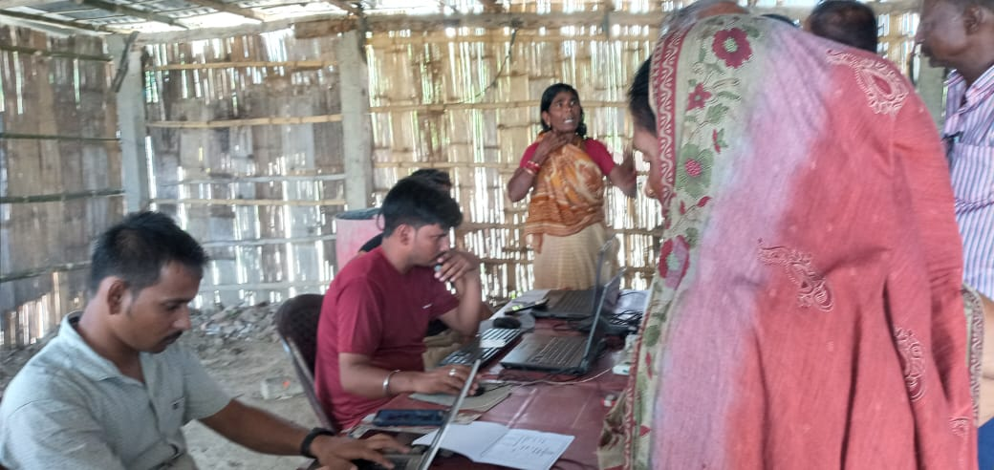 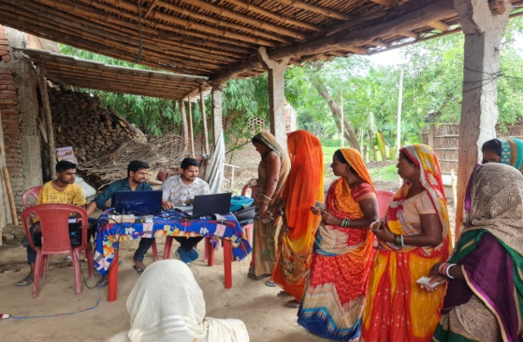

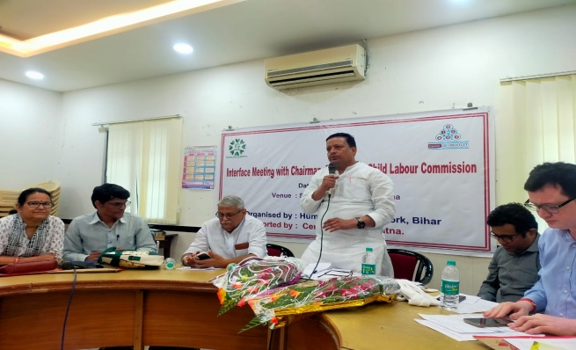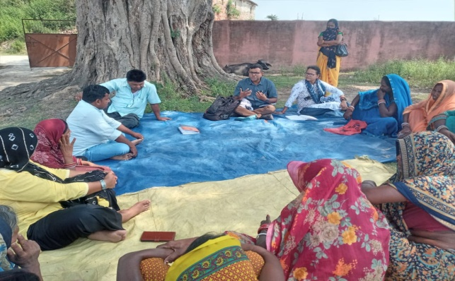

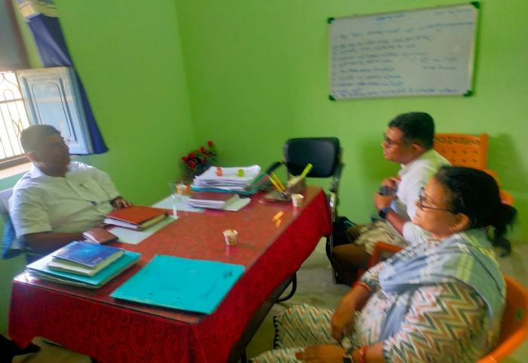 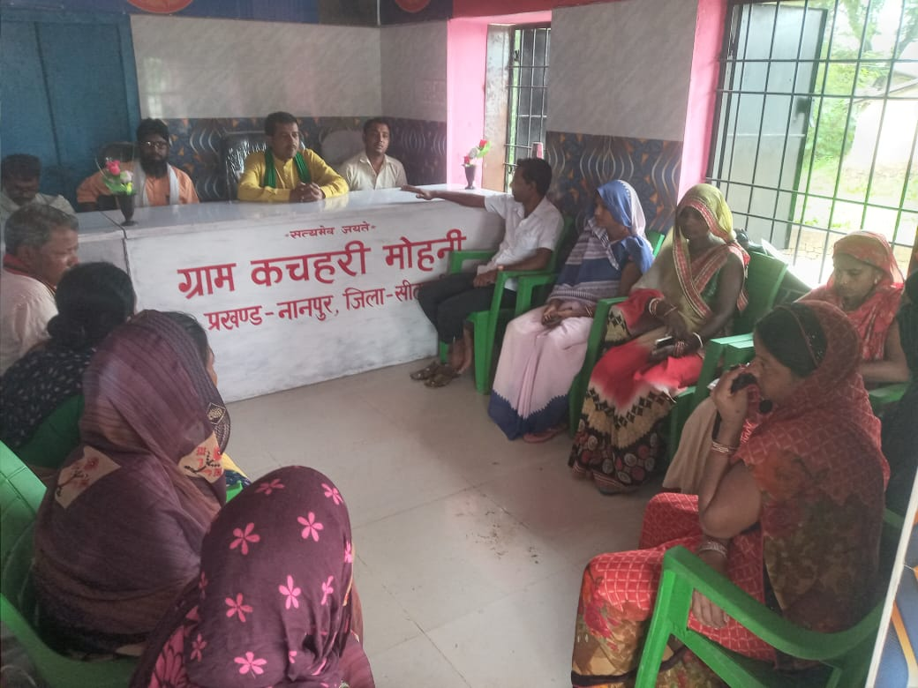

## Thanku

## 