Round 1 – General Knowledge
1 point for each

1) | Which American novelist’s works include A Perfect Stranger, Fine Things and Family Ties?  Danielle Steel
2) | What was the name of the boy whose toys came alive in the ‘Toy Story’ films?  Andy
3) | What is the capital of Cyprus?  Nicosia
4) | Which John Steinbeck work tells the story of George Milton and Lennie Small?  Of Mice and Men
5) | How many lines are there in a limerick?  5
6) | What is the capital city of Bulgaria?  Sofia
7) | Who has been married to Penny Calvert, Anthea Redfern and Wilnelia Merced?  Bruce Forsyth
8) | According the proverb, who is not recognised in his own land?  A prophet
9) | On Good Friday 1930, what unusual statement did the BBC radio service make about the news?  They said "There is no news" and then piano music followed.

Round 2 – Movie Quotes & Characters
For each quote, name the film and the character who said the quote
1 point for the film, 1 point for the character

1 i) | "Dead or alive, you're coming with me"  Film: Robocop | ii) | Character: Robocop / Alex Murphy
2 i) | "Two Rogers don't make a right"  Film: Gone in Sixty Seconds | ii) | Character: Memphis Raines
3 i) | "I know now why you cry"  Film: Terminator 2: Judgement Day | ii) | Character: The Terminator / T800 (no point for "Arnie"!)
4 i) | "What's the matter with you? Is this what you've become? A Hollywood finocchio who cries like a woman?"  Film: The Godfather | ii) | Character: Don Corleone (no point for just "the Godfather"!)
5 i) | "May I ask why you felt little Tiffany deserved to die?"  Film: Men in Black | ii) | Character: Zed / Z
6 i) | "Go ahead, make my day"  Film: Sudden Impact (not "Dirty Harry" or "Dirty Harry III"!) | ii) | Character: Dirty Harry / Harry Callahan
7 i) | "Hey Phil, if you're gonna spew, spew into this"  Film: Wayne's World (not "Wayne's World 2"!) | ii) | Character: Garth / Garth Algar
8 i) | "Put the bunny back in the box"  Film: Con Air | ii) | Character: Cameron Poe
9 i) | "Listen, I don't mean to be a sore loser but when it's done, if I'm dead, kill him"  Film: Butch Cassidy & The Sundance Kid | ii) | Character: Butch Cassidy
10 i) | "That's a Smith & Wesson. And you've had your six"  Film: "Dr No" | ii) | Character: James Bond / 007

Round 3 – Connections

1) | What does Wikipedia define as "..."an error, flaw, failure or fault in a computer program or system that causes it to produce an incorrect or unexpected result, or to behave in unintended way"  Bug / software bug
2) | What word, which defines a specific sport, practice or skill, derives from the Latin word arcus?  Archer
3) | Which American child star died in 2014, aged 93?  Mickey Rooney
4) | Which American literary character first appeared in a work by Mark Twain in 1876?  Tom Sawyer
5) | In Balmedie, Scotland, who recently pissed off local residents by building a wall around his golf course and then sent local residents the bill?  Donald Trump
6) | What mythical creature is half lion, half eagle?  Griffin
7 - Connection) | Cartoon characters  Bug (Bugs Bunny)  Archer (Archer)  Mickey Rooney (Mickey Mouse)  Tom Sawyer (Tom from Tom & Jerry)  Donald Trump (Donald Duck)  Griffin (Peter Griffin from Family Guy)

Round 4 – Science & Technology
1 point for each

1) | How many moons does Mars have? (1 point for correct number, 1/2 point each if you can name them) | Phobos (½) | Deimos (½)
2) | In what year was the original Nintendo Game Boy released?  1989
3) | What do you call something that speeds up a chemical reaction without being consumed in the reaction?  Catalyst
4) | The first proper clinical trial was conducted by James Lind in 1747 to investigate which disease?  Scurvy
5) | What percentage of the air is Nitrogen? (1% either way)  78%
6) | What year did Apple's App Store debut?  2008
7) | What did newspaper editor Christopher Latham Sholes patent in 1876 that still helps millions upon millions of people around the world communicate today?  QWERTY keyboard layout
8) | What do you call those little metal or plastic bits at the end of a shoelace?  An aglet

Round 5 – History

1) | James Earl Ray was responsible for who's death in 1968?  Martin Luther King
2) | Which major British newspaper closed down for almost a year in 1978?  The Times
3) | What were Benjy and Laska, which were sent into space in 1958?  Mice
4) | Who was the biggest selling female artist in America in the 1990s?  Mariah Carey
5) | In 1964, which was the 1st pirate radio station to start broadcasting in Britain?  Radio Caroline
6) | Which cathedral was badly damaged by lightning in July 1984?  York Minster
7) | In which harbour did an explosion take place aboard the Greenpeace ship Rainbow Warrior in 1985?  Auckland
8) | What year was the Arab Israeli six-day war?  1967
9) | Which coin was introduced in Britain in October 1969?  50 pence piece
10) | Why was Louise Brown famous in 1978?  She was the first test-tube baby

Name the Famous Person

1 | 2 | 3 | 4
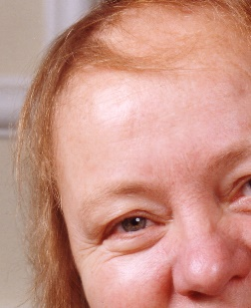 | 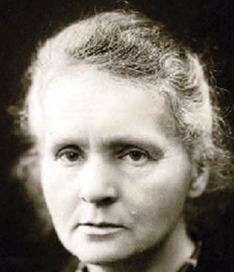 | 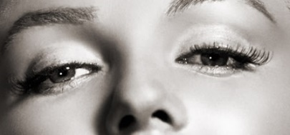 | 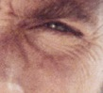
Mo Mowlam | Marie Curie | Marilyn Monroe | Clint Eastwood
5 | 6 | 7 | 8
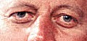 | 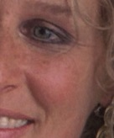 | 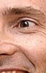 | 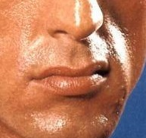
John F Kennedy | Glenn Close | David Tennant | Sylvester Stallone
9 | 10 | 11 | 12
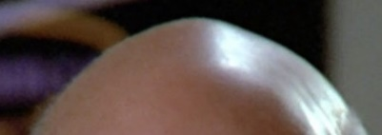 | 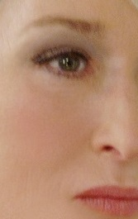 | 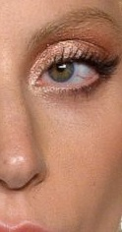 | 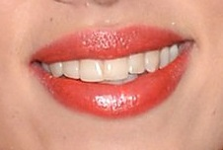
Patrick Stewart | Meryl Streep | Lady Gaga | Scalrett Johansson
13 | 14 | 15 | 16
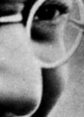 |  |  | 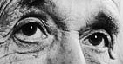
Mahatma Gandhi | Donald Trump | Hugh Jackan | Albert Einstein
17 | 18 | 19 | 20
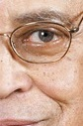 | 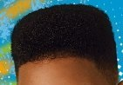 | 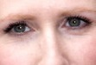 | 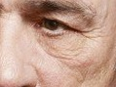
James Earl Jones | Will Smith | Katherine Tate | Tommy Lee Jones
21 | 22 | 23 | 24
 | 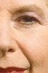
Anne Robinson | Margaret Thatcher | Charlie Chaplain | Katharine Hepburn

