Round 1 – A bit of everything
- How many finger holes does a recorder have running down the front of the instrument? 7
- Peter Benchley wrote a novel in 1974 which became the basis of which famous movie? Jaws
- Which island is Japan’s capitol city Tokyo on? Honshu
- What do female ants typically lose after mating? Their wings
- How old was Queen Victoria when she became queen of England? 18
- How many gold medals did Mo Farah win at the 2016 summer Olympics? 2: 5,000m and 10,000m
- What type of pasta is shaped like a bow-tie? Farfalle
- Which of Snow White’s dwarves has the longest name? (Disney ones!) Bashful (7 letters. Others are Doc, Dopey, Grumpy, Sneezy, Sleepy and Happy)
- What country is nicknamed the cockpit of Europe? Brussels
- Which famous movie character said “Close your mouth please, Michael. We are not a codfish” – Mary Poppins

Round 2 – Walls!
- What year was Hadrian’s Wall started? 122 AD (20 years either way)
- What is the length of Hadrian’s Wall? 73 miles (10 miles either way)
- What year was the Berlin Wall started? 1961 (exact)
- What year was it opened? (not taken down; opened for passage) 1989 (exact)
- What was the length of the Berlin Wall? 96 miles (10 either way)
- What year was the Great Wall of China started? 206 BC (20 years either way)
- What was the length of the Great Wall of China? 2150 miles (100 either way)
- In which book published in 1872 was Humpty Dumpty a character? Through the Looking Glass, Lewis Carroll
- What year was the Humpty Dumpty nursery rhyme first published? 1797 (30 either way)
- What year did Walls first start producing ice cream? 1922 (5 either way)
- Which company owns the brand name “Walls”? Unilver

Round 3 – Name the year
- What year were Robbie Williams, Leonardo di Caprio and Penelope Cruz all born in? 1974
- What year were Stevie Wonder, Suzi Quatro, Peter Gabriel and Johnny White all born in? 1950
- What year were Anne Hathaway, Eddie Redmayne and the Dutchess of Cambridge all born in? 1974
- What year were Julia Roberts, Nicole Kidman and Jamie Foxx all born in? 1967
- What year were Prince, Michael Jackson, Madonna and Lawrence Dixon all born in? 1958

Round 4 – Crime fiction
- Who created Philip Marlow? Raymond Chandler
- Who created Sam Spade? Dashell Hammett
- Who created Jules Maigret? Georges Simenon
- Who created Lord Peter (Death Bredon) Wimsey? Dorothy Sayers
- Who created Jack Reacher? Lee Child
- Who created Inspector Salvo Montalbano? Andrea Camilleri
- Who created Detective Harry Bosch? Michael Connelly
- Who created Adam Dalgliesh? P D James
- Who created Miss Marple? Agatha Christie
- Who created Dr Tony Hill? Val McDermid

Round 5 – Movie taglines
- You stop, you die – Crank, Speed or Midnight Run? – Crank
- Get ready for rush hour – Rush Hour, Speed or Premium Rush? – Speed
- The first casualty of war is innocence – Platoon, Apocalypse Now, Full Metal Jacket? – Platoon
- A Los Angeles Crime Saga – LA Confidential, Heat or Collateral? – Heat
- This time it’s war – Robocop 2, Terminator 2: Judgement Day or Aliens? – Aliens
- All the power on earth can’t change destiny – Masters of the Universe, The Godfather Part II or Remains of the Day? – The Godfather Part II
- He moves without sound, kills without emotion, disappears without trace – Leon: The Professional, Predator or First Blood? – Leon: The Professional
- The goal is to survive – First Blood, The Hunger Games or The Last Boy Scout? – The Last Boy Scout
- His story will touch you, even though he can’t – Edward Scissorhands, The Boy in the Plastic Bubble or Trapped? – Edward Scissorhands
- What one doesn’t have, the other is missing – Dude Where’s My Car?, Dumb & Dumber, Basketball? – Dumb & Dumber

Round 6 – Check out that fez!

1 | I went to the doctor's the other day. I said, “have you got anything for wind”  so he… | Gave me a kite
2 | I'm on a whisky diet, I've lost three… | Days already
3 | I bumped into an old acquaintance the other day, he told me he had taken a job as a postman. He said it was better than… | Walking the streets
4 | I bought my wife a wooden leg for Christmas! It's not her main present, just… | A stocking filler
5 | Doctor, I can't pronounce my F's, T's and H's… | Well you can’t say fairer than that then
6 | So, I went to the dentist.  He said "Say Aaah."  I said "Why?"  He said… | My dog’s dead

Round 7 – Name that famous moustache

1 – Ben Kingsley  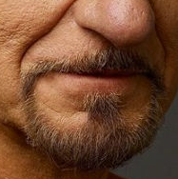 | 2 – Freddie Mercury  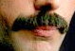 | 3 – Clark Gable  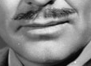
4 – Billy Dee Williams  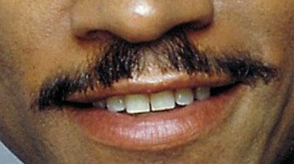 | 5 – Sam Elliott  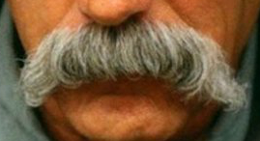 | 6 – Chuck Norris  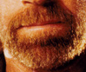
7 – Daniel Day Lewis  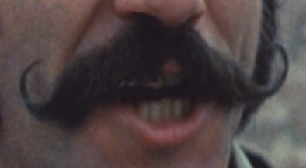 | 8 – John Cleese  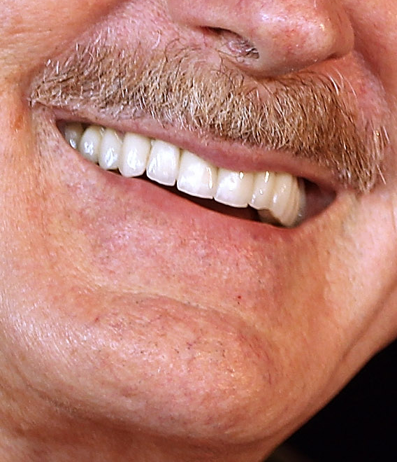 | 9 – Sacha Baron Cohen  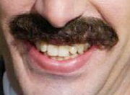
10 – John Lennon  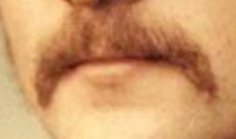 | 11 – Burt Reynolds  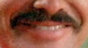 | 12 – Hulk Hogan  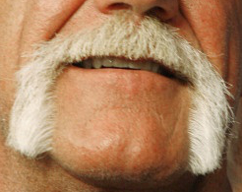
13 – Albert Einstein | 14 – Peter Sellers  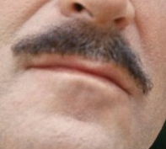 | 15 – Robert Downy Jr  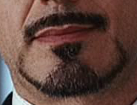
16 – Sean Connery  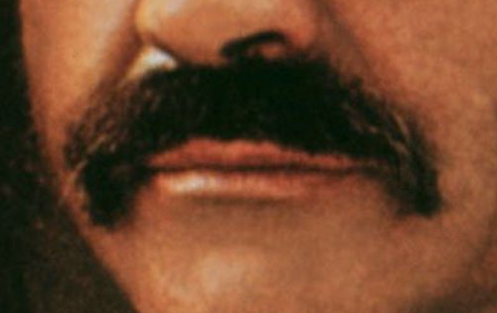 | 17 – Colin Farrell  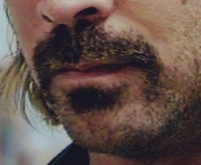 | 18 – Salvador Dali  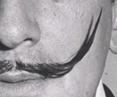
19 – Tom Selleck  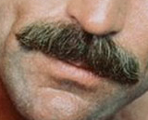 | 20 – Will Ferrell  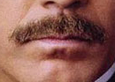 | 21 – Che Guevara

