Round 1 – General Knowledge
- What are Climax, Intercourse, Sugar Tit, Accident and Fred? Places in America
- What was the name of the first communications satellite to relay telephone, television and (at the time) high-speed data communications? Telstar 1 (1962)
- The island of Saipan is a commonwealth of which country? USA
- Lemurs, a type of primate, are native to what island nation? Madagascar
- Which British politician famously said in 1973 “I do not think there will be a woman prime minister in my lifetime”, only to be proven wrong a few years later? Margaret Thatcher
- On what date did the Brexit referendum take place? 23rd June 2016
- What is the highest-grossing film of all time, adjusted for inflation? Gone with the wind ($3,440,000,000)
- What is the highest-grossing film of all time, not adjusted for inflation? Avatar ($2,787,965,087)

Round 2 – History
- Who was vice president of the United States when Lincoln was assassinated? Andrew Johnson
- Marie Antoinette was born an archduchess of which country? Austria
- Jimmy Carter was the first US president born where? In a Hospital
- The United States constitution replaced which other document on 4th March, 1789? The Articles of Confederation
- The inventor Nikola Tesla was born on 10th July 1856 in what modern-day country? Croatia
- What battle was fought on 18th June 1815 in present-day Belgium? Battle of Waterloo
- The first human-made object to land on the moon was made by which country? Soviet Union
- Which British motorcar brand was purchased by Tata in 2008? Jaguar

Round 3 – Who said what now?
- The point is, you can never be too greedy – Donald Trump
- As long as you’re going to be thinking anyway, think big – Donald Trump
- I’ve always said that power is more important than money, but when it comes to elections, money gives power, well, a run for its money – Frank Underwood
- A lot of people don’t like to win. They actually don’t know how to win, and they don’t like to win because deep down inside they don’t want to win – Donald Trump
- This country demands bold, persistent experimentation. It is common sense to take a method and try it. And if it fails, admit it frankly and try another. But above all, try something – Frank Underwood
- Sometimes by losing a battle, you find a new way to win the war – Donald Trump
- For those of us climbing to the top of the food chain there can be no mercy. There is but one rule: hunt or be hunted – Frank Underwood
- My job is not to represent the world, my job is to represent the United States of America – Donald Trump
- What separates winners from losers is how a person reacts to each new twist of fate – Donald Trump
- Anyone who thinks my story is anywhere near over is sadly mistaken – Donald Trump
- Nobody’s a Boy Scout. Not even Boy Scouts – Frank Underwood
- Everything is about sex. Except sex. Sex is about power – Frank Underwood
- Nothing great in the world has been accomplished without passion – Donald Trump

BREAK

Round 4 – Science & technology
- What is the name of the unit of distance between the Earth and the sun? Astronomical unit / au / ua
- What is the distance in miles? 93 million (3 million either way)
- What developmental stage precedes embryo? Zygote
- In geology, what is the significance of the Cretaceous-Tertiary (K-T) boundary? Represents the mass extinction event 65 million years ago, end of dinosaurs, asteroid hitting the Earth
- What is the term for the phase transition from solid to gas, without passing through the liquid phase? Sublimation
- Thomas Midgley Jr was an American mechanical engineer and chemist, who registered over 100 patents in his career, but what two things is he notorious for helping to invent? Leaded petrol & CFCs

Round 5 – Connections Round
- When asked by a messenger from the pope to demonstrate his skill, 14th century artist Giotto is said to have drawn what simply by hand? Perfect circle.
  - Crop circles hoax, which began in the late 70s with circles made by Doug Bower and Dave Chorley.
- Starburst, Skittles, Twix and Topic are all sweets produced by which company? Mars.
  - Mars hoax, which began with an email circulated in 2002 claiming that Mars would appear as big as the moon in the night sky.
- In the 1947 Roswell incident where many believe an alien spaceship crashed in Roswell, New Mexico, what did the US Military say actually crashed? A weather balloon.
  - Balloon boy hoax. October 15th 2009, Richard and Mayumi Heene from Colorado allowed a gas balloon filled with helium to float into the atmosphere, then claimed that their 6-year-old son Falcon was inside it. Turned out he wasn’t, kid even implicated his parents when they were interviewed on Larry King Live.
- What type of celestial body is Callisto, which is in our solar system? Moon (of Jupiter).
  - Moon landing “hoax”, which has been around since the 1970s.
- According to the 1991 film Hook, which mythical creature will die if you say you do not believe in it, whilst clapping will bring it back to life? Fairy.
  - Cottingley fairies. Five photographs that appear to show Elsie Wright and Frances Griffiths interacting with fairies in Cottingly when they were children in 1917. Actually cardboard cut-outs.
- The name of which medical procedure derives from the Greek for “to see with one’s own eyes”? Autopsy.
  - Alien autopsy hoax. Released in 1995, appears be a black & white film showing the autopsy of an alien corpse. London-based entrepreneur Ray Santilli eventually admitted that the film was manufactured, though still claimed it was a “restoration” of an original alien autopsy filmed he’d once seen.
- Connection: hoaxes
- Odd one out: moon – believed to be a hoax by some idiots, but isn’t

Round 6 – Film titles from around the world
- If you leave me, I delete you (Italy) – Eternal Sunshine of the Spotless Mind
- I’m drunk and you’re a prostitute (Japan) – Leaving Las Vegas
- One night, big belly (China) – Knocked Up
- Vaseline (Argentina) – Grease
- The hit man is not as cold as he thought (China) – Leon: The Professional
- He’s a ghost! (China) – The Sixth Sense
- Mom, I missed the plane (France) – Home Alone
- American virgin man (China) – American Pie
- Interplanetary unusual attacking team (China) – Guardians of the Galaxy
- Touring around on a flying house (China) – Up
- Guessing the trains (China) – Trainspotting
- I will marry a prostitute to save money (China) – Pretty Woman

Round 7 – Picture Round – Name the title of the film AND the book it’s based on (they’re not the same)

Film… |  | …book
1) Apocalypse Now |  | Heart of Darkness, Joseph Conrad
2) Die Hard |  | Nothing Lasts Forever, Roderick Thorpe
3) 21 |  | Bringing Down the House, Ben Mezrick
4) Manhunter |  | Red Dragon, Thomas Harris
5) Stand by Me |  | The Body, Steven King
6) Blade Runner |  | Do Androids Dream of Electric Sheep, Philip K Dick
7) Clueless |  | Emma, Jane Austen
8) The Iron Giant |  | The Iron Man, Ted Hughes
9) Goodfellas |  | Wiseguy, Nicholas Pileggi
10) The 13th Warrior |  | Eaters of the Dead, Michael Chrichton
11) John Carter |  | A Princess of Mars, Edgar Rice Burrows
12) Total Recall |  | We can remember it for you wholesale, Philip K Dick

Jackpot question
According to Wikipedia as of today, in USA dollars, how much money in total have the Marvel Cinematic Universe films made? $12,657,000,000

Picture round – name the title of the film AND the book it’s based on (they’re not the same)

1  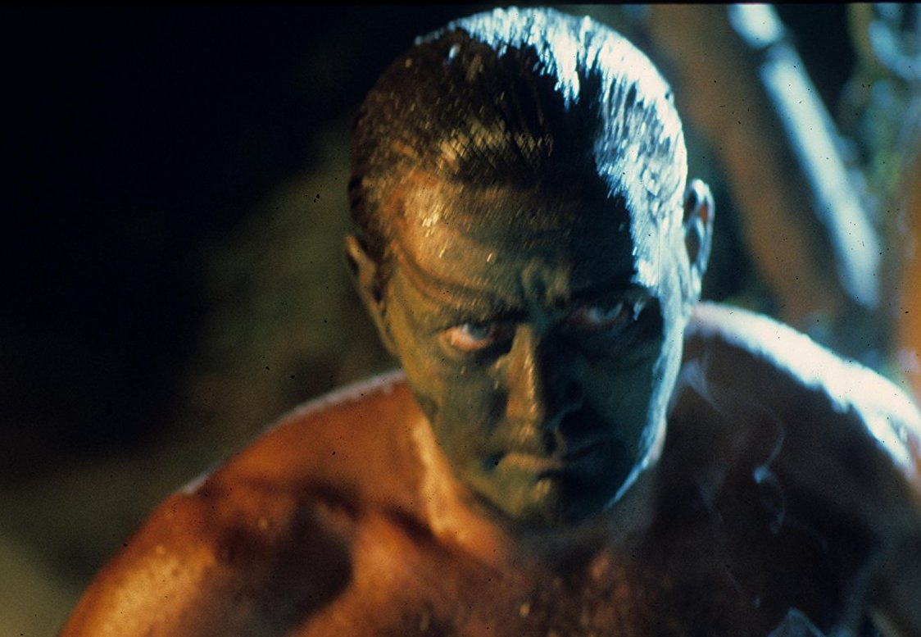 | 2 | 3  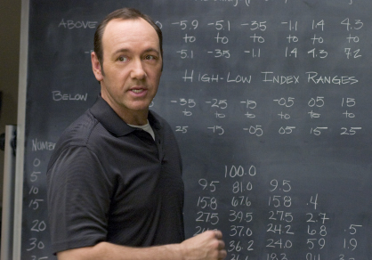 | 4
5 | 6 | 7 | 8
9  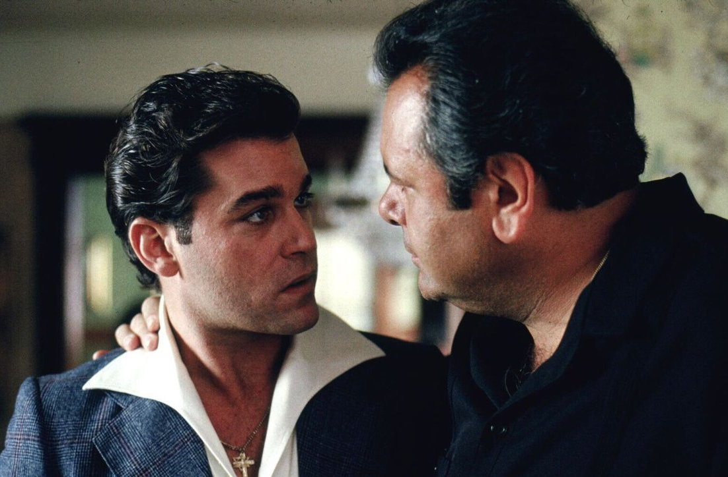 | 10  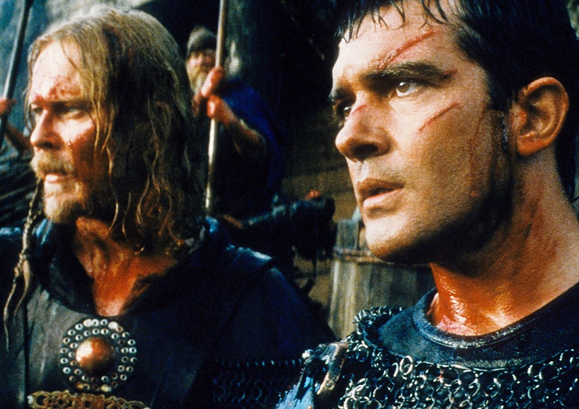 | 11  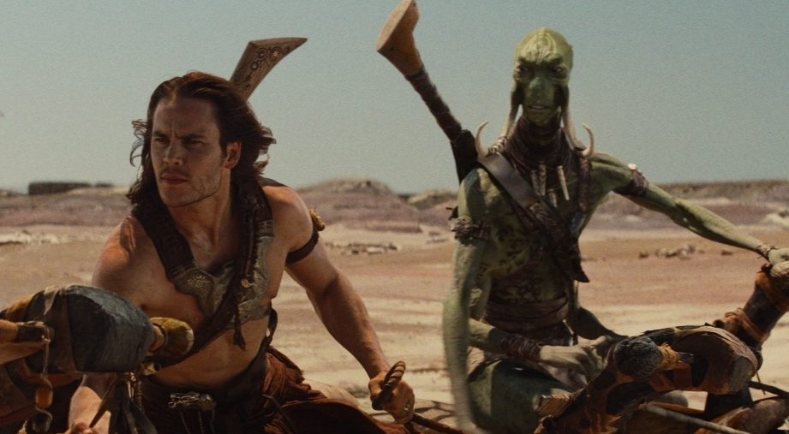 | 12  