Round 1 – Which film…
- Which film that currently occupies the #1 spot on the IMDB top 250, is based on a 1982 novella by Stephen King? The Shawshank Redemption
- Which 2006 US film directed by Martin Scorsese is a remake of the 2002 Hong Kong film Infernal Affairs? The Departed
- Which film featured the song I don’t want to miss a thing by Aerosmith on its soundtrack? Armageddon
- Which controversial 1996 erotic psychological thriller shares its title with a 2004 movie about racial and social tensions in Los Angeles? Crash
- Which was the first film in the Marvel Cinematic Universe? Iron Man (2nd May 2008)
- Which film franchise, beginning in 1975 and comprised of 4 films released over 12 years, had its third entry in 3D, while its fourth entry is often considered to be one of the worst films ever made? Jaws
- Which film contains the famous line “Get away from her, you bitch!”? Aliens
- Which film features Christopher Lloyd as an eccentric inventor named Emmett Brown? Back to the Future

Round 2 – Random knowledge
- Tsutomu Yamaguchi (1916-2010) was, in 2009, recognised by the Japanese government for what? Clue: he is one unlucky guy (or very lucky, depending on how you look at it) – survivor of both the Hiroshima and Nagasaki bombings
- What is the best-selling video game of all time? (clue: it’s not one of the GTAs) – Tetris (sold in excess of 170 million units)
- Who was manager of England when they beat San Marino 7-1 whilst trying to qualify for the 1994 world cup? (they didn’t) – Graham Taylor
- When did the smoking ban come into effect in England? (point for the year, bonus point for the month) – 2007, July
- How long – in km – is the circular tunnel in which the Large Hadron Collider (the world’s largest particle accelerator) is housed? (2km either way) – 27km (25-29)
- In what country is the world’s longest single-word place name? Bonus point – how many letters? (5 either way (80-90)) – New Zealand (85 letters)
  - Taumataw-hakatang-ihanga-koa-ua-uota-matea-turi-puka-kapi-kimaungahoro-nuku-pokai-whenuaki-tanatahu
  - The summit where Tamatea, the man with the big knees, the climber of mountains, the land-swallower who travelled about, played his nose flute to his loved one

Round 3 – Connections
- What is the device used in planes to record information about the flight for the purpose of air accident investigation better known as? Black box (Xbox)
- The bobcat is a member of which genus of wild cats, characterised by the tufts of black hair on the tips of their ears, making them look rather pointy? Lynx (Atari Lynx)
- Complete the title of this 2002 comedy-drama film starring Hugh Grant and based on a novel by Nick Hornby: About a …? Boy (Game Boy)
- What device used in electrical engineering to make or break a circuit shares its name with a flexible rod used for corporal punishment? Switch (Nintendo Switch)
- What was Skylab? A US Space station (PlayStation)
- What word is a prefix used in metric systems to denote a factor of one million? Mega (Mega Drive)
- CONNECTION: video game consoles

Round 4 – Superheroes
- What is Superman’s Kryptonian name? Kal El
- Which superhero is known as the man without fear? Daredevil
- Which superhero’s powers don’t work on anything that’s the colour yellow? Colour is a clue here! Green Lantern
- Which superhero is known for the phrase “Don’t make me angry, you wouldn’t like me when I’m angry”? The Hulk
- What fictional metal covers Wolverine’s bones and claws? Adamantium
- Which superhero’s catchphrase is “It’s clobberin’ time!”? Ben Grimm / The Thing

Round 5 – Wine
- In which country is Rioja produced? Spain
- How are fizzy wines, other than Champagnes, described? Sparkling
- In which country is the Marlborough wine region? New Zealand
- Which red wine is drunk when young and is called “nouveau”? Beaujolais
- In which part of the United States is the Zinfandel grape cultivated? California
- Claret wine is produced in the region surrounding which French city? Bordeaux

Round 6 – Better known as…
- Krishna Pandit Bhanji – Ben Kingsley
- Lawrence Tureaud – Mr T
- Georgios Panayiotou – George Michael
- Terry Gene Bollea – Hulk Hogan
- Ramon Antonio Gerard Estevez – Martin Sheen
- Archibald Alec Leach – Cary Grant
- Norma Jean Mortensen – Marilyn Monroe
- Henry Charles Albert David – Prince Harry

Round 7 – Who said this? Taylor Swift… or Adolf Hitler?
- As a Christian I have no duty to allow myself to be cheated, but I have the duty to be a fighter for truth and justice – Adolf Hitler
- I’m very aware and very conscious of the path I chose in life, and very aware of the path I didn’t choose – Taylor Swift
- And I can fight only for something that I love, love only what I respect, and respect only what I at least know – Adolf Hitler
- Words build bridges into unexplored regions – Adolf Hitler
- I have a recurring dream that people are lined up next to my bed, waiting for autographs and taking pictures of me – Taylor Swift
- I’m intimidated by the fear of being average – Taylor Swift
- When you walk out onstage in front of 65,000 people, it can bring you to tears – Taylor Swift
- The art of reading consists in remembering the essentials and forgetting non-essentials – Adolf Hitler
- If you want to shine like the sun you first have to burn like it – Adolf Hitler
- I know my flaws before other people point them out to me – Taylor Swift

Jackpot question
According to Wikipedia, how many number 1 singles were there in the UK in the 1990s? - 206

Picture round – name the film or TV show from the emojis

1 - Kiss Kiss Bang Bang  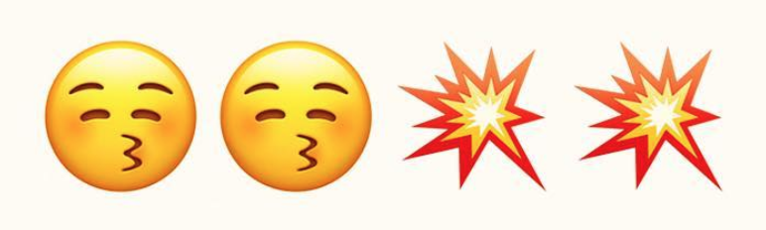 | 2 - Walk the Line  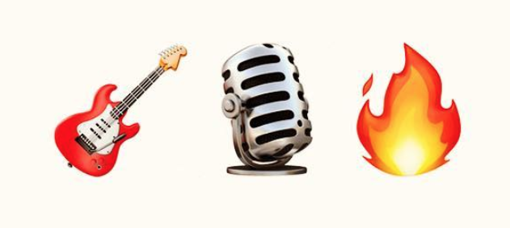 | 3 - Edward Scissorhands  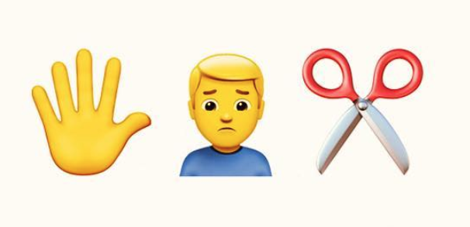
4 - Ghostbusters  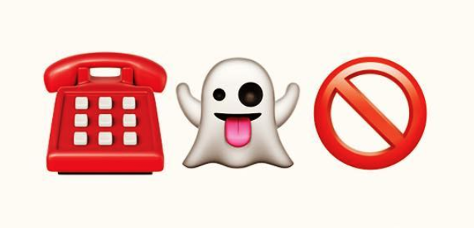 | 5 - Harry Potter  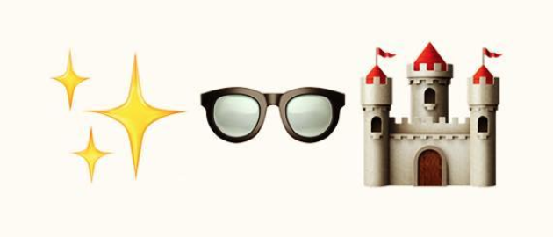 | 6 – The Wolf of Wall Street
7 - Teenage Mutant Ninja Turtles  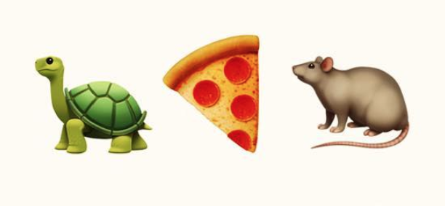 | 8 - Breaking Bad  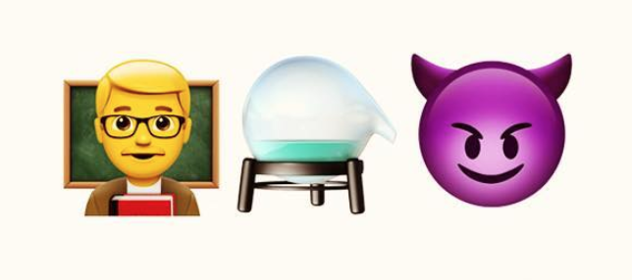 | 9 – Game of Thrones  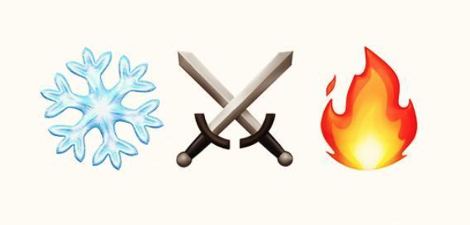
10 - Whiplash  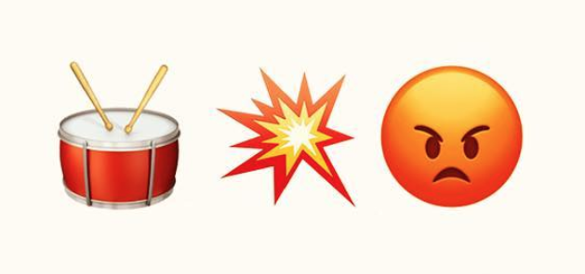 | 11 - Interstellar | 12 - The Matrix  