Round 1 - Sport
- In cycling, what do the initials BMX stand for? Bicycle motocross / bike motocross
- In golf, what do you have to do to get a condor? Hit 4 strokes under par
- Champion boxer Wladimir Klitschko is from which country? The Ukraine
- How long, in metres, is a furlong? (5% either way) 201.17 metres (191.11m – 211.23m)
- In what year did the first Wimbledon tennis championship take place? (3 years either way) 1877 (1874 – 1880)
- In 1971, astronaut Alan Shepard became the only human being in existence to do what? Play golf on the moon / anywhere other than on Earth
- Which baseball player – considered by many to be the greatest of all time – holds the record for the most career home runs at 714? Babe Ruth (George Herman Jr)
- In football, Stephan “Stanis” Dembicki holds the record for the most goals scored in a single match. How many did he score? (1 either way). 16 (15 – 17) (whilst playing for RC Lens against Auby-Asturies in 1942)

Round 2 – Literature
- Rene Goscinny and Albert Uderzo are best known for creating which comic character? Asterix the Gaul
- What is the best-selling book in the world? The Bible (over 5 billion copies sold)
- What is the second best-selling book in the world? (bonus point for how many, 20 million either way) Quotations from the Work of Mao Tse-tung / Little Red Book. 820 million (800 – 840 million)
- What is the title of the final and unfinished novel by Charles Dickens? The Mystery of Edwin Drood
- Who wrote the Fifty Shades of Grey books? E.L. James
- Author Harper Lee’s most notable work was To Kill a Mockingbird. What is the title of her second-most notable work, not released until 2015? Go Set a Watchman
- Who wrote the novel Farenheit 451? Ray Bradbury
- Singer Sting wrote the hit Every Breath You Take in which author’s house? (clue: very popular series of books, been made into films, other authors have even written new books for the franchise) Ian Flemming (written in Flemming Villa at the Goldeneye estate, Jamaica)

Round 3 – Connections round
- What home video format, resembling a giant CD, was first released in 1978 and never really caught on? LaserDisc (George Lazenby)
- Which US singer, who has sold over 75 million records and is known for his husky pop-rock ballads and (once) long hair, had a huge hit in 1991 with his cover of When a man loves a woman? Michael Bolton (Timothy Dolton)
- Who starred opposite Dame Judi Dench in the 1997 historical drama Mrs Brown? Billy Connolly (Sean Connery)
- Which unbelievably wank singer was charicatured in the sketch show Bo Selecta, where he would often be accompanied by Kes the kestrel? Craig David (Daniel Craig)
- What term refers primarily to the Muslim inhabitants of the Maghreb, the Iberian Peninsula, Sicily and Malta during the Middle Ages? The name was also later applied to Arabs (clue: Morgan Freeman played one in Robin Hood Prince of Thieves) Moors (Roger Moore)
- Which video game series sees a pair of plumbers repeatedly save a princess from an evil turtle? Super Mario Bros (Pierce Brosnan)

Connection: actors who played James Bond (in the official Bond series)

BREAK

Round 4 – Music
- Which band released a 1974 album entitled Crime of the Century? Supertramp
- Larry Mullen Jr is the drummer in which Irish Band? U2
- What is the best-selling album of all time? (album title only, bonus point for number of copies sold, 5% either way) Thriller (Michael Jackson), 47.3 million (44,935,000 – 49,665,000)
- What is the second best-selling album of all time (album title only, bonus point for number of copies sold, 5% either way) Back in Black (AC/DC), 26.1 million (24,795,000 – 27,405,000)
- Which singer has the nickname The Groover from Vancouver? Bryan Adams
- Which group performed the track Born Slippy from the soundtrack to the 1996 film Trainspotting? Underworld
- Who originally wrote the song Hallelujah, popularised by Jeff Buckley? Leonard Cohen
- Who is Ireland’s biggest selling solo artist? Enya

Round 5 – Science & technology
- In December 1979, which human disease was certified to have been eradicated? Smallpox
- In what year did the Apple App Store launch? 2008
- In the human body, what is stored in the adipose tissue? Fat
- How long does it take for light to travel from the Earth to the Sun? (10 seconds either way) 8 min 20 sec (8:10 – 8:30)
- Who said “The good thing about science is that it’s true whether you believe it or not”? Neil deGrasse Tyson
- What does SONAR stand for? SOund Navigation And Ranging
- In what country was the Uzi submachine gun developed? Israel
- Grand Theft Auto 5 was released in 2013. Which GTA game was the first to be a 3D, open world game? (bonus point for the year, dead on) GTA3 (released in 2002)

Round 6 – TV & film
- Who plays Wilson Fisk (AKA the Kingpin) in the Marvel Netflix series Daredevil? Vincent D’Onofrio
- In which of the Rocky films was the song Eye of the Tiger by Survivor first used? Rocky III
- What is Special Agent Mulder’s first name, which he hated being called by, in the TV show The X-Files? Fox
- Who directed the 1995 thriller Se7en? David Fincher
- What colours were the two pills offered to Keanu Reeves’ character Neo in the film The Matrix? Red and blue (½ point for each)
- Who played the male lead in the 1946 film It’s a Wonderful Life? James Stewart
- Which TV medical drama that began in 1994 was created by Michael Crichton? ER
- In the film The Terminator, what year were the Terminator and Kyle Reese sent back from to 1984? (1 year either way) 2029 (2028-2030)

Jackpot question: the RMS Titanic sank after colliding with an iceberg on its maiden voyage in the North Atlantic Ocean in 1912. At what depth, in metres, does the wreck lie? (2% either way) 3784m (3708m – 3860m)

Round 7 - picture round: name the movie from the snippet of its poster

1 – The Dawn of the Dead  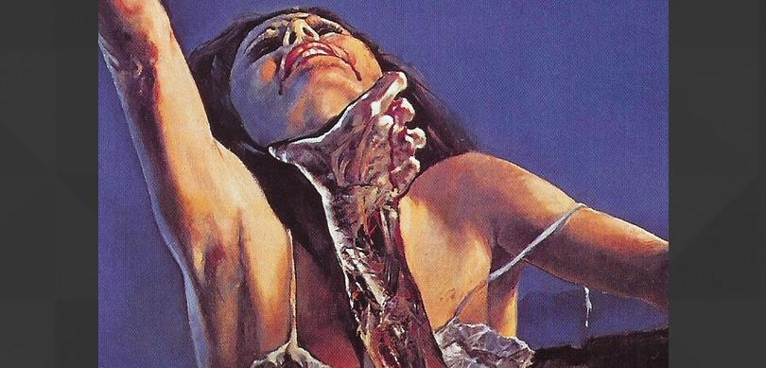 | 2 – 2001: A Space Oddesey | 3 – Halloween  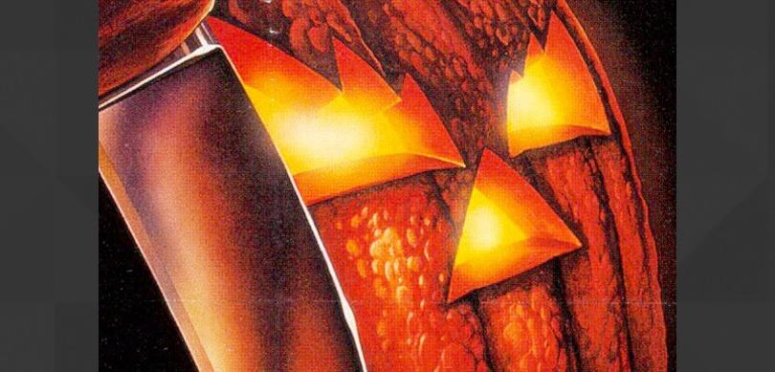
4 – Blade Runner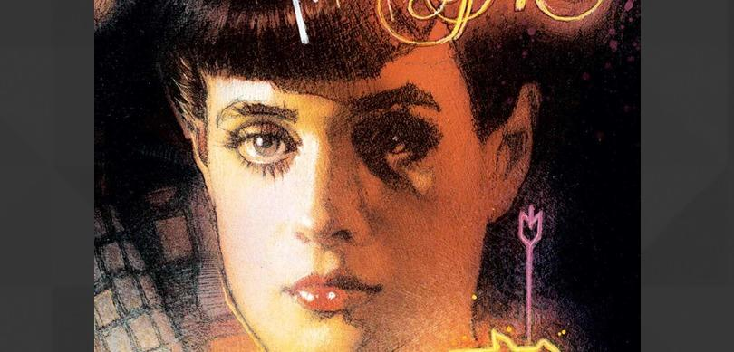 | 5 – Vertigo  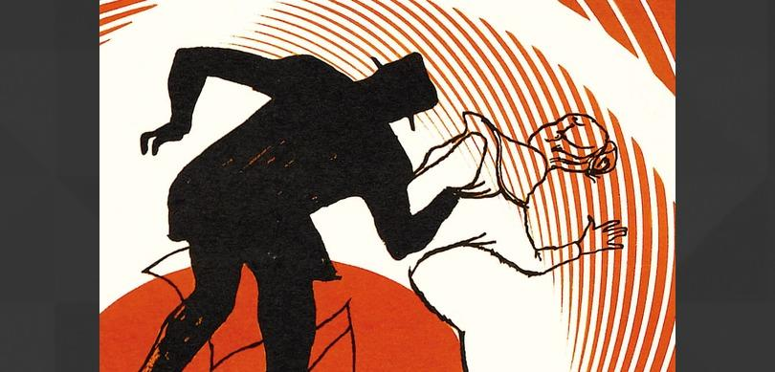 | 6 – The Silence of the Lambs  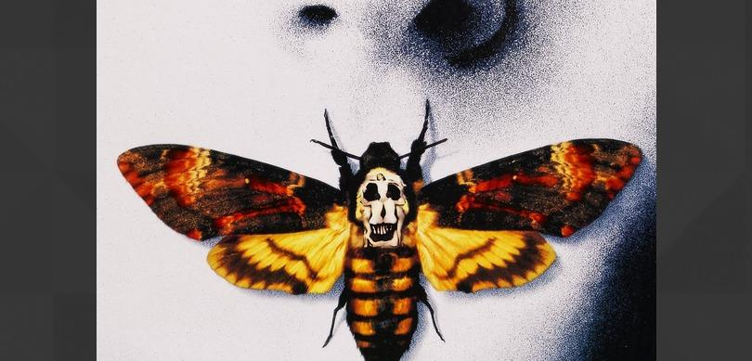
7 - Jaws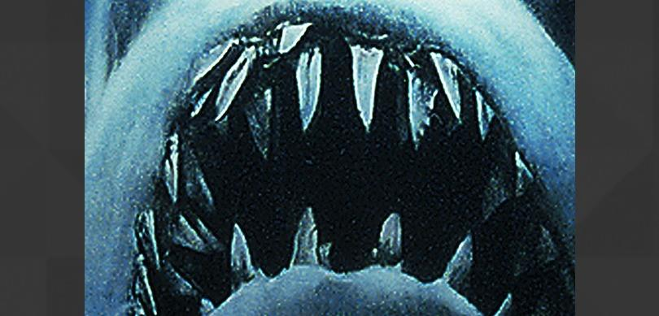 | 8 – Ersaerhead  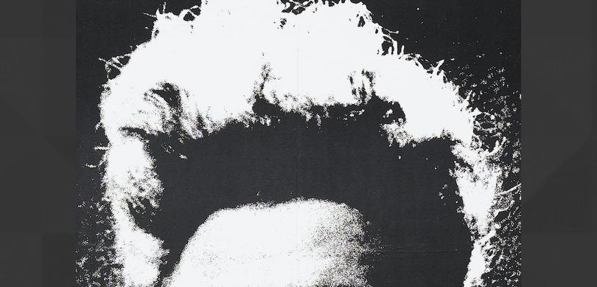 | 9 – The Exorcist  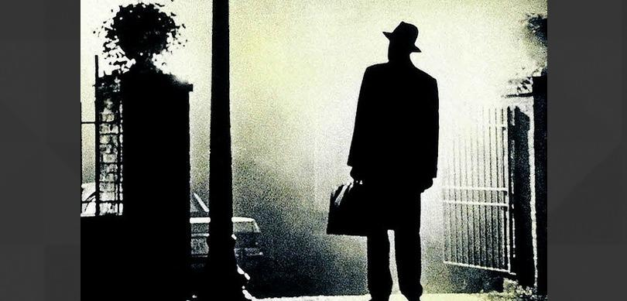
10 – Amadeus  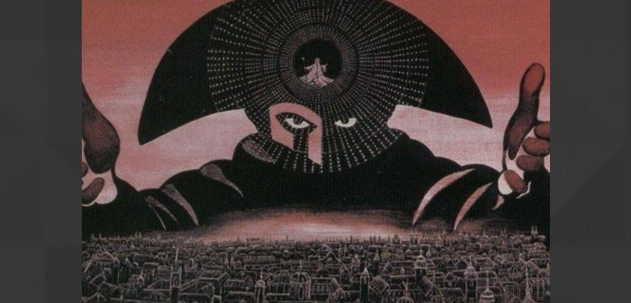 | 11 – Chinatown  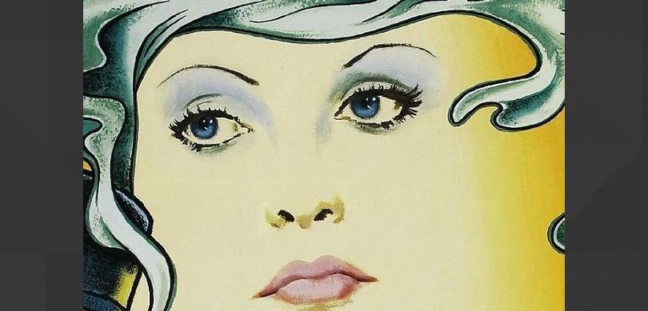 | 12 – Blue Velvet
13 – Alien  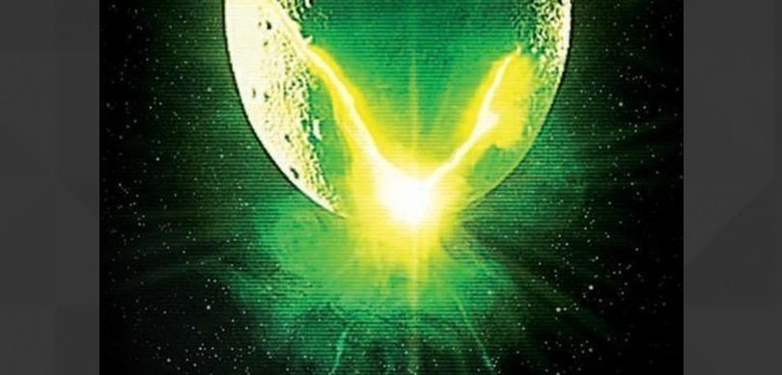 | 14 – Metropolis  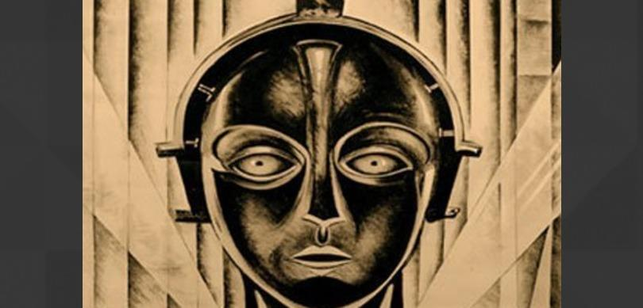 | 15 – The Goonies  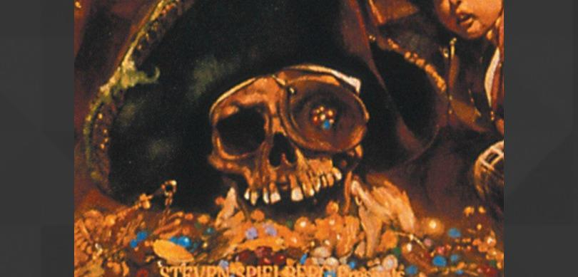
16 – Poltergeist  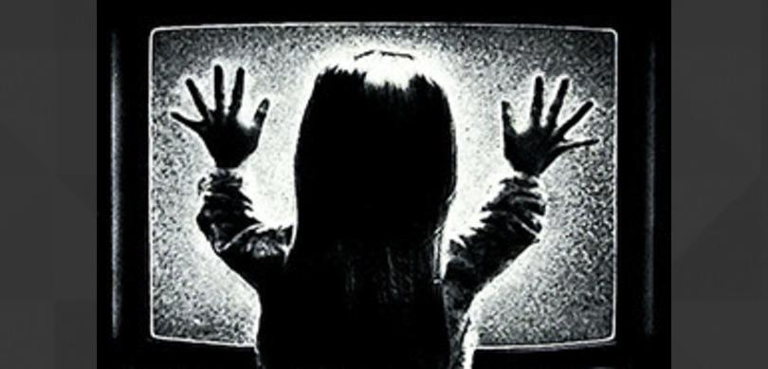 | 17 – Dawn of the Dead  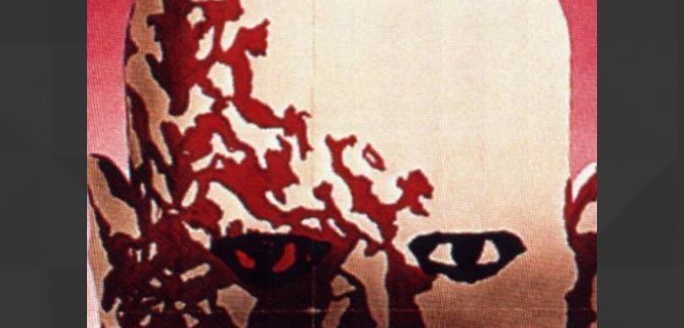 | 18 – Scream  