Round 1 – Sport
- In what year did footballer Eric Cantona get in trouble for launching a flying kick at an abusive fan? 1995
- In cricket, how many times have England won the ashes in this century? 5 (’05, ’09, ’10-11, ’13, ’15)
- In what year was tennis player Monica Seles stabbed on court? 1993
- How many gold medals did Team GB win at the 2016 Rio Olympics? (2 either way) 27 (25-29)
- According to the World Curling federation, how heavy can a curling stone be in Kg? (they’ve set a range, anything within that range, to 2 decimal places) 17.24kg – 19.96kg
- How many times have Cambridge won the men’s and women’s boat races combined? (10 either way) 126 (men:83, women:43) (116-136)
- In a ten-frame game of ten-pin bowling, what is the maximum possible score you can achieve, AKA bowling a perfect game? (exact answer only) 300, bowling a strike every time
- Who won the men’s and women’s singles championships at Wimbledon last year? (point for each) Roger Federer, Garbine Muguruza

Round 2 – Music
- How many weeks was Bryan Adams Everything I do, I do it for you at number 1 for? Clue: it’s the longest time spent at no. 1 by a single (bonus point for the year – must be exact) 16 (1991)
- The song that spent the 2nd longest time at no.1: ½ point each for the act, song and no. weeks at no. 1: Wet Wet Wet, Love is all around, 15 weeks
- What artist / group has spent the most total number of weeks at number 1 in the UK charts? (bonus point for how many weeks, 1 week either way) Spice Girls (22 (21 – 23))
- In what year did Elvis Presley die? (exact!) 1977
- Who shot John Lennon (1 point for full name, ½ point for not full name): Mark David Chapman
- Which artist or group had the most recent UK Christmas number one? (bonus ½ point for name of song) Ed Sheeran (Perfect)
- Who won the first series of Pop Idol in 2001? Will Young
- Who are the four current members of the Rolling Stones? (½ point for each) Mick Jagger, Keith Richards, Charlie Watts, Ronnie Wood

Round 3 – Film
- Who played Oskar Schindler in Schindler’s List? Liam Neeson
- How many films are there in the Blade series? (bonus ½ point: what did the vampires call him?) 3 (Daywalker)
- Who wrote the film Good Will Hunting? Matt Damon & Ben Affleck (½ point for each)
- Who played Superman in 2006’s Superman Returns? Brandon Routh
- What does SPECTRE stand for in the James Bond films? Special Executive for Counterintelligence, Terrorism, Revenge and Extortion
- Who starred as the Equalizer in the 2014 film? (bonus point: who starred as him in the 1980s TV series?) Denzel Washington (Edward Woodward)
- In the Godfather films, what fruit is associated with death or impending death? Oranges
- The 2017 film The Disaster Artist is a biographical comedy about Tommy Wiseau, who wrote, directed, financed and starred in which film that is so bad it has developed a cult following? The Room

Round 4 – Space
- List the planets in our solar system in order from the sun (½ for each one in correct order). Mercury, Venus, Earth, Mars, Jupiter, Saturn, Uranus, Neptune
- How far away is the moon from the Earth in km? (15% either way). 384,400km (326,740 - 442,060)
- In what year was the final space shuttle mission? (1 either way). 2011 (2010-2012)
- What name is shared by an aircraft carrier, a real spaceship and a fictional spaceship? Enterprise
- In what year was the Russian satellite Sputnik launched? (2 years either way) 1957 (1955-1959)
- Which US space station crashed down to Earth in 1979? Skylab
- What percentage is Mars’ surface gravity relative to Earth? (5% either way) 38% (33%-43%)
- What channel was the sitcom Spaced, created by Simon Pegg and Jessica Stevenson, first shown on when it premiered in 1999? Channel 4

Round 5 – General knowledge
- What are Spatzle, Bucatini and Pappardelle? Types of pasta
- Who wrote Moby Dick? Herman Melville
- Which company publishes the Grand Theft Auto games? Rockstar Games
- In what year did the Channel Tunnel open? 1994
- Name the 4 Teenage Mutant Ninja Turtles (½ point per turtle) (bonus point for the name of their sensei) Donatello, Michelangelo, Leonardo, Raphael (Splinter)
- Which country has the highest GDP? (bonus point for the amount, 10% either way) USA ($19.39 trillion ($17.45 – $21.33 trillion)
- Which is the oldest college in Cambridge? Peterhouse
- Who is the current chancellor of the exchequer? Philip Hammond

Round 6 – Speed
- In what year did the Bell X-1 become the first aircraft to break the sound barrier? (2 years either way) 1947 (1945 – 1949)
- The fastest land animal in the world is the cheetah. What is the top speed ever recorded by a cheetah, in mph? (1 either way) 61mph (60-62) (Sarah, Cincinnati zoo, 2012)
- Which film is the fastest to reach the $1-billion mark? Avengers: Infinity War (11 days, beating Star Wars: The Force Awakens)
- Which DC Comics character is described as the fastest man alive? The Flash
- Voyager 1 is the farthest man-made object from Earth, travelling on a path out of our solar system. How fast is it currently travelling, in km/s? (dead on) 17
- Who directed the 1994 film Speed? Jan de Bont
- What is the world’s fastest production car? Koenigsegg Agera RS (½ point for Bugatti Veyron)
- During the 1973 oil crisis, what was the national speed limit for all roads, including motorways, lowered to in an effort to reduce fuel consumption? (dead on) 50mph

Jackpot: what is the height difference, in feet, between the highest mountain peak and the deepest part of the oceans on Earth? (1% either way) 64,843 feet (63,546 – 66,1940), (Everest is 29,029 feet high, Mariana Trench is 35,814 feet deep)

Round 7 - picture round: name the movie

1)Django Unchained  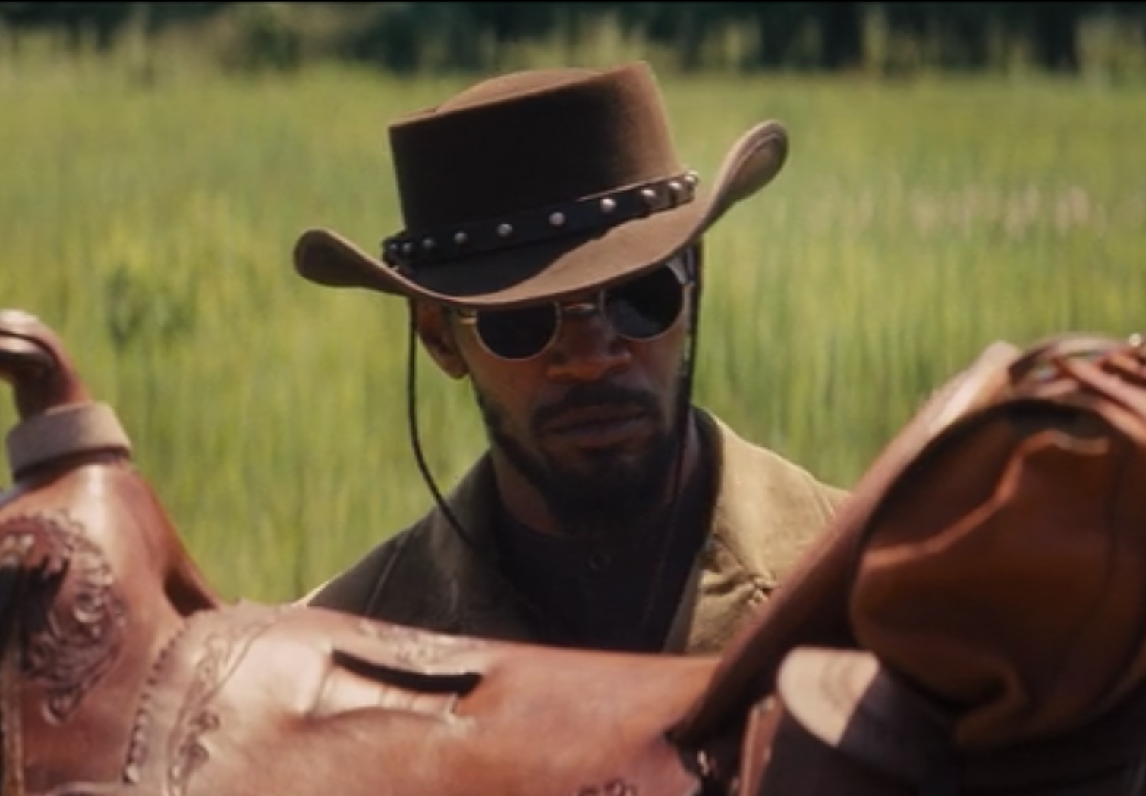 | 2) Guardians of the Galaxy Vol. 2  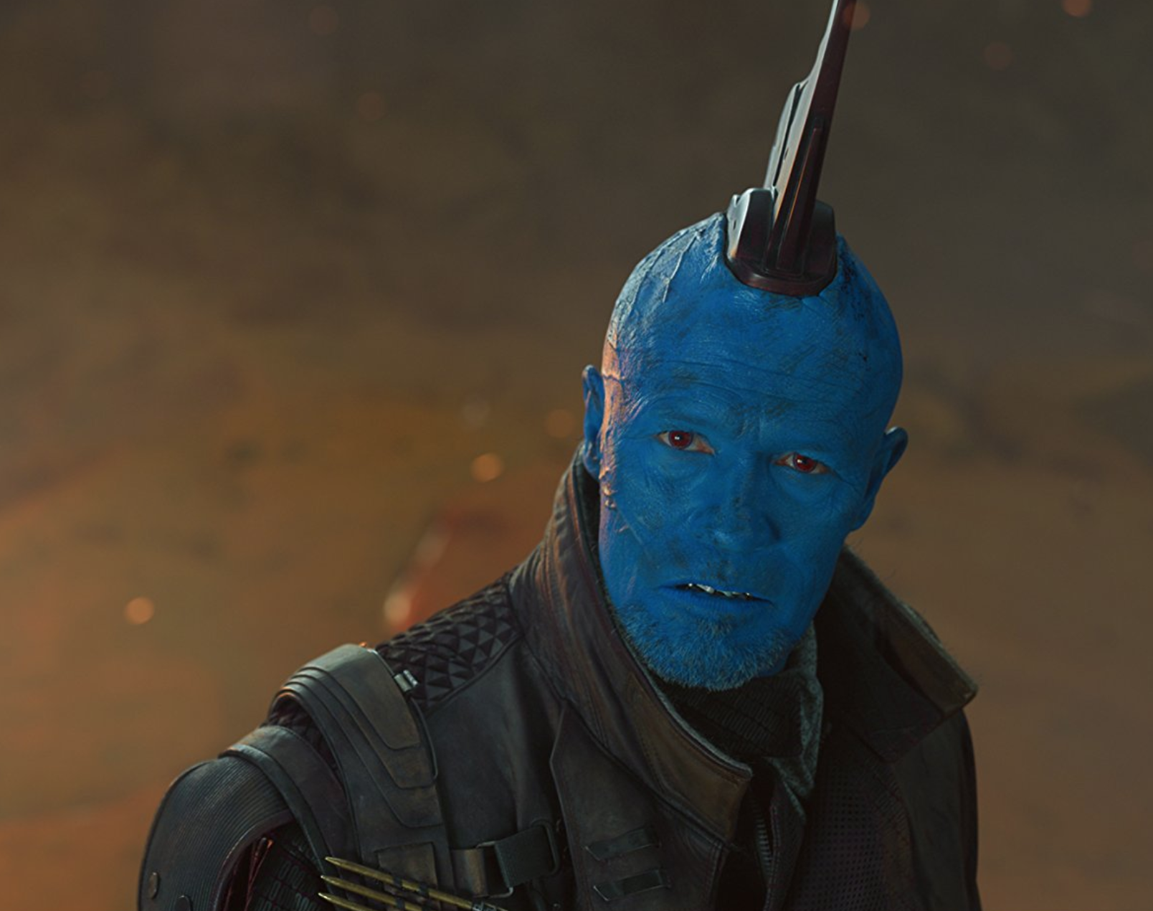 | 3) Taxi Driver  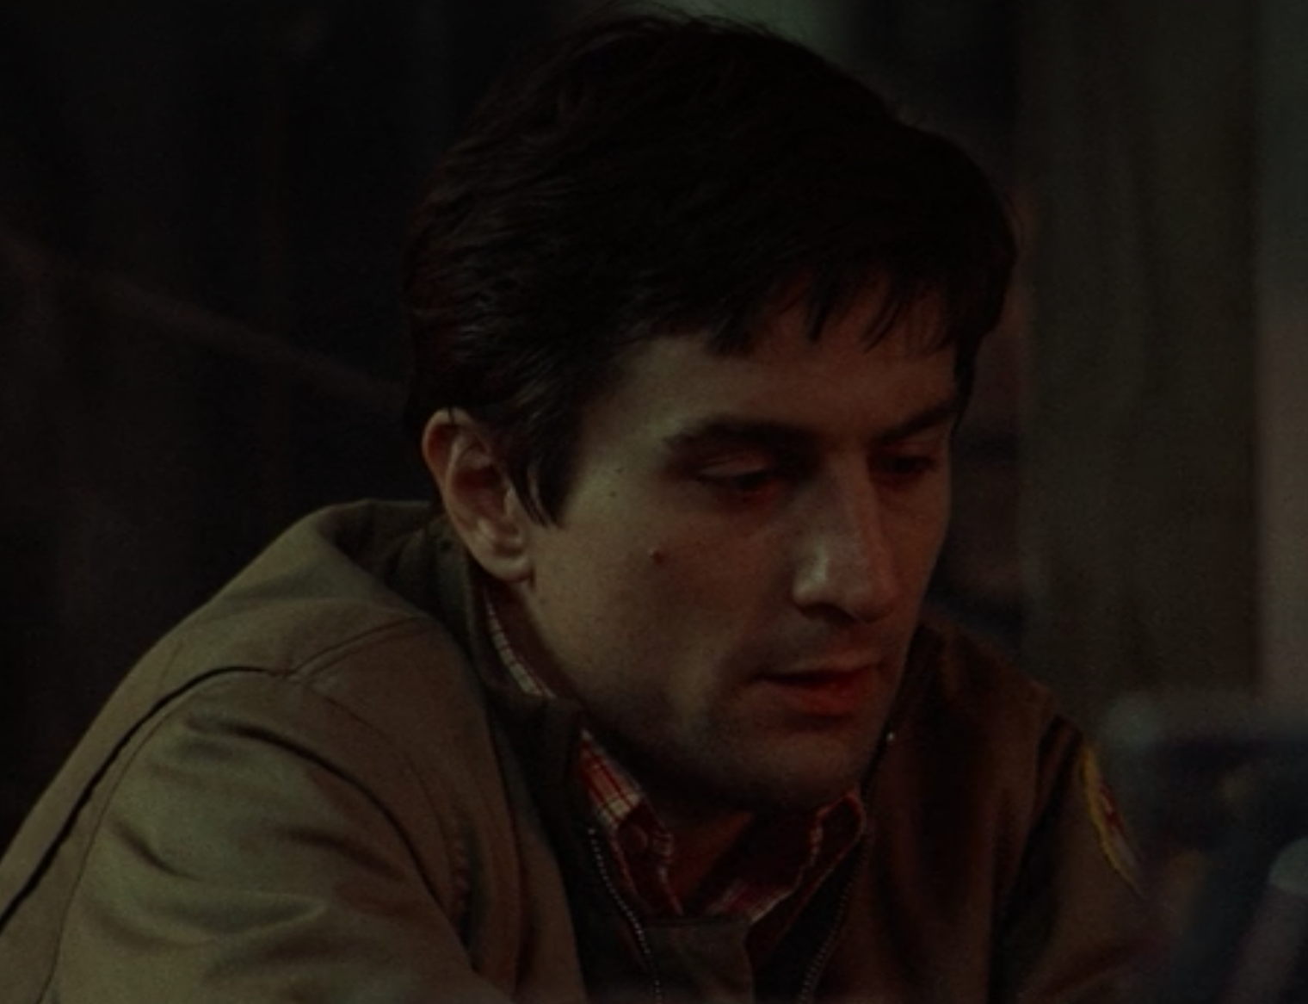
4) Life of Brian  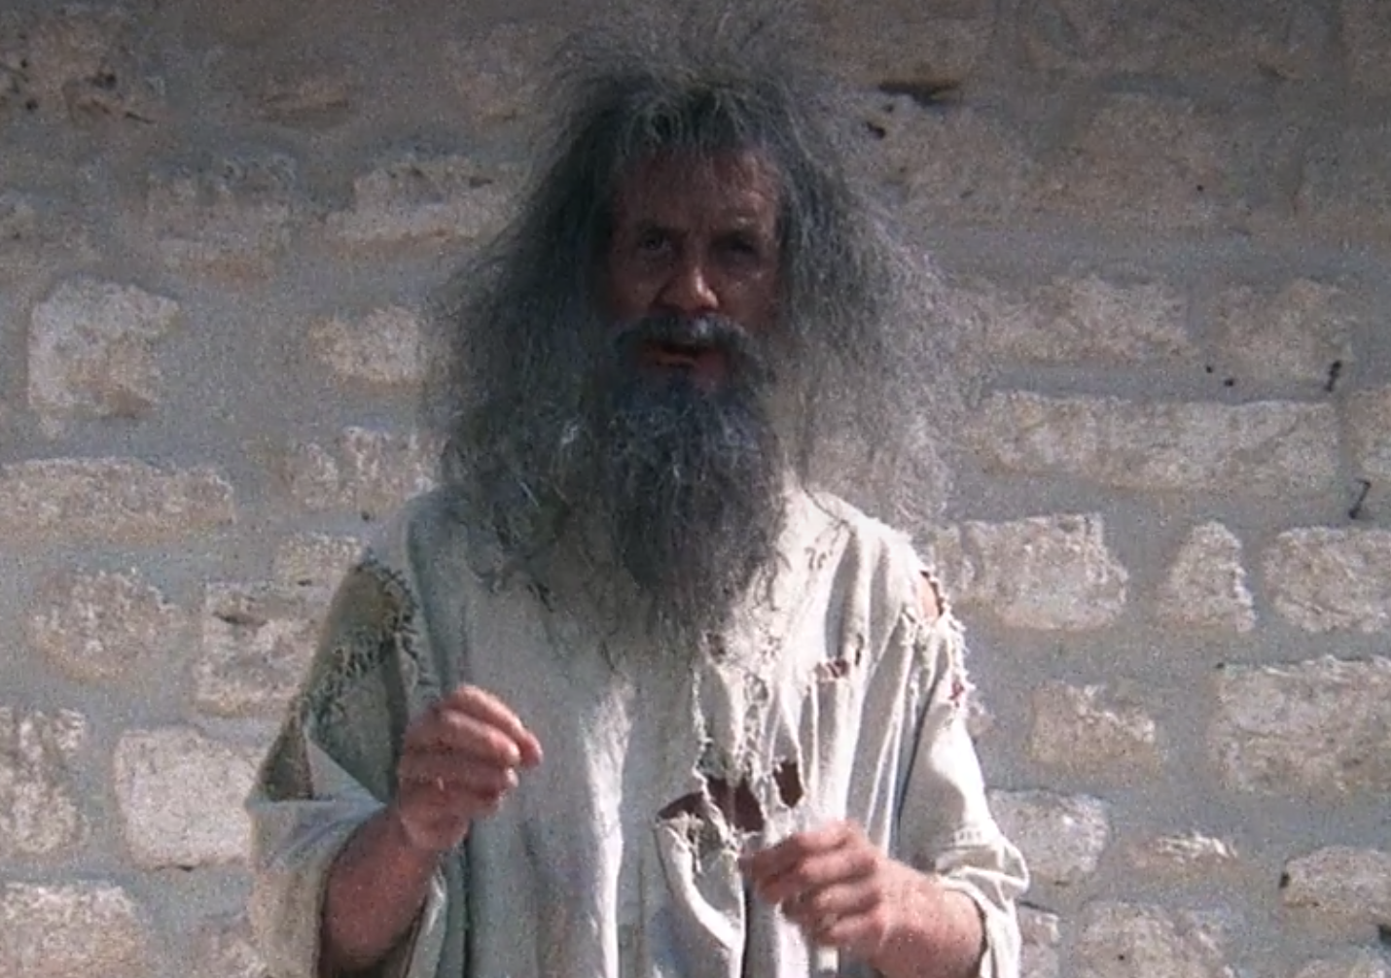 | 5) Mad Max Fury Road  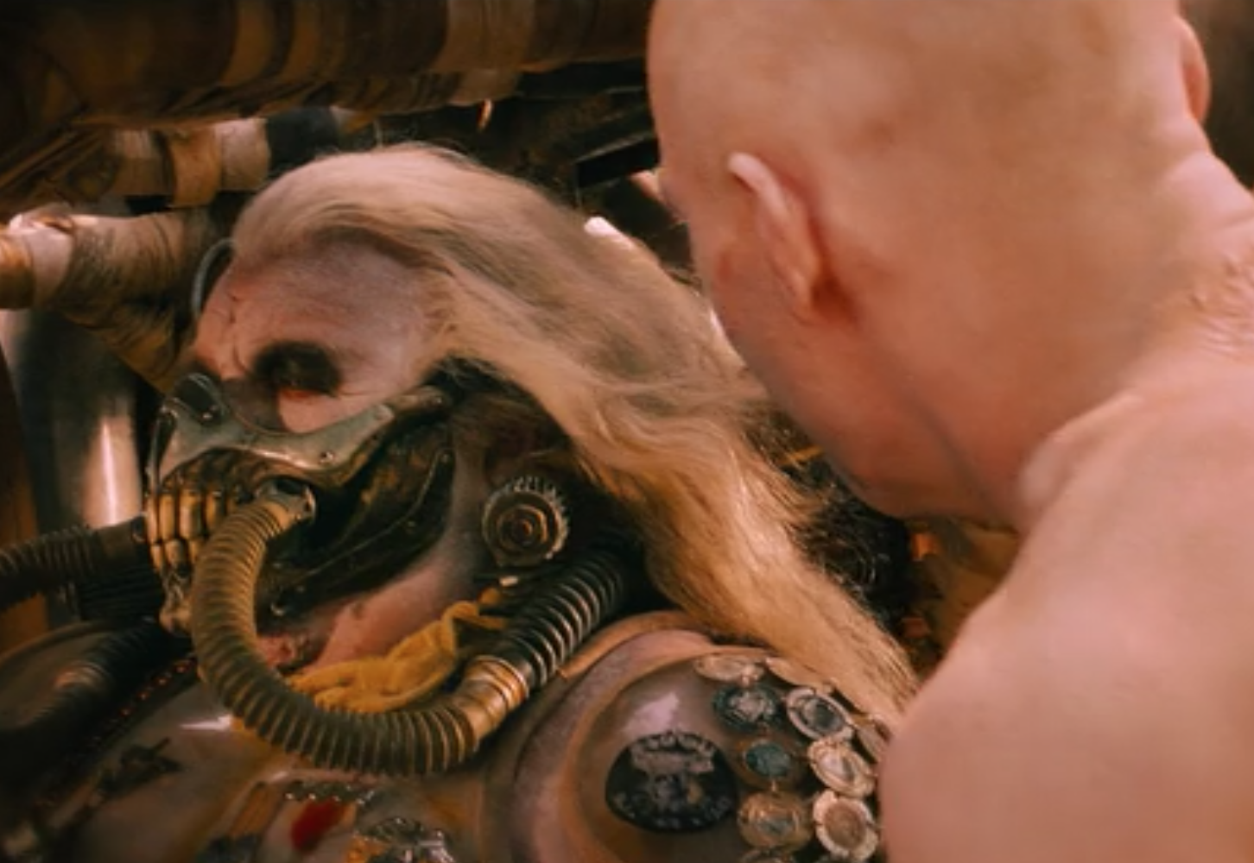 | 6) Watchmen  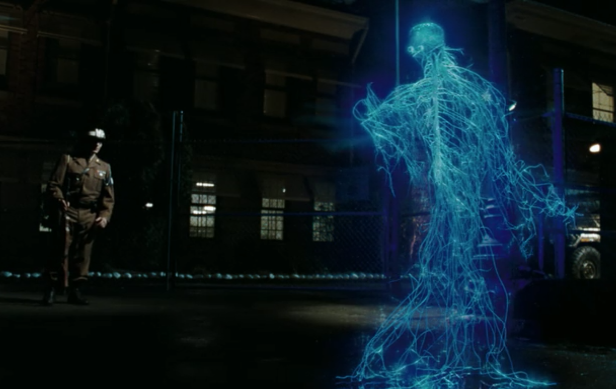
7) Hanna  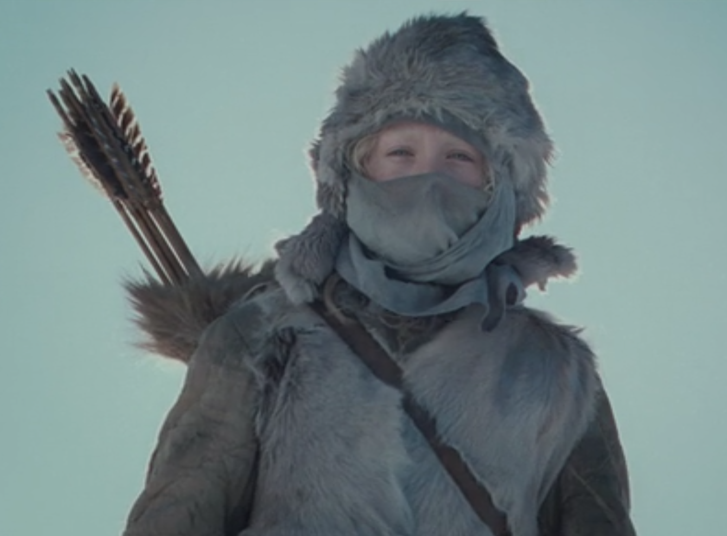 | 8) The Revenant  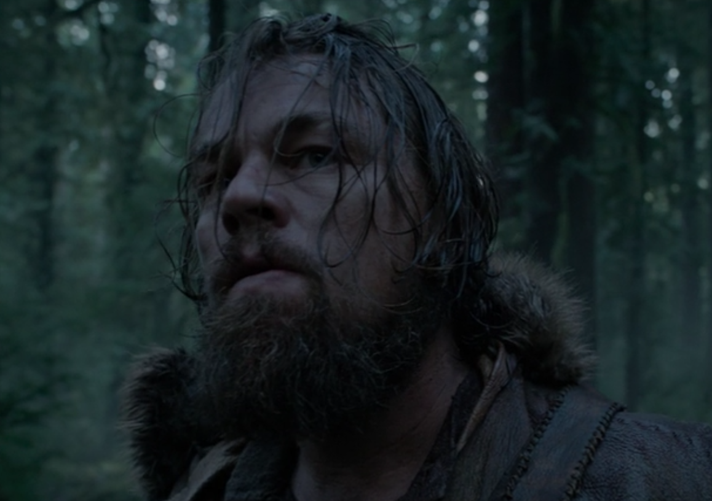 | 9) Oblivion
10) Black Hawk Down  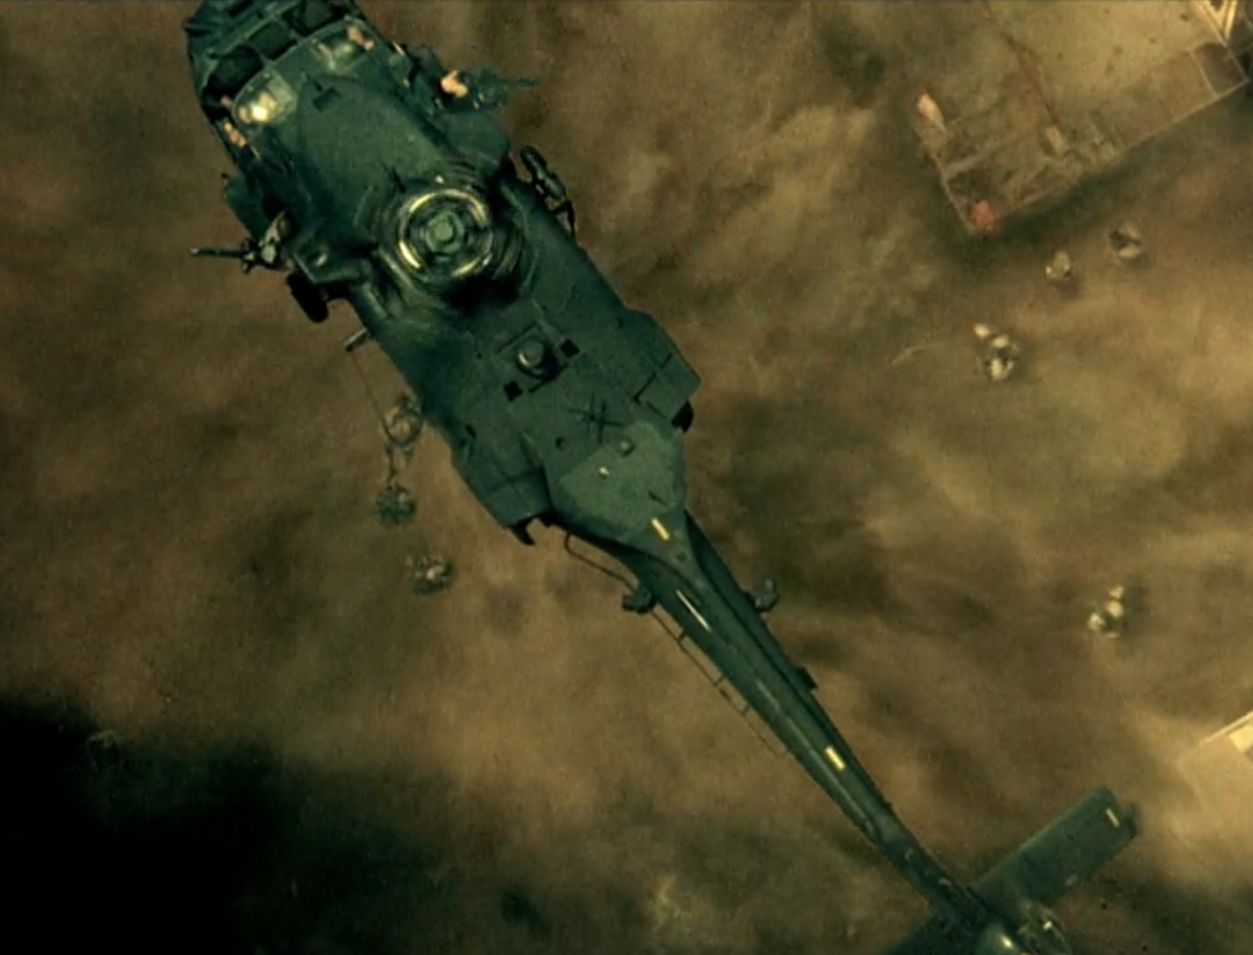 | 11) Pulp Fiction  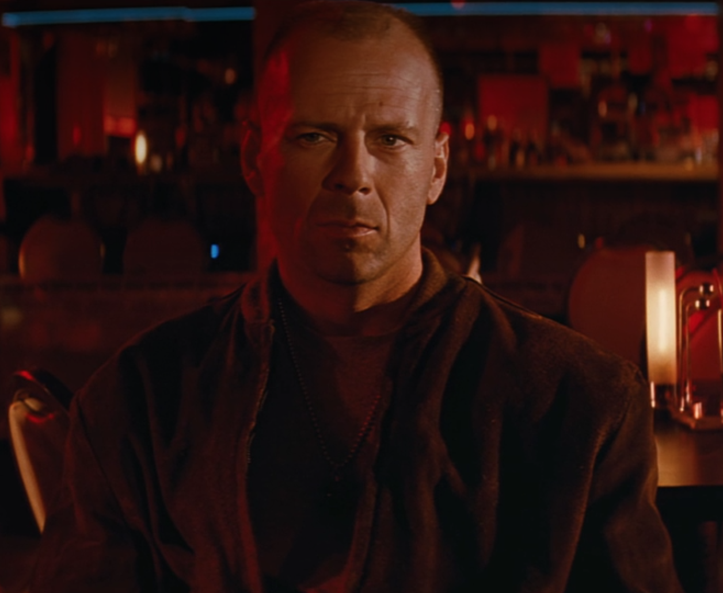
12) Wargames

