Pub Quiz

Round 1: Sport

- Name the two players with most free kick goals in the Italian top division (bonus point for how many goals they’ve scored)
  - Andre Pirlo, Sinisa Mihajlovic (28)
- Which male Tennis players have achieved a career Grand Slam in the open era (half point for each correct answer)
  - Roger Federer, Rafael Nadal, Novak Djokovic, Andre Agassi, Rod Laver
- Who scored the most goals in any of the four divisions of the English football league in a single season (bonus point for how many goals)
  - Dixie Dean, 60 goal
- What is the lowest grid position someone has started in and subsequently won the race in F1 (bonus point for who)
  - John Watson, 22nd
- The most points in a Rugby World Cup game were 145 to 17, who were involved (bonus point for what year)
  - New Zealand v Japan, 1995

Round 2: History

- In what year (within a range of four years) did the word conservative take on the meaning “an opponent of social change” (bonus point for which publication first used it in this sense)
  - 1832, The Times
- What rank was Nelson during the battle of Trafalgar
  - Vice Admiral
- Name the American presidents who won all but one state (Washington D.C. is not counted as a state)
  - Ronald Reagan, Richard Nixon
- Who, and when was the most emphatic election victory in UK parliamentary history (and bonus point if you can say how many MPs were elected for the largest party)
  - Stanley Baldwin, 1931, 470 MPs
- Who was the first person to be crowned Holy Roman Emperor
  - Charlemagne
- The Yamamoto was the largest battleship ever built, it had a sister ship – what was it called
  - Musashi
- What was the first film to win 11 Oscars
  - Ben-Hur

Round 3: Literature

- How many sonnets are in Shakespeare’s sequence?
  - 154 0.
- What was the name of the group of intellectuals in London in the 1920s which included Virginia Woolf and E.M. Forster?
  - Bloomsbury group. 0.
- Who is the current poet laureate?
  - Carol Ann Duffy. 0.
- The film ‘Apocalypse Now’ is based off which modernist novel?
  - (Bonus point for author) Heart of Darkness (Joseph Conrad) 0.
- Mary Ann Evans, the 19th century author, wrote under a male pen name to get her work published. What was this name?
  - George Elliot

Round 4: Collective nouns

- Owls?
  - Parliament.
- Mushrooms?
  - Troop 0.
- Bears?
  - Sloth 0.
- Crocodiles?
  - Bask 0.
- Ravens?
  - Unkindness 0.
- Gorillas?
  - Band 0.
- Hedgehogs?
  - Array 0.
- Hippos?
  - Bloat/pod

Round 5: Politics
- Constance Markievicz was the first woman elected to the House of Commons, which party did she represent
  - (Answer: Sinn Fein)
- Who was Prime Minister when the UK joined the European Communities, which would later become the EU – and for a bonus point, in which year did the UK join?
  - (Answer: Edward Heath, 1973)
- In the 2017 general election, by how many votes did the SNP’s Stephen Gethins win the seat of North East Fife?
  - (Answer: 2 – exact answer needed)
- Who did David Cameron once refer to as his favourite political joke?
  - (Answer: Nick Clegg)
- What was US President Harry S. Truman’s middle name?
  - (Answer: S.)
- Former footballer George Weah became president of which country earlier this year?
  - (Answer: Liberia)

Round 6: Picture round

- London City Hall
- Chrysler Building
- Burj-Khalifa
- Florence Duomo
- Church of Savior on Spilled Blood (allow Church of the Spilled Blood)
- Tate Modern
- Wren’s Library (allow Neville’s court or Trinity College Cambridge)
- Reichstag
- Taipai 101
- Edinburgh Castle

Jackpot question

The Vacheron Constantin Reference 57260 is the most complex pocket watch ever made, how many parts does it have:

2826

Picture round – Name the building

1  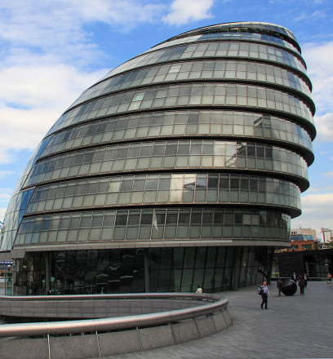 | 2 | 3  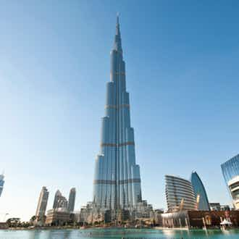
4  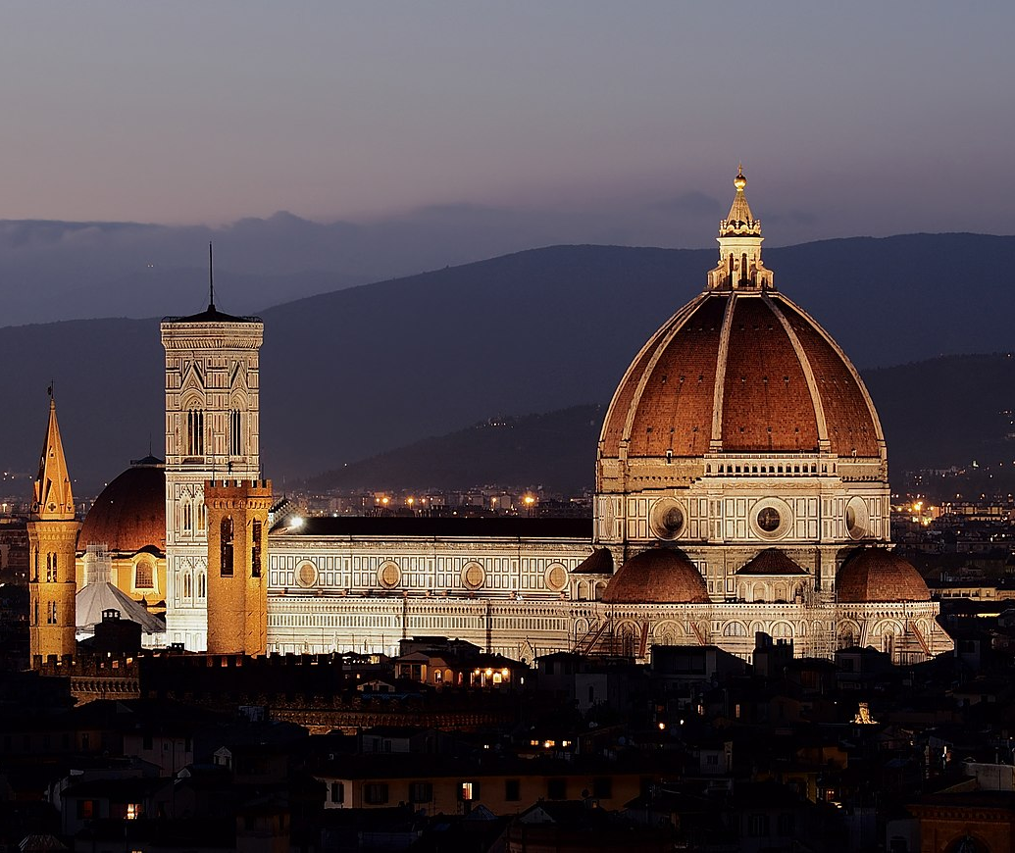 | 5  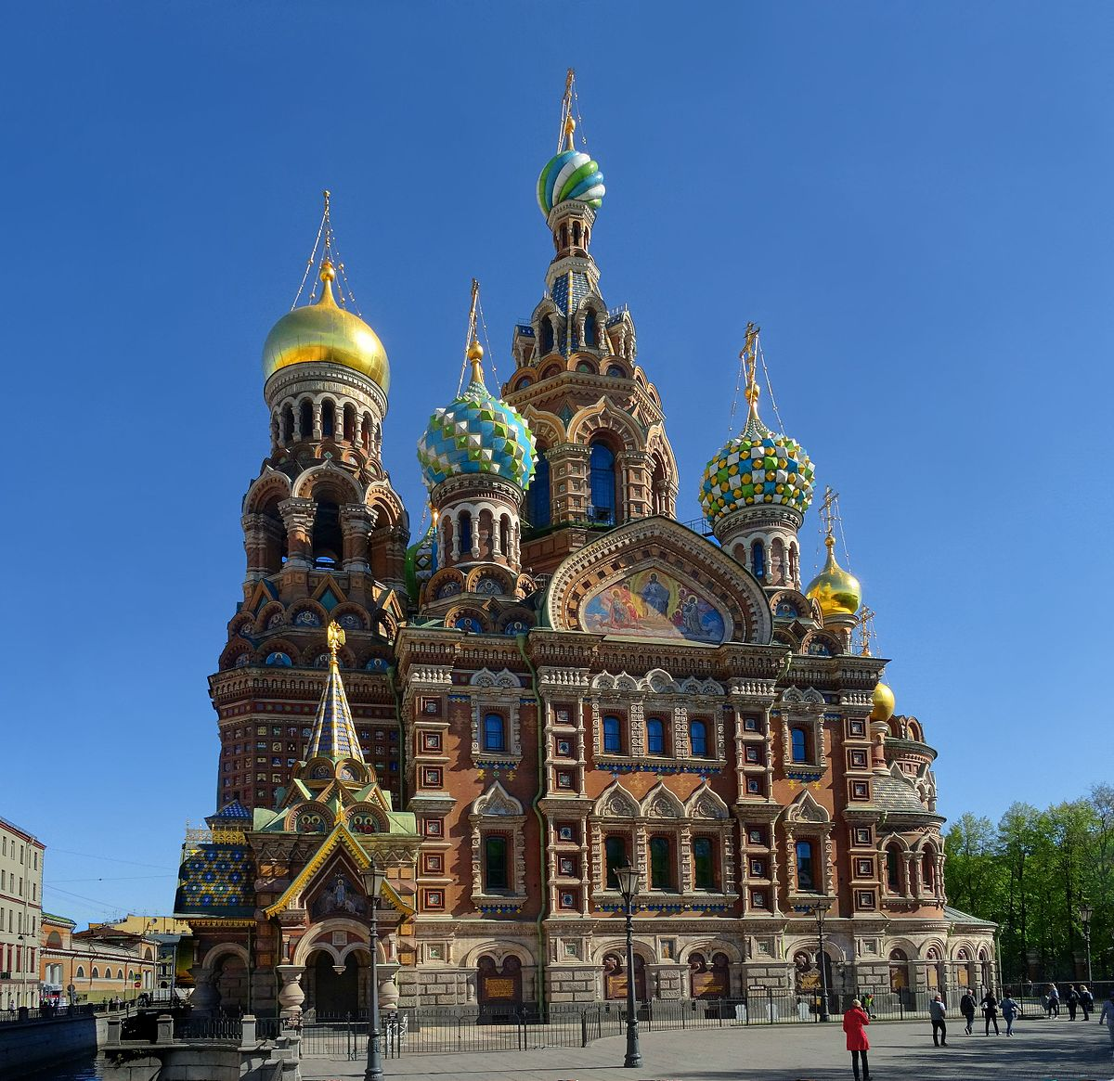 | 6  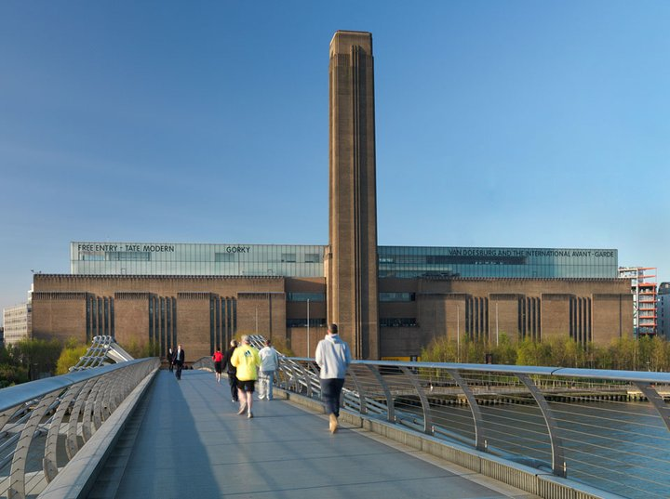
7  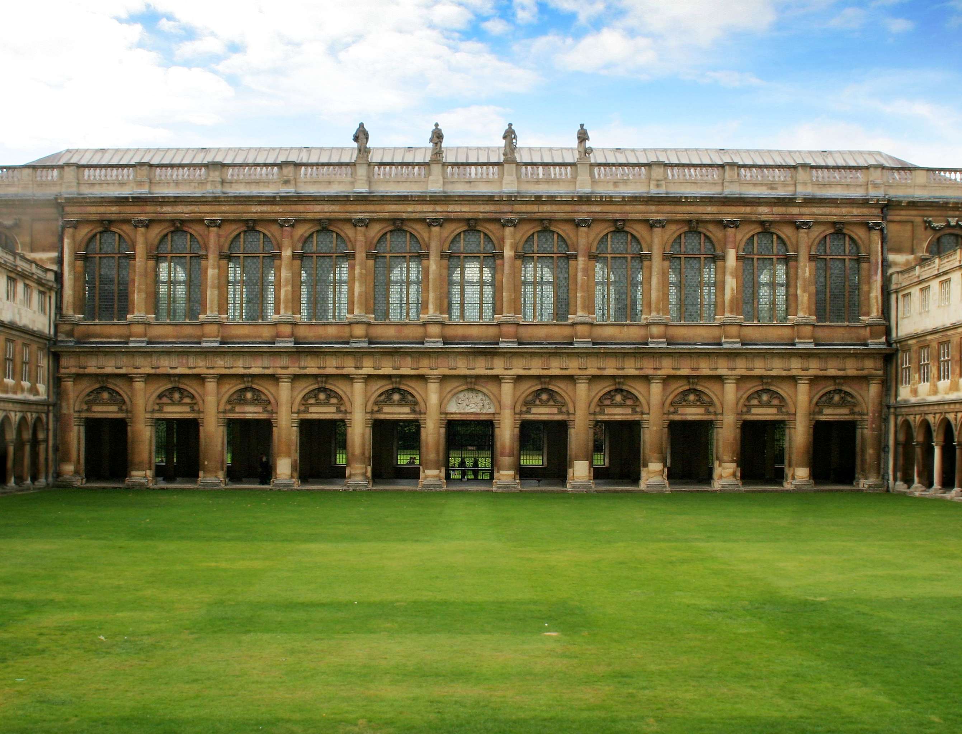 | 8  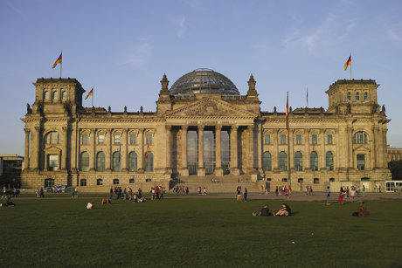 | 9
10
