Round 1: General knowledge
- Who played the title character in the BBC series Jonathan Creek? Alan Davies
- Who succeeded Henry II as king of England? Richard I / Richard the Lionheart
- What was Margaret Thatcher’s middle name? Hilda
- What is the first book of the Bible alphabetically? Acts
- Which action film actor is known as the muscles from Brussels? Jean-Claude Van Damme
- How many episodes were there of the original, UK version of The Office? 14 (two series of six episodes, plus two Christmas specials)

Round 2: What film franchise links these actors?
- Robert Patrick, Christian Bale, Emilia Clarke? Terminator (T2, Terminator Salvation, Terminator Genisys)
- Angelina Jolie, Daniel Craig, Alicia Vikander? Tomb Raider (Lara Croft: Tomb Raider, Tomb Raider)
- Chris Hemsworth, Whoopi Goldberg, Zachary Quinto? Star Trek (Star Trek, TNG)
- Al Pacino, Robert De Niro, Robert Duvall? The Godfather
- Tobey Maguire, Emma Stone, Michael Keaton? Spider-Man (Spider-Man, The Amazing Spider-Man, Spider-Man: Homecoming)

Round 3: Literature
- Which 1965 novel features a desert planet inhabited by giant sandworms? Dune
- Which Stephen King novel takes place mostly in the fictional Overlook Hotel? The Shining
- What is the best-selling novel of all time; Moby Dick, Don Quixote or The Hobbit? Don Quixote
- Which of Shakespeare’s plays features a sorcerer called Prospero? The Tempest
- Who is the protagonist of The Hunger Games? Katniss Everdeen
- Which of her own characters did Agatha Christie call “a detestable, bombastic, tiresome, egocentric little creep”? Hercule Poirot

Round 4: T’Internet
- What was the name of the primary precursor network to the internet, described by Wikipedia as “a backbone for interconnection of regional academic and military networks in the 1980s”? ARPANET
- Which internet service provider features in the 1998 film You’ve Got Mail? AOL
- In what year did Microsoft’s program Internet Explorer debut? 1995
- What is the most-used internet browser in the world? Chrome (61%)
- In 2004, which internet company met with Mark Zuckerberg to discuss buying Facebook, but declined because he was asking for too much money? MySpace
- According to Wikipedia, how many monthly active users does Facebook have? (5% either way) 2.2 billion (2,090,000,000 – 2,310,000,000)

Round 5: Connection round
- What is the name given to an athletic conference of eight private universities in the north-eastern United States? Ivy League
- Which 1973 song beings with the line “Some people call me the space cowboy”? The Joker, Steve Miller Band
- Who starred as the protagonist in the 2000 film Unbreakable? Bruce Willis
- Which character delivered the famous line “Greed is good?” in the 1987 film Wall Street? Gordon Gekko
- Which species of bird is found almost exclusively in the southern hemisphere, with only one species found north of the equator? Penguin
- Who played Dr Doug Ross on the TV series ER? George Clooney
Connection: Batman (Poison Ivy, The Joker, Bruce Wayne, Commissioner Gordon, The Penguin, George Clooney)

Round 6: Star Trek (yes, Star Trek)
- In Star Trek: The Next Generation, what was the name of the Enterprise’s second in command? (½ point for surname, 1 point for surname and first name) William Riker
- What was the subtitle title of the latest Star Trek movie? Beyond
- What species of animal was the focal point of the 1986 movie Star Trek: The Voyage Home? Whales
- Which Star Trek TV series features a female captain as the show’s lead? Star Trek: Voyager
- How many Star Trek movies have there been? 13 (The Motion Picture, The Wrath of Khan, The Search for Spock, The Voyage Home, The Final Frontier, The Undiscovered Country, Generations, First Contact, Insurrection, Nemesis, Star Trek, Into Darkness, Beyond)

Round 7: Picture round: name the famous person each animal looks like (clues provided)
- Adam Driver
- Donald Trump
- Samuel L Jackson
- Richard Branson
- Vladimir Putin
- John Travolta
- Adolf Hitler
- Harrison Ford
- Adrian Brody
- Lenin

Jackpot: According to Google, what is the current population of Japan? (2% either way)
Answer: 126,800,000 (124,264,000 – 129,336,000)

Picture round: name the famous person each animal looks like (clues provided)

1) Join me… | 2) It’s gonna be great  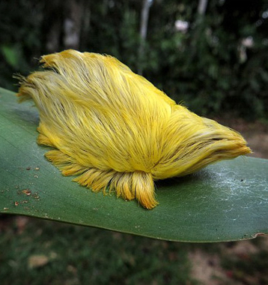 | 3) Motherf*cker | 4) Lost… in… spaaaaaace! | 5) Don’t annoy me or I might just send someone to kill you  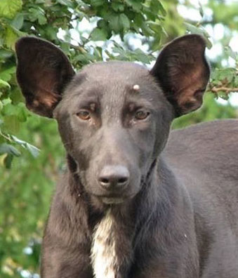
6) I (used to) feel like dancin’ | 7) EVERYBODY HATES ME | 8) Named after me? | 9) I’m that guy with that nose  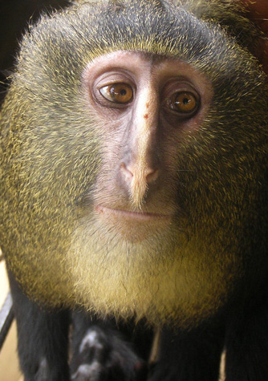 | 10) Everyone needs an ism

