Team name:

Answers

Round 1

1.

2.

3.

4.

5.

6.

Round 2

1.

2.

3.

4.

5.

6.

Round 3

1.

2.

3.

4.

5.

6.

Round 4

1.

2.

3.

4.

5.

6.

Round 5

1.

2.

3.

4.

5.

6.

Round 6

1.

2.

3.

4.

5.

6.

Round 7

1.

2.

3.

4.

5.

6.

Round 8

1.

2.

3.

4.

5.

6.

Team name:

Picture round

From the covers, name these best selling 21st century albums and artists. (½ point for artist, ½ point for name of album)

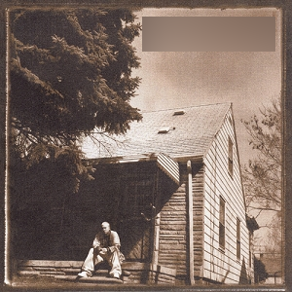  1. | 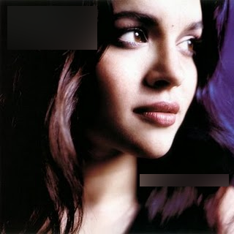  2. | 3.
4. | 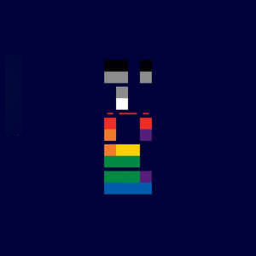  5. | 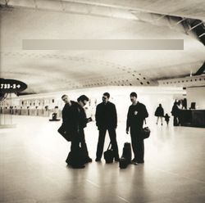  6.
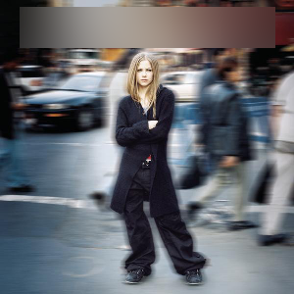  7. | 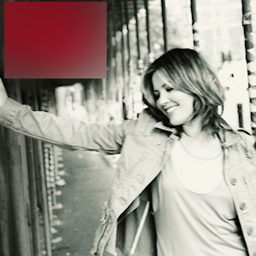  8. | 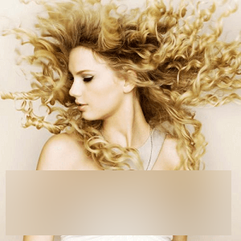  9.
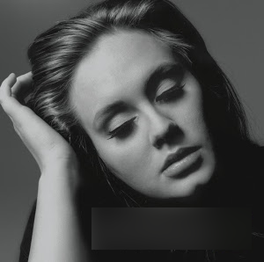  10. | 11. | 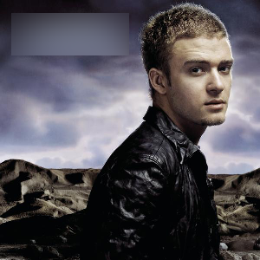  12.

