Round 1: Connections round
- By What name are members of the Unification Church colloquially known, after the name of their Korean founder?
  - Moonies
- What was Alphaville’s only UK top 10 hit?
  - Big in Japan
- Which playwright wrote “Cat on a hot tin roof”?
  - Tennessee Williams
- Whose perfume range includes Just Me and Heiress?
  - Paris Hilton
- Which newspaper ran the headline “Freddie Star ate my hamster”?
  - The Sun
- Which cocktail consists of vodka, ginger beer and lime juice?
  - Moscow mule
- What is the link between all of the previous answers:
  - all places which have had chemical elements named after them. (Selenium, Nihonium, Tenessine, Lutetium, Helium, Moscovium

Round 2: Sport & games
- Which Olympic athletics event has world records which stand at 74.08 metres for men and 76.80 metres for women?
  - Discus
- How many pins need to be knocked down to achieve a perfect score of 300 in 10 pin bowling?
  - 120 (10 strikes and then two strikes in the bonus frames after the last strike)
- Since the founding of the IAAF in 1912 nine US athletes have held the men’s 100m world record outright (ie they were the first to set a unique time not shared with anyone else). How many non-US male athletes have held world record outright in the same time period?
  - 5
- If you throw one dart at a dart board how many different scores is it possible to achieve? (NB 0 doesn’t count)
- (1-60 EXCEPT 59, 58, 56, 55, 53, 52, 49, 47, 46, 44, 43, 41, 37, 35, 31, 29, 23)
- How many spots are there in total on a set of 0 to 6 dominoes?
  - 168
- In indoor athletics men compete in a heptathlon, not a decathlon. Name the 7 events.
7 correct = 3 points. 6 correct = 2 ½, 5 = 2, 4= 1 point. Nothing for fewer than 4.
60m (sprint) long jump shot put high jump 60m hurdles pole vault 1000m

Round 3: Television
- Which couple were the first winners of Love Island?
  - Jessica Heyes and Max Morley
- Who won the final season of Big Brother in 2018?
  - Cameron Cole
- Which is the most successful act from X-factor in terms of records sold?
  - One direction
- Who won the first series of The Great British Bake-off?
  - Edd Kimber
- In 2009 Susan Boyle finished second in Britain’s got talent, after having been the favourite for the final. Which dance group won?
  - Diversity
- Who was the first winner of Strictly Come Dancing?
  - Natasha Kaplinksy
- Put the 6 series from the previous questions (Love Island, Big brother, X-factor, Bake off, I’m Britain’s got talent, Strictly) in the order that they first appeared on UK TV. ½ point for each in the correct place.
  - Big brother (2000)
  - Strictly (15 May 2004)
  - X-factor (4 Sep 2004)
  - Britain’s Got Talent (2007)
  - Bake off 2010
  - Love island 2015

Round 4: Connections round
- Which Cambridge college was founded in 1584 on the site of an old Dominican Priory?
  - Emmanuel college
- In 1963 which Liverpool group became the first to reach number 1 in the UK with their first 3 singles?
  - Gerry and the Pacemakers
- Who invented the time machine in back to the future?
  - Doc Emmet Brown
- Which British cyclist won golds in the 2008 and 2012 Olympics, and later spent a period as a jockey?
  - Victoria Pendleton
- Who was the man of a thousand voices, who voiced most of the Loonie Tunes cartoon characters including Bugs Bunny, Daffy Duck, and later Barney Rubble?
  - Mel Blanc
- Which Brewery, founded in 1845, has just anounced the sale of all of its Beer products to Asahi?
  - Fullers
- What is the link between the previous answers?
  - The spice Girls (Simon Fuller managed them, Emma Bunton, Geri Halliwell, Mel Brown, Victoria Adams, Mel Chisholm)

Round 5: Geography
Each of the following questions is the name of a river that flows through more than one Capital city. Name all of the capital cities that each flows through.1/2 point for each (no need for the country)
- The Danube
  - Belgrade (Serbia), Budapest (Hungary), Bratislava (Slovakia), Vienna (Austria)
- The River Plate
  - Buenos Aries (Argentina) & Monte Video (Uruguay)
- The Congo
  - Kinshasa (Democratic Republic of the Congo) & Brazzaville (Congo)
- The Mekong
  - Phnom Pen (Cambodia) & Vientiane (Laos)
- The Niger
  - Bamako (Mali) & Niamey (Niger)
- The Nile
  - Khartoum (Sudan) & Cairo (Egypt) (Not Juba in South Sudan, that’s the White Nile)
Round 6: Seconds
- Who is the second companion that Dorothy meets in the Wizard of Oz?
  - The Tin man
- At the end of the Apollo 13 mission in 1970 Jim Lovell became the only person to have achieved what probably unwanted double?
  - He is the only person to have travelled to the moon twice but not landed on it.
- On the first of January 1964 which group were the second to appear on Top of the Pops?
  - The Rolling Stones
- Who was the second England player to be sent off during a world cup finals match, just over 12 years after the first?
  - David Beckham
- What was Linus Pauling the second person to achieve?
  - Win two Nobel Prizes (Chemistry & Peace)
- List all the cities that have hosted the Summer Olympic Games at least twice.
  - Athens, Paris, London, Los Angeles
Answers to Picture Round
- Little Miss Bossy  - Little Miss Fabulous  - Little Miss Somersault  - Little Miss Inventor  - Little Miss Twins  - Little Miss Whoops  - Little Miss Chatterbox  - Little Miss Greedy | - Little Miss Star  - Little Miss Neat  - Little Miss Splendid  - Little Miss Princess  - Little Miss Shy  - Little Miss Scary  - Little Miss Tiny  - Little Miss Stubborn
Jackpot question: Roger Bannister was the first person to run a mile in under 4 minutes. John Landy of Australia was the next. For how many hours did Roger Bannister hold the world record? (range is 12 hours, which represents my level of uncertainty in the timing)
Answer: between 1093 and 1105 hours. (6pm on 6th May 1954 in the UK to some time on the 21st June 1954 in Finland – I took 09:00 to 21:00 Finnish time)

Name the characters
1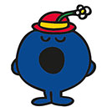 | 2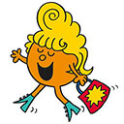 | 3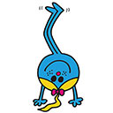 | 4
5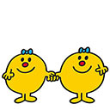 | 6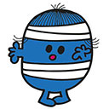 | 7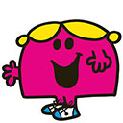 | 8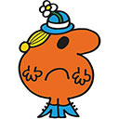
9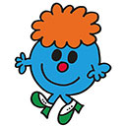 | 10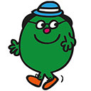 | 11 | 12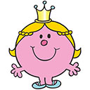
13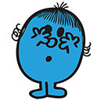 | 14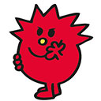 | 15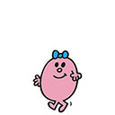 | 16