First Lines.

- I got my first real six string bought it at the five and dime, played it ‘till my fingers bled. (Summer of 69 - Bryan Adams.)
- I’ve been cheated by you since I don’t know when, so I made up my mind it must come to an end. (Mamma Mia - ABBA.)
- Train whistle blowin’ makes a sleepy noise; underneath their blankets go all the girls and boys. (Morningtown Ride – The Seekers.)
- When I got home that night early one morning, seeing the note written in ink pinned to the door. (Roll Over Lay Down – Status Quo.)
- Finished with my woman ‘cause she couldn’t help me with my mind, people think I’m insane because I am frowning all the time. (Paranoid – Black Sabbath.)
- This is the end, hold your breath and count to ten, feel the earth move and then, hear my heart burst again. (Skyfall – Adele.)
- You think I’m pretty, without any make-up on. You think I’m funny, when I tell the punch line wrong (Teenage Dream - Katy Perry.)

14 points

Food & Drink

- What is the tall hat a chef wears called? (Toque Blanches – toque - hat, blanches - white.)

- Which culinary delight did Margret Thatcher and a team of chemists help develop in the late 1940’s? (Soft scoop ice cream.)

- Why are 'quatorziennes' a welcome addition at the dinner table? (They are the 14th guest. Thirteen guests are or were considered to be unlucky. Quatorziennes are those who are ready to be called upon and save the evening.)

- What would you be eating if you ordered pamplemousse in a French restaurant? (Grapefruit.)

- The annual wine consumption in which small European country is 59.01 litres per person; a world record? (The Vatican State.)

- Which popular fruit; with variety names such as Bing, Lambert, Royal Ann and Empress; was apparently first introduced into England by Henry VIII? (Cherry.)

- Where is the oldest distillery in the world? (The Old Bushmills, County Antrim.)

7 Points

Geography.

- Which U.N. country has a flag with no colours in common with The Union Jack? (Jamaica.)

- Where are the three apexes of the Bermuda Triangle? (Bermuda, Miami & San Juan, Puerto Rico.)

- The name of which European country stems from the Germanic word for foreign? (Wales.)

- On which country’s flag would you find 2 cows? (Andorra.)

- With what country is France’s longest land border? (Brazil, because of French Guiana.)

- Which country has the most time zones? (France.)

- Since 1572, which countries flag is the oldest tricolour flag in the world? (The Tricolour of the Netherlands.)

9 Points

History.

- Name the five Allied code names for the beaches in Normandy on D-Day. 1 point for each correct answer. (Utah, Omaha, Gold, Juno and Sword.)

- What were the first four words to the speech given by King George VI when he addressed the nation on September 3rd, 1939? ("In this grave hour".)

- British Greek Sir Alexander Arnold Constantine Issigonis, was widely noted for the ground-breaking and influential development of what, that was launched in 1959? (The Mini.)

- The largest building in Britain in the late 18th century measured 1,094 ft. long, (nearly a quarter of a mile) by 54 ft. wide. In which city was it found and for an extra point, what was it used for? (Portsmouth. The 'Rope House' was where the rigging for Royal Navy ships was made.)

- During the 18th century Rupert’s Land varied in size from roughly that of modern day France to that of modern day Europe. What is Rupert’s Land called today? (Canada.)

- Queen Elizabeth I was the first British monarch to use what at the dinner table? (A fork.)

- What was unusual about the Roman Senator Incitatus? (He was a horse - Caligula’s.)

12 Points

Odds & Sods.

- Which defeat turned into a victory on April 6th 1974? (Waterloo - Abba won Eurovision Song Contest.)

- What usually moves in a clockwork direction at 12 m per second? (Mexican Wave.)

- Which famous board game is a combination of a French and a German word? (Ouija.)

- What does a cerevisaphile love? (Beer.)

- What does it mean if an honest person's left pronubus is bare? (They are not married. The left pronubus is the ring or wedding finger.)

- The 17.3 mile tunnel from East Finchley to Morden, the longest on the London Underground system is on which line? (Northern.)

- Which famous Russian female made around the world headlines after the 3rd of November 1957? (Laika. The Russian cosmonaut dog. (or muttnik )

7 Points

People.

- Which Irish actor was nominated eight times for an Oscar and never won, a record? (Peter O’Toole.)

- Who was the first female to win I’m A Celebrity Get Me Out Of Here? (Kerry Katona)

- Who fell head over heels in love with Annabelle Ann Darrow? (King Kong.)

- Who was Lisa Gherardini? (Model for Mona Lisa.)

- Dr Marsh Tracy was better known as whom? (Daktari.)

- What is Sir Paul McCartney’s middle name? (Paul.) His first name is James.

- Which little woman has been all of the following: dentist, doctor, firefighter, astronaut, palaeontologist and US Presidential candidate? (Barbie.)

7 Points

Finally…. The Jackpot Question…….
Plus or minus 2% what is the distance, in metres, in a straight line from Chicago Airport to London Heathrow? (6,437,376.) (6,308,628 – 6,566,124)

56 Points (+ Picture Quiz 20 points)

Round 7: Identify the breed of dog
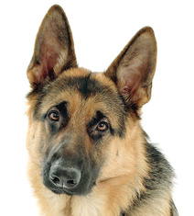  1 German shepherd | 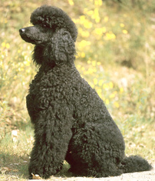  2 Poodle | 3 Daschund  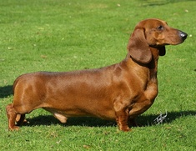 | 4 Chihuahua  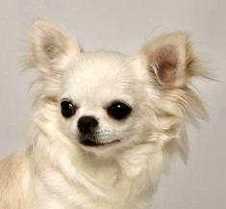
5 Beagle  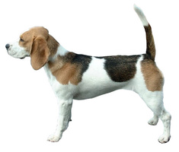 | 6 Siberian Husky  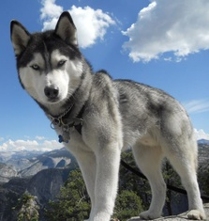 | 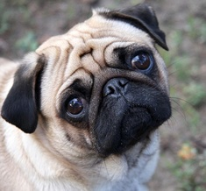  7 Pug | 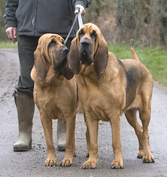  8 Bloodhound
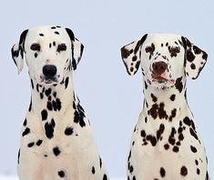  9 Dalmatian | 10 Bichon Frise | 11 Shiba Inu | 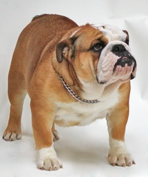  12 Bulldog
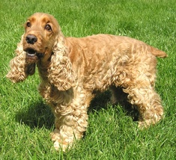  13 Cocker spaniel | 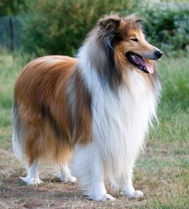  14 Rough collie | 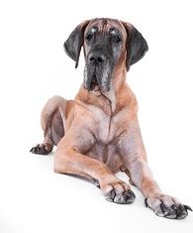  15 Great dane | 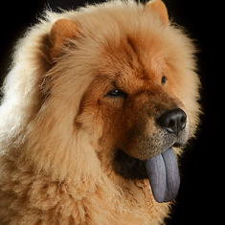  16 Chow chow
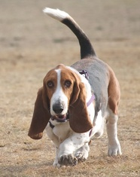  17 Basset hound | 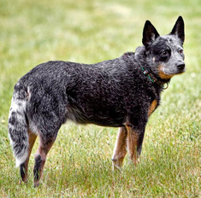  18 Australian cattle dog

