Round 1: Formerly known as…
- Pluto was formerly known as a planet, but what is it now known as? For a bonus half point, what year did it stop being a planet? Dwarf planet, 2006 (exact only)
- What was Ethiopia formerly known as? Abyssinia
- Who is the person formerly known as Marion Mitchell Morrison better known as? John Wayne
- The late musician Prince dropped his stage name and became known as The Artist Formerly Known as Prince after falling out with his record company, but in what year did this happen? (need to be exact) 1993
- Muhammed Ali was formerly known as Cassius Clay, but what prompted him to change his name? Joining the Nation of Islam
- Formerly known as the Blackjacks, then the Quarrymen, then a couple of other names, what is this band best known as today? The Beatles

Round 2: TV
- In the TV Show The X-Files, what were the first names of agents Mulder and Scully? Fox and Dana (½ point for each)
- In what year was Netflix founded? Clue: it wasn’t always a streaming service (1 either way). 1997 (1996 – 1998)
- Who played Walter White in the hit TV series Breaking Bad? Bryan Cranston
- What was seen on TV for the first time in history on 1st July 1941, before the beginning of a baseball game between the Brooklyn Dodgers and the Philadelphia Phillies? A TV commercial (for Bulova watches, in case you’re interested)
- What is the longest-running emergency medical drama television series in history? Casualty (FYI: first broadcast on 6th Sep 1986)
- To date, how many people have legitimately won the million-pound prize on the UK version of Who Wants to Be a Millionaire? (i.e. not counting cheating Charles Ingram). 5 (exact only)

Round 3: Technology
- What does HDMI stand for? High-Definition Multimedia Interface
- Speculation has begun to mount that Apple will close the iTunes store in favour of streaming-based apps instead. What did iTunes do in 2014 that upset a lot of its users? Automatically sent every user a copy of U2’s new album, Songs of Innocence, whether they wanted it or not
- Which company released the first commercially available CD player: Sharp, Hitachi or Sony? (bonus ½ point for year, 1 either way): Sony, 1982 (1981-1983)
- Which organisation’s first tweet, sent on 6th June 2014, read “We can neither confirm nor deny this is our first tweet”? The CIA
- What do the films X-Men: The Last Stand, Terminator Genisys and Rogue One: A Star Wars Story all have in common? They all feature characters made to look younger via digital de-aging technology
- What was the name of the American operation after WWII, where German scientists, engineers and technicians were taken out of Germany to the US, so that they could benefit from their knowledge and expertise? Operation Paperclip

Round 4: Music
- Who were the other two members of Destiny’s Child, other than Beyoncé Knowles, in its most famous line up? (½ each). Kelly Rowland and Michele Williams
- Who composed the Four Seasons? Vivaldi
- What was Coldplay’s first top 5 single? Yellow
- What was Elvis Presley’s first US number one hit single on the Billboard Hot 100 charts? Heartbreak Hotel
- Which artist made the 10th best-selling album of all time, Come On Over? Shania Twain
- Which British 1980s pop group took their name from a mad scientist in the movie Barbarella? Duran Duran

Round 5: History
- In what type of business establishment did the great fire of London start? A bakery
- In what year did the construction of Hadrian’s Wall commence? (20 either way). 122AD (102-142AD)
- Which king is believed to have died after being shot in the eye with an arrow at the Battle of Hastings in 1066? Harold
- In what year did the Battle of Stalingrad begin? (exact only) 1942
- Who shot and killed Lee Harvey Oswald? Jack Ruby
- What did the Queen open on 6th May 1994, which cost £14 billion to build (adjust for inflation), and was a year late? The Channel Tunnel

Round 6: Films
- Which film contains the line “This was no boating accident”? Jaws
- In what year was the first Star Wars film released? (exact year only) 1977
- Which eccentric character produced the 1920s and 30s films The Racket, Hell’s Angels and Scarface? Howard Hughes
- What unusual distinction does the 2005 film A History of Violence have? It was the last major Hollywood film to be released on VHS
- Who directed the 1990 film Dances with Wolves? Kevin Costner
- Which film is set in the Nakatomi Tower in Los Angeles? Die Hard

Round 7: Picture round
- Airwolf
- Voyager
- TARDIS
- Blue Thunder
- KITT
- ECTO-1
- The Interceptor
- Optimus Prime
- Silver
- Bluesmobile
- Canyonero
- Galactica

Jackpot Question
Russian cosmonaut Valeri Polyakov holds the record for the single longest stay in space, which was aboard the Mir space station. How long was he in space in minutes? 1% either way.

Answer: 630,360 minutes (624,056.4 – 636,663.6 minutes)

Round 7: Picture round: name the vehicle (or horse) from film & TV (not the film or TV show!)

1  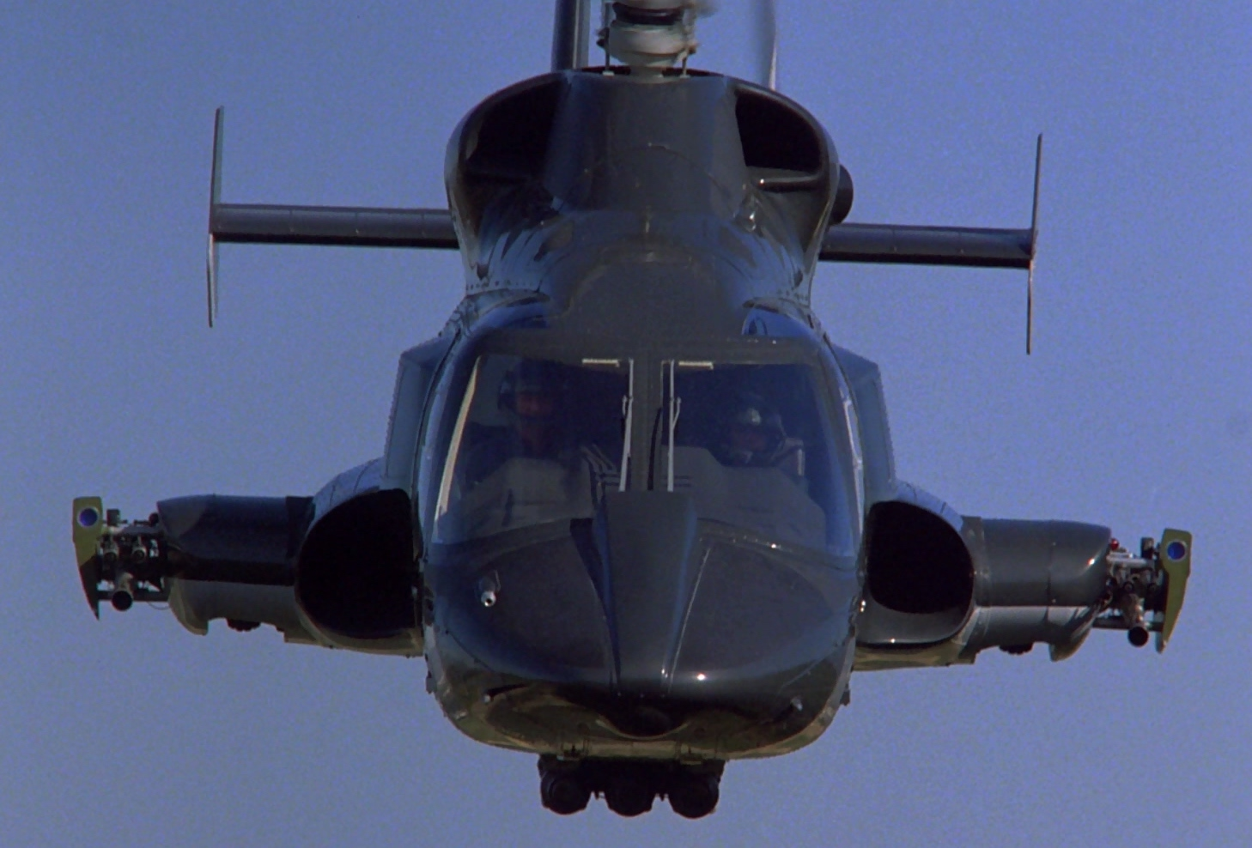 | 2  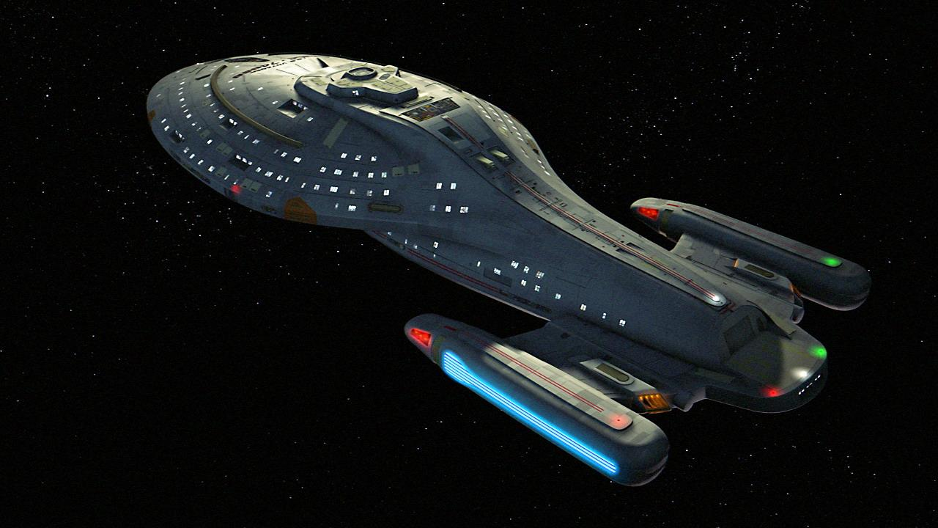 | 3  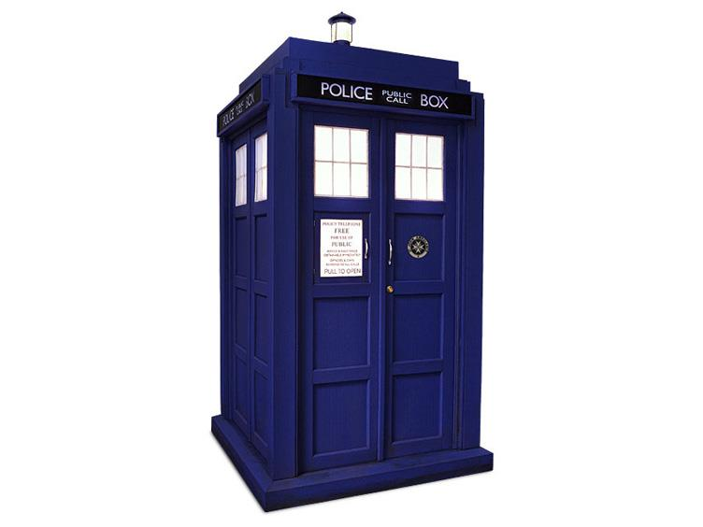
4 | 5  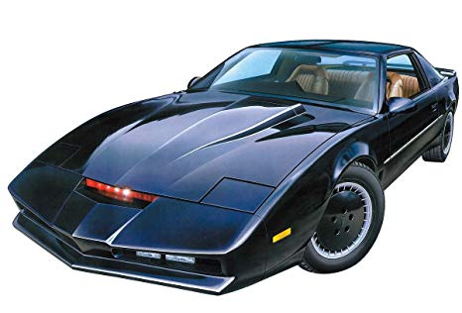 | 6  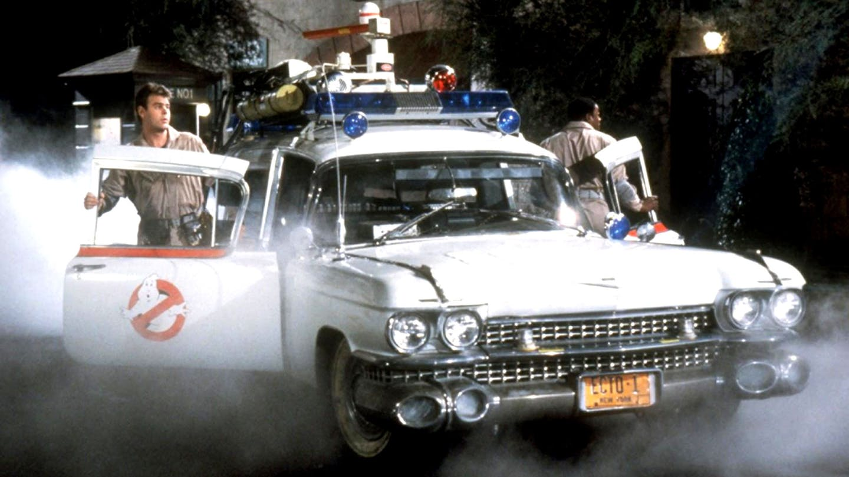
7  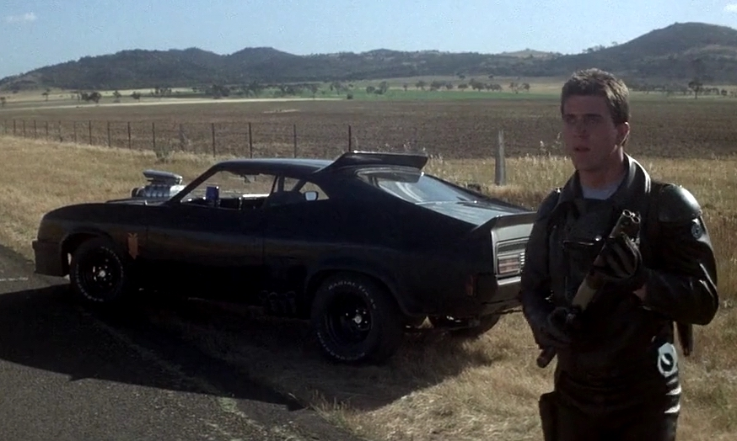 | 8  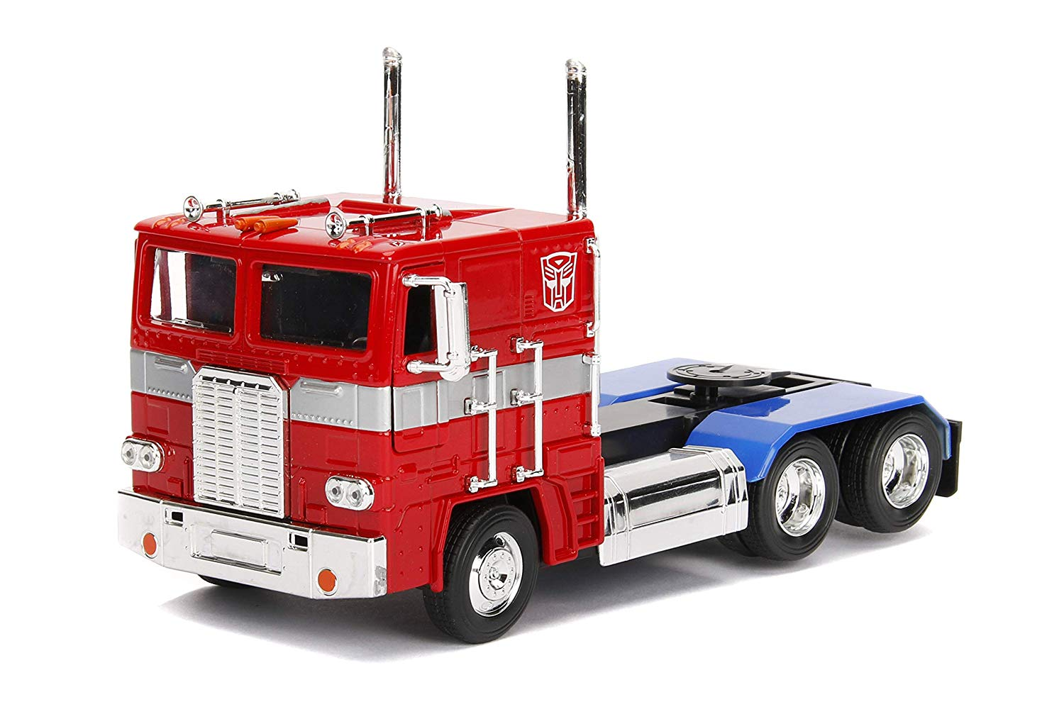 | 9  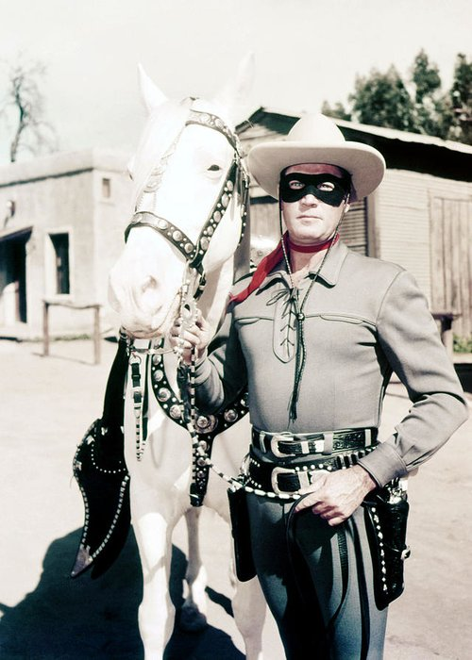
10  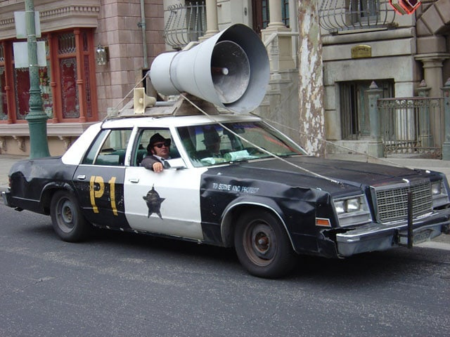 | 11 | 12  