Round 1 – Which film…
- Which three films are the three top rated on the IMDB website? (order doesn’t matter, ½ point for each) The Shawshank Redemption, The Godfather, The Godfather Part II
- Which 2006 US film directed by Martin Scorsese is a remake of the 2002 Hong Kong film Infernal Affairs? The Departed
- Which film featured the song I don’t want to miss a thing by Aerosmith on its soundtrack? Armageddon
- Which was the first film in the Marvel Cinematic Universe? Iron Man (2nd May 2008)
- Which film contains the famous line “Get away from her, you bitch!”? Aliens
- Which film features Christopher Lloyd as an eccentric inventor named Emmett Brown? Back to the Future

Round 2 – Random knowledge
- Tsutomu Yamaguchi (1916-2010) was, in 2009, recognised by the Japanese government for what? Clue: he is one unlucky guy (or very lucky, depending on how you look at it) – survivor of both the Hiroshima and Nagasaki bombings
- What is the best-selling video game console of all time? Is it the Nintendo DS, the Playstation 2 or the Nintendo Game Boy? Playstation 2
- Who was manager of England when they beat San Marino 7-1 whilst trying to qualify for the 1994 world cup? (they didn’t) – Graham Taylor
- On which side of the road do cars drive on in Japan? Left
- What is the sixth planet from the Sun? Saturn
- In what year was Stephenson’s Rocket designed? (5 either way) 1829 (1824 – 1834)

Round 3 – Connections
- What is the device used in planes to record information about the flight for the purpose of air accident investigation better known as? Black box (Xbox)
- The bobcat is a member of which genus of wild cats, characterised by the tufts of black hair on the tips of their ears, making them look rather pointy? Lynx (Atari Lynx)
- Complete the title of this 2002 comedy-drama film starring Hugh Grant and based on a novel by Nick Hornby: About a …? Boy (Game Boy)
- What device used in electrical engineering to make or break a circuit shares its name with a flexible rod used for corporal punishment? Switch (Nintendo Switch)
- What was Skylab? A US Space station (PlayStation)
- What word is a prefix used in metric systems to denote a factor of one million? Mega (Mega Drive)
- CONNECTION: video game consoles

Round 4 – Wine
- In which country is Rioja produced? Spain
- In which country is the Marlborough wine region? New Zealand
- Which red wine is drunk when young and is called “nouveau”? Beaujolais
- In which part of the United States is the Zinfandel grape cultivated? California
- Claret wine is produced in the region surrounding which French city? Bordeaux

Round 5 – Better known as…
- Krishna Pandit Bhanji – Ben Kingsley
- Georgios Panayiotou – George Michael
- Terry Gene Bollea – Hulk Hogan
- Archibald Alec Leach – Cary Grant
- Norma Jean Mortensen – Marilyn Monroe
- Henry Charles Albert David – Prince Harry

Round 6 – Who said this? Taylor Swift… or Adolf Hitler?
- As a Christian I have no duty to allow myself to be cheated, but I have the duty to be a fighter for truth and justice – Adolf Hitler
- I’m very aware and very conscious of the path I chose in life, and very aware of the path I didn’t choose – Taylor Swift
- And I can fight only for something that I love, love only what I respect, and respect only what I at least know – Adolf Hitler
- Words build bridges into unexplored regions – Adolf Hitler
- I have a recurring dream that people are lined up next to my bed, waiting for autographs and taking pictures of me – Taylor Swift
- When you walk out onstage in front of 65,000 people, it can bring you to tears – Taylor Swift
- If you want to shine like the sun you first have to burn like it – Adolf Hitler

Jackpot question
How many number one singles have there been in the UK this century? 1% either way. 507 (275 in 2000s + 232 in 2010s) (502 – 512)

Picture round – name the film or TV show from the emojis

1 - Kiss Kiss Bang Bang  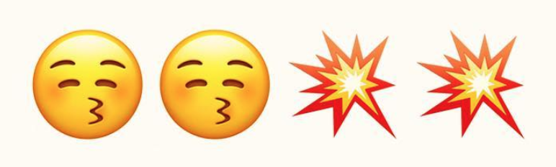 | 2 - Walk the Line  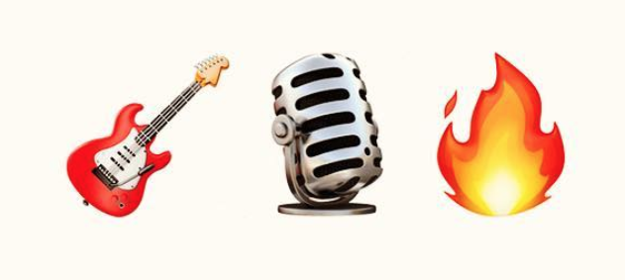 | 3 - Edward Scissorhands  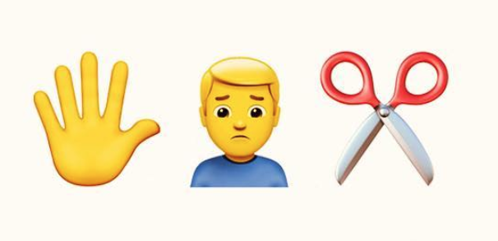
4 - Ghostbusters | 5 - Harry Potter | 6 – The Wolf of Wall Street
7 - Teenage Mutant Ninja Turtles  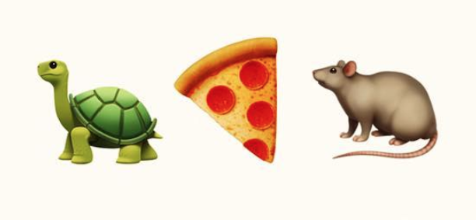 | 8 - Breaking Bad  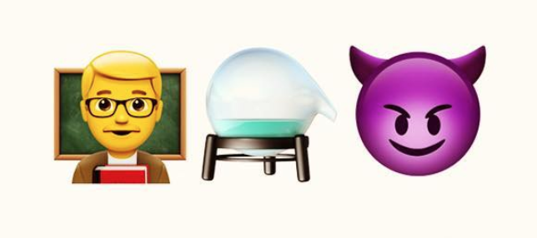 | 9 – Game of Thrones  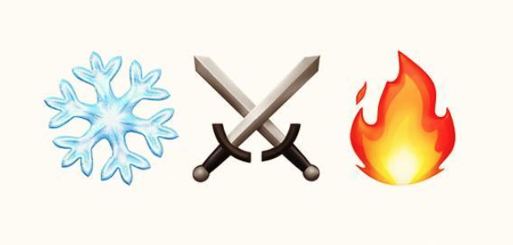
10 - Whiplash  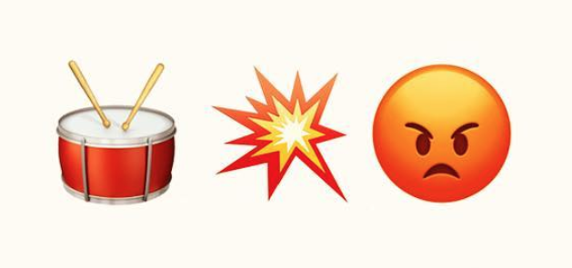 | 11 - Interstellar | 12 - The Matrix  