Round 1 – Divorce
- In 2004, Britney Spears married her childhood friend Jason Allen Alexander at a wedding chapel in Vegas. How long did it take before the marriage was annulled? 26 hours, 55 hours or 74 hours? 55 hours
- Elizabeth Taylor and Richard Burton divorced in 1974. Historically, what is unusual about this? They got married again in 1975 (then got divorced again in 1976)
- How much money – in US dollars – was MacKenzie Bezos granted in her divorce from Amazon founder Jeff Bezos? $36 – 38 billion
- Which British singer-songwriter, drummer and multi-instrumentalist became infamous for allegedly dumping his wife by fax in 1993? Phil Collins
- Who did Madonna divorce in 2008 after eight years of marriage? Guy Ritchie
- True or false: prenuptial agreements can be enforced by courts in England and Wales? True (following a 2010 supreme court test case; Radmacher v Granatino)

Round 2 – Under cover (who was the original writer of these songs, made famous by their cover versions?)
- All along the watchtower, Jimi Hendrix – Bob Dylan
- I will always love you, Whitney Houston (from the movie The Bodyguard) – Dolly Parton
- Can’t help falling in love, UB40 (from the movie Sliver) – Elvis Presley
- Big yellow taxi, Counting Crows – Joni Mitchell
- Mad world, Gary Jules (from the movie Donnie Darko) – Tears for Fears
- I’m a believer, Smashmouth (from the movie Shrek) – Neil Diamond

Round 3 – Random knowledge
- On average, how many Friday 13ths are there a century? (10% either way). 172 (155 – 189)
- What does HDMI stand for? High-definition multimedia interface
- True or false: the human tongue is divided into different areas that taste different flavours? False
- Which soft drink was created during World War II by Coca-Cola Deutschland because they couldn’t get the ingredients needed to make Coca-Cola due to trade embargos against Germany, and so needed an alternative? Fanta
- In which country was Tesla founder Elon Musk born and raised in, before moving to Canada at age 17 to study? South Africa

Round 4 – Booze
- In modern usage, where would whisky (without an e) be from? Scotland
- What ingredient is fermented to make the Japanese drink sake? Rice
- In England and Wales, what is the legal alcohol limit for drivers in milligrammes per 100 millilitres of blood? (10% either way) 80 milligrammes per 100 millilitres of bloody (72 – 88 milligrammes)
- Which beer uses the slogan “The king of beers”? Budweiser
- In what year was prohibition introduced in the United States, and in what year was it repealed? (½ point for each, exact years only). 1920 and 1933

Round 5 – Cartoons
- In South Park, what is the first name of the arrogant, prejudiced and narcissistic schoolboy, Cartman? Eric
- Complete the phrase yelled by Prince Adam as he transforms into He-Man: “By the power of…”. Bonus ½ point: what other phrase does he say after this? Grayskull, “I have the power”
- In what year did the Tom & Jerry cartoons debut? (1 year either way). 1940 (1939 – 1941)
- Which still-running comedy sci-fi cartoon’s popularity and subsequent demand from fans led McDonalds to briefly reintroduce Szechuan sauce in 2017? Rick and Morty
- In The Flintstones, what was the surname of Fred Flintstone’s best friend, Barney? Rubble
- In The Simpsons, all characters are drawn with only four fingers (3 and a thumb), except for one who is drawn with all five. Which character is this? God

Round 6 – Space
- In astronomy and astrobiology, the range of orbits around a star within which a planetary surface can support liquid water given sufficient atmospheric pressure is known as what? Habitable zone or Goldilocks zone
- What is the Moon’s gravity compared to Earth’s? 1/6 or 0.17
- The Hale-Bopp comet was observable in the sky with the naked eye for around 18 months in 1997. How many years will it be before the comet returns to our solar system and will be observable again? Clue: there may be a reference to Hale-Bopp in a piece of recorded human history (5% either way). 4,200 years (3,990 – 4,410). May have been observed in 2215 BC, ancient Egypt, during the 6th dynasty reign of Pharaoh Pepi II, whose pyramid contains text referring to an “nnh-star”, where “nnh” is the hieroglyph for “long hair”
- What word beginning with P is the name of the theory that life exists throughout the universe and is distributed from planet to planet via carriers such as space dust, meteoroids, asteroids, comets, planetoids or even spacecraft? Panspermia
- In our solar system, the moon of Titan orbits which planet? Saturn
- Which sci-fi film’s depiction of a black hole required the effects team to develop a CGI rendering engine that led to a number of scientific papers on black holes being published? Interstellar

Round 7 – Picture round – name the actor behind the makeup or CGI

NB: ½ a point for each

- Sam Worthington
- Christopher Plummer
- John Hurt
- Jonny Depp
- Ian McDiarmid
- Benedict Cumberbatch
- Tommy Lee Jones
- Kelsey Grammer
- Dustin Hoffman
- Charlize Theron
- Gary Oldman
- Andy Serkis
- Jeff Goldblum
- Danny DeVito

Jackpot question
When it’s at its farthest distance, how far is Pluto from Earth in miles? (1% either way). 4.67 billion miles (4,623,300,000 – 4,716,700,000)

Picture round – name the actor behind the makeup or CGI

1  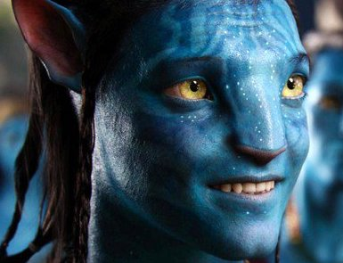 | 2  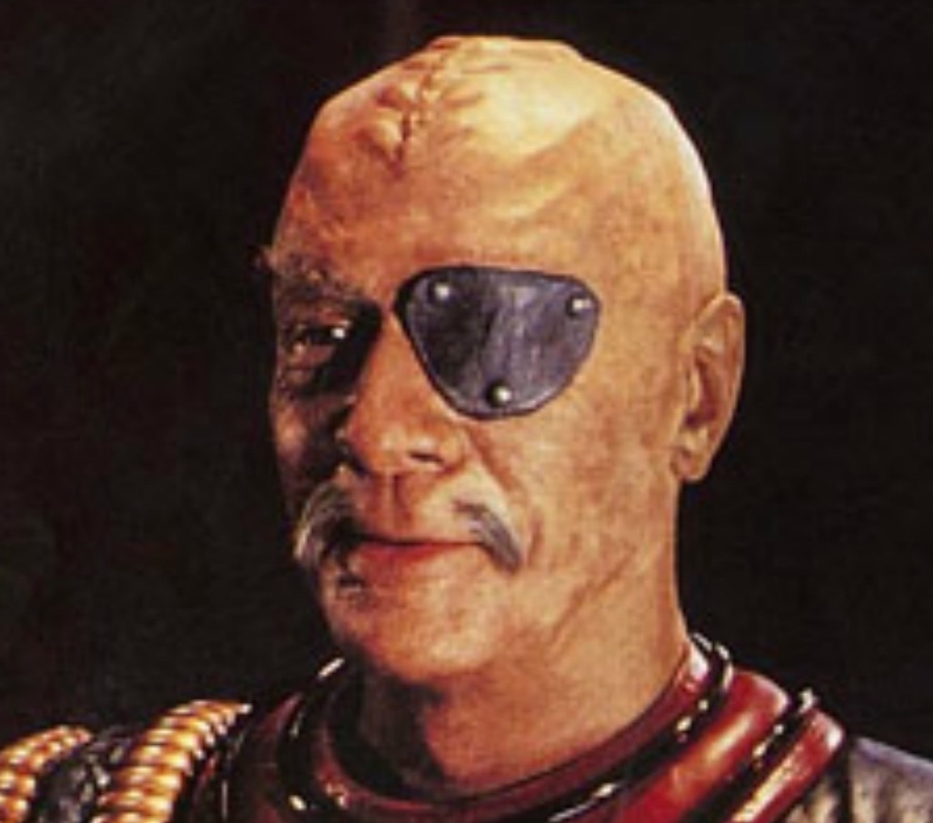 | 3  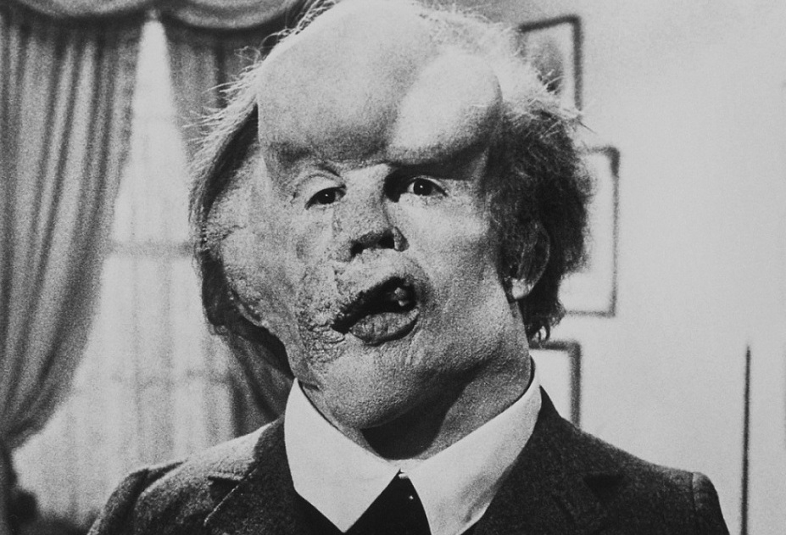 | 4
5 | 6  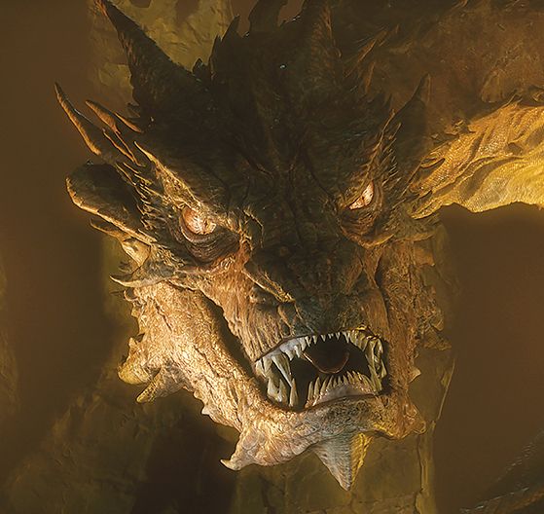 | 7  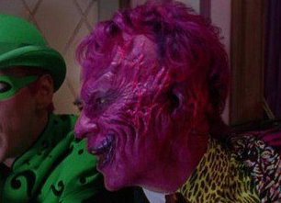 | 8  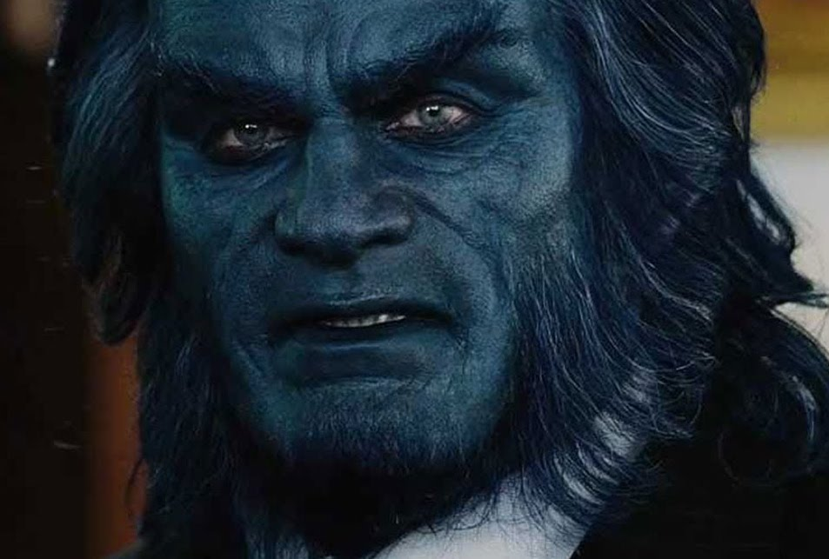
9  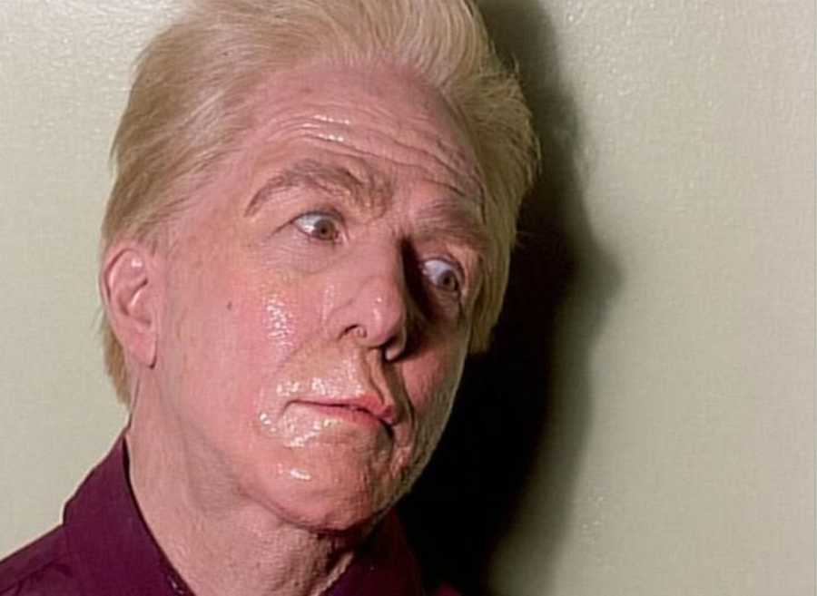 | 10  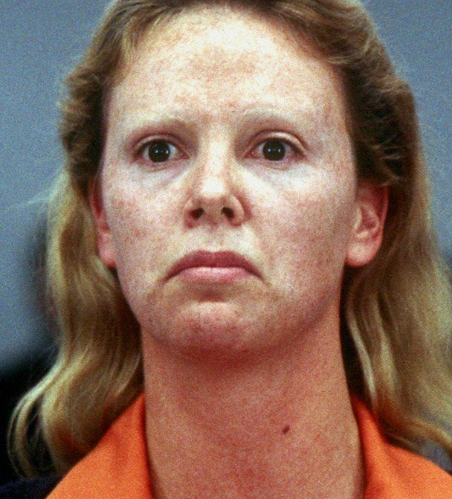 | 11  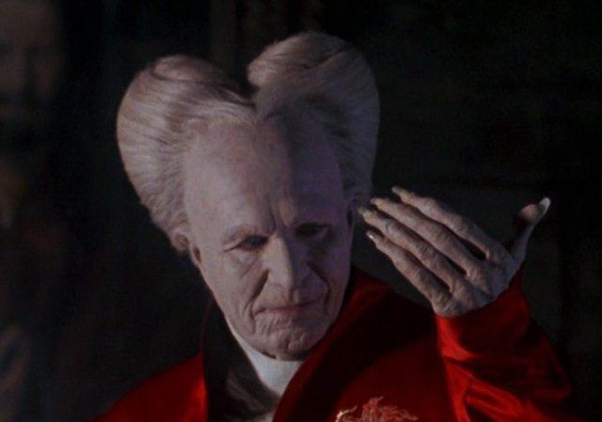 | 12  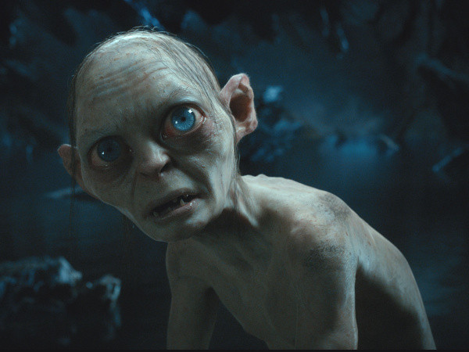
13  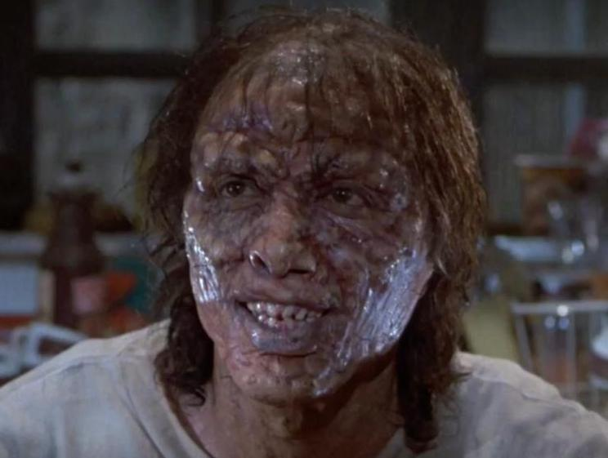 | 14  