Round 1- Britain

- The 5 Boroughs of the Danelaw were the 5 main towns of Danish Mercia, what is now the East Midlands. What are the 5 Towns? One point for each of them. (Derby, Stamford, Nottingham, Leicester and Lincoln.)
- What are the only London Boroughs to begin with a vowel? One point for each. (Ealing, Enfield and Islington.)
- Which city is linked to Liverpool by a 127-mile canal, although it is only 75 miles away by road? (Leeds.)
- In which seaside town is there a Nelson’s Column? (Gt. Yarmouth.)
- What is unique in this country about the public road that leads up to the Savoy Hotel? (Drive on the right-hand side of the road.)
- What famous attraction can be found at SE1 7PB? (London Eye.)

Round 2 – Food & Drink

- In the 15th and 16th centuries in Europe which bird was an indispensable course at almost all feasts for the rich and royalty? (A Peacock.)
- In which TV show does Paul McCartney claim that if you play his song 'Maybe I'm amazed' backwards you can hear a great recipe for lentil soup? (The Simpsons.)
- What is the largest tree borne fruit in the world which can reach up to 80 pounds in weight and 36 inches in length? (Jackfruit.)
- Which fast food chain opened its first UK outlet in London in 1954? (Wimpy.)
- Which 2 cheeses are layered in a Huntsman Cheese? One point for each correct answer. (Double Gloucester & Stilton.)
- The name for which indispensable part of the Indian cuisine means "the fragrant one"? (Basmati.)

Round 3 – Music

- The Beatles released I want to hold your hand in the USA on Boxing Day 1963. The number one song at the time in the US charts was a little ditty sung by a Belgian named Soeur Sourire. What was a. her stage name and b. the number one song? (a. The Singing Nun b. Dominique.)
- Which English rock band has appeared a record 106 times on the BBC's Top Of The Pops? (Status Quo.)
- A barber, a banker, a fireman and a nurse all feature in the lyrics of which Beatles song? (Penny Lane.)
- What is the name of the German classical composer, famous for his opera Hansel & Gretel? (Englebert Humperdinck.)
- Whose albums include Aladdin Sane, Diamond Dogs and Tonight? (David Bowie.)
- Which Queen No 1 has the title of an ABBA number 1 in its lyrics? (Bohemian Rhapsody - Mamma Mia.)

Round 4 – People

- Which jolly, fat and somewhat disreputable character appears in Shakespeare’s Henry V1 & Merry Wives of Windsor? (Sir John Falstaff.)

- What is the name of the famous statue by Edvard Eriksen? (The Little Mermaid.)
- What is the first name of the daughter of Professor Archimedes Q Porter of Baltimore? (Jane, in Tarzan.)
- Murganah is the slave girl in which story? (Ali Baba & the Forty Thieves.)
- Which somewhat often baffling invention was devised by John Spilsbury in the 1760s? (Jigsaw Puzzle.)
- Which icon of the cinema was born Issur Danielovitch Demsky? (Kirk Douglas.)

Round 5 - Soaps
- Other than EastEnders, in which soap did Ross Kemp appear? (Emmerdale)
- In Coronation Street, which double barrelled name did Les and Camilla have? (Battersby-Brown.)
- Who was the caretaker at the Glad Tidings Mission Hall? (Ena Sharples.)
- What is the name of the town in which Home and Away is set? (Summer Bay.)
- What was the name of the pub in Albion Market? (Watermans Arms.)

Round 6 – The Royals
- What was Camilla’s surname before she married Anthony Parker Bowles? (Shand.)
- Who became the first monarch of the House of Windsor after it was renamed from the House of Saxe-Coburg and Gotha? (George V.)
- Who in 2008, did Autumn Kelly marry? (Peter Phillips.)
- There are two duchies in England, one is the Duchy of Cornwall, can you name the other? (Duchy of Lancaster.)
- "If it doesn't fart or eat hay, she's not interested." Who said this quote, and about whom? (Prince Philip (the Duke of Edinburgh) about Princess Anne (the Princess Royal)
- Who is the first in line of succession to the British throne that is not a descendant of Queen Elizabeth II? (Viscount Linley David Armstrong-Jones, 2nd Earl of Snowdon - Princess Margaret's son)

Round 7 – Picture Round: Name the Star Wars Characters
- Count Dooku / Darth Tyranus
- Darth Maul
- Chewbacca
- Lando Calrissian
- Boba Fett
- Han Solo & Jabba the Hutt
- Jar Jar Binks
- Grand Moff Tarkin
- Mace Windu
- Admiral Ackbar
- General Grievous
- Queen Amidala / Padmé
- Luke Skywalker & Uncle Owen
- Jango Fett
- Supreme Leader Snoke

Round 7 – Picture Round: Name the Star Wars Characters

1  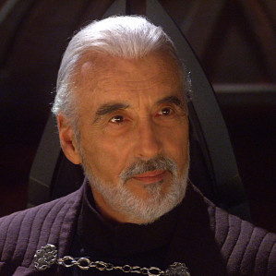 | 2 | 3  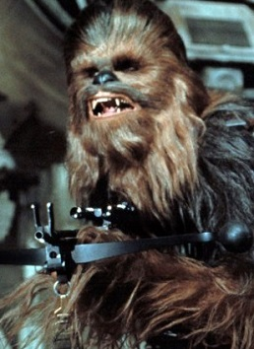
4  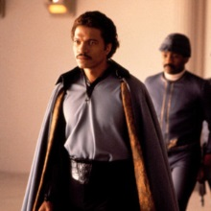 | 5  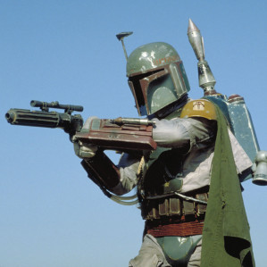 | 6  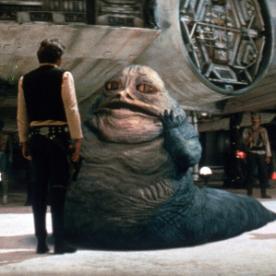
7  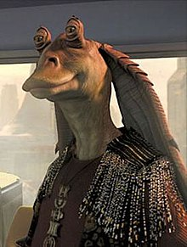 | 8  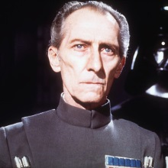 | 9  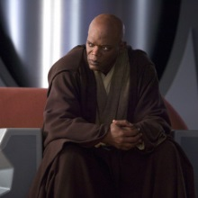
10  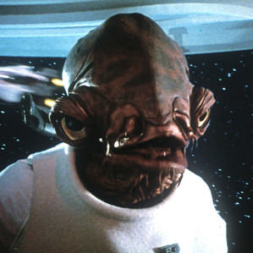 | 11  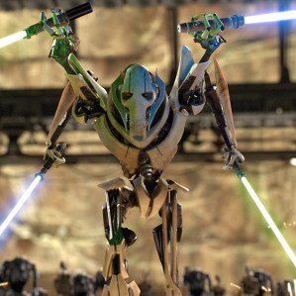 | 12  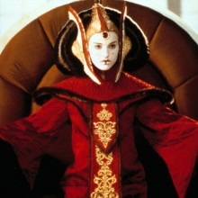
13  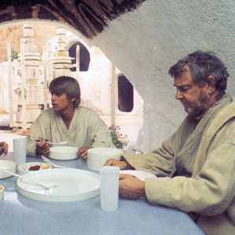 | 14  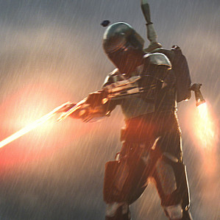 | 15  