UTAH CANNABIS PHARMACIES

Salt Lake City: Dragonfly Health and Wellness
711 South State Street, Salt Lake City, UT 84111
(801) 413-6945
wellness@dragonflyut.com

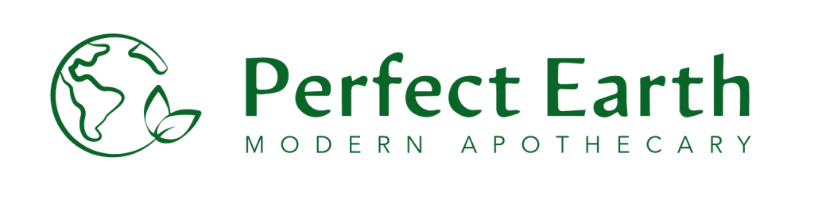
North Logan: Perfect Earth Modern Apothecary
2150 N Main, Suite 1, North Logan, UT 84341
(435) 554-1444
contact@truenorthofutah.com

Ogden: Perfect Earth Modern Apothecary
3775 S Wall Ave, South Ogden, UT 84405
(435) 554-1444
contact@truenorthofutah.com

