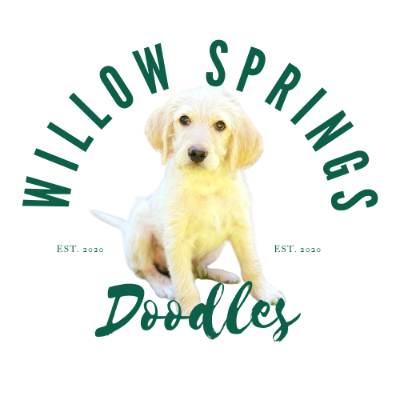

Puppy Application Form

Name:

Address:

City, State, Zip:

Phone Number:

E-Mail:

Best time to call:

Were you referred?

OR

How did you hear about us?

Which litter are you interested in?

Are you interested in a: Male Female

Are you interested in a:

Companion/ Pet Show Prospect Working/ Service Prospect Other

Why do you want to own a Willow Springs Doodle? What qualities are you looking for?

What experience do you have with Labradoodles or other dog breeds?

What are you goals for this pup?



Tell us about your family (hobbies or interest)

How many adults live in home?

How many children? Children’s ages:

Do you have any cats or other pets?

Tell us more about your family, lifestyle, work schedules, etc.:

Tell us about your home:

Is the area you live in: Rural Suburban City

Will your pup live: Indoors Outdoors

Will this pup have acess to a fence yard? Yes No

Are you planning on crate training? Yes No

List any dog clubs you belong to and titles you’ve achieved with your dogs:

Please provide us with two references. One please must be from a breeder, Veterinarian or trainer (or Vet you plan on using):

1. Name: Relationship: Phone #:
2. Name: Occupation: Phone #:

Are you willing to travel to travel to Middlesex, NC to pick up pup? Yes No

Do you need any delivery services or help flying pup to you? Yes No