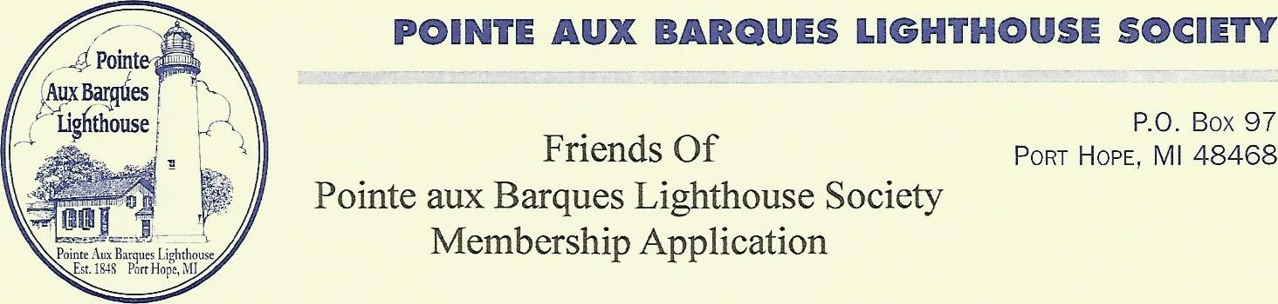
Date:

First Name: Last Name:
Spouse First Name: Spouse Last Name:
Address:

City: State: Zip Code:
Phone:

E-Mail:

Type of Membership: Single Family {Family has one vote, but both spouses are eligible to be members of the Board of Directors. {but not to serve concurrently}
New Member:Renewal :
Please mark all that may apply:
I would like to pay my membership dues. $25.00
I would like to make additional donation, $
I would like to make a donation of material or historical items.
I would like to contribute to on-site work.
I would like to assist with Tower Climb.
I would like to assist with the Museum Store.
I would like to assist with Lighthouse Festival.
Please make checks out to PABLS and mail with form to:
Pointe aux Barques Lighthouse Society Attn: PABLS Membership Chairman Marolyn Becker
36839 Main Street
New Baltimore, Ml 48047
www.pointeauxbarqueslighthouse.org
OUR MISSION: The Pointe Aux Barques Lighthouse Society exists to preserve the history of the lighthouse and surrounding waters of Lake Huron and to assist in maintaining and preserving the lighthouse buildings and grounds.

