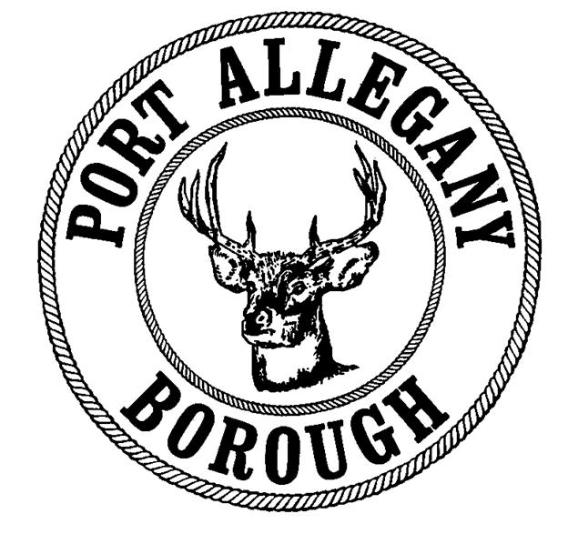 | Port Allegany Borough  Application for Water/Sewer Service  Applications and payment must be returned to the Port Allegany Borough Office  45 W. Maple Street, Port Allegany, PA 16749

I. Applicant Information
Name |  | Phone Number

II. Address Where Service is Requested
Street Address
City |  |  | State |  | Zip

What date would you like to have services activated?

Do you own or rent this property? Own Rent
If you will be renting this property please complete section IV.

III. Billing Address (if different than address where service is requested)
Street Address
City |  |  | State |  | Zip

IV. Landlord Information
Name |  |  | Phone Number
Address
City |  |  |  | State |  |  | Zip

V. Services Requested
Water Only (only available at designated properties in Liberty Township) Water and Sewer
Sewer Only (only available at designated properties in Liberty Township)

VI. Type of Service
Standard Metered (property must have an approved meter) Senior (65+)

Applicant Signature:
In making this application, the undersigned agrees that upon application approval, the applicant will be bound by the provisions contained in the pertinent ordinances, rules, and regulations of the Port Allegany Borough and that the service applied for may be provided on condition of compliance with all applicable ordinances, rules, and regulations. By signing below, the applicant also attests that all information provided on this application is true and accurate to the best of their knowledge.

Signature: Date:

Owner/Landlord Signature:
Service to rental properties will not be approved without Owner/Landlord authorization. By signing below, the owner/landlord authorizes that the borough is permitted to provide water service to the applicant and that in the event of termination of services to the applicant through the closing of the applicant account or termination for non-payment that the water service and all applicable fees will transfer to the land owner / landlord.

Signature: Date:

For Office Use Only
Security Deposit Payment Method:  Cash Check / Money Order #: | Security Deposit Amount Paid:
Date Water / Sewer Service Activated:
What documentation was provided and photcopied to verify identity?

